UNITED STATES
SECURITIES AND EXCHANGE COMMISSION
Washington, D.C. 20549
FORM 6-K
REPORT OF FOREIGN PRIVATE ISSUER
PURSUANT TO RULE 13a-16 OR 15d-16
UNDER THE SECURITIES EXCHANGE ACT OF 1934
For the month of May 2026
Commission File Number: 001-40451
DLocal Limited
(Exact name of registrant as specified in its charter)
DPO Box 1093, Boundary Hall,
Cricket Square, Grand Cayman
KY1-1102
Cayman Islands
Indicate by check mark whether the registrant files or will file annual reports under cover of Form 20-F or Form 40-F:
Form 20-F ☒ Form 40-F ☐

TABLE OF CONTENTS
EXHIBIT
99.1 |  |  |  |  |  | Press release dated May 14, 2026 - dLocal Reports 2026 First Quarter Financial Results
99.2 |  |  |  |  |  | DLocal Limited Unaudited Consolidated Condensed Interim Financial Statements as of March 31, 2026 and for the three-month period ended March 31, 2026 and 2025
99.3 |  |  |  |  |  | Quarterly Report 2026 - dLocal Reports 2026 First Quarter Financial Results
99.4 |  |  |  |  |  | dLocal Q1 2026 Earnings Presentation

SIGNATURE
Pursuant to the requirements of the Securities Exchange Act of 1934, the registrant has duly caused this report to be signed on its behalf by the undersigned, thereunto duly authorized.

 |  |  | DLocal Limited
 |  |  | By: |  |  | /s/ Guillermo López Pérez
 |  |  | Name: |  |  | Guillermo López Pérez
 |  |  | Title: |  |  | Chief Financial Officer

Date: May 14, 2026

Exhibit 99.1



dLocal Reports First Quarter 2026 Financial Results

TPV surpassed US$14 billion for the first time (+73% year-over-year), six consecutive quarters of 50%+ year-over-year growth.
Record gross profit: US$119 million (+40% year-over-year).
Operating profit US$57 million excluding prior years tax adjustments (+25% year-over-year).
Expected higher OPEX from 2025 carry-over; operating leverage to improve in 2H26.
Net income at US$52 million excluding prior-years tax adjustments (+11% year-over-year).
Adjusted Free Cash Flow US$15 million, driven by temporary working capital effects, expected to revert.
Guidance unchanged.

Montevideo, Uruguay, May 14, 2026 — DLocal Limited (“dLocal”, “we”, “us”, and “our”) (NASDAQ:DLO), a leading cross-border financial infrastructure platform connecting global merchants to emerging markets, today announced its financial results for the first quarter ended March 31, 2026.
dLocal’s management team will host a conference call and audio webcast on May 14, 2026 at 5:00 p.m. Eastern Time. Please click here to pre-register for the conference call and obtain your dial in number and passcode.
The live conference call can be accessed via audio webcast at the investor relations section of dLocal’s website, at https://investor.dlocal.com/. An archive of the webcast will be available for a year following the conclusion of the conference call. The investor presentation will also be filed on EDGAR at www.sec.gov.

“Ten years in, the thesis is intact, the opportunity is larger than ever, and we are better equipped to capture it than at any point in our history. The infrastructure we have built - the licenses, the payment methods, the stakeholder relationships, the data, the technology - abstracts local complexity and compounds in value over time. The combination of strong base business momentum, a product roadmap that is gaining traction, and secular tailwinds across our markets as merchants increasingly convert to local processing, gives us confidence that the next decade can be as impressive as the last,” said Pedro Arnt, CEO of dLocal.

First quarter 2026 financial highlights
dLocal reports in US dollars and in accordance with IFRS as issued by the IASB

•Total Payment Volume (“TPV”) reached US$14.1 billion in the first quarter of 2026, up 73% year-over-year compared to US$8.1 billion in the first quarter of 2025 and up 7% compared to US$13.1 billion in the fourth quarter of 2025. In constant currency, TPV growth for the period would have been 63% year-over-year.
•Revenues amounted to US$335.9 million, up 55% year-over-year compared to US$216.8 million in the first quarter of 2025 and broadly flat compared to US$337.9 million in the fourth quarter of 2025. In constant currency, revenue growth for the period would have been 52% year-over-year. The quarter-over-quarter comparison reflects a less favorable payment method mix and narrower FX spreads.
•Gross profit was US$118.7 million in the first quarter of 2026, a new record, up 40% compared to US$84.9 million in the first quarter of 2025 and up 2% compared to US$115.8 million in the fourth quarter of 2025. In constant currency, gross profit growth for the period would have been 35% year-over-year. The quarter-over-quarter comparison is explained by (i) Argentina's strong volume growth and normalized funding costs; (ii) broad-based volume growth in Africa and Asia, with notable contributions from Nigeria, Mozambique, and Vietnam; partially offset by (iii) Brazil's normalization following an exceptionally strong fourth quarter of 2025; and (iv) a modest mix shift toward lower take rate merchants in Other LatAm markets.
•As a result, gross profit margin was 35% in this quarter, compared to 39% in the first quarter of 2025 and 34% in the fourth quarter of 2025.

Exhibit 99.1
•Gross profit over TPV was at 0.84%, decreasing from 1.05% in the first quarter of 2025 and from 0.88% in the fourth quarter of 2025, reflecting the continued strong TPV momentum and the natural margin dynamics of scaling volume with established merchants and into new payment methods, products, and countries.
•During the first quarter of 2026, dLocal recorded a one-off prior-periods tax adjustment of US$9.7 million related to installment payment products in certain markets. This out-of-period adjustment was not material to any previously reported annual or interim period. Of the total adjustment, approximately US$5.3 million impacted the income tax expense line and US$4.4 million in operating expenses related to indirect and other taxes. The Company does not expect to record comparable items in future quarters.
•Operating expenses totaled US$65.9 million for the first quarter of 2026, or US$61.5 million excluding the prior-periods adjustment, up 58% year-over-year and 16% quarter-over-quarter on a normalized basis, reflecting the expected carry-over of the last part of the investment cycle costs, which ramped up mostly towards the end of 2025.
•As a result, Operating profit was US$52.8 million, or would have been US$57.2 million excluding the one-off prior-periods tax adjustment, representing growth of 25% year-over-year and decrease of 9% on a normalized basis. The Operating Profit to Gross Profit ratio was 44% as reported and 48% excluding the one-off.
•Net financial result was US$5.2 million gain, compared to a net finance gain of US$7.0 million in the first quarter of 2025 and a net finance gain of US$3.4 million in the fourth quarter of 2025.
•Our effective income tax rate for the period was approximately 26% as reported, elevated by the non-recurring prior-period adjustment. Excluding the adjustment, the effective rate would have been approximately 16%, broadly in line with prior quarters.
•Net income for the first quarter of 2026 was US$41.9 million, or US$0.14 per diluted share, down 10% compared to a profit of US$46.7 million, or US$0.16 per diluted share, for the first quarter of 2025 and down 25% compared to a profit of US$55.6 million, or US$0.18 per diluted share for the fourth quarter of 2025. Excluding the prior-periods tax adjustment, net income would have been US$51.6 million, or US$0.17 per diluted share, up 11% year-over-year.
•Adjusted Free cash flow for the first quarter of 2026 amounted to US$14.7 million, down 63% year-over-year compared to US$39.7 million in the first quarter of 2025 and down 77% compared to US$64.9 million in the fourth quarter of 2025. The year-over-year and sequential variation is primarily explained by temporary working capital effects, including timing in tax credit netting and higher receivables from our advancement operations, which are expected to normalize in upcoming quarters.
•As of March 31, 2026, dLocal had US$815.6 million in cash and cash equivalents, which includes US$451.8 million of Corporate cash and cash equivalents. The Corporate cash and cash equivalents increased by US$95.9 million from US$355.9 million as of March 31, 2025. When compared to the US$424.5 million Corporate cash and cash equivalents position as of December 31, 2025, it increased by US$27.3 million quarter-over-quarter.

The following table summarizes our key performance metrics:
 |  |  | Three months ended on March 31
 |  |  | 2026 |  |  | 2025 |  |  | % change
Key Performance metrics |  |  | (In millions of US$ except for %)
TPV |  |  | 14,055 |  |  | 8,107 |  |  | 73%
Revenue |  |  | 335.9 |  |  | 216.8 |  |  | 55%
Gross Profit |  |  | 118.7 |  |  | 84.9 |  |  | 40%
Gross Profit margin |  |  | 35% |  |  | 39% |  |  | -4p.p
Operating Profit |  |  | 52.8 |  |  | 45.8 |  |  | 15%
Operating Profit/Gross Profit |  |  | 44% |  |  | 54% |  |  | -10p.p
Net Income |  |  | 41.9 |  |  | 46.7 |  |  | -10%
Net Income margin |  |  | 12% |  |  | 22% |  |  | -9p.p

Exhibit 99.1
Adjusted Free Cash Flow reconciliation

We calculate “Adjusted Free Cash Flow” as net cash (used in) / generated from cash flows from operating activities, less (i) changes in working capital (merchant), and (ii) capital expenditures. The working capital (merchant) is defined as (i) changes in Trade receivables net (disclosed in Note 16 to our consolidated financial statements for the year ended December 31, 2025 and Note 21 to our financial statements for the year ended December 31, 2024 (“FY25 Financial statements” and “FY24 Financial Statements”, respectively)), plus (ii) changes in Trade payables (disclosed in Note 21 to our FY25 and FY24 Financial Statements), plus (iii) changes in Other tax liabilities (disclosed in note 23 to our FY25 and FY24 Financial Statements). Capital expenditures consist of acquisitions of property, plant and equipment and additions of intangible assets.

Management uses Adjusted Free Cash Flow as a measure for evaluating the Company's cash generation and the cash available for distribution to our shareholders as dividends pursuant to our dividend policy. Adjusted Free Cash Flow is not a financial measure recognized under IFRS and does not purport to be an alternative to cash generated from operating activities or as a measure of liquidity. Our presentation of Adjusted Free Cash Flow has limitations as an analytical tool, and you should not consider it in isolation or as a substitute for analysis of our results as reported under IFRS. See below for a reconciliation of our Adjusted Free Cash Flow to the nearest IFRS measure.

The table below presents a reconciliation of dLocal’s Adjusted Free Cash Flow reconciliation:
$ in thousands (except percentages) |  |  | Three months ended on March 31
 |  |  | 2026 |  |  | 2025
Net cash (used in ) / generated from operating activities |  |  | 92,781 |  |  | 95,411
Changes in working capital (merchant)¹ |  |  | (68,391) |  |  | (48,170)
Capital expenditures² |  |  | (9,738) |  |  | (7,512)
Adjusted Free Cash Flow |  |  | 14,652 |  |  | 39,729

Note: 1 Changes in working capital (merchant) consists of (i) changes in the period in the balance of trade receivables net, plus (ii) changes in the period in the balance of trade payables, plus (iii) changes in the period in the balance of other tax liabilities. 2 Capital expenditures consist of acquisitions of property, plant and equipment and Additions of Intangible Assets.

Operating profit excluding prior years tax adjustments reconciliation

We calculate "Operating Profit Excluding Prior Years Tax Adjustments" as operating profit for the period, excluding the impact of prior periods tax adjustments. During the three-months period ended on March 31, 2026, certain tax assessments related to prior years were adjusted, resulting in tax impacts amounting to US$9,699 corresponding to fiscal years 2023, 2024 and 2025. From the total amount, US$5,296 relates to income tax and related interest (refer to Note 12. Income tax, footnote (i)) and US$4,403 relates to indirect taxes, other taxes and related interest which were included within other operating expenses. The Company concluded that the out of period adjustment was not material to any previously reported annual or interim period.

Management uses Operating Profit Excluding Prior Years Tax Adjustments as a measure for evaluating the Company's underlying operating performance by removing the effect of non-recurring, out-of-period tax assessments. Operating Profit Excluding Prior Years Tax Adjustments is not a financial measure recognized under IFRS and does not purport to be an alternative to operating profit as a measure of operating performance. Our presentation of Operating Profit Excluding Prior Periods Tax Adjustments has limitations as an analytical tool, and you should not consider it in isolation or as a substitute for analysis of our results as reported under IFRS.

Exhibit 99.1
The table below presents a reconciliation of dLocal’s operating profit excluding prior years tax adjustments reconciliation:

$ in thousands |  |  | Three months ended on March 31
 |  |  | 2026 |  |  | 2025
Operating profit |  |  | 52,772 |  |  | 45,845
Prior years tax adjustments (2023-2025) |  |  | 4,404 |  |  | -
Operating profit excluding prior years tax adjustments |  |  | 57,176 |  |  | 45,845

Net income excluding prior years tax adjustments reconciliation

We calculate "Net Income Excluding Prior Years Tax Adjustments" as net income (profit for the period), excluding the impact of prior periods tax adjustments. During the three-months period ended on March 31, 2026, certain tax assessments related to prior years were adjusted, resulting in tax impacts amounting to US$9,699 corresponding to fiscal years 2023, 2024 and 2025. From the total amount, US$5,296 relates to income tax and related interest (refer to Note 12. Income tax, footnote (i)) and US$4,403 relates to indirect taxes, other taxes and related interest which were included within other operating expenses. The Company concluded that the out of period adjustment was not material to any previously reported annual or interim period.

Management uses Net Income Excluding Prior Years Tax Adjustments as a measure for evaluating the Company's underlying profitability by removing the effect of non-recurring, out-of-period tax assessments. Net Income Excluding Prior Years Tax Adjustments is not a financial measure recognized under IFRS and does not purport to be an alternative to profit for the period as a measure of profitability. Our presentation of Net Income Excluding Prior Periods Tax Adjustments has limitations as an analytical tool, and you should not consider it in isolation or as a substitute for analysis of our results as reported under IFRS.

The table below presents a reconciliation of dLocal’s net income excluding prior years tax adjustments reconciliation:

$ in thousands |  |  | Three months ended on March 31
 |  |  | 2026 |  |  | 2025
Net income (Profit for the period) |  |  | 41,936 |  |  | 46,667
Prior years tax adjustments (2023-2025) |  |  | 9,700 |  |  | -
Net income excluding prior years tax adjustments |  |  | 51,636 |  |  | 46,667

Exhibit 99.1
dLocal Limited
Certain financial information
Consolidated Statements of Comprehensive Income for the three-month period ended March 31, 2026 and 2025
(All amounts in thousands of U.S. Dollars except share data or as otherwise indicated)

 |  |  | Three months ended on March 31
 |  |  | 2026 |  |  | 2025
Continuing operations
Revenues |  |  | 335,862 |  |  | 216,759
Cost of services |  |  | (217,178) |  |  | (131,880)
Gross profit |  |  | 118,684 |  |  | 84,879
Technology and development expenses |  |  | (12,124) |  |  | (6,767)
Sales and marketing expenses |  |  | (9,919) |  |  | (7,135)
General and administrative expenses |  |  | (42,657) |  |  | (24,324)
Impairment (loss)/gain on financial assets |  |  | (780) |  |  | (386)
Other operating loss |  |  | (432) |  |  | (422)
Operating profit |  |  | 52,772 |  |  | 45,845
Finance income |  |  | 10,757 |  |  | 12,228
Finance costs |  |  | (5,598) |  |  | (5,259)
Inflation adjustment |  |  | (1,386) |  |  | (885)
Other results |  |  | 3,773 |  |  | 6,084
Profit before income tax |  |  | 56,545 |  |  | 51,929
Income tax expense |  |  | (14,609) |  |  | (5,262)
Profit for the period |  |  | 41,936 |  |  | 46,667
Profit attributable to:
Owners of the Group |  |  | 41,975 |  |  | 46,630
Non-controlling interest |  |  | (39) |  |  | 37
Profit for the period |  |  | 41,936 |  |  | 46,667
Earnings per share (in USD)
Basic Earnings per share |  |  | 0.14 |  |  | 0.16
Diluted Earnings per share |  |  | 0.14 |  |  | 0.15
Other comprehensive Income
Items that are or may be reclassified to profit or loss:
Exchange difference on translation on foreign operations |  |  | 3,047 |  |  | 3,526
Other comprehensive income for the period, net of tax |  |  | 3,047 |  |  | 3,526
Total comprehensive income for the period |  |  | 44,983 |  |  | 50,193
Total comprehensive income for the period is attributable to:
Owners of the Group |  |  | 45,022 |  |  | 50,174
Non-controlling interest |  |  | (39) |  |  | 19
Total comprehensive income for the period |  |  | 44,983 |  |  | 50,193

Exhibit 99.1
dLocal Limited
Certain financial information
Consolidated Condensed Interim Statements of Financial Position as of March 31, 2026 and December 31, 2025
(All amounts in thousands of U.S. dollars)
 |  |  | Three months ended on March 31
 |  |  | 2026 |  |  | 2025
 |  |  | on March 31, 2026 |  |  | on December 31, 2025
ASSETS
Current Assets
Cash and cash equivalents |  |  | 815,605 |  |  | 719,897
Financial assets at fair value through profit or loss |  |  | 97,995 |  |  | 99,089
Trade and other receivables |  |  | 740,432 |  |  | 572,024
Derivative financial instruments |  |  | 2,341 |  |  | 140
Other assets |  |  | 20,871 |  |  | 29,607
Total Current Assets |  |  | 1,677,244 |  |  | 1,420,757
Non-Current Assets
Financial assets at fair value through profit or loss |  |  |  |  |  | -
Trade and other receivables |  |  | 26,664 |  |  | 25,982
Deferred tax assets |  |  | 10,251 |  |  | 7,666
Property, plant and equipment |  |  | 4,043 |  |  | 3,985
Right-of-use assets |  |  | 2,808 |  |  | 2,995
Intangible assets |  |  | 92,506 |  |  | 73,965
Goodwill |  |  | 6,550 |  |  | -
Other assets |  |  | 5,701 |  |  | 5,614
Total Non-Current Assets |  |  | 148,523 |  |  | 120,207
TOTAL ASSETS |  |  | 1,825,767 |  |  | 1,540,964
LIABILITIES
Current Liabilities
Trade and other payables |  |  | 1,116,490 |  |  | 854,436
Lease liabilities |  |  | 1,003 |  |  | 1,076
Tax liabilities |  |  | 39,778 |  |  | 21,500
Derivative financial instruments |  |  | 567 |  |  | 1,567
Financial liabilities |  |  | 106,944 |  |  | 86,898
Provisions |  |  | 461 |  |  | 433
Total Current Liabilities |  |  | 1,265,243 |  |  | 965,910
Non-Current Liabilities
Deferred tax liabilities |  |  | 5,427 |  |  | 3,316
Lease liabilities |  |  | 1,761 |  |  | 2,309
Total Non-Current Liabilities |  |  | 7,188 |  |  | 5,625
TOTAL LIABILITIES |  |  | 1,272,431 |  |  | 971,535
EQUITY
Share Capital |  |  | 588 |  |  | 590
Share Premium |  |  | 7,097 |  |  | 7,097
Treasury Shares |  |  | (10,122) |  |  | -
Capital Reserve |  |  | 48,899 |  |  | 42,641
Other Reserves |  |  | (12,919) |  |  | (15,885)
Retained earnings |  |  | 519,584 |  |  | 534,818
Total Equity Attributable to owners of the Group |  |  | 553,127 |  |  | 569,261
Non-controlling interest |  |  | 209 |  |  | 168
TOTAL EQUITY |  |  | 553,336 |  |  | 569,429
TOTAL EQUITY AND LIABILITIES |  |  | 1,825,767 |  |  | 1,540,964

Exhibit 99.1
dLocal Limited
Certain interim financial information.
Consolidated Statements of Cash flows for the three-month period ended March 31, 2026 and 2025
(All amounts in thousands of U.S. dollars)

 |  |  | Three months ended on March 31
 |  |  | 2026 |  |  | 2025
Cash flows from operating activities
Profit before income tax |  |  | 56,545 |  |  | 51,929
Adjustments:
Interest Income from financial instruments |  |  | (10,590) |  |  | (5,106)
Interest charges for lease liabilities |  |  | 57 |  |  | 41
Other interests charges |  |  | 7,512 |  |  | 883
Finance expense related to derivative financial instruments |  |  | 700 |  |  | 414
Net exchange differences |  |  | (2,616) |  |  | 4,142
Fair value loss/(gain) on financial assets at FVPL |  |  | (167) |  |  | (7,343)
Amortization of Intangible assets |  |  | 7,062 |  |  | 4,584
Depreciation and disposals of PP&E and right-of-use |  |  | 653 |  |  | 703
Share-based payment expense, net of forfeitures |  |  | 6,066 |  |  | 6,020
Other operating gain |  |  | 432 |  |  | 422
Net Impairment loss/(gain) on financial assets |  |  | 780 |  |  | 386
Inflation adjustment and other financial results |  |  | 2,862 |  |  | 6,083
 |  |  | 69,296 |  |  | 63,158
Changes in working capital
Increase in Trade and other receivables |  |  | (170,302) |  |  | 21,082
Decrease / (Increase) in Other assets |  |  | (14,279) |  |  | 1,025
Increase / (Decrease) in Trade and Other payables |  |  | 204,843 |  |  | 16,346
Increase / (Decrease) in Tax Liabilities |  |  | 9,577 |  |  | 965
Increase / (Decrease) in Provisions |  |  | 28 |  |  | 43
Cash (used) / generated from operating activities |  |  | 99,163 |  |  | 102,619
Income tax paid |  |  | (6,382) |  |  | (7,208)
Net cash (used) / generated from operating activities |  |  | 92,781 |  |  | 95,411
Cash flows from investing activities
Acquisitions of Property, plant and equipment |  |  | (522) |  |  | (945)
Additions of Intangible assets |  |  | (9,216) |  |  | (6,567)
Acquisition of financial assets at FVPL |  |  | (26,876) |  |  | (41,374)
Collections of financial assets at FVPL |  |  | 27,179 |  |  | 47,416
Interest collected from financial instruments |  |  | 10,590 |  |  | 5,106
Cash acquired in a business combination |  |  | 791 |  |  | -
Payments for investments in other assets at FVPL |  |  | - |  |  | (10,000)
Net cash (used in) / generated investing activities |  |  | 1,946 |  |  | (6,364)
Cash flows from financing activities
Repurchase of shares |  |  | (10,122) |  |  | -
Share-options exercise paid |  |  | 192 |  |  | -
Interest payments on lease liability |  |  | (57) |  |  | (41)
Principal payments on lease liability |  |  | (748) |  |  | (663)
Finance expense paid related to derivative financial instruments |  |  | (3,901) |  |  | (3,132)
Net proceeds from financial liabilities |  |  | 25,353 |  |  | 5,790
Interest payments on financial liabilities |  |  | (5,306) |  |  | (2,166)
Other finance expense paid |  |  | (7,455) |  |  | (714)
Net cash used in by financing activities |  |  | (2,044) |  |  | (926)
Net increase in cash flow |  |  | 92,683 |  |  | 88,121
Cash and cash equivalents at the beginning of the period |  |  | 719,897 |  |  | 425,172
Net (decrease)/increase in cash flow |  |  | 92,683 |  |  | 88,121

Exhibit 99.1
Effects of exchange rate changes on inflation and cash and cash equivalents |  |  | 3,025 |  |  | (1,787)
Cash and cash equivalents at the end of the period |  |  | 815,605 |  |  | 511,506

About dLocal
dLocal builds financial infrastructure for markets of the future, connecting global enterprises with billions of emerging market consumers in more than 60 countries across high-growth markets in Africa, Asia, the Middle East, and Latin America. Through the "One dLocal" concept (one direct API, one platform, and one contract), global companies can accept payments, send payouts, and settle funds globally without the need to manage multiple local entities and integrations. For more information, visit www.dlocal.com

Forward-looking statements
This presentation may contain forward-looking statements. These forward-looking statements convey dLocal’s current expectations or forecasts of future events, including guidance in respect of total payment volume, gross profit and operating profit. Forward-looking statements regarding dLocal and amounts stated as guidance involve known and unknown risks, uncertainties and other factors that may cause dLocal’s actual results, performance or achievements to be materially different from any future results, performances or achievements expressed or implied by the forward-looking statements. Certain of these risks and uncertainties are described in the “Risk Factors,” and “Cautionary Statement Regarding Forward-Looking Statements” sections of dLocal’s filings with the U.S. Securities and Exchange Commission.

Unless required by law, dLocal undertakes no obligation to publicly update or revise any forward-looking statements to reflect circumstances or events after the date hereof.

Starting in 2026, we provide guidance in respect of Operating Profit, which management believes is useful as a measure to compare our operating results to the operations of other companies in our industry, and to assess our operating performance independently of our capital structure, tax position, and non-cash depreciation and amortization charges.

Investor Relations Contact:
investor@dlocal.com

Media Contact:
media@dlocal.com

This press release does not contain sufficient information to constitute an interim financial report as defined in International Accounting Standards 34, “Interim Financial Reporting” nor a financial statement as defined by International Accounting Standards 1 “Presentation of Financial Statements”. The first quarter financial information in this press release has not been audited nor has it been subject to any limited review procedures, whereas the annual results for the year ended December 31, 2025 are audited.

Exhibit 99.2

DLocal Limited
Unaudited Consolidated Condensed Interim Financial Statements as of March 31, 2026 and For the Quarter ended March 31, 2026 and 2025

DLocal Limited
Unaudited Consolidated Condensed Interim Statements of Comprehensive Income
For the Quarter ended March 31, 2026 and 2025
(All amounts in thousands of U.S. Dollars except share data or as otherwise indicated)
Comprehensive Income
 |  |  |  |  |  |  |  |  |  |  |  | Three months ended
 |  |  | Notes |  |  |  |  |  |  |  |  |  |  |  | March 31, 2026 |  |  |  |  |  |  |  | March 31, 2025
Continuing operations
Revenues |  |  | 6 |  |  |  |  |  |  |  |  |  |  |  | 335,862 |  |  |  |  |  |  |  | 216,759
Cost of services |  |  | 6 |  |  |  |  |  |  |  |  |  |  |  | (217,178) |  |  |  |  |  |  |  | (131,880)
Gross profit |  |  |  |  |  |  |  |  |  |  |  |  |  |  | 118,684 |  |  |  |  |  |  |  | 84,879
Technology and development expenses |  |  | 7 |  |  |  |  |  |  |  |  |  |  |  | (12,124) |  |  |  |  |  |  |  | (6,767)
Sales and marketing expenses |  |  | 8 |  |  |  |  |  |  |  |  |  |  |  | (9,919) |  |  |  |  |  |  |  | (7,135)
General and administrative expenses |  |  | 8 |  |  |  |  |  |  |  |  |  |  |  | (42,657) |  |  |  |  |  |  |  | (24,324)
Impairment (loss)/gain on financial assets |  |  | 17 |  |  |  |  |  |  |  |  |  |  |  | (780) |  |  |  |  |  |  |  | (386)
Other operating loss |  |  |  |  |  |  |  |  |  |  |  |  |  |  | (432) |  |  |  |  |  |  |  | (422)
Operating profit |  |  |  |  |  |  |  |  |  |  |  |  |  |  | 52,772 |  |  |  |  |  |  |  | 45,845
Finance income |  |  | 11 |  |  |  |  |  |  |  |  |  |  |  | 10,757 |  |  |  |  |  |  |  | 12,228
Finance costs |  |  | 11 |  |  |  |  |  |  |  |  |  |  |  | (5,598) |  |  |  |  |  |  |  | (5,259)
Inflation adjustment |  |  | 11 |  |  |  |  |  |  |  |  |  |  |  | (1,386) |  |  |  |  |  |  |  | (885)
Other results |  |  |  |  |  |  |  |  |  |  |  |  |  |  | 3,773 |  |  |  |  |  |  |  | 6,084
Profit before income tax |  |  |  |  |  |  |  |  |  |  |  |  |  |  | 56,545 |  |  |  |  |  |  |  | 51,929
Income tax expense |  |  | 12 |  |  |  |  |  |  |  |  |  |  |  | (14,609) |  |  |  |  |  |  |  | (5,262)
Profit for the period |  |  |  |  |  |  |  |  |  |  |  |  |  |  | 41,936 |  |  |  |  |  |  |  | 46,667
Profit attributable to:
Owners of the Group |  |  |  |  |  |  |  |  |  |  |  |  |  |  | 41,975 |  |  |  |  |  |  |  | 46,630
Non-controlling interest |  |  |  |  |  |  |  |  |  |  |  |  |  |  | (39) |  |  |  |  |  |  |  | 37
Profit for the period |  |  |  |  |  |  |  |  |  |  |  |  |  |  | 41,936 |  |  |  |  |  |  |  | 46,667
Earnings per share
Basic Earnings per share |  |  | 14 |  |  |  |  |  |  |  |  |  |  |  | 0.14 |  |  |  |  |  |  |  | 0.16
Diluted Earnings per share |  |  | 14 |  |  |  |  |  |  |  |  |  |  |  | 0.14 |  |  |  |  |  |  |  | 0.15
Other comprehensive income
Items that are or may be reclassified subsequently to profit or loss:
Exchange difference on translation on foreign operations |  |  |  |  |  |  |  |  |  |  |  |  |  |  | 3,047 |  |  |  |  |  |  |  | 3,526
Other comprehensive income for the period, net of tax |  |  |  |  |  |  |  |  |  |  |  |  |  |  | 3,047 |  |  |  |  |  |  |  | 3,526
Total comprehensive income for the period |  |  |  |  |  |  |  |  |  |  |  |  |  |  | 44,983 |  |  |  |  |  |  |  | 50,193
Total comprehensive income for the period is attributable to:
Owners of the Group |  |  |  |  |  |  |  |  |  |  |  |  |  |  | 45,022 |  |  |  |  |  |  |  | 50,174
Non-controlling interest |  |  |  |  |  |  |  |  |  |  |  |  |  |  | (39) |  |  |  |  |  |  |  | 19
Total comprehensive income for the period |  |  |  |  |  |  |  |  |  |  |  |  |  |  | 44,983 |  |  |  |  |  |  |  | 50,193
The accompanying notes are an integral part of these Unaudited Consolidated Condensed Interim Financial Statements.

1

DLocal Limited
Unaudited Consolidated Condensed Interim Statements of Financial Position
As of March 31, 2026 and December 31, 2025
(All amounts in thousands of U.S. Dollars except share data or as otherwise indicated)
Financial Position
 |  |  | Notes |  |  |  |  |  | March 31, 2026 |  |  |  |  |  | December 31, 2025
ASSETS
Current assets
Cash and cash equivalents |  |  | 15 |  |  |  |  |  | 815,605 |  |  |  |  |  | 719,897
Financial assets |  |  | 16 |  |  |  |  |  | 97,995 |  |  |  |  |  | 99,089
Trade and other receivables |  |  | 17 |  |  |  |  |  | 740,432 |  |  |  |  |  | 572,024
Derivative financial instruments |  |  | 22 |  |  |  |  |  | 2,341 |  |  |  |  |  | 140
Other assets |  |  | 18 |  |  |  |  |  | 20,871 |  |  |  |  |  | 29,607
Total current assets |  |  |  |  |  |  |  |  | 1,677,244 |  |  |  |  |  | 1,420,757
Non-current assets
Trade and other receivables |  |  | 17 |  |  |  |  |  | 26,664 |  |  |  |  |  | 25,982
Deferred tax assets |  |  |  |  |  |  |  |  | 10,251 |  |  |  |  |  | 7,666
Property, plant and equipment |  |  |  |  |  |  |  |  | 4,043 |  |  |  |  |  | 3,985
Right-of-use assets |  |  |  |  |  |  |  |  | 2,807 |  |  |  |  |  | 2,995
Intangible assets |  |  | 19 |  |  |  |  |  | 92,507 |  |  |  |  |  | 73,965
Goodwill |  |  | 27 |  |  |  |  |  | 6,550 |  |  |  |  |  | —
Other assets |  |  | 18 |  |  |  |  |  | 5,701 |  |  |  |  |  | 5,614
Total non-current assets |  |  |  |  |  |  |  |  | 148,523 |  |  |  |  |  | 120,207
TOTAL ASSETS |  |  |  |  |  |  |  |  | 1,825,767 |  |  |  |  |  | 1,540,964
LIABILITIES
Current liabilities
Trade and other payables |  |  | 20 |  |  |  |  |  | 1,116,490 |  |  |  |  |  | 854,436
Lease liabilities |  |  |  |  |  |  |  |  | 1,003 |  |  |  |  |  | 1,076
Tax liabilities |  |  | 21 |  |  |  |  |  | 39,778 |  |  |  |  |  | 21,500
Derivative financial instruments |  |  | 22 |  |  |  |  |  | 567 |  |  |  |  |  | 1,567
Financial liabilities |  |  | 23 |  |  |  |  |  | 106,944 |  |  |  |  |  | 86,898
Provisions |  |  | 24 |  |  |  |  |  | 461 |  |  |  |  |  | 433
Total current liabilities |  |  |  |  |  |  |  |  | 1,265,243 |  |  |  |  |  | 965,910
Non-current liabilities
Deferred tax liabilities |  |  |  |  |  |  |  |  | 5,427 |  |  |  |  |  | 3,316
Lease liabilities |  |  |  |  |  |  |  |  | 1,761 |  |  |  |  |  | 2,309
Total non-current liabilities |  |  |  |  |  |  |  |  | 7,188 |  |  |  |  |  | 5,625
TOTAL LIABILITIES |  |  |  |  |  |  |  |  | 1,272,431 |  |  |  |  |  | 971,535
EQUITY
Share capital |  |  | 14 |  |  |  |  |  | 588 |  |  |  |  |  | 590
Share premium |  |  |  |  |  |  |  |  | 7,097 |  |  |  |  |  | 7,097
Treasury shares |  |  |  |  |  |  |  |  | (10,122) |  |  |  |  |  | —
Capital reserve |  |  |  |  |  |  |  |  | 48,899 |  |  |  |  |  | 42,641
Other reserves |  |  |  |  |  |  |  |  | (12,917) |  |  |  |  |  | (15,885)
Retained earnings |  |  |  |  |  |  |  |  | 519,582 |  |  |  |  |  | 534,818
Total equity attributable to owners of the Group |  |  |  |  |  |  |  |  | 553,127 |  |  |  |  |  | 569,261
Non-controlling interest |  |  |  |  |  |  |  |  | 209 |  |  |  |  |  | 168
TOTAL EQUITY |  |  |  |  |  |  |  |  | 553,336 |  |  |  |  |  | 569,429
TOTAL EQUITY AND LIABILITIES |  |  |  |  |  |  |  |  | 1,825,767 |  |  |  |  |  | 1,540,964
The accompanying notes are an integral part of these Unaudited Consolidated Condensed Interim Financial Statements.

2

DLocal Limited
Unaudited Consolidated Condensed Interim Statements of Changes in Equity
For the three-month period ended March 31, 2026 and 2025
(All amounts in thousands of U.S. Dollars except share data or as otherwise indicated)
Changes in Equity
 |  |  |  | Notes |  |  |  |  |  | Share Capital |  |  |  |  |  | Share Premium |  |  |  |  |  | Treasury Shares |  |  |  |  |  | Capital Reserve |  |  |  |  |  | Other Reserves |  |  |  |  |  | Retained Earnings |  |  |  |  |  | Total |  |  |  |  |  | Non-controlling interests |  |  |  |  |  | Total equity
Balance as of January 1st, 2026 |  |  |  |  |  |  |  |  |  | 590 |  |  |  |  |  | 7,097 |  |  |  |  |  | — |  |  |  |  |  | 42,641 |  |  |  |  |  | (15,885) |  |  |  |  |  | 534,818 |  |  |  |  |  | 569,261 |  |  |  |  |  | 168 |  |  |  |  |  | 569,429
Comprehensive income for the period:
Profit for the period |  |  |  |  |  |  |  |  |  | — |  |  |  |  |  | — |  |  |  |  |  | — |  |  |  |  |  | — |  |  |  |  |  | — |  |  |  |  |  | 41,975 |  |  |  |  |  | 41,975 |  |  |  |  |  | (39) |  |  |  |  |  | 41,936
Exchange difference on translation on foreign operations |  |  |  |  |  |  |  |  |  | — |  |  |  |  |  | — |  |  |  |  |  | — |  |  |  |  |  | — |  |  |  |  |  | 2,968 |  |  |  |  |  | — |  |  |  |  |  | 2,968 |  |  |  |  |  | 80 |  |  |  |  |  | 3,048
Total comprehensive income for the period |  |  |  |  |  |  |  |  |  | — |  |  |  |  |  | — |  |  |  |  |  | — |  |  |  |  |  | — |  |  |  |  |  | 2,968 |  |  |  |  |  | 41,975 |  |  |  |  |  | 44,943 |  |  |  |  |  | 41 |  |  |  |  |  | 44,984
Transactions with Group owners in their capacity as owners:
Share-options exercise |  |  |  | 14 |  |  |  |  |  | — |  |  |  |  |  | — |  |  |  |  |  | — |  |  |  |  |  | 192 |  |  |  |  |  | — |  |  |  |  |  | — |  |  |  |  |  | 192 |  |  |  |  |  | — |  |  |  |  |  | 192
Share-based payments net of forfeitures |  |  |  | 9 |  |  |  |  |  | — |  |  |  |  |  | — |  |  |  |  |  | — |  |  |  |  |  | 6,066 |  |  |  |  |  | — |  |  |  |  |  | — |  |  |  |  |  | 6,066 |  |  |  |  |  | — |  |  |  |  |  | 6,066
Dividends paid |  |  |  | 1.2.c |  |  |  |  |  | — |  |  |  |  |  | — |  |  |  |  |  | — |  |  |  |  |  | — |  |  |  |  |  | — |  |  |  |  |  | (57,211) |  |  |  |  |  | (57,211) |  |  |  |  |  | — |  |  |  |  |  | (57,211)
Treasury shares |  |  |  | 14 |  |  |  |  |  | (2) |  |  |  |  |  | — |  |  |  |  |  | (10,122) |  |  |  |  |  | — |  |  |  |  |  | — |  |  |  |  |  | — |  |  |  |  |  | (10,124) |  |  |  |  |  | — |  |  |  |  |  | (10,124)
Transactions with Group owners in their capacity as owners |  |  |  |  |  |  |  |  |  | (2) |  |  |  |  |  | — |  |  |  |  |  | (10,122) |  |  |  |  |  | 6,258 |  |  |  |  |  | — |  |  |  |  |  | (57,211) |  |  |  |  |  | (61,077) |  |  |  |  |  | — |  |  |  |  |  | (61,077)
Balance as of March 31, 2026 |  |  |  |  |  |  |  |  |  | 588 |  |  |  |  |  | 7,097 |  |  |  |  |  | (10,122) |  |  |  |  |  | 48,899 |  |  |  |  |  | (12,917) |  |  |  |  |  | 519,582 |  |  |  |  |  | 553,127 |  |  |  |  |  | 209 |  |  |  |  |  | 553,336
Balance as of January 1st, 2025 |  |  |  |  |  |  |  |  |  | 570 |  |  |  |  |  | 186,769 |  |  |  |  |  | (200,980) |  |  |  |  |  | 33,438 |  |  |  |  |  | (20,934) |  |  |  |  |  | 490,024 |  |  |  |  |  | 488,887 |  |  |  |  |  | 100 |  |  |  |  |  | 488,987
Comprehensive income for the period
Profit for the period |  |  |  |  |  |  |  |  |  | — |  |  |  |  |  | — |  |  |  |  |  | — |  |  |  |  |  | — |  |  |  |  |  | — |  |  |  |  |  | 46,630 |  |  |  |  |  | 46,630 |  |  |  |  |  | 37 |  |  |  |  |  | 46,667
Exchange difference on translation on foreign operations |  |  |  |  |  |  |  |  |  | — |  |  |  |  |  | — |  |  |  |  |  | — |  |  |  |  |  | — |  |  |  |  |  | 3,544 |  |  |  |  |  | — |  |  |  |  |  | 3,544 |  |  |  |  |  | (18) |  |  |  |  |  | 3,526
Total comprehensive income for the period |  |  |  |  |  |  |  |  |  | — |  |  |  |  |  | — |  |  |  |  |  | — |  |  |  |  |  | — |  |  |  |  |  | 3,544 |  |  |  |  |  | 46,630 |  |  |  |  |  | 50,174 |  |  |  |  |  | 19 |  |  |  |  |  | 50,193
Transactions with Group owners in their capacity as owners
Share-options exercise |  |  |  | 14 |  |  |  |  |  | — |  |  |  |  |  | 902 |  |  |  |  |  | — |  |  |  |  |  | (902) |  |  |  |  |  | — |  |  |  |  |  | — |  |  |  |  |  | — |  |  |  |  |  | — |  |  |  |  |  | —
Share-based payments net of forfeitures |  |  |  | 9 |  |  |  |  |  | — |  |  |  |  |  | — |  |  |  |  |  | — |  |  |  |  |  | 6,020 |  |  |  |  |  | — |  |  |  |  |  | — |  |  |  |  |  | 6,020 |  |  |  |  |  | — |  |  |  |  |  | 6,020
Transactions with Group owners in their capacity as owners |  |  |  |  |  |  |  |  |  | — |  |  |  |  |  | 902 |  |  |  |  |  | — |  |  |  |  |  | 5,118 |  |  |  |  |  | — |  |  |  |  |  | — |  |  |  |  |  | 6,020 |  |  |  |  |  | — |  |  |  |  |  | 6,020
Balance as of March 31, 2025 |  |  |  |  |  |  |  |  |  | 570 |  |  |  |  |  | 187,671 |  |  |  |  |  | (200,980) |  |  |  |  |  | 38,556 |  |  |  |  |  | (17,390) |  |  |  |  |  | 536,654 |  |  |  |  |  | 545,081 |  |  |  |  |  | 119 |  |  |  |  |  | 545,200
The accompanying notes are an integral part of these Unaudited Consolidated Condensed Interim Financial Statements.

3

DLocal Limited
Unaudited Consolidated Condensed Interim Statements of Cash Flows
For the three-month period ended March 31, 2026 and 2025
(All amounts in thousands of U.S. Dollars except share data or as otherwise indicated)
Cash Flows
 |  |  | Notes |  |  |  |  |  | March 31, 2026 |  |  |  |  |  |  |  |  | March 31, 2025
Cash flows from operating activities
Profit before income tax |  |  |  |  |  |  |  |  | 56,545 |  |  |  |  |  |  |  |  | 51,929
Adjustments:
Interest income from financial instruments |  |  | 11 |  |  |  |  |  | (10,590) |  |  |  |  |  |  |  |  | (5,106)
Interest charges for lease liabilities |  |  | 11 |  |  |  |  |  | 57 |  |  |  |  |  |  |  |  | 41
Other interests charges |  |  |  |  |  |  |  |  | 7,512 |  |  |  |  |  |  |  |  | 883
Finance expense related to derivative financial instruments |  |  |  |  |  |  |  |  | 700 |  |  |  |  |  |  |  |  | 414
Amortization of intangible assets |  |  | 10 |  |  |  |  |  | 7,062 |  |  |  |  |  |  |  |  | 4,584
Depreciation and disposals of property, plant and equipment and right-of-use assets |  |  | 10 |  |  |  |  |  | 653 |  |  |  |  |  |  |  |  | 703
Share-based payment expense, net of forfeitures |  |  | 9 |  |  |  |  |  | 6,066 |  |  |  |  |  |  |  |  | 6,020
Net exchange differences |  |  |  |  |  |  |  |  | (2,616) |  |  |  |  |  |  |  |  | 4,142
Fair value gain on financial assets at FVPL |  |  | 11 |  |  |  |  |  | (167) |  |  |  |  |  |  |  |  | (7,343)
Other operating loss |  |  |  |  |  |  |  |  | 432 |  |  |  |  |  |  |  |  | 422
Net Impairment loss/(gain) on financial assets |  |  | 17 |  |  |  |  |  | 780 |  |  |  |  |  |  |  |  | 386
Inflation adjustment and other financial results |  |  |  |  |  |  |  |  | 2,862 |  |  |  |  |  |  |  |  | 6,083
 |  |  |  |  |  |  |  |  | 69,296 |  |  |  |  |  |  |  |  | 63,158
Changes in working capital
Increase in trade and other receivables |  |  |  |  |  |  |  |  | (170,302) |  |  |  |  |  |  |  |  | 21,082
Decrease in other assets |  |  |  |  |  |  |  |  | (14,279) |  |  |  |  |  |  |  |  | 1,025
Increase in trade and other payables |  |  |  |  |  |  |  |  | 204,843 |  |  |  |  |  |  |  |  | 16,346
(Decrease) / Increase in tax liabilities |  |  |  |  |  |  |  |  | 9,577 |  |  |  |  |  |  |  |  | 965
Increase in provisions |  |  |  |  |  |  |  |  | 28 |  |  |  |  |  |  |  |  | 43
Cash generated from operating activities |  |  |  |  |  |  |  |  | 99,163 |  |  |  |  |  |  |  |  | 102,619
Income tax paid |  |  |  |  |  |  |  |  | (6,382) |  |  |  |  |  |  |  |  | (7,208)
Net cash generated from operating activities |  |  |  |  |  |  |  |  | 92,781 |  |  |  |  |  |  |  |  | 95,411
Cash flows from investing activities
Acquisitions of property, plant and equipment |  |  |  |  |  |  |  |  | (522) |  |  |  |  |  |  |  |  | (945)
Additions of intangible assets |  |  | 19 |  |  |  |  |  | (9,216) |  |  |  |  |  |  |  |  | (6,567)
Acquisitions of financial assets |  |  |  |  |  |  |  |  | (26,876) |  |  |  |  |  |  |  |  | (41,374)
Collections of financial assets |  |  |  |  |  |  |  |  | 27,179 |  |  |  |  |  |  |  |  | 47,416
Interest collected from financial instruments |  |  |  |  |  |  |  |  | 10,590 |  |  |  |  |  |  |  |  | 5,106
Cash acquired in a business combination |  |  | 27 |  |  |  |  |  | 791 |  |  |  |  |  |  |  |  | —
Payments for investments in other assets at FVPL |  |  | 18 |  |  |  |  |  | — |  |  |  |  |  |  |  |  | (10,000)
Net cash generated from investing activities |  |  |  |  |  |  |  |  | 1,946 |  |  |  |  |  |  |  |  | (6,364)
Cash flows from financing activities
Repurchase of shares |  |  | 14 |  |  |  |  |  | (10,122) |  |  |  |  |  |  |  |  | —
Share-options exercise received |  |  | 14 |  |  |  |  |  | 192 |  |  |  |  |  |  |  |  | —
Net proceeds from financial liabilities |  |  |  |  |  |  |  |  | 25,353 |  |  |  |  |  |  |  |  | 5,790
Interest payments on financial liabilities |  |  |  |  |  |  |  |  | (5,306) |  |  |  |  |  |  |  |  | (2,166)
Interest payments on lease liability |  |  |  |  |  |  |  |  | (57) |  |  |  |  |  |  |  |  | (41)
Principal payments on lease liability |  |  |  |  |  |  |  |  | (748) |  |  |  |  |  |  |  |  | (663)
Finance expense paid related to derivative financial instruments |  |  |  |  |  |  |  |  | (3,901) |  |  |  |  |  |  |  |  | (3,132)
Other finance expense paid |  |  |  |  |  |  |  |  | (7,455) |  |  |  |  |  |  |  |  | (714)
Net cash used in financing activities |  |  |  |  |  |  |  |  | (2,044) |  |  |  |  |  |  |  |  | (926)
Net increase in cash flow |  |  |  |  |  |  |  |  | 92,683 |  |  |  |  |  |  |  |  | 88,121
Cash and cash equivalents at the beginning of the period |  |  |  |  |  |  |  |  | 719,897 |  |  |  |  |  |  |  |  | 425,172
Effects of exchange rate changes on inflation and cash and cash equivalents |  |  |  |  |  |  |  |  | 3,025 |  |  |  |  |  |  |  |  | (1,787)
Cash and cash equivalents at the end of the period |  |  |  |  |  |  |  |  | 815,605 |  |  |  |  |  |  |  |  | 511,506
Non-cash transactions
Intangible asset and Goodwill acquired through a decrease in other assets at FVPL |  |  | 15.1 |  |  |  |  |  | 23,742 |  |  |  |  |  |  |  |  | —
The accompanying notes are an integral part of these Unaudited Consolidated Condensed Interim Financial Statements.

4

DLocal Limited
Notes to the Unaudited Consolidated Condensed Interim Financial Statements
At March 31, 2026
(All amounts in thousands of U.S. Dollars except share data, par value or as otherwise indicated)
Notes to Unaudited Consolidated Condensed Interim Financial Statements

1. General information and significant events of the period
1.1. General information
DLocal Limited (“dLocal” or the “Company”) was established on October 5, 2016 as a limited liability holding company in Malta (together with its subsidiaries as the “Group”). On April 14, 2021 the Group was reorganized under dLocal and domiciled and incorporated in the Cayman Islands. The Company holds a controlling financial interest in the Group.
The Group processes payment transactions, enabling merchants generally located in developed economies (mainly United States, Europe and China) to receive payments (“pay-ins”) from customers in emerging markets and to facilitate payments (“pay-outs”) to customers in emerging markets. As of the date these Consolidated Condensed Interim Financial Statements were issued, the Group continued to focus on its geographic expansion, increasing the total number of in-network countries.
The Group processes local payments in emerging markets through its network of acquirers and payments processors. Through its partnership with financial institutions, the Group expatriates/repatriates funds to/from developed economies where the merchant customers elect settlement in their preferred currency (mainly U.S. Dollar and Euro). These Unaudited Consolidated Condensed Interim Financial Statements include dLocal’s subsidiaries.
The Group is licensed and regulated in the EU as an Electronic Money Issuer, or EMI, and Payment Institution, or PI, and registered as a Money Service Business with the Financial Crimes Enforcement Network of the U.S. Department of the Treasury, or FinCEN, and operates and may be licensed, where applicable, in many countries in emerging markets, primarily in the Americas, Asia and Africa. In December 2024, the Group achieved a significant advancement by obtaining a license in the United Kingdom as an Authorized Payment Institution (API), further enhancing its global regulatory framework.
In addition, the Group is subject to laws aimed at preventing money laundering, corruption, and the financing of terrorism. This regulatory landscape is constantly evolving, as evidenced by the implementation of the Fifth Anti-Money Laundering Directive (Directive (EU) 2018/843, “MLD5”) and the proposed amendments to the Fourth Anti-Money Laundering Directive (MLD4).
1.2. Significant events during the period
a)Class action lawsuits
On February 23 and February 28, 2023, respectively, the Company was named, along with several of its senior executives and/or directors, as defendants in certain putative class action lawsuits filed in the Supreme Court of the State of New York, New York County, asserting claims under Sections 11, 12, and 15 of the Securities Act of 1933, based in significant part on a short-seller report. These matters, Zappia et al. v. DLocal Limited et al., Index No. 151778/2023 (Sup. Ct. N.Y. Cty.), and Hunt et al. v. DLocal Limited et al., Index No. 651058/2023 (Sup. Ct. N.Y. Cty.), or the Zappia and Hunt Actions, allege, among other things, that the registration statement for the Company’s June 2021 initial public offering reflected certain material misstatements or omissions.
On March 3, 2023, plaintiffs in the two actions filed a stipulation and proposed order consolidating the cases and appointing putative lead counsel. The parties also agreed to a schedule for plaintiffs’ filing of an amended complaint and a subsequent briefing schedule for a motion to dismiss the amended complaint.
On May 12, 2023, plaintiffs in the Zappia and Hunt Actions jointly filed a consolidated amended complaint. On July 11, 2023, the Company filed a motion to dismiss the complaint. Plaintiffs filed their opposition brief on August 15, 2023, and the Company filed a reply in further support of its motion to dismiss on September 22, 2023. On February 29, 2024, the court presided over oral argument on the motion. On March 20, 2025, the court issued a decision and order granting the motion and dismissing the complaint as to all moving defendants, including dLocal. On April 18, 2025, the plaintiffs filed a notice of appeal of the decision and order granting the motion to dismiss. The plaintiffs had until October 18, 2025 to “perfect” their appeal by filing their opening appellate brief and the record on appeal. In an order dated June 9, 2025, the court dismissed the complaint in its entirety against the Individual Defendants for failure to effectuate service. On October 20, 2025, the plaintiffs filed their opening appellate brief as against the Company in the Supreme Court of the State of New York, Appellate Division, First Judicial Department. The Company’s response brief was filed on January 9, 2026, and Plaintiffs submitted a reply brief on February 13, 2026. The First Department heard oral argument on Plaintiffs’ appeal on March 25, 2026 and, on April 16, 2026, issued a unanimous Decision and Order affirming the lower court’s dismissal Order in full. The deadline for Plaintiffs to file any motion for leave to reargue and/or for permission to appeal to the New York Court of Appeals is May 18, 2026.
5

DLocal Limited
Notes to the Unaudited Consolidated Condensed Interim Financial Statements
At March 31, 2026
(All amounts in thousands of U.S. Dollars except share data, par value or as otherwise indicated)
The Company has also been named, along with several of its senior executives and/or directors, in a putative class action lawsuit filed in the U.S. District Court for the Eastern District of New York, asserting claims under Sections 11 and 15 of the Securities Act and Sections 10(b) and 20(a) of the Securities Exchange Act of 1934, as well as Rule 10b-5 promulgated thereunder. This lawsuit, captioned Laurenzi v. dLocal Ltd., et al., 1:23-cv-07501 (E.D.N.Y.) (Laurenzi Action), was initiated on October 6, 2023. On January 4, 2024, the Court appointed a Lead Plaintiff. On March 18, 2024, Lead Plaintiff filed an amended class action complaint. The amended complaint alleges misstatements and omissions in the registration statement for the Company’s June 2021 initial public offering and in various public filings and press releases during the period of June 2, 2021, through June 5, 2023. Pursuant to a schedule agreed upon with Lead Plaintiff’s counsel, the Company filed on April 30, 2024, a letter, as required by court rules, requesting a pre-motion conference regarding an anticipated motion to dismiss the Laurenzi Action in full. Lead Plaintiff responded to that letter on May 14, 2024. On June 10, 2024, the court held the requested preliminary conference and set a schedule for briefing on the Company’s motion to dismiss. The Company served its opening brief on August 9, 2024, Lead Plaintiff served an opposition on October 11, 2024, and the Company served its reply on November 8, 2024. The court has not yet indicated whether it will hear oral argument on the Company’s motion, and no other proceedings are currently ongoing or scheduled. On July 9, 2025, the court issued an order holding the motion “in abeyance” until six months after the issuance of letters rogatory addressed to certain individual defendants. On August 20, 2025, the court formally issued letters rogatory addressed to such individual defendants. On February 10, 2026, the court granted at Lead Plaintiff’s request an extension of time until April 15, 2026 to effectuate international service of process on such individual defendants. Those individual defendants received international service of process in approximately early March 2026 and, on March 31, 2026, filed a notice of joinder in dLocal’s motion to dismiss.
Due to the preliminary posture of the above-described lawsuits as of the date of issuance of these Unaudited Consolidated Condensed Interim Financial Statements, the Company’s management and its legal advisors are unable to evaluate the likelihood of an adverse outcome or estimate a range of potential losses and no provision for contingencies has been recorded for the aforementioned matters. DLocal Limited intends to defend itself vigorously in these actions. As of the date of issuance of the Company’s Unaudited Consolidated Condensed Interim Financial Statements there were no further updates in this regard.
•
b)Dividends
On May 13, 2026, the Company’s Board of Directors authorized and declared a cash dividend of an aggregate of US$57,211,274, equivalent to approximately US$0.1939 per share (subject to adjustment according to the number of shares outstanding as of the record date), to shareholders of record as of the close of the business day on May 27, 2026, to be paid on or about June 10, 2026.

2. Presentation and preparation of the Unaudited Consolidated Condensed Interim Financial Statements and significant accounting policies
2.1. Basis of preparation of Unaudited Consolidated Condensed Interim Financial Statements
These Unaudited Consolidated Condensed Interim Financial Statements for the three months ended March 31, 2026, have been prepared in accordance with International Accounting Standard 34, “Interim Financial Reporting” as issued by the International Accounting Standard Board.
These Unaudited Consolidated Condensed Interim Financial Statements do not include all the notes of the type normally included in an annual consolidated financial statement. Accordingly, this report should be read in conjunction with the annual consolidated financial statements for the year ended December 31, 2025 (the “Annual Financial Statements”), except for the business combination and goodwill accounting policies adopted in this quarter as follows:
2.1.1 Business combination
Acquisitions of businesses are accounted for using acquisition method. The consideration transferred in a business combination is measured at fair value, which is calculated as the sum of the acquisition date fair value of the assets transferred to the Company, liabilities incurred by the Company to the former owners of the acquiree and the equity interest issued by the Company in exchange for control of the acquiree. Acquisition-related costs are recognized in profit or loss as incurred.
At the acquisition date, the identifiable assets acquired and the liabilities assumed are recognized at their fair value, except that:
•deferred tax assets or liabilities, and assets or liabilities related to employee benefit arrangements are recognized and measured in accordance with IAS 12 - Income taxes and IAS 19 - Employee Benefits; and
6

DLocal Limited
Notes to the Unaudited Consolidated Condensed Interim Financial Statements
At March 31, 2026
(All amounts in thousands of U.S. Dollars except share data, par value or as otherwise indicated)
•Liabilities or equity instruments related to share-based payment arrangements of the acquiree or share-based payment arrangements of the Company entered into to replace shared-based payment arrangements of the acquiree are measured in accordance with IFRS 2 - Share-based Payment.
Goodwill is measured as the excess of the sum of the consideration transferred, the amount of any non-controlling interest in the acquired business, and the fair value of the acquirer’s previously held equity interest in the acquired business (if any) over the net of the acquisition date amounts of the identifiable assets acquired and liabilities assumed. If, after reassessment, the net of the acquisition date amounts of the identifiable assets acquired and liabilities assumed exceeds the sum of the consideration transferred, the amount of any non-controlling interests in the acquired business and the fair value of the acquirer’s previously held equity interest in the acquired business (if any), the excess is recognized immediately in profit or loss as a bargain purchase gain.
Non-controlling interests that are present ownership interest and entitle their holders to a proportionate share of the entity’s net assets in the event of liquidation may be initially measured either at fair value or at the non-controlling interests’ proportionate share of the recognized amounts of the acquired business identifiable net assets. The choice of measurement basis is made on a transaction-by-transaction basis.
When the consideration transferred by the Company in a business combination includes assets or liabilities resulting from a contingent consideration arrangement, the contingent consideration is measured as its acquisition-date fair value and included as part of the consideration transferred in a business combination. Changes in the fair value of the contingent consideration that qualify as measurement period adjustments are adjusted retrospectively, with corresponding adjustments against goodwill. Measurement period adjustments are adjustments that arise from additional information obtained during the ‘measurement period’ (which cannot exceed one year from the acquisition date) about facts and circumstances that existed at the acquisition date.
The subsequent accounting for changes in the fair value of the contingent consideration that do not quality as measurement period adjustments depends on how the contingent consideration is classified. Contingent consideration that is classified as equity is not remeasured at subsequent reporting dates and its subsequent settlement is accounted for within equity. Contingent consideration that is classified as an asset or a liability is remeasured at subsequent reporting dates in accordance with IFRS 3 and IFRS 13, as appropriate, with the corresponding gain or loss being recognized in profit or loss.
When a business combination is achieved in stages, the Company’s previously held equity interest in the acquiree is remeasured to its acquisition-date fair value and the resulting gain or loss, if any, is recognized in profit or loss. Amounts arising from interests in the acquiree prior to the acquisition date that have previously been recognized in other comprehensive income are reclassified to profit or loss where such treatment would be appropriate if that interest were disposed of.
Arrangements that include remuneration of former owners of the acquiree for future services are excluded of the acquisitions and will be recognized as expense during the required service period.
2.1.2 Goodwill
Goodwill arising in a business combination is carried at cost as established at the acquisition date of the business less accumulated impairment losses, if any. For the purpose of impairment testing, goodwill is allocated to a unique cash generating unit (“CGU”).
Goodwill is not amortized and is reviewed for impairment at least annually or more frequently when there is an indication that the business may be impaired. If the recoverable amount of the business is less than its carrying amount, the impairment loss is allocated first to reduce the carrying amount of any goodwill allocated to the business and then to the other assets of the business pro-rata on the basis of the carrying amount of each asset in the business. Any impairment loss for goodwill is recognized directly in profit or loss in the consolidated statement of comprehensive income. An impairment loss recognized for goodwill is not reversed in a subsequent period.
The Company has not recognized any impairment loss in the three-months period ended on March 31, 2026 and 2025.
The accounting policies and critical accounting estimates and judgments adopted, except for those explicitly indicated on these Unaudited Consolidated Condensed Interim Financial Statements, are consistent with those of the previous financial year and corresponding interim reporting period, except in relation to the fair value measurements arising from the business combination completed during the period, as further described in Note 27. Business Combination.
All amounts are presented in thousands of U.S. Dollars except share data or as otherwise indicated.
7

DLocal Limited
Notes to the Unaudited Consolidated Condensed Interim Financial Statements
At March 31, 2026
(All amounts in thousands of U.S. Dollars except share data, par value or as otherwise indicated)
These Unaudited Consolidated Condensed Interim Financial Statements for the three months ended March 31, 2026 were authorized for issuance by dLocal’s Board of Directors on May 14, 2026.
2.2. New accounting pronouncements
The accounting policies adopted in the preparation of the Unaudited Consolidated Condensed Interim Financial statements are consistent with those followed in the preparation of the Group’s Annual Consolidated Financial Statements for the year ended December 31, 2025.
IFRS 9 – Financial Instruments and IFRS 7 Financial Instruments: Disclosure (effective on January 1, 2026)
On May 30, 2024, the IASB issued target amendments to IFRS 9 and IFRS 7. The amendments intend to:
•Clarify the period of recognition and derecognition of some financial assets and liabilities, with new exception for some financial liabilities settled through electronic cash transfer;
•Provides further guidance for assessing whether a financial asset meets the solely payments of principal and interest (SPPI) criterion;
•add new disclosures for certain instruments with contractual terms that can change cash flows (such as some financial instruments with features linked to the achievement of environment, social and governance targets)/ and
•update the disclosures for equity instruments designated at fair value through other comprehensive income (“FVTOCI”).
The Group adopted these amendments on 1 January 2026. The adoption did not have a material impact on the Group’s financial statements.
2.3. Impact of IFRS Accounting Standards issued but not yet applied by the Group
The following new standards, amendments to standards and interpretation of IFRS issued by the IASB were not adopted since they are not effective for the issuance of the Unaudited Consolidated Condensed Interim Financial Statements. The Company is assessing the impact of the standards and plans to adopt these new standards, amendments, and interpretation, if applicable, when they become effective.
IFRS 18 - Presentation and disclosure in financial statements (effective on January 1, 2027)
IFRS 18 will replace IAS 1 Presentation of financial statements, introducing new requirements that will help to achieve comparability of the financial performance of similar entities and provide more relevant information and transparency to users. Even though IFRS 18 will not impact the recognition or measurement of items in the financial statements, its impacts on presentation and disclosure are expected to be pervasive, particularly those related to the statement of financial performance and providing management-defined performance measures within the financial statements.
The group is in the process of determining the impact on the group of applying IFRS 18, which will be followed by a transition plan to report our first IFRS 18-compliant interim financial statements for the period ending 31 March 2027 and annual financial statements for the period ending 31 December 2027. It is also expected that the cash flow statement will be impacted, because interest and dividends received and finance costs paid are required to each be presented in a single category.
The group currently presents an operating profit subtotal. The group is performing a detailed assessment to determine the appropriate classification of items to ensure that the operating profit subtotal will comply with the requirements of IFRS 18. Furthermore, the new aggregation and disaggregation requirements will lead into changes to present the most useful structured summary.
The group will apply the new standard from its mandatory effective date of 1 January 2027. Retrospective application is required, and so the comparative information for the financial year ending 31 December 2026 will be restated in accordance with IFRS 18.
At each subsequent reporting period, the group will provide an update on the progress towards transition to IFRS 18.
IFRS 19 - Subsidiaries without Public Accountability: Disclosures and amendment (effective on January 1, 2027)
Issued on May 9, 2024, IFRS 19 allows for certain eligible subsidiaries of parent entities that report under IFRS Accounting Standards to apply reduced disclosure requirements. The Group does not expect this standard to have an impact on its operations or financial statements.
8

DLocal Limited
Notes to the Unaudited Consolidated Condensed Interim Financial Statements
At March 31, 2026
(All amounts in thousands of U.S. Dollars except share data, par value or as otherwise indicated)
Amendments to IAS 21 – Translation to a Hyperinflationary Presentation Currency
Issued in November 2025, the IASB amended IAS 21 to clarify the translation requirements when an entity presents its financial statements in the currency of a hyperinflationary economy while its functional currency, or the functional currency of a foreign operation, is not hyperinflationary. The amendments provide guidance on how such financial statements should be translated in these circumstances.
The Group does not expect this amendment to have an impact on its operations or financial statements.

3. Accounting estimates and judgments
Accounting estimates and judgments are continually evaluated and are based on historical experience and other factors, including expectations of future events that are believed to be reasonable under the circumstances.
The accounting estimates and judgments adopted in these Unaudited Consolidated Condensed Interim Financial Statements are consistent with those of the previous financial year and the corresponding interim reporting period, except in relation to the fair value measurements arising from the business combination completed during the period, as further described in Note 27. Business Combination.

4. Consolidation of subsidiaries
DLocal Limited is the Group parent and acts as a holding company for all subsidiaries. Its principal sources of revenue include dividends from subsidiaries and profit-sharing payments from subsidiary partnerships. dLocal’s main activity is the processing of cross-border and local payments, enabling international merchants to access end customers in emerging markets.
There were no changes since December 31, 2025 in the accounting practices adopted for consolidation of the Company’s direct and indirect interests in its subsidiaries for the purposes of these Unaudited Consolidated Condensed Interim Financial Statements. During the three-month period ended Mach 31, 2026, Dlocal Netherlands BV was incorporated in Netherlands, with a 100% ownership by the Group. The Group has determined that the incorporation of this subsidiary during 2026 do not constitute a business combination according to IFRS 3.
On February 27, 2026, the Company acquired 100% of the issued shares and obtained control of Mint Code Solutions S.A., Cameroon, refer to Note 27. Business Combination.

5. Segment reporting
The Group operates as a single operating segment, “payment processing”. Operating segments are defined as components of an enterprise for which separate financial information is regularly evaluated by the chief operating decision maker (“CODM”) which is the group’s executive team represented by executive officers and directors. The Group has determined that its Executive Team is the chief operating decision maker as they determine the allocation of resources and assess performance.
The Executive Team evaluates the Group’s financial information and resources, and assesses the financial performance of these resources based on consolidated Revenue and Operating Profit as disclosed in the Statement of Comprehensive Income . Effective from January 1, 2026, operating profit is used as a performance measure by the Executive Team. Adjusted EBITDA and Adjusted EBITDA margin are no longer used as measures of segment performance.
The Group’s revenue, operating profit and assets for this one reportable segment can be determined by reference to the Unaudited Consolidated Condensed Interim Statement of Comprehensive Income and Unaudited Consolidated Condensed Interim Statement of Financial Position.
As required by IFRS 8 Operating Segments, below are presented applicable entity-wide disclosures related to Group’s revenues.
Revenue breakdown by region and country
The Group derives its revenues from delivering services to international merchants (mainly in the United States, Europe, and China), enabling them to receive payments and facilitate payments in emerging markets. The Group has operations in more than 60 countries, where its merchant customers operate.
9

DLocal Limited
Notes to the Unaudited Consolidated Condensed Interim Financial Statements
At March 31, 2026
(All amounts in thousands of U.S. Dollars except share data, par value or as otherwise indicated)
The following table presents the Group’s revenue by region based on the country in which the end users of our merchant customers executed their payments. This presentation does not imply that revenue is generated, sourced, or subject to taxation in the respective country. Revenue recognition is based on IFRS principles and reflects the contractual relationships between the Group, its merchants, and its operating companies. For financial reporting purposes, regions are disclosed separately only if payments from/to merchant customers in a given region represented at least 10% of total revenues.
 |  |  |  |  | Three months ended
 |  |  |  |  |  |  | March 31, 2026 |  |  |  |  |  | March 31, 2025
LatAm |  |  |  |  |  |  | 262,486 |  |  |  |  |  | 162,895
Brazil |  |  |  |  |  |  | 57,834 |  |  |  |  |  | 34,419
Argentina |  |  |  |  |  |  | 61,212 |  |  |  |  |  | 28,244
Mexico |  |  |  |  |  |  | 55,680 |  |  |  |  |  | 36,711
Other countries |  |  |  |  |  |  | 87,760 |  |  |  |  |  | 63,521
Non-LatAm (i) |  |  |  |  |  |  | 73,376 |  |  |  |  |  | 53,863
Total |  |  |  |  |  |  | 335,862 |  |  |  |  |  | 216,758
(i) Revenue generated in Egypt, which is included within the Non-LatAm region, represented more than 10% of the Group’s total revenue for the three-month period ended March 31, 2025, amounting to US$22,048.
During the three months ended March 31, 2026 and 2025, the Group had no revenues from customers domiciled in the Cayman Islands. The Group’s revenues are derived from payment processing services provided to merchants, regardless of the geographic location of their customers. dLocal does not engage with or provide services directly to the end-users of its merchants.
Revenue with large customers
For the thee months ended March 31, 2026, the Group’s revenue from its top 10 merchants represented 62.24% of revenue (60% of revenue for the three months ended March 31, 2025). For the three months ended March 31, 2026 there is one merchant (two merchants for the three months ended March 31, 2025) that on an individual level accounted for more than 10% of the total revenue.
Non-current assets by country
The Company does not have any non-current assets located in the Cayman Islands.
Material non-current assets are the intangible assets described in Note 19. Intangible Assets.

6. Revenues and Cost of Services
(a)Revenue and Gross profit description
dLocal derives revenue by processing payments for international merchants who operate in selected emerging markets.
The breakdown of revenue from contracts with customers per type of service is as follows:
 |  |  |  |  | Three months ended
 |  |  |  |  |  |  | March 31, 2026 |  |  |  |  |  | March 31, 2025
Transaction revenues (i) |  |  |  |  |  |  | 320,776 |  |  |  |  |  | 214,301
Other revenues (ii) |  |  |  |  |  |  | 15,086 |  |  |  |  |  | 2,458
Revenues from payment processing |  |  |  |  |  |  | 335,862 |  |  |  |  |  | 216,759
Cost of services |  |  |  |  |  |  | (217,178) |  |  |  |  |  | (131,880)
Gross profit |  |  |  |  |  |  | 118,684 |  |  |  |  |  | 84,879
(i)Transaction revenues consist of processing, foreign exchange, advancements, installment , chargebacks, refunds and other transactional fees. These fees are recognized as revenue at a point in time when a payment transaction, or its reversal in the case of chargebacks and refunds, has been processed.
(ii)Other revenues are comprised mainly of fees related to transactional taxes, minimum monthly fees, transfer fees and initial setup fees. Other revenues are recognized at a point in time when the performance obligation is satisfied.
10

DLocal Limited
Notes to the Unaudited Consolidated Condensed Interim Financial Statements
At March 31, 2026
(All amounts in thousands of U.S. Dollars except share data, par value or as otherwise indicated)
(b)Revenue recognized at a point in time and over time
Transaction revenues are recognized at a point in time when the payment transaction, or its reversal in the case of chargeback and refunds, has been processed. Other revenues are recognized as revenue at a point in time when the respective performance obligation is satisfied. The Group did not recognize revenues over time for the three months ended March 31, 2026 and 2025.
(c)Cost of services
Cost of services are composed of the following:
 |  |  |  |  | Three months ended
 |  |  |  |  |  |  | March 31, 2026 |  |  |  |  |  | March 31, 2025
Processing costs (i) |  |  |  |  |  |  | 206,848 |  |  |  |  |  | 124,329
Hosting expenses (ii) |  |  |  |  |  |  | 3,024 |  |  |  |  |  | 2,559
Amortization of intangible assets (iii) |  |  |  |  |  |  | 6,121 |  |  |  |  |  | 4,060
Salaries and wages (iv) |  |  |  |  |  |  | 1,185 |  |  |  |  |  | 932
Total |  |  |  |  |  |  | 217,178 |  |  |  |  |  | 131,880
(i)Include fees financial institutions (e.g., banks, local acquirers, or payment method providers) charge the Group, typically as a percentage of the transaction value (but in certain cases, as a fixed fee such as in the case of pay-outs in relation to payment processing, cash advances, installment payments and merchant advances finance cost). Such fees vary by financial institution and typically depend on the settlement period contracted with such institution, the payment method used and the type of product (e.g., pay-in or a pay-out). These fees also include conversion and expatriation or repatriation costs charged by banks and brokers and the corresponding hedging results. For further details related to effect of hedging results see Note 22. Derivative financial instruments.
(ii)Expenses related to hosting services for the Group’s payment platform.
(iii)Represents the amortization of capitalized internally-generated software (i.e., dLocal’ s payment platform). For further detail refer to Note 19. Intangible Assets.
(iv)Consists of salaries and wages of employees and contractors directly involved in our day-to-day operations. For further detail refer to Note 9. Employee Benefits.

7. Technology and development expenses
Technology and development expenses consist of the following:
 |  |  |  |  | Three months ended
 |  |  |  |  |  |  | March 31, 2026 |  |  |  |  |  | March 31, 2025
Salaries and wages (i) |  |  |  |  |  |  | 6,625 |  |  |  |  |  | 3,241
Software licenses (ii) |  |  |  |  |  |  | 1,896 |  |  |  |  |  | 1,475
Infrastructure expenses (iii) |  |  |  |  |  |  | 1,567 |  |  |  |  |  | 995
Information and technology security expenses (iv) |  |  |  |  |  |  | 750 |  |  |  |  |  | 250
Other technology expenses |  |  |  |  |  |  | 1,286 |  |  |  |  |  | 806
Total |  |  |  |  |  |  | 12,124 |  |  |  |  |  | 6,767
(i)Consists primarily of compensation of full-time equivalents, or FTEs, engaged in or related to product and technology development, excluding capitalized salaries and wages related to internally generated software. For further detail on total salaries and wages refer to Note 9. Employee Benefits.
(ii)Consists of software licenses used exclusively by the technology development department for the development of the platform.
(iii)Represents information technology costs to support the Group’s infrastructure and back-office operations.
(iv)Represents costs incurred to monitor the security of our network and platform.

8. Sales and marketing expenses and General and administrative expenses
Sales and marketing expenses and General and administrative expenses are comprised of the following:
 |  |  |  |  |  |  |  |  | Three months ended
Sales and marketing expenses |  |  |  |  |  |  |  |  |  |  | March 31, 2026 |  |  |  |  |  | March 31, 2025
Salaries and wages (i) |  |  |  |  |  |  |  |  |  |  | 7,780 |  |  |  |  |  | 5,681
Marketing expenses (ii) |  |  |  |  |  |  |  |  |  |  | 2,139 |  |  |  |  |  | 1,454
Total |  |  |  |  |  |  |  |  |  |  | 9,919 |  |  |  |  |  | 7,135
11

DLocal Limited
Notes to the Unaudited Consolidated Condensed Interim Financial Statements
At March 31, 2026
(All amounts in thousands of U.S. Dollars except share data, par value or as otherwise indicated)
General and administrative expenses |  |  |  |  |  |  |  |  |  |  | March 31, 2026 |  |  |  |  |  | March 31, 2025
Salaries and wages (iii) |  |  |  |  |  |  |  |  |  |  | 21,056 |  |  |  |  |  | 14,347
Third-party services (iv) |  |  |  |  |  |  |  |  |  |  | 7,809 |  |  |  |  |  | 4,774
Other operating expenses (v) |  |  |  |  |  |  |  |  |  |  | 13,792 |  |  |  |  |  | 5,203
Total |  |  |  |  |  |  |  |  |  |  | 42,657 |  |  |  |  |  | 24,324
(i)Represents salaries and wages related to FTE’s in the Group’s sales and marketing department. For further detail on total salaries and wages refer to Note 9. Employee Benefits.
(ii)Represents expenses related to trade marketing events, the distribution and production of marketing and advertising campaigns, public relations expenses, third-party sales commissions, and online performance marketing.
(iii)Represents salaries and wages related to administrative FTE’s. For further detail on total salaries and wages refer to Note 9. Employee Benefits.
(iv)Includes advisors’ fees, legal fees, auditors’ fees and human resources’ fees.
(v)Includes office rent and related expenses, amortization of right-of-use assets, intangible assets and depreciation of property, plant and equipment, taxes, travel and other expenses.
During the three-months period ended on March 31, 2026, certain tax assessments related to prior years were adjusted, resulting in tax impacts amounting to US$9.699 corresponding to fiscal years 2023, 2024 and 2025. From the total amount, US$5.296 relates to income tax and related interest (refer to Note 12. Income tax, footnote (i)) and US$4.403 relates to indirect taxes, other taxes and related interest which were included within other operating expenses. The Company concluded that the out of period adjustment was not material to any previously reported annual or interim period.

9. Employee benefits
Employee benefits costs are comprised of the following:
 |  |  |  |  | Three months ended
 |  |  |  |  |  |  | March 31, 2026 |  |  |  |  |  | March 31, 2025
Salaries, wages and contractor fees (i) |  |  |  |  |  |  | 39,796 |  |  |  |  |  | 24,533
Share-based payments (ii) |  |  |  |  |  |  | 6,066 |  |  |  |  |  | 6,020
Total |  |  |  |  |  |  | 45,862 |  |  |  |  |  | 30,553
(i)Salaries, wages and contractor fees include social security costs and annual bonuses. This line also includes US$9,216 for the three months ended March 31, 2026 (US$6,352 for the three months ended March 31, 2025) related to capitalized salaries and wages.
(ii)Represents compensation expenses from share-based arrangements settled in the Group’s common shares. For further information refer to Note 13. Share-based payments.

10. Amortization and depreciation
Amortization and depreciation expenses are composed of the following:
 |  |  |  |  | Three months ended
 |  |  |  |  |  |  | March 31, 2026 |  |  |  |  |  | March 31, 2025
Amortization of intangible assets |  |  |  |  |  |  | 7,062 |  |  |  |  |  | 4,584
Amortization of right-of-use assets |  |  |  |  |  |  | 189 |  |  |  |  |  | 163
Depreciation of property, plant & equipment |  |  |  |  |  |  | 464 |  |  |  |  |  | 315
Total |  |  |  |  |  |  | 7,715 |  |  |  |  |  | 5,062
For further information related to amortization of intangible assets refer to Note 19. Intangible Assets.

12

DLocal Limited
Notes to the Unaudited Consolidated Condensed Interim Financial Statements
At March 31, 2026
(All amounts in thousands of U.S. Dollars except share data, par value or as otherwise indicated)
11. Other results
Other results is composed of the following categories:
 |  |  |  |  | Three months ended
 |  |  |  |  |  |  | March 31, 2026 |  |  |  |  |  | March 31, 2025
Interest income from financial instruments (i) |  |  |  |  |  |  | 10,590 |  |  |  |  |  | 5,106
Fair value gains of financial assets at FVPL (i) |  |  |  |  |  |  | 167 |  |  |  |  |  | 7,122
Finance income |  |  |  |  |  |  | 10,757 |  |  |  |  |  | 12,228
 |  |  |  |  |  |  | March 31, 2026 |  |  |  |  |  | March 31, 2025
Finance expense related to derivative financial instruments (ii) |  |  |  |  |  |  | (700) |  |  |  |  |  | (414)
Other finance expenses (iii) |  |  |  |  |  |  | (4,841) |  |  |  |  |  | (4,804)
Interest charges for lease liabilities (iv) |  |  |  |  |  |  | (57) |  |  |  |  |  | (41)
Finance costs |  |  |  |  |  |  | (5,598) |  |  |  |  |  | (5,259)
Inflation adjustment (v) |  |  |  |  |  |  | (1,386) |  |  |  |  |  | (885)
Total |  |  |  |  |  |  | 3,773 |  |  |  |  |  | 6,084

(i)Includes interest income from short-term liquid financial instruments and financial assets at amortized cost, and fair value gains and losses from financial assets measured at fair value through profit and loss. For further detail refer to Note 16. Financial assets.
(ii)Represents the rate implicit in derivative financial instruments not designated as hedging instruments. The Group elected to separate the spot element from the forward element of the derivative foreign exchange instruments and designated as a hedging instrument the changes in the fair value of the spot element. Changes in the fair value of the hedging portion of the derivative contract are recognized within Costs of services while changes in the fair value of the non-designated portion; i.e. the forward element, are presented within Finance costs. For further information refer to Note 22. Derivative financial instruments.
(iii)Mainly represented by net effects of foreign exchange results in subsidiaries, mainly due to the devaluation of the local currencies against the U.S. dollar, and in an intra-group loan denominated in US Dollars between subsidiaries located in Argentina and Malta, and the fair value losses of other assets.
(iv)Finance costs associated with lease liabilities resulting from the application of IFRS 16 Leases.
(v)As required by IAS 29, Group’s Argentina and Ghana subsidiaries were considered hyperinflationary economies, due to the materiality, only the financial statements of the Group’s Argentina subsidiaries were restated to reflect the purchasing power of the hyperinflationary currency. Therefore, a loss on net monetary position was recognized during the three months ended March 31, 2026 and 2025.

12. Income tax
Income tax expense is recognized based on management’s estimate of the weighted average effective annual income tax rate expected for the full financial year. The estimated average income tax rate used for the three months ended March 31, 2026 is 26.1%, compared to 10.1% for the three months ended March 31, 2025. The effective income tax rate increase is explained by: (i) an increase in the results of subsidiaries located in countries where the income tax rate is higher; and (ii) the recognition of income tax expense related to adjustments on certain tax assessments for prior years, resulting in an income tax impact of US$5,296
The income tax charge recognized in profit and loss is the following:
 |  |  |  |  | Three months ended
Current income tax |  |  |  |  |  |  | March 31, 2026 |  |  |  |  |  | March 31, 2025
Current income tax on profits for the period |  |  |  |  |  |  | (15,083) |  |  |  |  |  | (5,359)
Total current income tax expense (i) |  |  |  |  |  |  | (15,083) |  |  |  |  |  | (5,359)
Deferred income tax |  |  |  |  |  |  | March 31, 2026 |  |  |  |  |  | March 31, 2025
(Decrease)/increase in deferred income tax assets |  |  |  |  |  |  | 2,585 |  |  |  |  |  | 101
(Increase)/decrease in deferred income tax liabilities |  |  |  |  |  |  | (2,111) |  |  |  |  |  | (4)
Total deferred income tax (expense)/benefit |  |  |  |  |  |  | 474 |  |  |  |  |  | 97
Income tax expense |  |  |  |  |  |  | (14,609) |  |  |  |  |  | (5,262)

(i) Includes US$5.296 related to income tax (and related interest) as mentioned in the Note 8. Sales and marketing expenses and General and administrative expenses, footnote (v).

13

DLocal Limited
Notes to the Unaudited Consolidated Condensed Interim Financial Statements
At March 31, 2026
(All amounts in thousands of U.S. Dollars except share data, par value or as otherwise indicated)
13. Share-based payments
During the three months ended March 31, 2026, the Group granted new restricted share units under the Amended and Restated 2020 Global Share Incentive Plan to executives and employees in return for their services, which represented changes in the composition of share options outstanding at the end of the period.
Set out below are summaries of restricted share units and share options granted under the plan:
 |  |  |  |  |  | March 31, 2026 |  |  |  |  |  |  |  |  |  |  |  | December 31, 2025
 |  |  |  |  |  | Average exercise price (U.S. Dollars) |  |  |  |  |  | Number of options and RSUs and PSUs |  |  |  |  |  | Average exercise price (U.S. Dollars) |  |  |  |  |  | Number of options and RSUs and PSUs
At the beginning of the period |  |  |  |  |  | 3.73 |  |  |  |  |  | 7,641,161 |  |  |  |  |  | 5.32 |  |  |  |  |  | 7,507,841
Granted during the period |  |  |  |  |  | 0.002 |  |  |  |  |  | 43,501 |  |  |  |  |  | 0.002 |  |  |  |  |  | 1,905,684
Exercised during the period |  |  |  |  |  | 0.002 |  |  |  |  |  | (74,332) |  |  |  |  |  | 6.89 |  |  |  |  |  | (1,299,314)
Forfeited during the period |  |  |  |  |  | 0.002 |  |  |  |  |  | (30,538) |  |  |  |  |  | 13.18 |  |  |  |  |  | (473,050)
At the end of the period |  |  |  |  |  | 3.76 |  |  |  |  |  | 7,579,792 |  |  |  |  |  | 3.73 |  |  |  |  |  | 7,641,161
Vested and exercisable at the end of the period |  |  |  |  |  | 8.33 |  |  |  |  |  | 1,931,603 |  |  |  |  |  | 7.84 |  |  |  |  |  | 1,652,474
No options expired during the periods covered by the above table.
As of March 31, 2026, the Group has 180,000 Performance Share Units (“PSUs”), 5,547,932 Restricted Stock Units (RSUs), and 1,851,860 Stock Options outstanding.
For the three months ended March 31, 2026, total compensation expense of the plans was US$6,066 (for the three months ended March 31, 2025 US$6,020) as presented in Note 9. Employee Benefits.

14. Capital management
(a)Share capital
At the date of this interim report, the total authorized share capital of the Group was US$3,000,000 divided into 1,500,000,000 shares par value US$0.002 each, of which:
•1,000,000,000 shares are designated as Class A common shares (“Class A Common Shares”); and
•250,000,000 shares are designated as Class B common shares (“Class B Common Shares”).
The remaining 250,000,000 authorized but unissued shares are presently undesignated and may be issued by our board of directors as common shares of any class or as shares with preferred, deferred or other special rights or restrictions.
The rights of the holders of Class A Common Shares and Class B Common Shares are identical, except with respect to voting, conversion and transfer restrictions applicable to the Class B Common Shares. Each Class A Common Share is entitled to one vote while Class B Common Shares are entitled to five votes each. Each Class B Common Share is convertible into one Class A Common Share automatically upon transfer, subject to certain exceptions. Holders of Class A Common Shares and Class B Common Shares vote together as a single class on all matters unless otherwise required by law.
14

DLocal Limited
Notes to the Unaudited Consolidated Condensed Interim Financial Statements
At March 31, 2026
(All amounts in thousands of U.S. Dollars except share data, par value or as otherwise indicated)
Authorized shares, as well as issued and fully paid-up shares, are presented below:
 |  |  |  |  |  | March 31, 2026 |  |  |  |  |  |  |  |  |  |  |  | March 31, 2025
 |  |  |  |  |  | Amount |  |  |  |  |  | US$ |  |  |  |  |  | Amount |  |  |  |  |  | US$
Issued and fully paid up shares of US$0.002 each
Class A common shares |  |  |  |  |  | 178,035,757 |  |  |  |  |  | 356 |  |  |  |  |  | 151,475,780 |  |  |  |  |  | 302
Class B common shares |  |  |  |  |  | 116,233,376 |  |  |  |  |  | 232 |  |  |  |  |  | 134,054,192 |  |  |  |  |  | 268
 |  |  |  |  |  | 294,269,133 |  |  |  |  |  | 588 |  |  |  |  |  | 285,529,972 |  |  |  |  |  | 570
Share capital evolution
Share capital as of January 1 |  |  |  |  |  | 294,931,956 |  |  |  |  |  | 590 |  |  |  |  |  | 285,475,136 |  |  |  |  |  | 570
i) Issue of common shares at US$0.002 |  |  |  |  |  | 139,084 |  |  |  |  |  | — |  |  |  |  |  | 54,836 |  |  |  |  |  | —
ii) Repurchase of shares |  |  |  |  |  | (801,907) |  |  |  |  |  | (2) |  |  |  |  |  | — |  |  |  |  |  | —
Share capital as of March 31 |  |  |  |  |  | 294,269,133 |  |  |  |  |  | 588 |  |  |  |  |  | 285,529,972 |  |  |  |  |  | 570
(b)Share Premium
For the three months ended March 31, 2026 and 2025, dLocal issued 139,084 and 54,836 new Class A Common Shares receiving total proceeds of US$192 and US$0.01, respectively, related to the vesting of restricted stock units and the exercise of share-options.
(c) Treasury Shares
On March 13, 2026, the Company's Board of Directors authorized a new share repurchase program to purchase up to US$300 million of Class A common shares, expiring at the earliest of March 19, 2027 or upon reaching the US$300 million repurchase limit.
As of March 31, 2026, the Company has repurchased 801,907 shares at an average price of US$12.60 per share, amounting to a total consideration of of US$10,124. The repurchased shares are held as treasury shares and are accounted for at cost.
15

DLocal Limited
Notes to the Unaudited Consolidated Condensed Interim Financial Statements
At March 31, 2026
(All amounts in thousands of U.S. Dollars except share data, par value or as otherwise indicated)
(d) Capital reserve
The Capital reserve corresponds to reserves related to the share-based plans, as described in Note 13. Share-based payments and warrants to the Annual Financial Statements for the year ended December 31, 2025. As of March 31, 2026, the movement in the Capital reserve was US$6,258 which is comprised of US$6,066 increase related to share-based expenses and US$192 decrease related to exercise and vesting of shares per the share-based plan.
(e) Other Reserves
The reserves for the Group relate to cumulative translation adjustment representing differences on conversion of assets and liabilities at the reporting date.
(f) Earnings per share
Basic earnings per share is calculated by dividing net income for the period attributed to the owners of the parent by the weighted average number of ordinary shares outstanding during the period.
Diluted earnings per share is calculated by dividing net income attributable to owners of the Company by the weighted average number of shares outstanding during the year plus the weighted average number of shares that would be issued on conversion of all dilutive potential shares into shares by applying the treasury stock method. The shares in the share-based plan are the only shares with potential dilutive effect.
The following table presents the calculation of net income applicable to the owners of the parent and basic and diluted EPS for the three months period ended of March 31:
 |  |  |  |  |  |  |  | Three months ended
 |  |  |  |  |  |  |  |  |  | March 31, 2026 |  |  |  |  |  | March 31, 2025
Profit attributable to common shareholders (U.S. Dollars) |  |  |  |  |  |  |  |  |  | 41,974,548 |  |  |  |  |  | 46,630,331
Weighted average number of common shares |  |  |  |  |  |  |  |  |  | 290,998,897 |  |  |  |  |  | 285,528,671
Adjustments for calculation of diluted earnings per share (1) |  |  |  |  |  |  |  |  |  | 7,455,439 |  |  |  |  |  | 15,355,624
Weighted average number of common shares for calculating diluted earnings per share |  |  |  |  |  |  |  |  |  | 298,454,336 |  |  |  |  |  | 300,884,295
Basic earnings per share |  |  |  |  |  |  |  |  |  | 0.14 |  |  |  |  |  | 0.16
Diluted earnings per share |  |  |  |  |  |  |  |  |  | 0.14 |  |  |  |  |  | 0.15
(1)For the three months ended March 31, 2026, the adjustment corresponds to the dilutive effect of 7,455,439 average shares related to share-based payment plans with employees. For the three months ended March 31, 2025, the adjustment corresponds to: i) 8,161,828 average shares related to share-based payment warrants; and ii) 7,245,096 average shares related to share-based payment plans with employees.

15. Cash and cash equivalents
Cash and cash equivalents breakdown is presented below:
 |  |  |  |  |  |  |  | March 31, 2026 |  |  |  |  |  |  |  | December 31, 2025
Corporate cash and cash equivalents |  |  |  |  |  |  |  | 451,815 |  |  |  |  |  |  |  | 424,498
Merchant cash and cash equivalents (i) |  |  |  |  |  |  |  | 363,790 |  |  |  |  |  |  |  | 295,399
Total |  |  |  |  |  |  |  | 815,605 |  |  |  |  |  |  |  | 719,897
As of March 31, 2026, US$815,605 (US$719,897 on December 31, 2025) represents cash on hand, demand deposits and other short-term liquid financial instruments.
(i)Merchant cash and cash equivalents includes freely available funds which belong to the merchants or their customers but are held by the Company.

15.1 Non-cash transactions
The following table shows a detail of significant non-cash transactions occurred in the three-period ended on March 31, 2026:
16

DLocal Limited
Notes to the Unaudited Consolidated Condensed Interim Financial Statements
At March 31, 2026
(All amounts in thousands of U.S. Dollars except share data, par value or as otherwise indicated)
 |  |  |  |  |  | March 31, 2026 |  |  |  |  |  | December 31, 2025
Intangible asset and Goodwill acquired through a decrease in other assets at FVPL (i) |  |  |  |  |  | 23,742 |  |  |  |  |  | —
(i) Refer to note 27. Business Combination

17

DLocal Limited
Notes to the Unaudited Consolidated Condensed Interim Financial Statements
At March 31, 2026
(All amounts in thousands of U.S. Dollars except share data, par value or as otherwise indicated)
16. Financial assets
(a)Classification of financial assets
Financial assets include the following:
Financial assets at Fair Value through Profit or Loss:
Instrument |  |  |  |  |  | Reference |  |  |  |  |  |  |  |  | Maturity date |  |  |  |  |  | Interest rate (%) |  |  |  |  |  | Linked with |  |  |  |  |  | March 31, 2026 (i) |  |  |  |  |  | December 31, 2025 (i)
Argentina Treasury Notes |  |  |  |  |  | D16E6 |  |  |  |  |  |  |  |  | Jan-26 |  |  |  |  |  | 0.0% |  |  |  |  |  | Dollar linked |  |  |  |  |  | — |  |  |  |  |  | 9,139
Brazil Money Market |  |  |  |  |  | LFT |  |  |  |  |  | * |  |  | Apr-25 |  |  |  |  |  | Selic + 0.08% |  |  |  |  |  | — |  |  |  |  |  | — |  |  |  |  |  | 1,757
 |  |  |  |  |  |  |  |  |  |  |  |  |  |  |  |  |  |  |  |  |  |  |  |  |  |  |  |  |  |  |  |  | — |  |  |  |  |  | 10,896
*Stabilization Reference Coefficient adjusted by inflation
Financial assets at Amortized Cost:
Instrument |  |  |  |  |  | Reference |  |  |  |  |  |  | Maturity date |  |  |  |  |  | Interest rate (%) |  |  |  |  |  | Linked with |  |  |  |  |  | March 31, 2026(i) |  |  |  |  |  | December 31, 2025(i)
US Treasury Bonds |  |  |  |  |  | US912797RU32 |  |  |  |  |  |  | Feb-26 |  |  |  |  |  | 0.0% |  |  |  |  |  | — |  |  |  |  |  | — |  |  |  |  |  | 16,759
US Treasury Bonds |  |  |  |  |  | US912797QN08 |  |  |  |  |  |  | May-26 |  |  |  |  |  | 3.4% |  |  |  |  |  | — |  |  |  |  |  | 48,131 |  |  |  |  |  | 48,244
US Treasury Bonds |  |  |  |  |  | US912797QX89 |  |  |  |  |  |  | Jun-26 |  |  |  |  |  | 3.2% |  |  |  |  |  | — |  |  |  |  |  | 7,618 |  |  |  |  |  | 7,563
US Treasury Bonds |  |  |  |  |  | US912797RF64 |  |  |  |  |  |  | Jul-26 |  |  |  |  |  | 3.2% |  |  |  |  |  | — |  |  |  |  |  | 7,613 |  |  |  |  |  | 7,563
US Treasury Bonds |  |  |  |  |  | US912797SW88 |  |  |  |  |  |  | May-26 |  |  |  |  |  | 3.2% |  |  |  |  |  | — |  |  |  |  |  | 7,618 |  |  |  |  |  | 7,563
US Treasury Bonds |  |  |  |  |  | US912797RG48 |  |  |  |  |  |  | Aug-26 |  |  |  |  |  | 3.29% |  |  |  |  |  | — |  |  |  |  |  | 5,653 |  |  |  |  |  | —
US Treasury Bonds |  |  |  |  |  | US912797TE71 |  |  |  |  |  |  | Jun-26 |  |  |  |  |  | 3.3% |  |  |  |  |  | — |  |  |  |  |  | 4,779 |  |  |  |  |  | —
US Treasury Bonds |  |  |  |  |  | US912797TF47 |  |  |  |  |  |  | Jul-26 |  |  |  |  |  | 3.3% |  |  |  |  |  | — |  |  |  |  |  | 4,778 |  |  |  |  |  | —
US Treasury Bonds |  |  |  |  |  | US912797TP29 |  |  |  |  |  |  | Jul-26 |  |  |  |  |  | 3.3% |  |  |  |  |  | — |  |  |  |  |  | 5,653 |  |  |  |  |  | —
US Treasury Bonds |  |  |  |  |  | US912797TQ02 |  |  |  |  |  |  | Jul-26 |  |  |  |  |  | 3.3% |  |  |  |  |  | — |  |  |  |  |  | 5,652 |  |  |  |  |  | —
Banco Diners |  |  |  |  |  | C049001 |  |  |  |  |  |  | Nov-26 |  |  |  |  |  | 5.7% |  |  |  |  |  | — |  |  |  |  |  | 500 |  |  |  |  |  | 501
 |  |  |  |  |  |  |  |  |  |  |  |  |  |  |  |  |  |  |  |  |  |  |  |  |  |  |  |  |  |  | 97,995 |  |  |  |  |  | 88,193
 |  |  |  |  |  |  |  |  |  |  |  |  |  |  |  |  |  |  |  |  |  |  |  |  |  |  |  |  |  |  | 97,995 |  |  |  |  |  | 99,089
(i) As of March 31, 2026 and December 31, 2025, certain financial assets with a carrying amount of US$77,059 and US$74,478, respectively, were held as security for the borrowings detailed in Note 23. Financial liabilities.

(b)Amounts recognized in profit or loss
Information about the Group’s impact on profit or loss of bonds is discussed in Note 11. Other Results
(c)Risk exposure and fair value measurements
The Group’s financial assets at fair value through profit or loss consist of Argentina Treasury Notes and Bonds that are listed on the Argentinean Stock Exchange (Bolsas y Mercados Argentinos - BYMA). For the investments classified as FVPL, the impact of a 10% increase in the listed prices at the reporting date on profit or loss would have been an increase of US$9,294 after tax. An equal change in the opposite direction would have decreased profit or loss by US$9,294 after tax.

18

DLocal Limited
Notes to the Unaudited Consolidated Condensed Interim Financial Statements
At March 31, 2026
(All amounts in thousands of U.S. Dollars except share data, par value or as otherwise indicated)
17. Trade and other receivables
Trade and other receivables of the Group are composed of the following:
Current |  |  |  |  |  | March 31, 2026 |  |  |  |  |  | December 31, 2025
Trade receivables |  |  |  |  |  | 646,760 |  |  |  |  |  | 521,736
Loss allowance |  |  |  |  |  | (1,636) |  |  |  |  |  | (856)
Trade receivables net |  |  |  |  |  | 645,124 |  |  |  |  |  | 520,880
Advances and other receivables |  |  |  |  |  | 95,308 |  |  |  |  |  | 51,144
Total Current Trade and other receivables |  |  |  |  |  | 740,432 |  |  |  |  |  | 572,024
Non-current
Advances and other receivables |  |  |  |  |  | 26,664 |  |  |  |  |  | 25,982
Total Non-current Trade and other receivables |  |  |  |  |  | 26,664 |  |  |  |  |  | 25,982
Trade receivables represent uncollateralized gross amounts due from acquirers, processors, merchants and collection entities for services performed that will be collected in less than one year. As a result, they are classified as current. All Trade and other receivables have been assigned a “normal” credit risk rating which applies to financial assets for which a significant increase in credit risk has not occurred since initial recognition.
Advances and other receivables include payments made in advance as well as tax credits.
Loss allowance and impairment losses
The following table presents the evolution of the loss allowance:
 |  |  |  |  |  | March 31, 2026 |  |  |  |  |  | March 31, 2025
As of January 1 |  |  |  |  |  | (856) |  |  |  |  |  | (148)
(Increase)/decrease in loss allowance for trade receivables |  |  |  |  |  | (2,214) |  |  |  |  |  | (386)
Write-off |  |  |  |  |  | 1,434 |  |  |  |  |  | 12
As of March 31 |  |  |  |  |  | (1,636) |  |  |  |  |  | (522)
Net impairment (loss)/gain for trade receivables |  |  |  |  |  | (780) |  |  |  |  |  | (386)
For purposes of initial recognition and subsequent measurement, the Group applies the simplified approach to determine expected credit losses on trade receivables.
To measure the expected credit losses, trade and other receivables have been grouped based on shared credit risk characteristics and the days past due.
The expected loss rates are based on the payment profiles of debtors over a period of 48 months before year end and the corresponding historical credit losses experienced within this period. The historical loss rate is adjusted to reflect current and forward-looking information on credit risk ratings of the countries in which the Group sells its services which affects the ability of the debtors to settle the receivables. On that basis, the average expected credit loss rate was determined at 0.3% for the three months ended March 31, 2026 (0.3% in the three months ended March 31, 2025).

19

DLocal Limited
Notes to the Unaudited Consolidated Condensed Interim Financial Statements
At March 31, 2026
(All amounts in thousands of U.S. Dollars except share data, par value or as otherwise indicated)
18. Other assets
Other assets are composed of the following:
Current |  |  | March 31, 2026 |  |  |  |  |  | December 31, 2025
Money held in escrow and guarantees due to: (i) |  |  | 20,808 |  |  |  |  |  | 5,081
– Banks and regulatory requirements (ii) |  |  | 19,620 |  |  |  |  |  | 3,646
– Processors and others requirements |  |  | 1,181 |  |  |  |  |  | 1,427
– Credit card requirements |  |  | 7 |  |  |  |  |  | 8
Rental guarantees |  |  | 2 |  |  |  |  |  | 14
Other financial asset measured at FVPL (iii) |  |  | 61 |  |  |  |  |  | 24,512
Total Current Other assets |  |  | 20,871 |  |  |  |  |  | 29,607
Non current
Other financial asset measured at FVPL (iv) |  |  | 5,701 |  |  |  |  |  | 5,614
Total Non-current Other assets |  |  | 5,701 |  |  |  |  |  | 5,614
(i)Includes own funds and investments held in escrow and guarantees required by processors, credit cards and merchants. Amounts held in escrow also include funds held in a pledge account to collateralize overdrafts and pre-settlements agreements with a bank. It also includes guarantees issued to processors and credit cards institutions. These agreements have short-term maturities.
(ii)As of March 31, 2026, this balance mainly relates to restricted cash subject to regulatory requirements in Egypt and Morocco.
(iii)In December 2024 and June 2025, dLocal entered into short-term credit facility agreements with Aza Finance, a fintech company specializing in cross-border payments and foreign exchange solutions in Africa, as a working capital facility at 7% and 15% annual interest rates. These agreements encompassed a call option (the "Call Option") that granted dLocal the right to acquire designated entities or groups of assets from the borrower group.On January 6, 2026, the Company exercised the Call Option, and On February 27, 2026, acquired and obtained control as disclosed in Note 27. Business Combination.
(iv)The financial asset measured at FVPL relates to amounts contractually due from a third-party payment processor. During 2025, the Company reassessed the recoverable amount of this asset and recognized a fair value adjustment in financial results. As of March 31, 2026, the carrying amount totaled US$5,701 (US$5,614 as of December 31, 2025). The Company has formally initiated a legal claim against the third-party payment processor. While the legal proceedings are ongoing, dLocal continues to monitor developments and assess the recoverability of the remaining balance in accordance with the accounting policies and applicable accounting standards. The Company, together with its external legal counsel, continues to believe that it has good prospects of recovering the total amounts, including the written off (see Note 17. Trade and other receivables) and that this matter should not result in any material additional loss to the Company.

19. Intangible assets
Intangible assets of the Group correspond to acquired software, capitalized expenses related to internally generated software and acquired merchant agreements, and are stated at cost less accumulated amortization.
 |  |  | March 31, 2026 |  |  |  |  |  |  |  |  |  |  |  |  |  |  |  |  |  |  |  |  |  |  |  | December 31, 2025
At January 1, |  |  | Internally generated software |  |  |  |  |  | Acquired intangible assets |  |  |  |  |  | Acquired in a business combination (ii) |  |  |  |  |  | Total |  |  |  |  |  | Internally generated software |  |  |  |  |  | Acquired intangible assets |  |  |  |  |  | Total
Cost |  |  | 94,520 |  |  |  |  |  | 41,273 |  |  |  |  |  | — |  |  |  |  |  | 135,793 |  |  |  |  |  | 60,255 |  |  |  |  |  | 41,034 |  |  |  |  |  | 101,289
Accumulated amortization |  |  | (50,883) |  |  |  |  |  | (10,945) |  |  |  |  |  | — |  |  |  |  |  | (61,828) |  |  |  |  |  | (30,096) |  |  |  |  |  | (7,875) |  |  |  |  |  | (37,971)
Opening book value as of January 1 |  |  | 43,637 |  |  |  |  |  | 30,328 |  |  |  |  |  | — |  |  |  |  |  | 73,965 |  |  |  |  |  | 30,159 |  |  |  |  |  | 33,159 |  |  |  |  |  | 63,318
Additions (i) |  |  | 9,216 |  |  |  |  |  | — |  |  |  |  |  | 16,388 |  |  |  |  |  | 25,604 |  |  |  |  |  | 34,265 |  |  |  |  |  | 239 |  |  |  |  |  | 34,504
Amortization of the year |  |  | -5,622 |  |  |  |  |  | -1,440 |  |  |  |  |  |  |  |  |  |  |  | (7,062) |  |  |  |  |  | (20,787) |  |  |  |  |  | (3,070) |  |  |  |  |  | (23,857)
Total as of period end |  |  | 47,231 |  |  |  |  |  | 28,888 |  |  |  |  |  | 16,388 |  |  |  |  |  | 92,507 |  |  |  |  |  | 43,637 |  |  |  |  |  | 30,328 |  |  |  |  |  | 73,965
Cost |  |  | 103,736 |  |  |  |  |  | 41,273 |  |  |  |  |  | 16,388 |  |  |  |  |  | 161,397 |  |  |  |  |  | 94,520 |  |  |  |  |  | 41,273 |  |  |  |  |  | 135,793
Accumulated amortization |  |  | (56,505) |  |  |  |  |  | (12,385) |  |  |  |  |  | — |  |  |  |  |  | (68,890) |  |  |  |  |  | (50,883) |  |  |  |  |  | (10,945) |  |  |  |  |  | (61,828)
(i) The additions of internally generated software for the three months ended March 31, 2026 include US$5,622 related to capitalized salaries and wages (US$6,352 as of March 31, 2025).
(ii) Acquired in business combinations relates to identifiable intangible assets recognized in connection with business combinations, as further described in Note 27. Business Combination.
20

DLocal Limited
Notes to the Unaudited Consolidated Condensed Interim Financial Statements
At March 31, 2026
(All amounts in thousands of U.S. Dollars except share data, par value or as otherwise indicated)
As of March 31, 2026, and December 31, 2025 no indicator of impairment related to intangible assets existed, so the Group did not perform an impairment test.

20. Trade and other payables
Trade and other payables are composed of the following:
 |  |  | March 31, 2026 |  |  |  |  |  | December 31, 2025
Trade payables |  |  | 1,004,257 |  |  |  |  |  | 812,895
Accrued liabilities |  |  | 3,352 |  |  |  |  |  | 3,418
Other payables |  |  | 108,881 |  |  |  |  |  | 38,123
Total |  |  | 1,116,490 |  |  |  |  |  | 854,436
Trade and other payables are classified as current liabilities as the payment is due within one year or less. Moreover, the carrying amounts are considered to be the same as fair values, due to their short – term nature.
Trade payables correspond to liabilities with Merchants, either related to pay-in transactions processed or pay-out pending at their request. Accrued liabilities mainly correspond to obligations with legal and tax advisors, as well as auditors. Other payables include general administrative expenses and other obligations.

21. Tax liabilities
The tax liabilities breakdown is as follows:
 |  |  | March 31, 2026 |  |  |  |  |  | December 31, 2025
Income tax payable |  |  | 35,122 |  |  |  |  |  | 18,116
Other tax liabilities |  |  | 4,656 |  |  |  |  |  | 3,384
Income tax perception |  |  | 2,197 |  |  |  |  |  | 1,505
Digital services withholding VAT |  |  | 2,459 |  |  |  |  |  | 1,879
Total |  |  | 39,778 |  |  |  |  |  | 21,500

22. Derivative financial instruments
Derivative financial instruments: forward agreements
The Group’s operations are in various foreign currencies and consequently are exposed to foreign currency risk. As a consequence, the Group uses derivative instruments, delivery and non-delivery currency forward contracts and future contracts, to reduce the volatility of earnings and cash flows, caused by the exchange rate variation in which dLocal is exposed on the conversion of local currency into the settlement currency (usually US dollars). All outstanding derivatives are recognized in the Group’s consolidated statement of financial position at fair value and the impacts are recognized on profit or loss, as shown on the tables below.
The Group uses foreign exchange forward contracts to manage some of its transaction exposures. The spot element of foreign exchange forward contracts is designated as hedging instruments in fair value hedges and are entered into for periods consistent with foreign currency exposure of the underlying transactions, generally from one to 12 months.
21

DLocal Limited
Notes to the Unaudited Consolidated Condensed Interim Financial Statements
At March 31, 2026
(All amounts in thousands of U.S. Dollars except share data, par value or as otherwise indicated)
Transaction |  |  |  |  |  |  | Type Contract |  |  |  |  |  | Notional amount in US$ as of March 31, 2026 |  |  |  |  |  | Outstanding balance as of At March 31, 2026 - Derivative financial assets / (liabilities) |  |  |  |  |  | Notional amount in US$ as of December 31, 2025 |  |  |  |  |  | Outstanding balance as of December 31, 2025 - Derivative financial assets / (liabilities)
Assets
Buy EUR
US Dollar |  |  |  |  |  |  | Futures Contract |  |  |  |  |  | 5,650 |  |  |  |  |  | 1 |  |  |  |  |  | 5,698 |  |  |  |  |  | 21
US Dollar |  |  |  |  |  |  | Forward |  |  |  |  |  | 37,041 |  |  |  |  |  | 1 |  |  |  |  |  | — |  |  |  |  |  | —
Buy US$
Indian Rupee |  |  |  |  |  |  | Non-delivery forwards |  |  |  |  |  | 5,000 |  |  |  |  |  | 69 |  |  |  |  |  | 3,475 |  |  |  |  |  | 16
United Arab Emirates Dirham |  |  |  |  |  |  | Forward |  |  |  |  |  | 900 |  |  |  |  |  | — |  |  |  |  |  | 900 |  |  |  |  |  | —
Argentine Peso |  |  |  |  |  |  | Futures Contract |  |  |  |  |  | — |  |  |  |  |  | — |  |  |  |  |  | 4,300 |  |  |  |  |  | 11
Peso filipino |  |  |  |  |  |  | Non-delivery forwards |  |  |  |  |  | 8,000 |  |  |  |  |  | 151 |  |  |  |  |  | 4,500 |  |  |  |  |  | 4
Mexican Peso |  |  |  |  |  |  | Forward |  |  |  |  |  | 5,543 |  |  |  |  |  | — |  |  |  |  |  | — |  |  |  |  |  | —
Baht tailandés |  |  |  |  |  |  | Forward |  |  |  |  |  | 4,928 |  |  |  |  |  | 135 |  |  |  |  |  | — |  |  |  |  |  | —
Moroccan Dirham |  |  |  |  |  |  | Forward |  |  |  |  |  | 10,317 |  |  |  |  |  | 31 |  |  |  |  |  | — |  |  |  |  |  | —
Southafrican Rand |  |  |  |  |  |  | Forward |  |  |  |  |  | 5,298 |  |  |  |  |  | 318 |  |  |  |  |  | — |  |  |  |  |  | —
Mexican Peso |  |  |  |  |  |  | Futures Contract |  |  |  |  |  | 11,100 |  |  |  |  |  | 9 |  |  |  |  |  | — |  |  |  |  |  | —
Egyptian Pound |  |  |  |  |  |  | Non-delivery forwards |  |  |  |  |  | 11,546 |  |  |  |  |  | 1,305 |  |  |  |  |  | — |  |  |  |  |  | —
Nigerian Naira |  |  |  |  |  |  | Non-delivery forwards |  |  |  |  |  | 9,730 |  |  |  |  |  | 91 |  |  |  |  |  | — |  |  |  |  |  | —
Vietnamese Dong |  |  |  |  |  |  | Non-delivery forwards |  |  |  |  |  | 6,907 |  |  |  |  |  | 53 |  |  |  |  |  | — |  |  |  |  |  | —
West African CFA franc |  |  |  |  |  |  | Non-delivery forwards |  |  |  |  |  | 4,147 |  |  |  |  |  | 3 |  |  |  |  |  | — |  |  |  |  |  | —
Sell EUR
US Dollar |  |  |  |  |  |  | Forward |  |  |  |  |  | — |  |  |  |  |  | — |  |  |  |  |  | (15,294) |  |  |  |  |  | 3
Sell US$
Brazilian Real |  |  |  |  |  |  | Non-delivery forwards |  |  |  |  |  | (16,001) |  |  |  |  |  | 148 |  |  |  |  |  | (10,961) |  |  |  |  |  | 85
Saudi Riyal |  |  |  |  |  |  | Forward |  |  |  |  |  | (2,257) |  |  |  |  |  | — |  |  |  |  |  | — |  |  |  |  |  | —
Nigerian Naira |  |  |  |  |  |  | Non-delivery forwards |  |  |  |  |  | (3,500) |  |  |  |  |  | 9 |  |  |  |  |  | — |  |  |  |  |  | —
West African CFA franc |  |  |  |  |  |  | Non-delivery forwards |  |  |  |  |  | (2,579) |  |  |  |  |  | 17 |  |  |  |  |  | — |  |  |  |  |  | —
Total |  |  |  |  |  |  |  |  |  |  |  |  |  |  |  |  |  |  | 2,341 |  |  |  |  |  |  |  |  |  |  |  | 140
22

DLocal Limited
Notes to the Unaudited Consolidated Condensed Interim Financial Statements
At March 31, 2026
(All amounts in thousands of U.S. Dollars except share data, par value or as otherwise indicated)
Transaction |  |  |  |  |  |  | Type Contract |  |  |  |  |  | Notional amount in US$ as of March 31, 2026 |  |  |  |  |  | Outstanding balance as of At March 31, 2026 - Derivative financial assets / (liabilities) |  |  |  |  |  | Notional amount in US$ as of December 31, 2025 |  |  |  |  |  | Outstanding balance as of December 31, 2025 - Derivative financial assets / (liabilities)
Liabilities
Buy EUR
US Dollar |  |  |  |  |  |  | Forward |  |  |  |  |  | — |  |  |  |  |  | — |  |  |  |  |  | 31,874 |  |  |  |  |  | (45)
Buy US$
Chilean Peso |  |  |  |  |  |  | Forward |  |  |  |  |  | 10,895 |  |  |  |  |  | (42) |  |  |  |  |  | 27,128 |  |  |  |  |  | (198)
South African Rand |  |  |  |  |  |  | Forward |  |  |  |  |  | — |  |  |  |  |  | — |  |  |  |  |  | 5,064 |  |  |  |  |  | (27)
Saudi Riyal |  |  |  |  |  |  | Forward |  |  |  |  |  | 2,256 |  |  |  |  |  | (1) |  |  |  |  |  | 4,504 |  |  |  |  |  | (5)
Moroccan Dirham |  |  |  |  |  |  | Forward |  |  |  |  |  | — |  |  |  |  |  | — |  |  |  |  |  | 8,740 |  |  |  |  |  | (167)
Mexican Peso |  |  |  |  |  |  | Forward |  |  |  |  |  | — |  |  |  |  |  | — |  |  |  |  |  | 5,407 |  |  |  |  |  | (132)
Turkish Lira |  |  |  |  |  |  | Forward |  |  |  |  |  | 4,492 |  |  |  |  |  | (42) |  |  |  |  |  | 1,533 |  |  |  |  |  | (31)
Thai Baht |  |  |  |  |  |  | Forward |  |  |  |  |  | — |  |  |  |  |  | — |  |  |  |  |  | 2,887 |  |  |  |  |  | (8)
Mexican Peso |  |  |  |  |  |  | Futures Contract |  |  |  |  |  | — |  |  |  |  |  | — |  |  |  |  |  | 10,864 |  |  |  |  |  | (176)
Brazilian Reais |  |  |  |  |  |  | Non-delivery forwards |  |  |  |  |  | 23,001 |  |  |  |  |  | (334) |  |  |  |  |  | 7,929 |  |  |  |  |  | (142)
Vietnamese Dong |  |  |  |  |  |  | Non-delivery forwards |  |  |  |  |  | — |  |  |  |  |  | — |  |  |  |  |  | 5,000 |  |  |  |  |  | (48)
Nigerian Naira |  |  |  |  |  |  | Non-delivery forwards |  |  |  |  |  | — |  |  |  |  |  | — |  |  |  |  |  | 4,759 |  |  |  |  |  | (179)
Egyptian Pound |  |  |  |  |  |  | Non-delivery forwards |  |  |  |  |  | — |  |  |  |  |  | — |  |  |  |  |  | 12,908 |  |  |  |  |  | (379)
Pakistani Rupee |  |  |  |  |  |  | Non-delivery forwards |  |  |  |  |  | 4,193 |  |  |  |  |  | (9) |  |  |  |  |  | 4,193 |  |  |  |  |  | (30)
Argentine Peso |  |  |  |  |  |  | Futures Contract |  |  |  |  |  | 1,100 |  |  |  |  |  | — |  |  |  |  |  | — |  |  |  |  |  | —
Sell US$
Peso filipino |  |  |  |  |  |  | Non-delivery forwards |  |  |  |  |  | (2,000) |  |  |  |  |  | (91) |  |  |  |  |  | — |  |  |  |  |  | —
Sell EUR
US Dollar |  |  |  |  |  |  | Forward |  |  |  |  |  | (16,130) |  |  |  |  |  | (48) |  |  |  |  |  | — |  |  |  |  |  | —
Total |  |  |  |  |  |  |  |  |  |  |  |  |  |  |  |  |  |  | (567) |  |  |  |  |  |  |  |  |  |  |  | (1,567)
 |  |  |  |  |  |  |  | Three months ended
 |  |  |  |  |  |  |  |  |  | March 31, 2026 |  |  |  |  |  | March 31, 2025
Net gain/(loss) on foreign currency forwards recognized in ‘Costs of Services’ (Note 6) |  |  |  |  |  |  |  |  |  | 2,229 |  |  |  |  |  | (2,373)
Net loss on foreign currency forwards recognized in ‘Finance Costs’ (Note 11) |  |  |  |  |  |  |  |  |  | (700) |  |  |  |  |  | (414)
(i) Classification of derivatives
Derivatives are financial instruments entered into only for economic hedging purposes and not contracted as speculative investments. However, where derivatives do not meet the hedge accounting criteria, they are classified as ‘held for trading’ for accounting purposes and are accounted for at fair value through profit or loss. The full fair value of hedging derivatives is classified as a non-current asset or liability when the remaining maturity of the hedged item is more than 12 months, otherwise they are classified as a current asset or liability. Derivatives held for trading are classified as a current asset or liability.

23. Financial liabilities
The financial liabilities breakdown is as follows:
23

DLocal Limited
Notes to the Unaudited Consolidated Condensed Interim Financial Statements
At March 31, 2026
(All amounts in thousands of U.S. Dollars except share data, par value or as otherwise indicated)
 |  |  | March 31, 2026 |  |  |  |  |  | December 31, 2025
Borrowings (i) |  |  | 103,503 |  |  |  |  |  | 86,713
Bank overdraft (ii) |  |  | 3,441 |  |  |  |  |  | 185
Total Financial liabilities (iii) |  |  | 106,944 |  |  |  |  |  | 86,898
(i)As of March 31, 2026 and December 31, 2025, the Group entered into borrowing agreements and, as of as of December 30, 2025,, issued promissory notes denominated in Argentinean Pesos (AR$) with a financial institution in Argentina. The borrowing is agreed on a daily basis and pays an annual interest rate with reference to BADLAR, which represents the average interest rate on time deposits in Argentinean pesos published by the Central Bank of Argentina. The promissory notes have short-term maturities and interest at an annual rate referenced to TAMAR, the average lending rate in Argentine pesos published by the Central Bank of Argentina. The borrowings cost as of March 31, 2026 amounts to US$4,841 recognized in processing cost as merchant advances finance cost (see Note 11. Other results). As part of this financing, as of March 31, 2026 and December 31, 2025, certain financial assets for a carrying amount of US$77,059 and US$74,478, respectively, were held as security of this borrowing (see Note 16. Financial assets for additional information).
(ii)As of March 31, 2026, the Group recognized an overdraft balance at dLocal Argentina related to a credit line agreement with Banco Industrial. This overdraft facility is a short-term liability with an annual interest rate referenced to TAMAR + 900bs As of December 31, 2025, the Group recognized an overdraft balance at dLocal Chile related to a credit line agreement with Itaú Chile
(iii)Financial liabilities are presented net of cash payments, have a high turnover, the amounts are large, and the maturity period is three months or less.

24. Provisions
(a) Current or potential proceedings for labor provisions and civil claims
The Group has been associated with civil and labor lawsuits that present risk of potential loss. Provisions for losses arising from these lawsuits and potential labor contingencies are recognized when management, based on assessments by the Group’s legal advisors, determines that an outflow of resources is more likely than not required to settle the obligation and that a reliable estimate of the amount can be made.
As of March 31, 2026, the total amount recognized for existing contingencies classified as probable by the Group, as evaluated by its legal advisors, is US$461. This amount includes provisions for labor contractor claims and civil claims.
(b) Movements in current or potential proceedings
Movements in current or potential proceedings are set out below:
 |  |  |  |  |  | March 31, 2026 |  |  |  |  |  | December 31, 2025
Carrying amount as of January 1 |  |  |  |  |  | 433 |  |  |  |  |  | 500
Reversal |  |  |  |  |  | — |  |  |  |  |  | (180)
Interest charges |  |  |  |  |  | — |  |  |  |  |  | 4
Additions |  |  |  |  |  | 28 |  |  |  |  |  | 109
Carrying amount as of March 31 |  |  |  |  |  | 461 |  |  |  |  |  | 433
(c) Other legal matters
(a)Class action lawsuits
On February 23 and February 28, 2023, respectively, the Company was named, along with several of its senior executives and/or directors, as defendants in certain putative class action lawsuits filed in the Supreme Court of the State of New York, New York County, asserting claims under Sections 11, 12, and 15 of the Securities Act of 1933, based in significant part on a short-seller report. These matters, Zappia et al. v. DLocal Limited et al., Index No. 151778/2023 (Sup. Ct. N.Y. Cty.), and Hunt et al. v. DLocal Limited et al., Index No. 651058/2023 (Sup. Ct. N.Y. Cty.), or the Zappia and Hunt Actions, allege, among other things, that the registration statement for the Company’s June 2021 initial public offering reflected certain material misstatements or omissions.
On March 3, 2023, plaintiffs in the two actions filed a stipulation and proposed order consolidating the cases and appointing putative lead counsel. The parties also agreed to a schedule for plaintiffs’ filing of an amended complaint and a subsequent briefing schedule for a motion to dismiss the amended complaint.
24

DLocal Limited
Notes to the Unaudited Consolidated Condensed Interim Financial Statements
At March 31, 2026
(All amounts in thousands of U.S. Dollars except share data, par value or as otherwise indicated)
On May 12, 2023, plaintiffs in the Zappia and Hunt Actions jointly filed a consolidated amended complaint. On July 11, 2023, the Company filed a motion to dismiss the complaint. Plaintiffs filed their opposition brief on August 15, 2023, and the Company filed a reply in further support of its motion to dismiss on September 22, 2023. On February 29, 2024, the court presided over oral argument on the motion. On March 20, 2025, the court issued a decision and order granting the motion and dismissing the complaint as to all moving defendants, including dLocal. On April 18, 2025, the plaintiffs filed a notice of appeal of the decision and order granting the motion to dismiss. The plaintiffs had until October 18, 2025 to “perfect” their appeal by filing their opening appellate brief and the record on appeal. In an order dated June 9, 2025, the court dismissed the complaint in its entirety against the Individual Defendants for failure to effectuate service. On October 20, 2025, the plaintiffs filed their opening appellate brief as against the Company in the Supreme Court of the State of New York, Appellate Division, First Judicial Department. The Company’s response brief was filed on January 9, 2026, and Plaintiffs submitted a reply brief on February 13, 2026. The First Department heard oral argument on Plaintiffs’ appeal on March 25, 2026 and, on April 16, 2026, issued a unanimous Decision and Order affirming the lower court’s dismissal Order in full. The deadline for Plaintiffs to file any motion for leave to reargue and/or for permission to appeal to the New York Court of Appeals is May 18, 2026.
The Company has also been named, along with several of its senior executives and/or directors, in a putative class action lawsuit filed in the U.S. District Court for the Eastern District of New York, asserting claims under Sections 11 and 15 of the Securities Act and Sections 10(b) and 20(a) of the Securities Exchange Act of 1934, as well as Rule 10b-5 promulgated thereunder. This lawsuit, captioned Laurenzi v. dLocal Ltd., et al., 1:23-cv-07501 (E.D.N.Y.) (Laurenzi Action), was initiated on October 6, 2023. On January 4, 2024, the Court appointed a Lead Plaintiff. On March 18, 2024, Lead Plaintiff filed an amended class action complaint. The amended complaint alleges misstatements and omissions in the registration statement for the Company’s June 2021 initial public offering and in various public filings and press releases during the period of June 2, 2021, through June 5, 2023. Pursuant to a schedule agreed upon with Lead Plaintiff’s counsel, the Company filed on April 30, 2024, a letter, as required by court rules, requesting a pre-motion conference regarding an anticipated motion to dismiss the Laurenzi Action in full. Lead Plaintiff responded to that letter on May 14, 2024. On June 10, 2024, the court held the requested preliminary conference and set a schedule for briefing on the Company’s motion to dismiss. The Company served its opening brief on August 9, 2024, Lead Plaintiff served an opposition on October 11, 2024, and the Company served its reply on November 8, 2024. The court has not yet indicated whether it will hear oral argument on the Company’s motion, and no other proceedings are currently ongoing or scheduled. On July 9, 2025, the court issued an order holding the motion “in abeyance” until six months after the issuance of letters rogatory addressed to certain individual defendants. On August 20, 2025, the court formally issued letters rogatory addressed to such individual defendants. On February 10, 2026, the court granted at Lead Plaintiff’s request an extension of time until April 15, 2026 to effectuate international service of process on such individual defendants. Those individual defendants received international service of process in approximately early March 2026 and, on March 31, 2026, filed a notice of joinder in dLocal’s motion to dismiss.
Due to the preliminary posture of the above-described lawsuits as of the date of issuance of these Unaudited Consolidated Condensed Interim Financial Statements, the Company’s management and its legal advisors are unable to evaluate the likelihood of an adverse outcome or estimate a range of potential losses and no provision for contingencies has been recorded for the aforementioned matters. DLocal Limited intends to defend itself vigorously in these actions. As of the date of issuance of the Company’s Unaudited Consolidated Condensed Interim Financial Statements there were no further updates in this regard.
(b)Developments in Argentina
As described in note 1.2. b) to these Unaudited Consolidated Interim Financial Statements, in 2023, certain administrative and judicial inquiries were initiated concerning the Company’s Argentinean subsidiary, dLocal Argentina S.A. These inquiries do not seek penalties at this stage. Based on consultations with the Company’s legal advisors, the management believes that the subsidiary’s activities comply with applicable laws and regulations, including foreign exchange and tax regulations. As of the date of this filing, no new developments have emerged in 2026 regarding these matters.

25. Related parties
(a) Related Parties Transactions
In June 2023, Dlocal Argentina S.A. entered into a loan agreement with DLocal Group for a total amount of US$100,000, which currently matures in December 2025. In August 2024, Dlocal Argentina partially repaid the intra-group loan by transferring approximately US$69,100 worth of Argentine government bonds to the subsidiary in Malta. In October 2024, Dlocal Argentina S.A. made a repayment of US$5,000, and in May 2025 an additional repayment of US$23,266. In September 2025, DLocal Group made a final repayment of US$11,639, thereby fully settling the outstanding balance. The primary impact on the Unaudited Consolidated Condensed Interim Financial Statements relates to foreign exchange losses incurred by Dlocal Argentina S.A. For further detail refer to Note 11. Other Results.
25

DLocal Limited
Notes to the Unaudited Consolidated Condensed Interim Financial Statements
At March 31, 2026
(All amounts in thousands of U.S. Dollars except share data, par value or as otherwise indicated)
(b) Key Management compensation
The Group’s Executive Team and Director compensation was as follows:
 |  |  |  |  |  |  |  |  |  | Three months ended
 |  |  |  |  |  |  |  |  |  |  |  | March 31, 2026 |  |  |  |  |  | March 31, 2025
Short-term employee benefits – Salaries and wages |  |  |  |  |  |  |  |  |  |  |  | 1,649 |  |  |  |  |  | 4,386
Long-term employee benefits – Share-based payment |  |  |  |  |  |  |  |  |  |  |  | 3,703 |  |  |  |  |  | 1,212
 |  |  |  |  |  |  |  |  |  |  |  | 5,352 |  |  |  |  |  | 5,598
(c) Transactions with other related parties
The following transactions occurred with related parties:
 |  |  |  |  |  |  |  |  |  | Three months ended
 |  |  |  |  |  |  |  |  |  |  |  | March 31, 2026 |  |  |  |  |  | March 31, 2025
Transactions with merchants – Revenues |  |  |  |  |  |  |  |  |  |  |  | 1,725 |  |  |  |  |  | 182
Transactions with collection entities – Costs |  |  |  |  |  |  |  |  |  |  |  | (10,989) |  |  |  |  |  | (2,230)
Transactions with other related parties – Financial expenses (item (a)) (1) |  |  |  |  |  |  |  |  |  |  |  | — |  |  |  |  |  | (1,394)
(1) Foreign exchange losses not eliminated on the Unaudited Consolidated Condensed Interim Financial Statements, refer to note 11.
(d) Outstanding balances arising from transactions with other related parties
The following balances are outstanding at the end of the reporting period in relation to transactions with related parties:
 |  |  |  |  |  | March 31, 2026 |  |  |  |  |  |  |  | December 31, 2025
Balances with merchants – trade payables |  |  |  |  |  | (726) |  |  |  |  |  |  |  | (1,738)
Balances with collection entities – Trade payables |  |  |  |  |  | (65) |  |  |  |  |  |  |  | (65)
Balances with collection entities – Trade receivables |  |  |  |  |  | 17,492 |  |  |  |  |  |  |  | 12,012
Balances with collection entities – Advances and other receivables |  |  |  |  |  | 36,129 |  |  |  |  |  |  |  | 12,081
All transactions with related parties were made on normal commercial terms and conditions and at market rates. Outstanding balances are unsecured and are repayable in cash.

26. Fair value hierarchy
The following tables show financial instruments recognized at fair value for the period ended March 31, 2026 and December 31, 2025, analyzed between those whose fair value is based on:
•Level 1: quoted (unadjusted) prices in active markets for identical assets or liabilities.
•Level 2: other techniques for which all inputs which have a significant effect on the recorded fair value are observable, either directly or indirectly.
•Level 3: techniques which use inputs which have a significant effect on the recorded fair value that are not based upon observable market data.
26

DLocal Limited
Notes to the Unaudited Consolidated Condensed Interim Financial Statements
At March 31, 2026
(All amounts in thousands of U.S. Dollars except share data, par value or as otherwise indicated)
The table also includes financial instruments measured at amortized cost. The Group determined that the book value of such instruments approximates their fair value.
March 31, 2026 |  |  |  |  |  | FVPL |  |  |  |  |  | Amortized cost |  |  |  |  |  | Total |  |  |  |  |  | Level 1 |  |  |  |  |  | Level 2
Assets
Cash and cash equivalents |  |  |  |  |  | — |  |  |  |  |  | 815,605 |  |  |  |  |  | 815,605 |  |  |  |  |  | — |  |  |  |  |  | —
Cash and demand deposit |  |  |  |  |  | — |  |  |  |  |  | 757,998 |  |  |  |  |  | 757,998 |  |  |  |  |  | — |  |  |  |  |  | —
Money market fund and others |  |  |  |  |  | 57,607 |  |  |  |  |  | — |  |  |  |  |  | 57,607 |  |  |  |  |  | 57,607 |  |  |  |  |  | —
Financial assets |  |  |  |  |  | — |  |  |  |  |  | 97,995 |  |  |  |  |  | 97,995 |  |  |  |  |  | — |  |  | — |  |  | —
Other assets |  |  |  |  |  | 5,762 |  |  |  |  |  | 20,810 |  |  |  |  |  | 26,572 |  |  |  |  |  | — |  |  |  |  |  | 5,762
Trade and other receivables |  |  |  |  |  | — |  |  |  |  |  | 767,096 |  |  |  |  |  | 767,096 |  |  |  |  |  | — |  |  | — |  |  | —
Derivative financial instruments (1) |  |  |  |  |  | 2,341 |  |  |  |  |  | — |  |  |  |  |  | 2,341 |  |  |  |  |  | — |  |  |  |  |  | 2,341
 |  |  |  |  |  | 65,710 |  |  |  |  |  | 2,459,504 |  |  |  |  |  | 2,525,214 |  |  |  |  |  | 57,607 |  |  |  |  |  | 8,103

December 31, 2025 |  |  |  |  |  |  | FVPL |  |  |  |  |  | Amortized cost |  |  |  |  |  | Total |  |  |  |  |  | Level 1 |  |  |  |  |  | Level 2
Assets
Cash and cash equivalents |  |  |  |  |  |  | 53,670 |  |  |  |  |  | 666,227 |  |  |  |  |  | 719,897 |  |  |  |  |  | 53,670 |  |  |  |  |  | —
Cash and demand deposit |  |  |  |  |  |  | — |  |  |  |  |  | 666,227 |  |  |  |  |  | 666,227 |  |  |  |  |  | — |  |  |  |  |  | —
Money market fund and others |  |  |  |  |  |  | 53,670 |  |  |  |  |  | — |  |  |  |  |  | 53,670 |  |  |  |  |  | 53,670 |  |  |  |  |  | —
Financial assets |  |  |  |  |  |  | 10,896 |  |  |  |  |  | 88,193 |  |  |  |  |  | 99,089 |  |  |  |  |  | 10,896 |  |  |  |  |  | —
Other assets |  |  |  |  |  |  | 30,126 |  |  |  |  |  | 5,095 |  |  |  |  |  | 35,221 |  |  |  |  |  | — |  |  |  |  |  | 30,126
Trade and other receivables |  |  |  |  |  |  | — |  |  |  |  |  | 598,006 |  |  |  |  |  | 598,006 |  |  |  |  |  | — |  |  |  |  |  | —
Derivative financial instruments (1) |  |  |  |  |  |  | 140 |  |  |  |  |  | — |  |  |  |  |  | 140 |  |  |  |  |  | — |  |  |  |  |  | 140
 |  |  |  |  |  |  | 94,832 |  |  |  |  |  | 1,357,521 |  |  |  |  |  | 1,452,353 |  |  |  |  |  | 64,566 |  |  |  |  |  | 30,266
March 31, 2026 |  |  |  |  |  | FVPL |  |  |  |  |  | Amortized cost |  |  |  |  |  | Total |  |  |  |  |  | Level 1 |  |  |  |  |  | Level 2
Liabilities
Trade and other payables |  |  |  |  |  | — |  |  |  |  |  | (1,116,490) |  |  |  |  |  | (1,116,490) |  |  |  |  |  | — |  |  |  |  |  | —
Derivative financial instruments (1) |  |  |  |  |  | (567) |  |  |  |  |  | — |  |  |  |  |  | (567) |  |  |  |  |  | — |  |  |  |  |  | (567)
Financial liabilities |  |  |  |  |  | — |  |  |  |  |  | (106,944) |  |  |  |  |  | (106,944) |  |  |  |  |  | — |  |  |  |  |  | —
Lease liabilities |  |  |  |  |  | — |  |  |  |  |  | (2,763) |  |  |  |  |  | (2,763) |  |  |  |  |  | — |  |  |  |  |  | —
 |  |  |  |  |  | (567) |  |  |  |  |  | (1,226,197) |  |  |  |  |  | (1,226,764) |  |  |  |  |  | — |  |  |  |  |  | (567)
December 31, 2025 |  |  |  |  |  | FVPL |  |  |  |  |  | Amortized  cost |  |  |  |  |  | Total |  |  |  |  |  | Level 1 |  |  |  |  |  | Level 2
Liabilities
Trade and other payables |  |  |  |  |  | — |  |  |  |  |  | (854,436) |  |  |  |  |  | (854,436) |  |  |  |  |  | — |  |  |  |  |  | —
Derivative financial instruments (1) |  |  |  |  |  | (1,567) |  |  |  |  |  | — |  |  |  |  |  | (1,567) |  |  |  |  |  | — |  |  |  |  |  | (1,567)
Financial liabilities |  |  |  |  |  | — |  |  |  |  |  | (86,898) |  |  |  |  |  | (86,898) |  |  |  |  |  | — |  |  |  |  |  | —
Lease liabilities |  |  |  |  |  | — |  |  |  |  |  | (3,385) |  |  |  |  |  | (3,385) |  |  |  |  |  | — |  |  |  |  |  | —
 |  |  |  |  |  | (1,567) |  |  |  |  |  | (944,719) |  |  |  |  |  | (946,286) |  |  |  |  |  | — |  |  |  |  |  | (1,567)
(1)The most frequently applied valuation techniques include forward pricing models. The models incorporate various inputs including: foreign exchange spot, interest rates curves of the respective currencies and the terms of the contract.
There were no changes of items between level 2 and level 3, acquisitions, disposals nor gains or losses recognized in profit for the period related to level 3 instruments. Consequently, for the periods ended March 31, 2026 and December 31, 2025, the Group did not recognize any financial assets under level 3.

27

DLocal Limited
Notes to the Unaudited Consolidated Condensed Interim Financial Statements
At March 31, 2026
(All amounts in thousands of U.S. Dollars except share data, par value or as otherwise indicated)
27. Business Combination
Background
On January 06, 2026, the Group exercised a call option originally entered on November 27, 2024. On February 27, 2026 (“Acquisition date”), all the precedent conditions, including all the regulatory approvals were obtained and the Group obtained control over Mint Code Solutions Cameroon (“Mint Code”) and the following assets pertaining to NeWurth S.A. (“NeWurth”), a Luxembourg-incorporated African fintech company operating under the brand “AZA Finance,” which provides fiat-to-fiat cross-border payment, treasury and FX services across the South African region (“The transaction”) :
•100% of issued share capital of Mint Code Solutions S.A., Cameroon (“Mint Code”) and Mint Code License;
•NeWurth’s intellectual property; and
•Customer relationships.
The acquisition was undertaken to enhance the Group’s cross-border payment capabilities and accelerate its strategic expansion across key African markets.
The Transaction was accounted for as a business combination in accordance with IFRS 3 Business Combinations, refer to the Group’s accounting policy in note 2.1.1 Business combination.
a) Consideration transferred
The total consideration transferred of US$23,742 was settled entirely through the extinguishment of NeWurth’s obligations under the Group’s credit facility agreements. No cash was paid to NeWurth. The consideration is comprised as follows:
Description |  |  |  |  |  | February 27, 2026
Outstanding credit facility principal amount as of acquisition date |  |  |  |  |  | 22,285
Accrued and unpaid interest in the credit facility agreements |  |  |  |  |  | 1,957
Trade payable Newurth’s subsidiary offset |  |  |  |  |  | (500)
Total consideration transferred |  |  |  |  |  | 23,742
Pursuant to the Framework Agreement executed on 6 January 2026, the total outstanding credit facility and accrued interest under the facility agreements were irrevocably waived, released and discharged as full payment for the call option consideration. The total outstanding amount of US$24,242 was reduced by US$500 representing a trade payable owed by the Group to NeWurth’s subsidiary, which was offset against the total outstanding credit facility agreements, resulting in a net consideration of US$23,742.
b) Recognized amounts of identifiable assets acquired and liabilities assumed
The fair values of identifiable assets acquired, and liabilities assumed at the acquisition are as follows:
28

DLocal Limited
Notes to the Unaudited Consolidated Condensed Interim Financial Statements
At March 31, 2026
(All amounts in thousands of U.S. Dollars except share data, par value or as otherwise indicated)
Description |  |  |  |  |  | February 27, 2026
Intangible assets:
Customer relationships |  |  |  |  |  | 14,220
Intellectual property |  |  |  |  |  | 2,048
Mint code License |  |  |  |  |  | 120
Total intangible assets |  |  |  |  |  | 16,388
Other net identifiable assets:
Cash and cash equivalents |  |  |  |  |  | 791
Prepaid expenses |  |  |  |  |  | 22
Other current liabilities |  |  |  |  |  | (9)
Total other net identifiable assets |  |  |  |  |  | 804
Total net identifiable assets |  |  |  |  |  | 17,192
Goodwill (i) |  |  |  |  |  | 6,550
Total consideration transferred |  |  |  |  |  | 23,742
(i) The excess of the purchase consideration over the fair value of net identifiable assets acquired was recorded as goodwill in a total amount of US$6,550, primarily attributable to the significant synergies expected to arise from the acquisition, including the integration with NeWurth’s South African and other countries presence with the Group’s existing payment infrastructure. Goodwill will not be deductible for tax purposes.

The allocation of the purchase price for this acquisition has been prepared on a preliminary basis and changes to the allocation to certain assets and liabilities may occur as additional information becomes available throughout the measurement period, which according to IFRS 03, paragraph 45, will not exceed 12 months from the acquisition date.

c) Cash flow from acquisition
Description |  |  |  |  |  | February 27, 2026
Cash and cash equivalents acquired (Mint Code) |  |  |  |  |  | 791
Cash consideration paid |  |  |  |  |  | —
Net cash inflow from acquisition |  |  |  |  |  | 791
No cash was transferred to NeWurth as consideration, once the total consideration was paid through the credit facility agreements previously provided. The cash and cash equivalents acquired relate exclusively to the balance held by Mint Code Solutions S.A., Cameroon at the acquisition date.
d) Contribution to Group results
From the acquisition date February 27, 2026 to March 31, 2026 and for three-months period ended on March 31, 2026, the acquired NeWurth business contributed revenue and gross profit was not material.
e) Acquisition-related costs
Acquisition-related costs of US$326 have been recognized in other operating expenses in the condensed consolidated statement of profit or loss for the three months ended 31 March 2026 (US$2.320 acquisition-related costs in 2025). These costs are presented within operating cash flows in the condensed consolidated statement of cash flows.

29





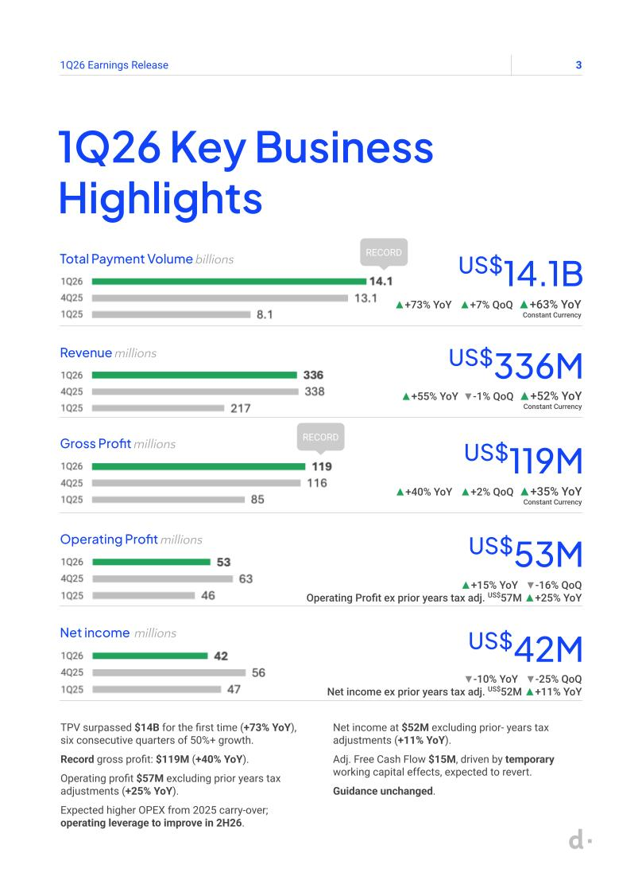

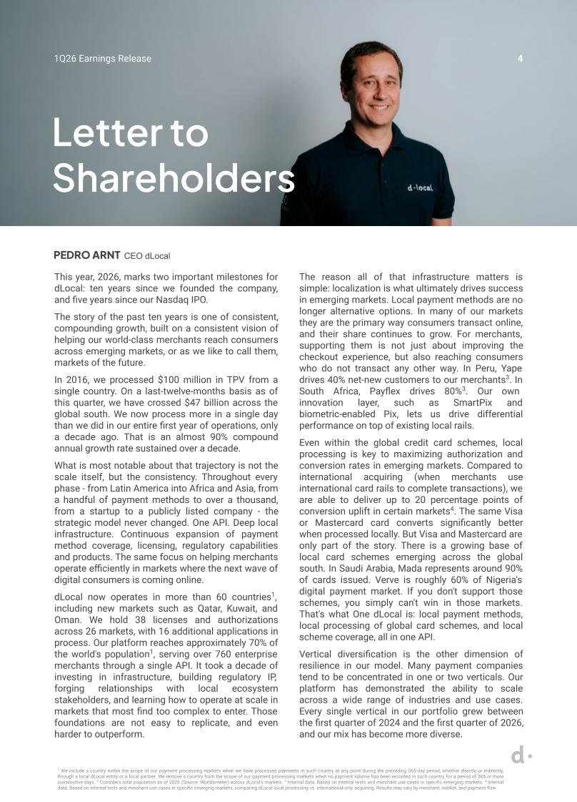

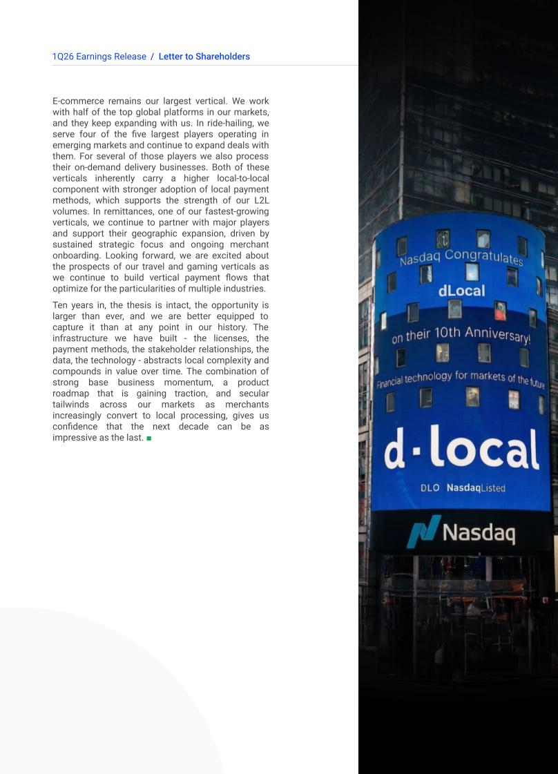



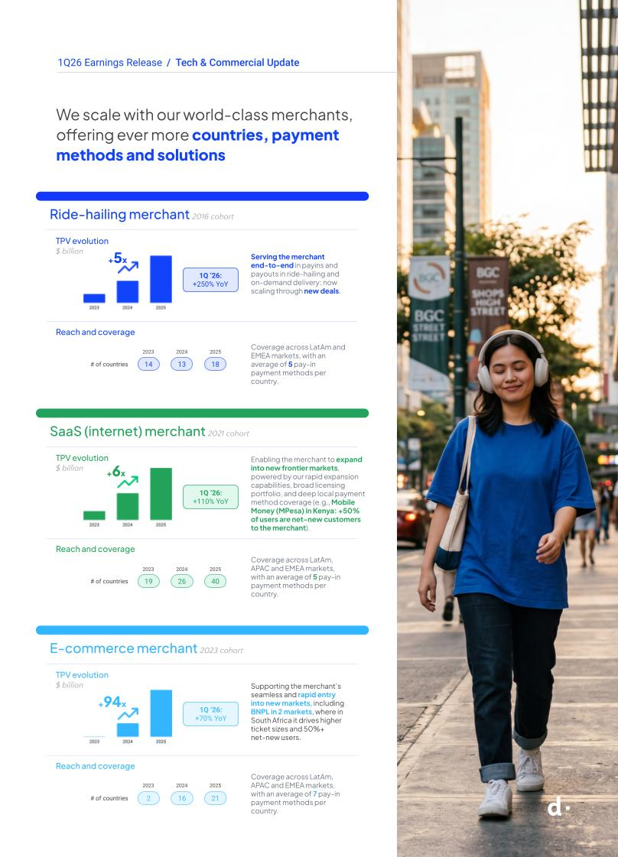



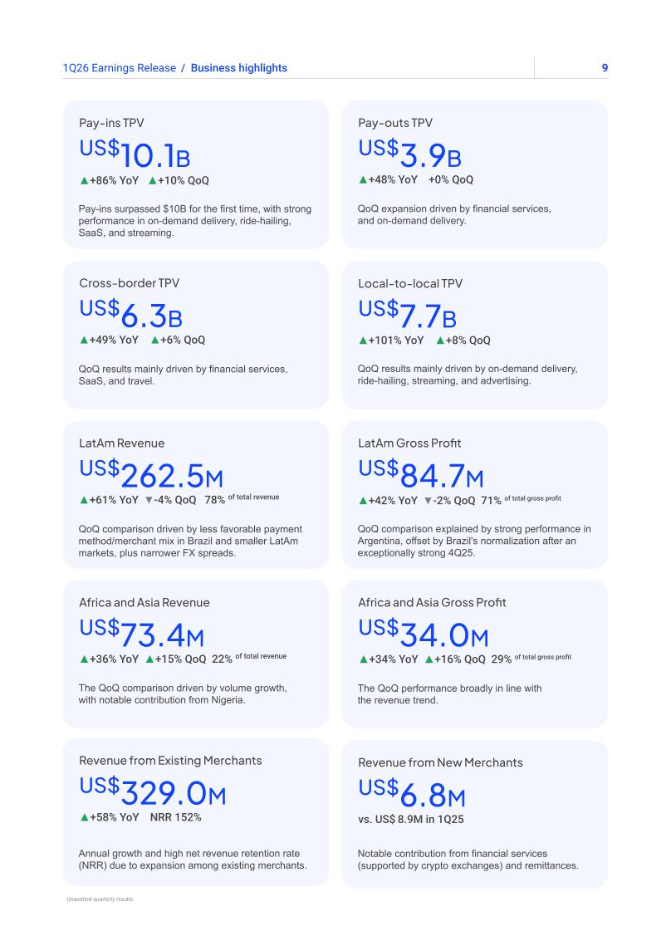

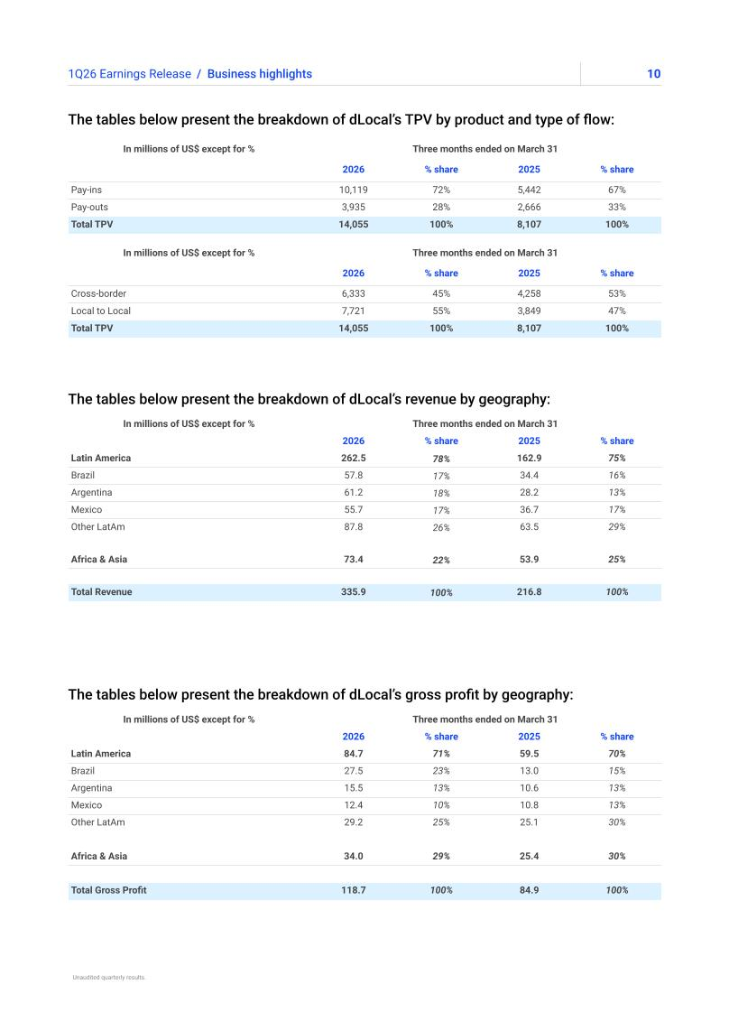



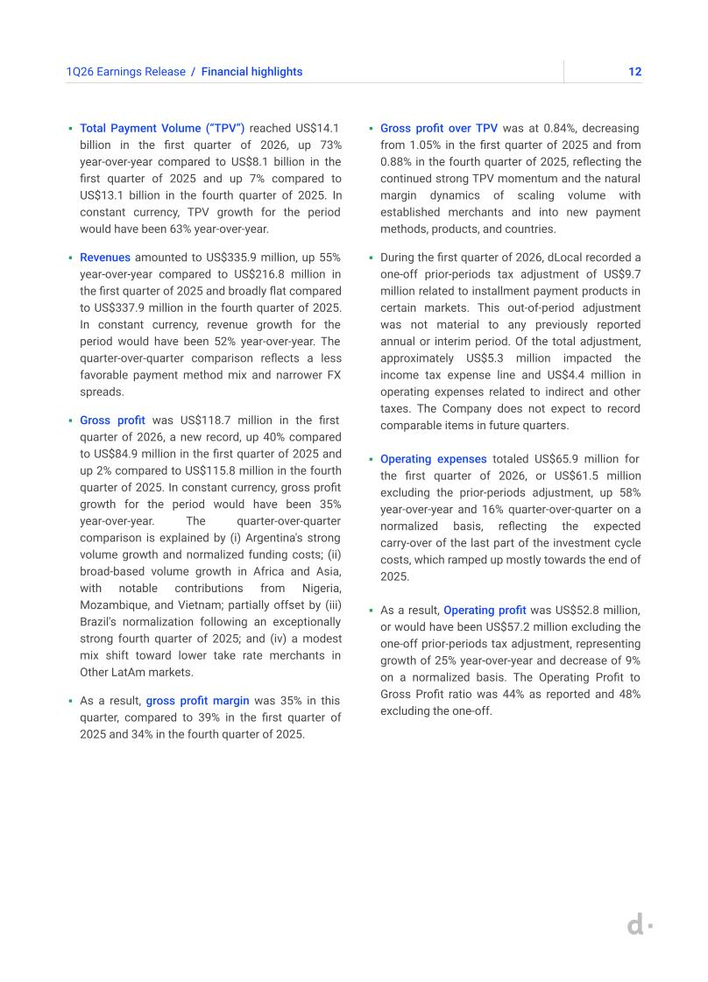

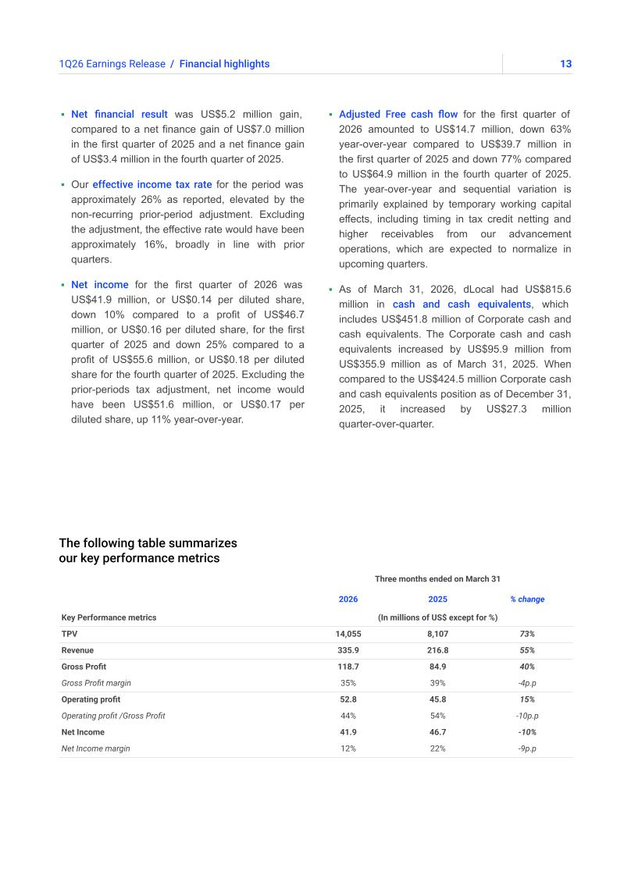

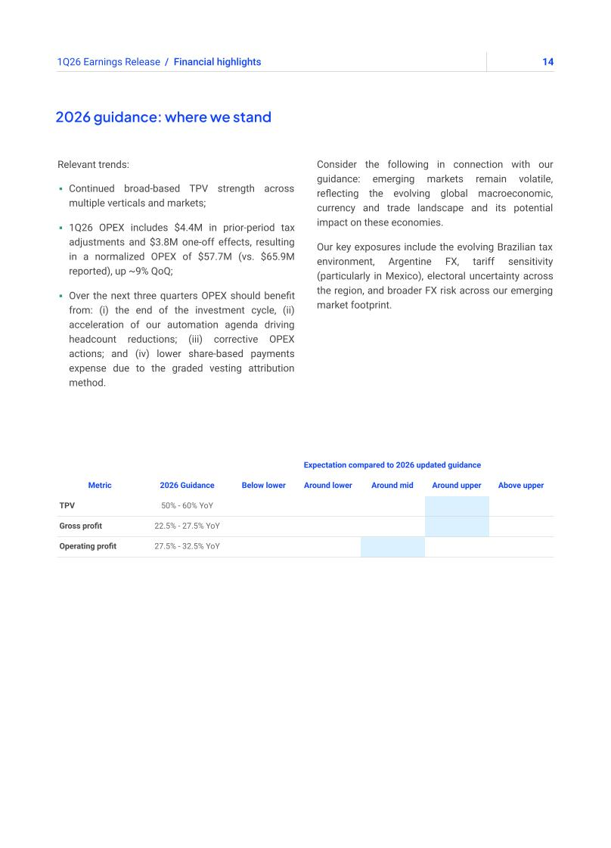

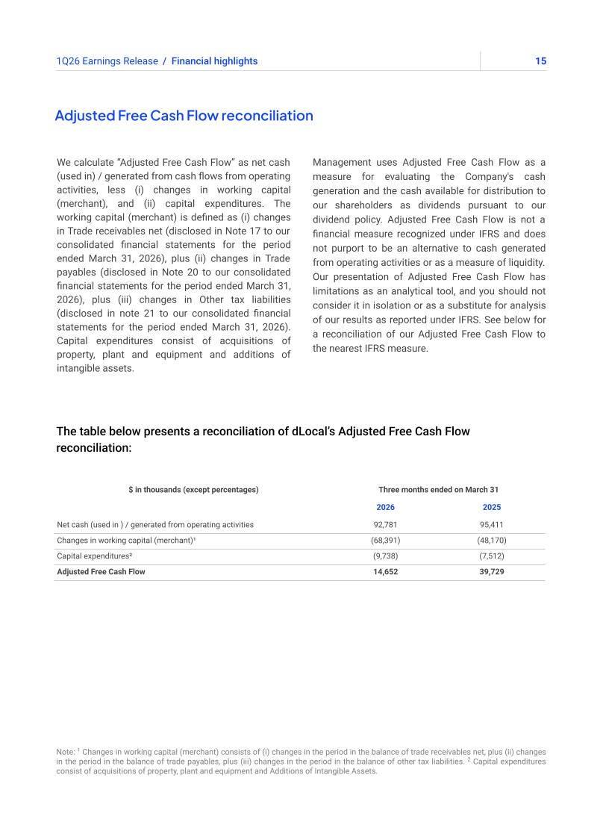

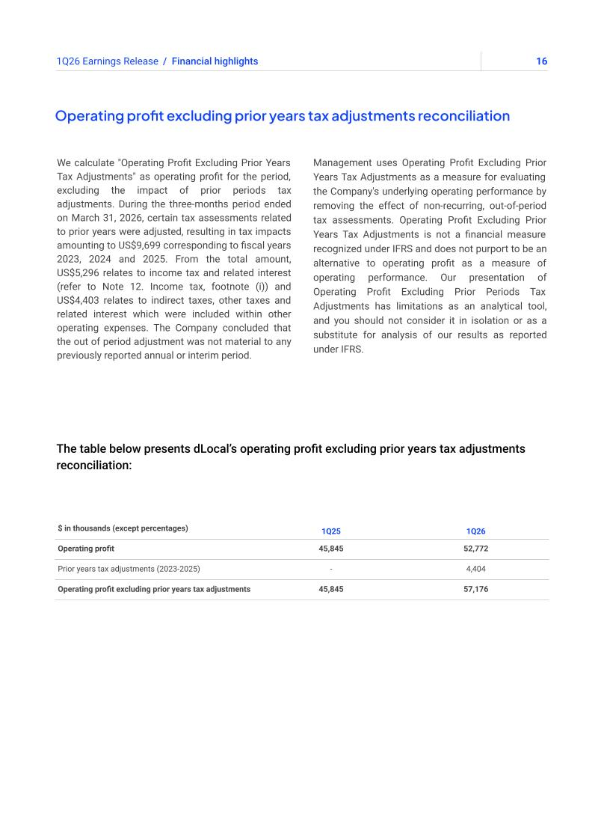

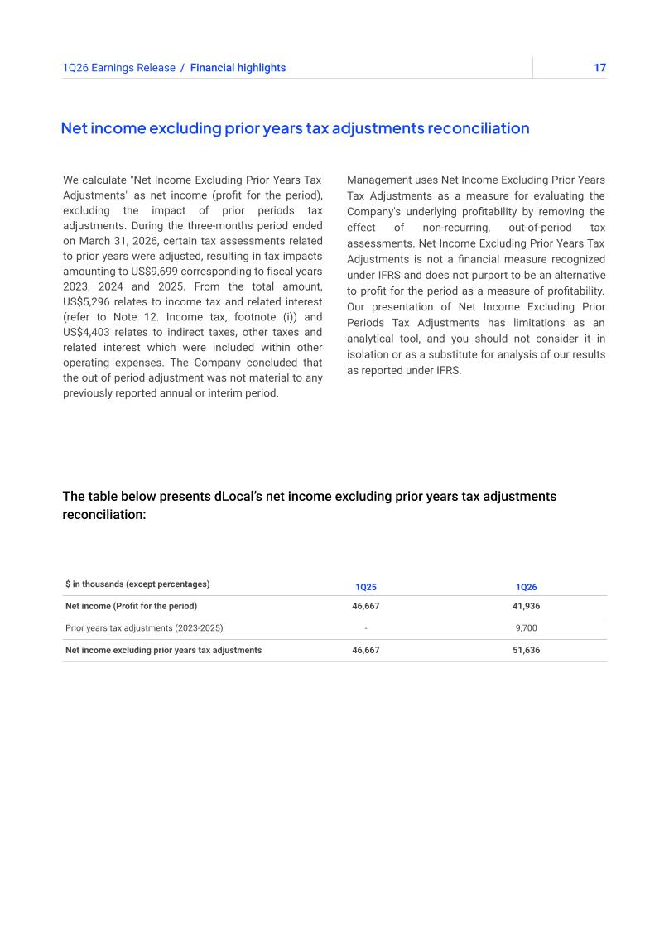

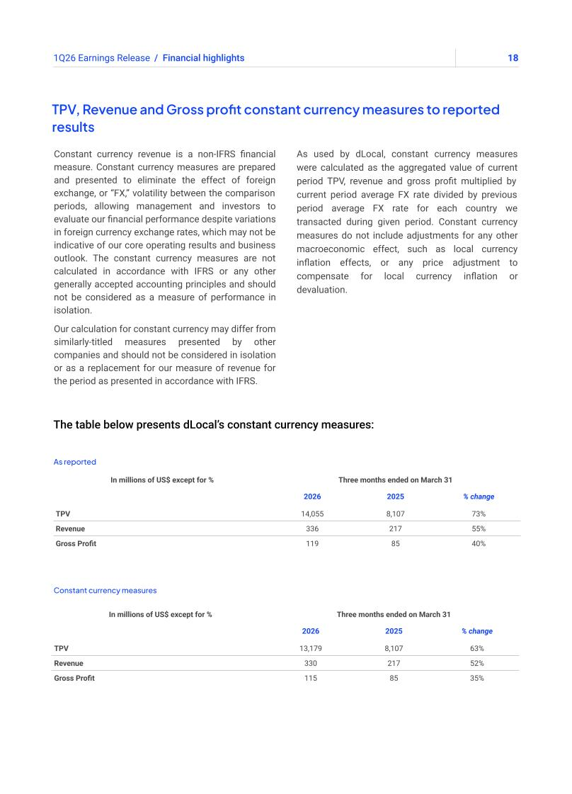

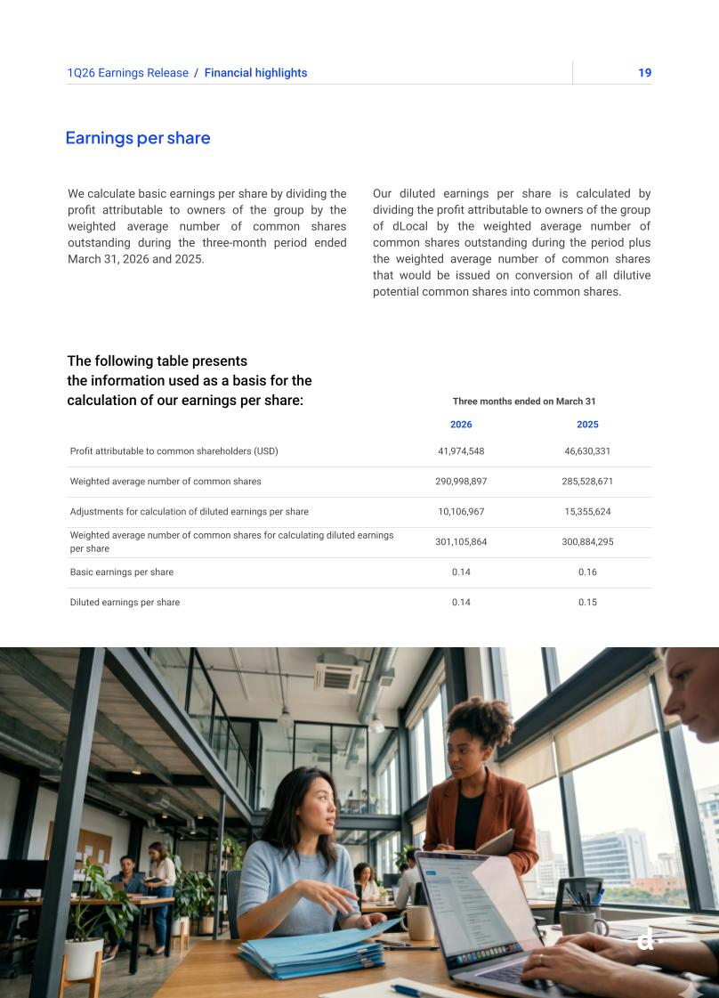



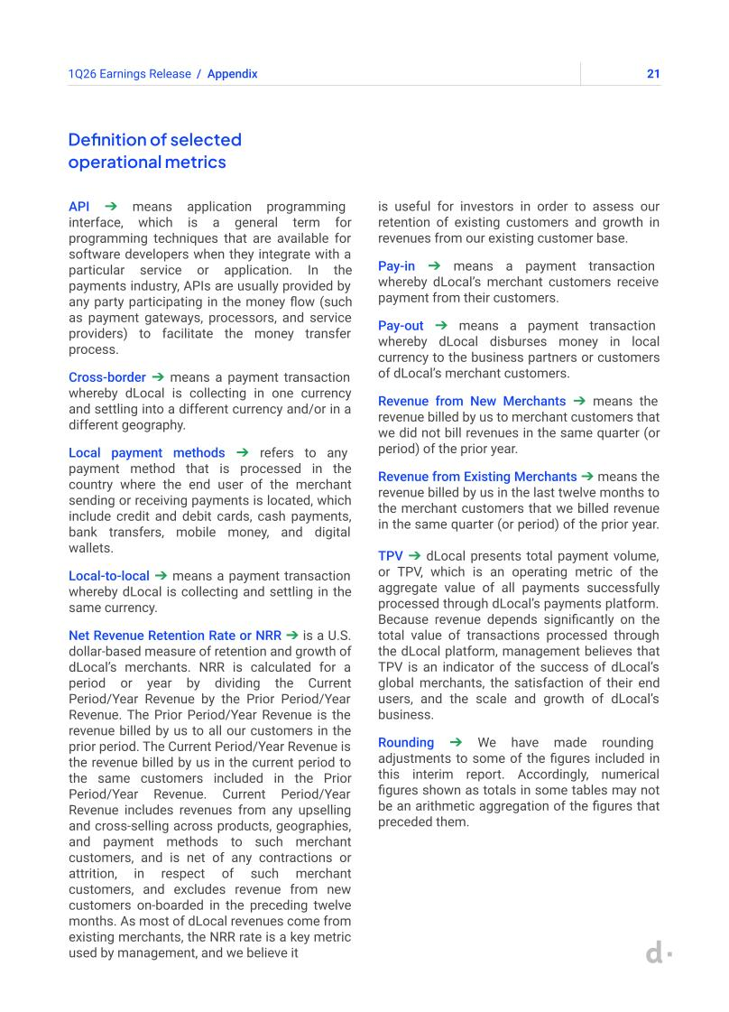

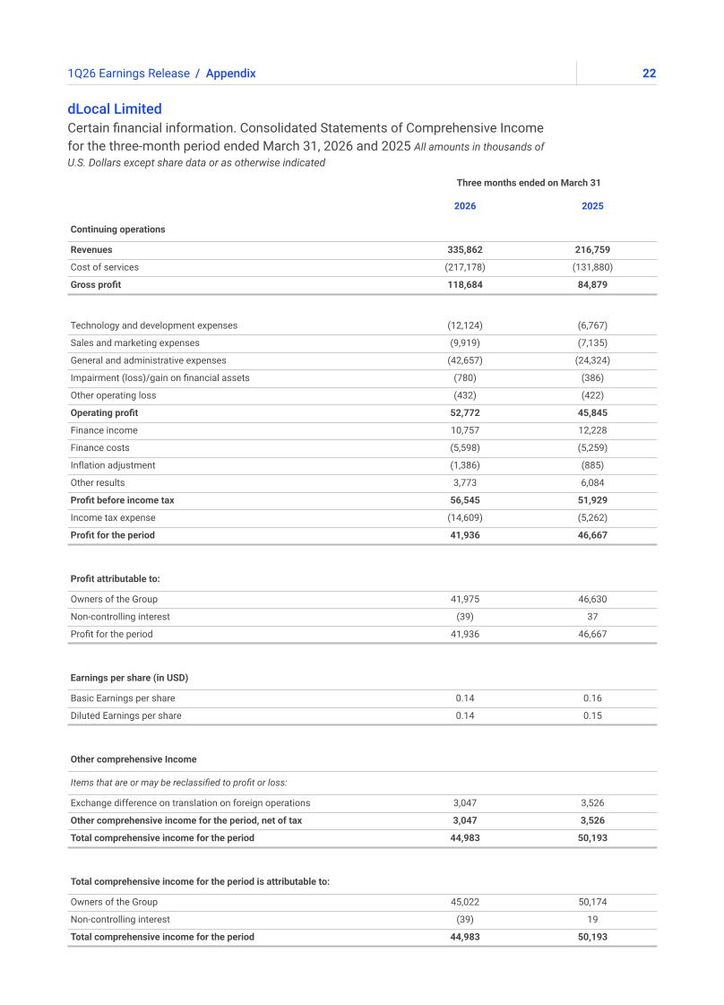

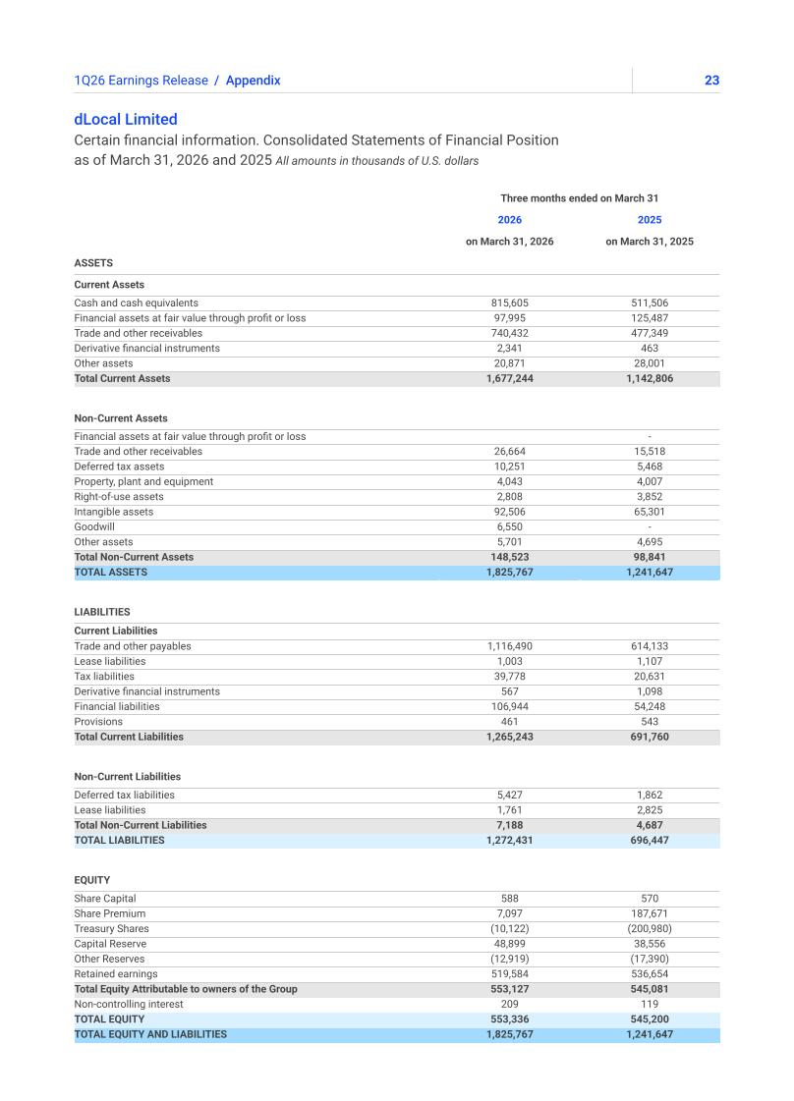

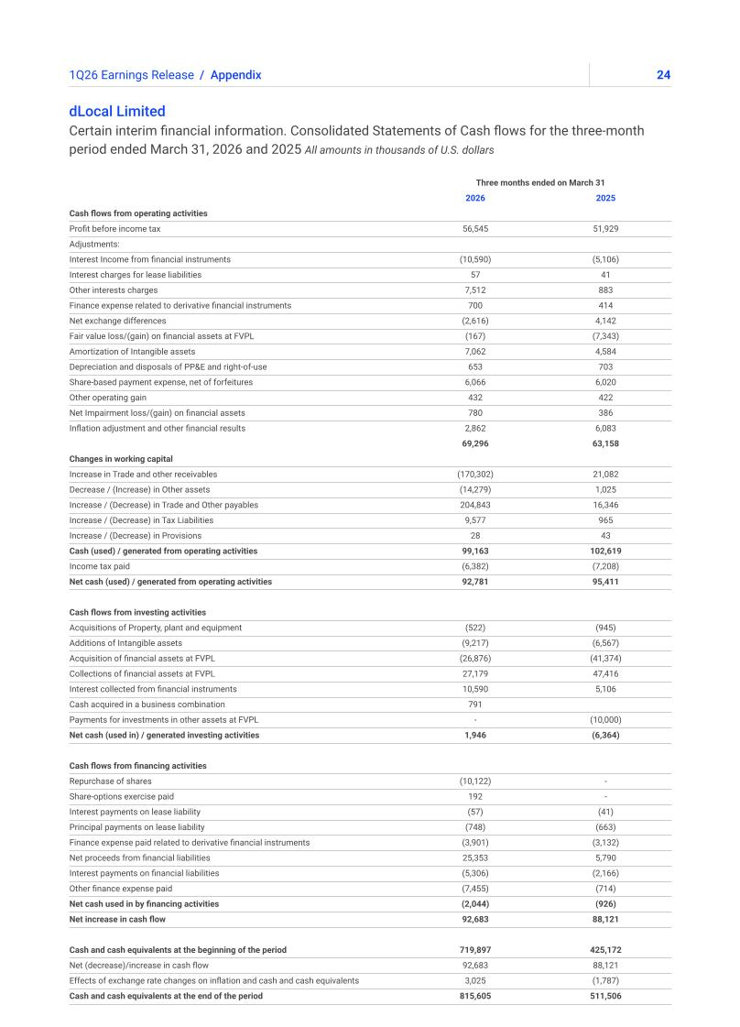















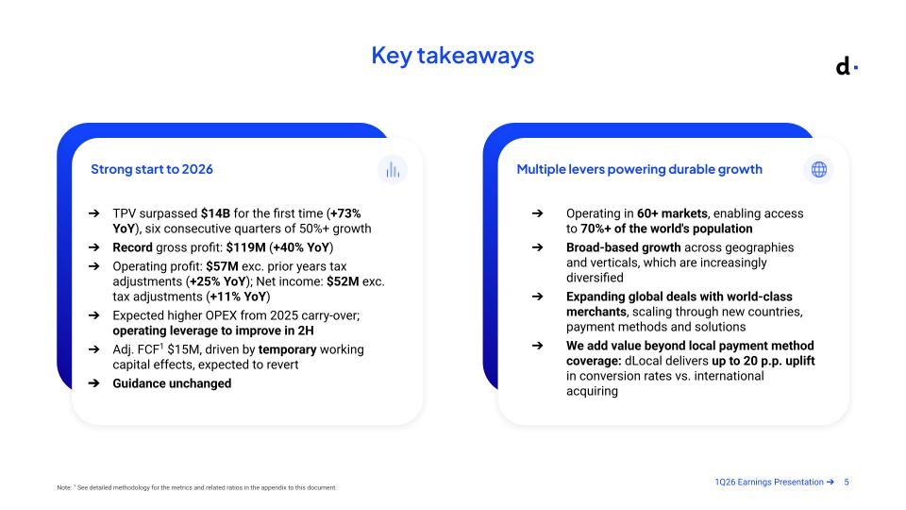



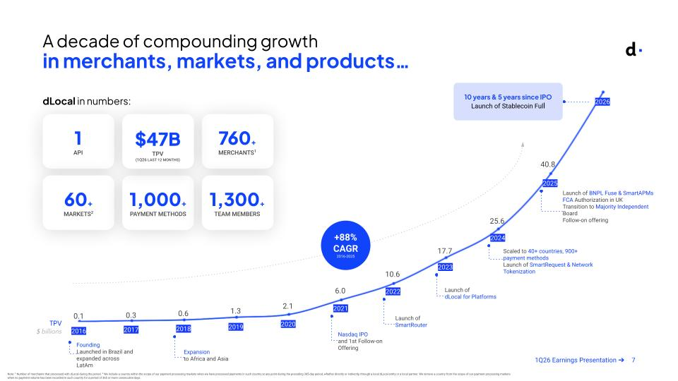

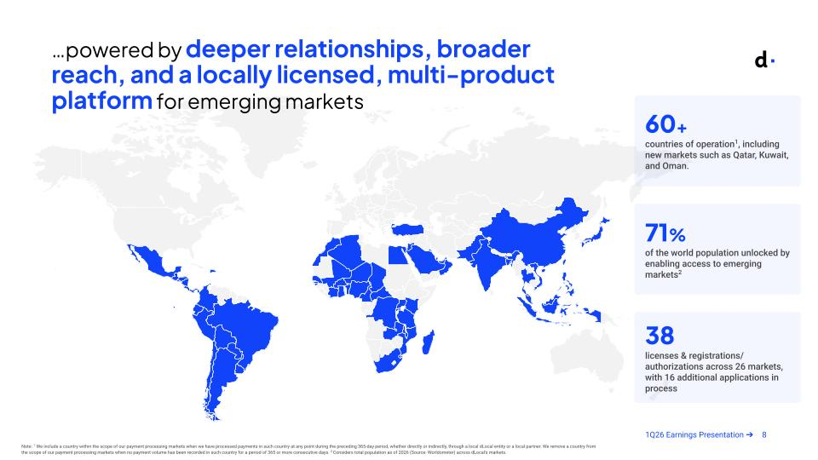

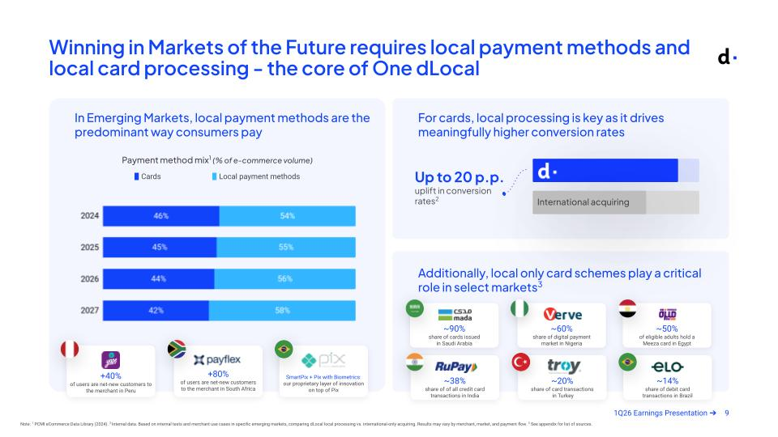

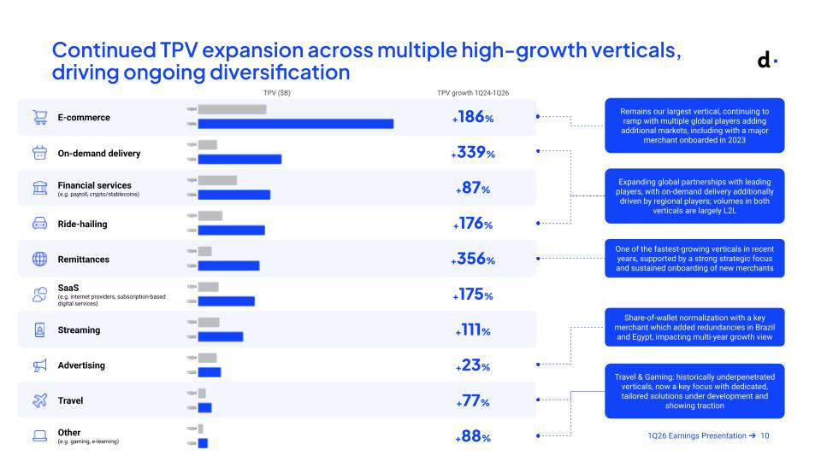

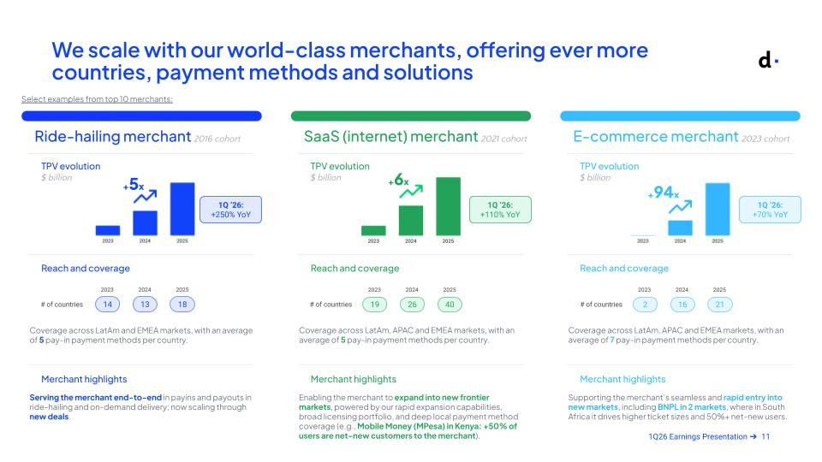



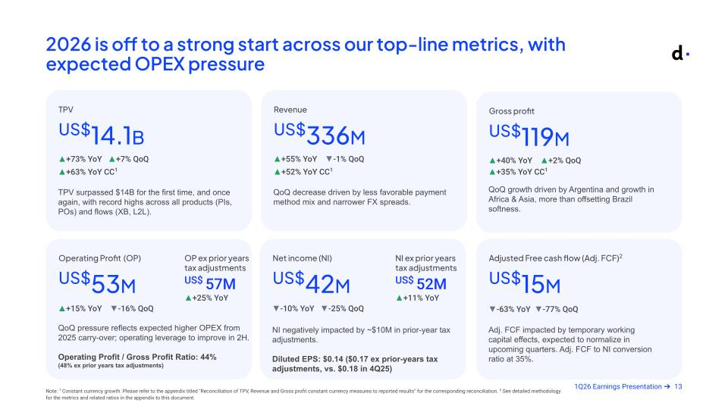

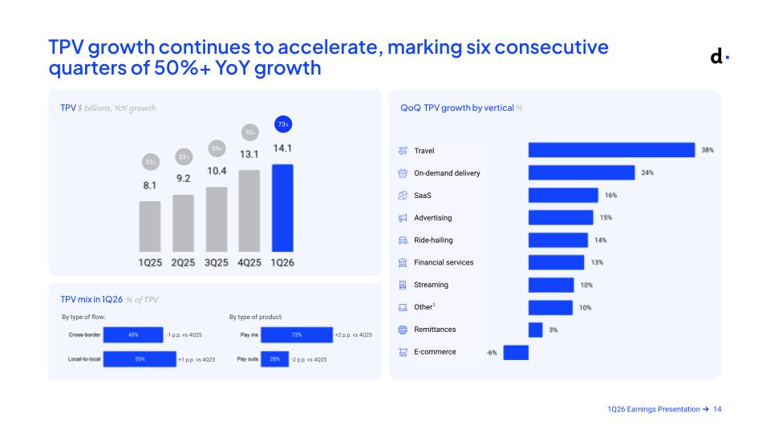

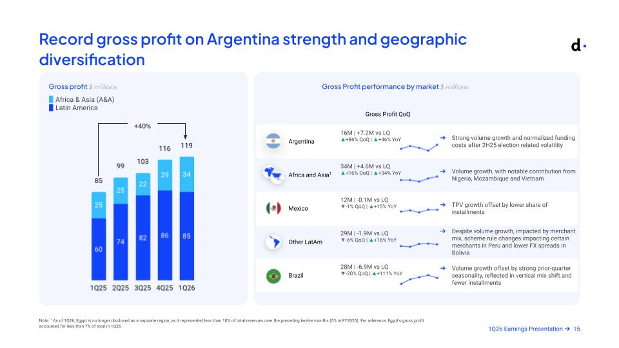

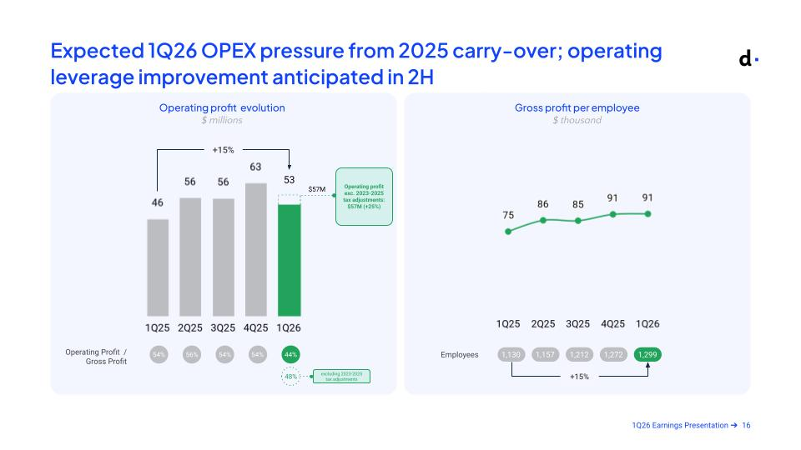

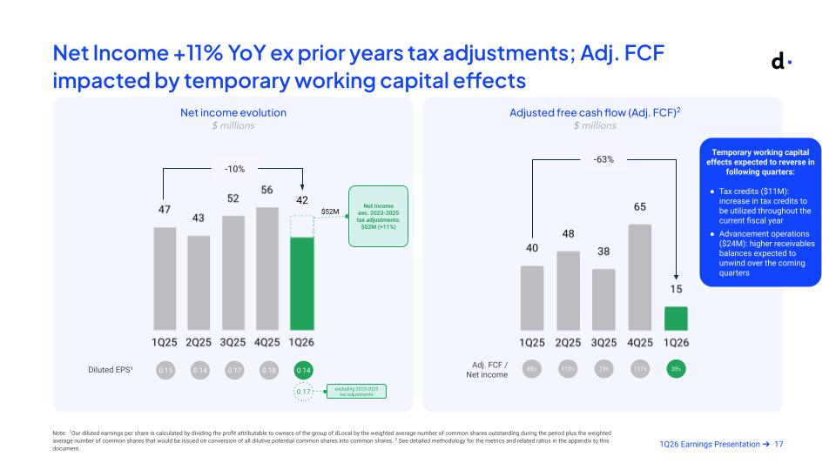

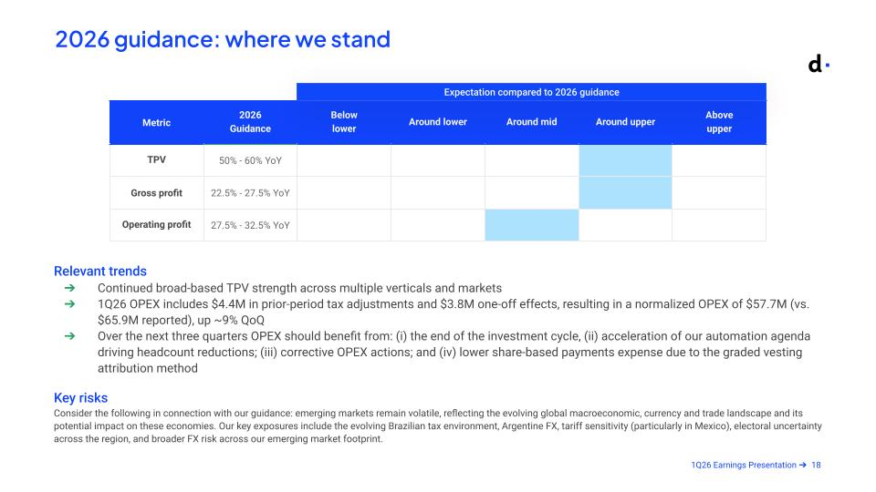





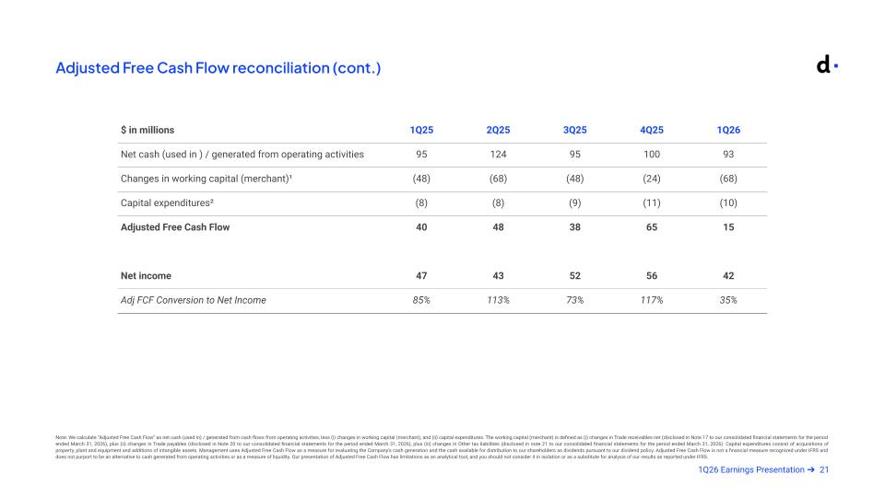

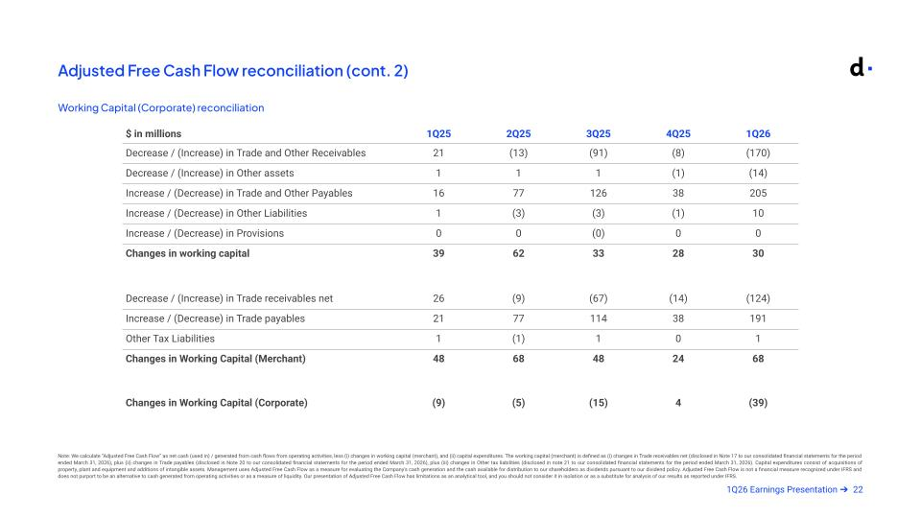

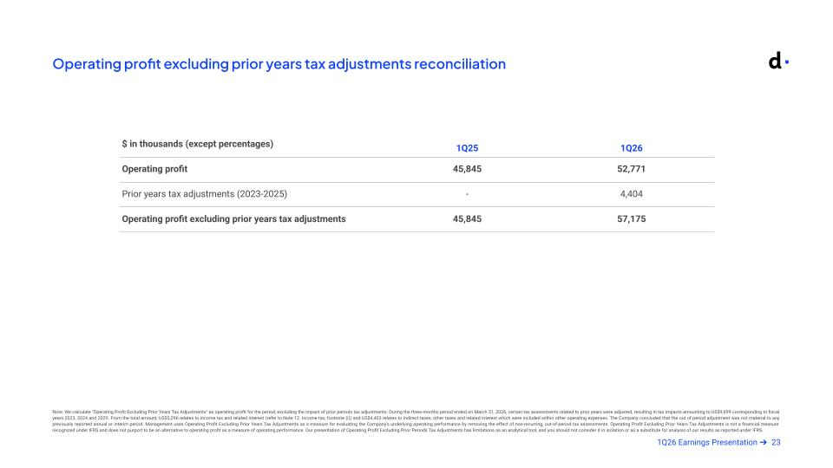

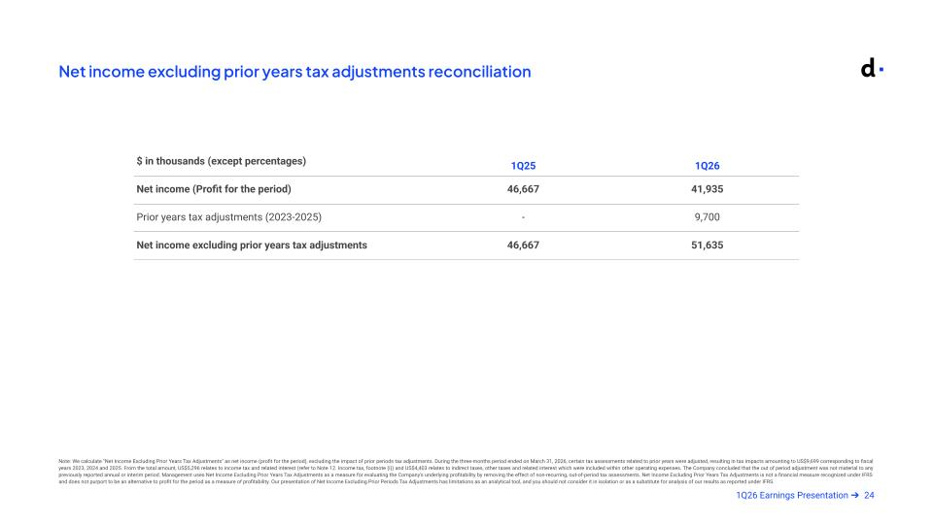

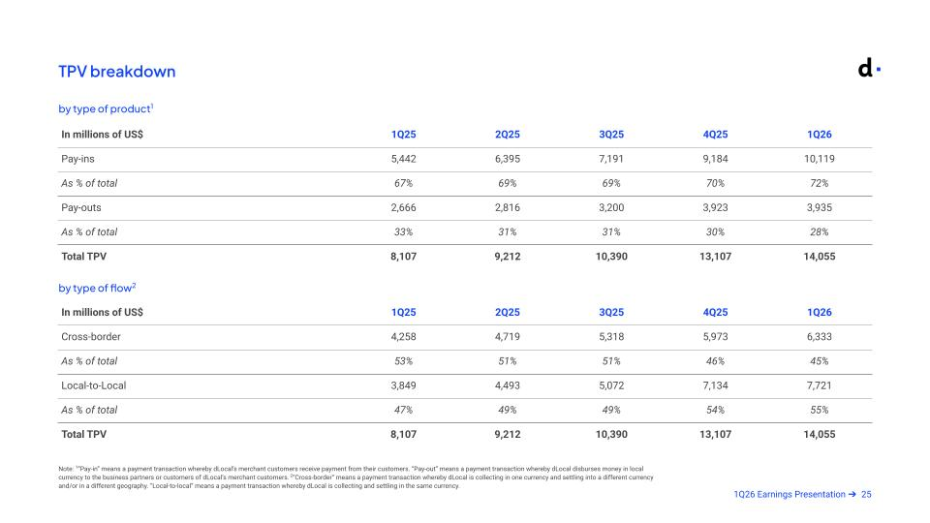

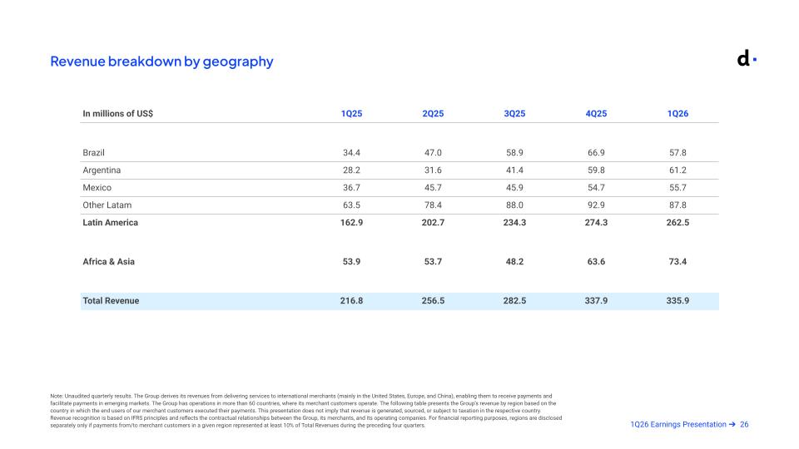

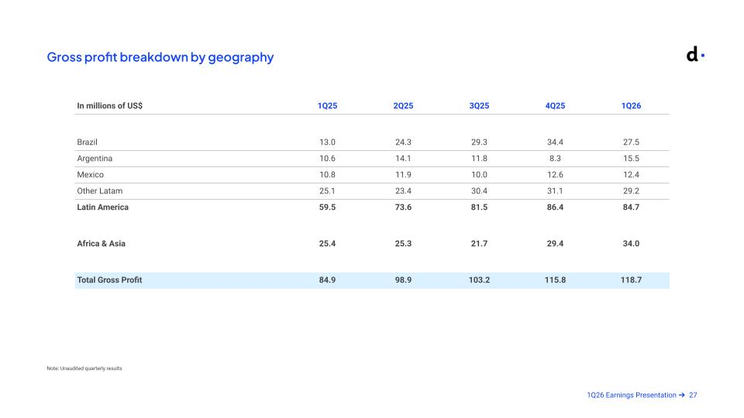

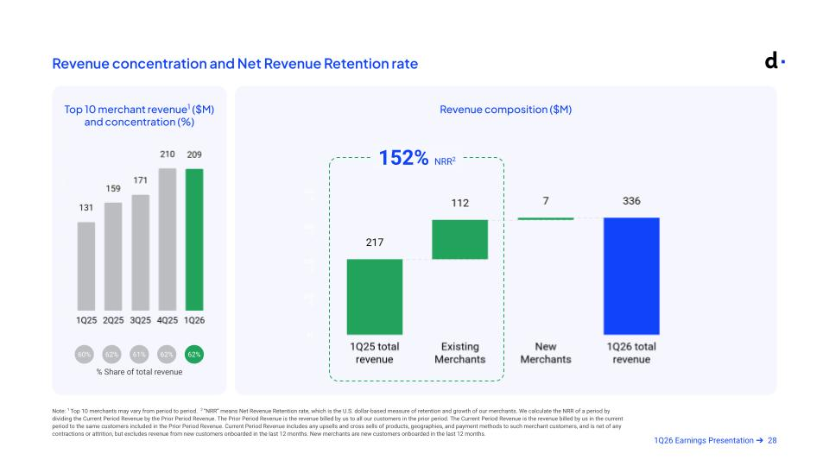

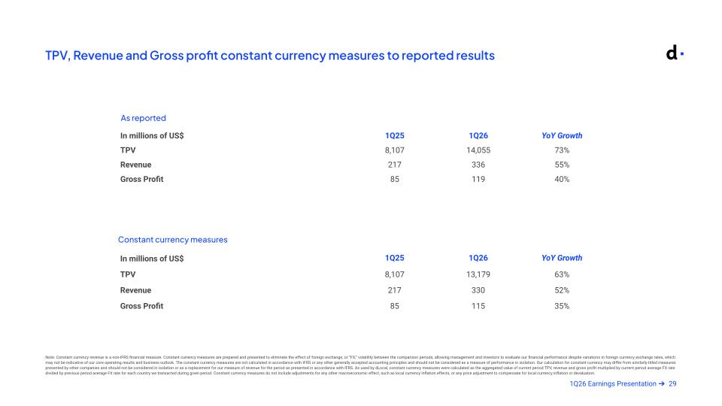

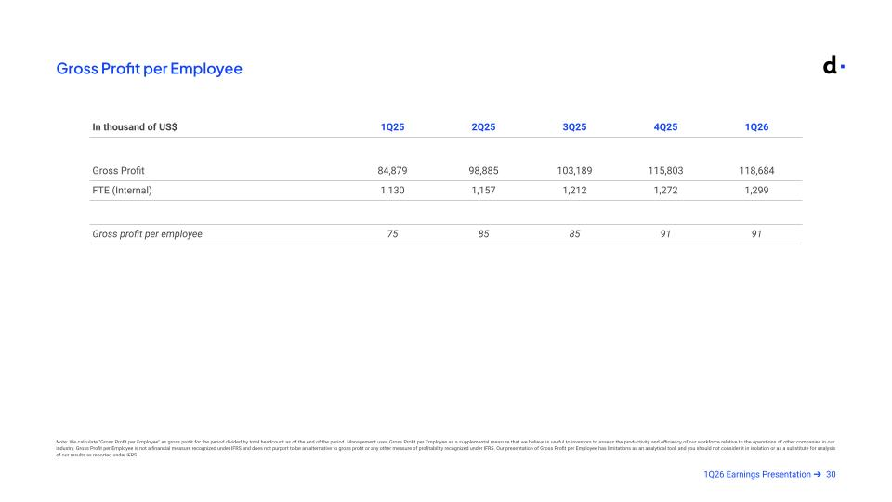

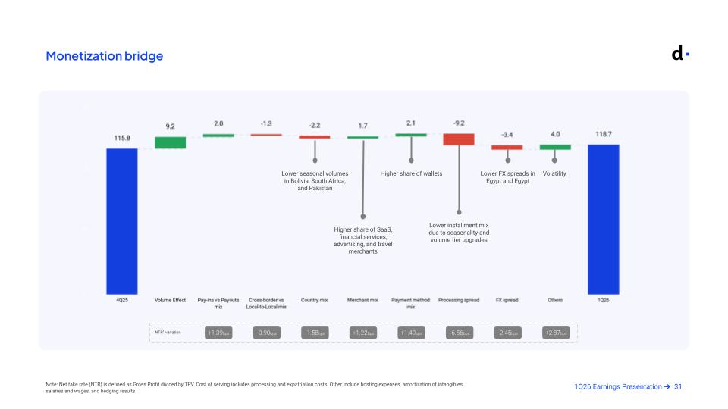

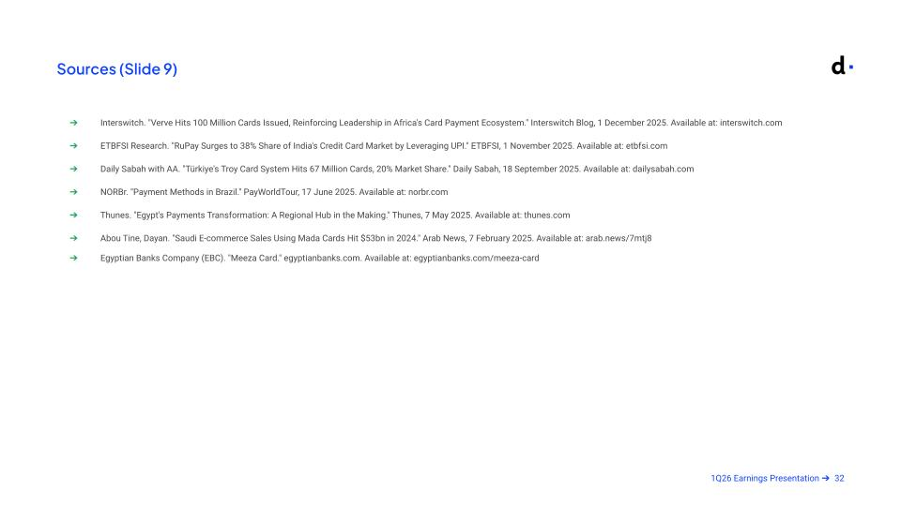




1Q26 Earnings Release


1Q26 Earnings Release dLocal reports in US dollars and in accordance with IFRS as issued by the IASB Montevideo, Uruguay, May 14, 2026 — DLocal Limited (“dLocal”, “we”, “us”, and “our”) (NASDAQ:DLO), the leading cross-border payment platform connecting global merchants to emerging markets today announced its financial results for the first quarter ended March 31, 2026. Key Business Highlights Letter to Shareholders Business Highlights Financial Highlights Commercial Highlights Appendix

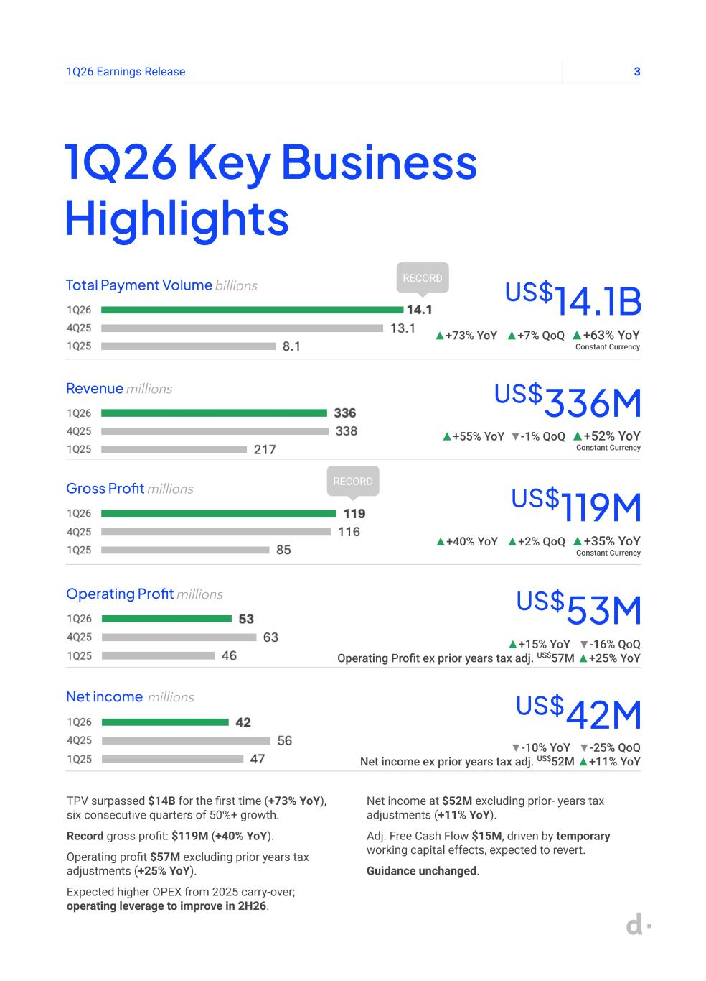
31Q26 Earnings Release 1Q26 Key Business Highlights Total Payment Volume billions US$14.1B ▲+73% YoY ▲+7% QoQ ▲+63% YoY Constant Currency RECORD TPV surpassed $14B for the first time (+73% YoY), six consecutive quarters of 50%+ growth. Record gross profit: $119M (+40% YoY). Operating profit $57M excluding prior years tax adjustments (+25% YoY). Expected higher OPEX from 2025 carry-over; operating leverage to improve in 2H26. Net income at $52M excluding prior- years tax adjustments (+11% YoY). Adj. Free Cash Flow $15M, driven by temporary working capital effects, expected to revert. Guidance unchanged. Revenue millions US$336M ▲+55% YoY ▼-1% QoQ ▲+52% YoY Constant Currency Gross Profit millions US$119M ▲+40% YoY ▲+2% QoQ ▲+35% YoY Constant Currency Operating Profit millions US$53M ▲+15% YoY ▼-16% QoQ Operating Profit ex prior years tax adj. US$57M ▲+25% YoY Net income millions US$42M ▼-10% YoY ▼-25% QoQ Net income ex prior years tax adj. US$52M ▲+11% YoY RECORD

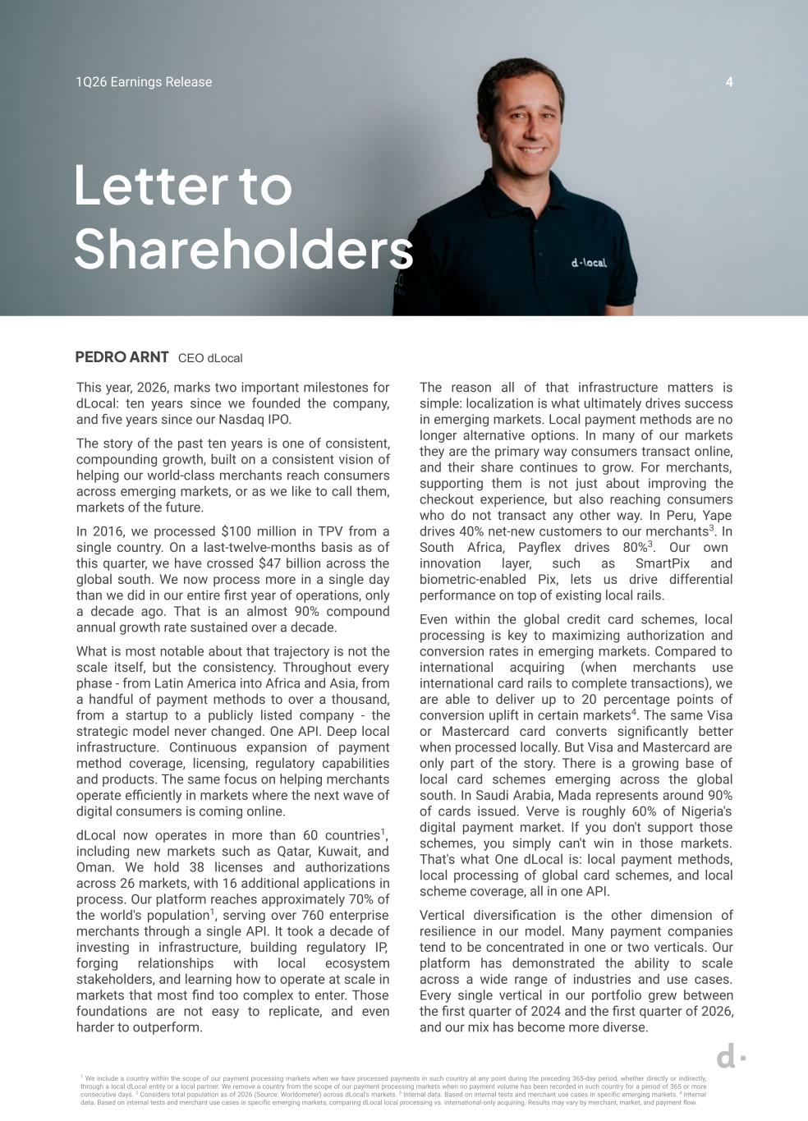
41Q26 Earnings Release This year, 2026, marks two important milestones for dLocal: ten years since we founded the company, and five years since our Nasdaq IPO. The story of the past ten years is one of consistent, compounding growth, built on a consistent vision of helping our world-class merchants reach consumers across emerging markets, or as we like to call them, markets of the future. In 2016, we processed $100 million in TPV from a single country. On a last-twelve-months basis as of this quarter, we have crossed $47 billion across the global south. We now process more in a single day than we did in our entire first year of operations, only a decade ago. That is an almost 90% compound annual growth rate sustained over a decade. What is most notable about that trajectory is not the scale itself, but the consistency. Throughout every phase - from Latin America into Africa and Asia, from a handful of payment methods to over a thousand, from a startup to a publicly listed company - the strategic model never changed. One API. Deep local infrastructure. Continuous expansion of payment method coverage, licensing, regulatory capabilities and products. The same focus on helping merchants operate efficiently in markets where the next wave of digital consumers is coming online. dLocal now operates in more than 60 countries1, including new markets such as Qatar, Kuwait, and Oman. We hold 38 licenses and authorizations across 26 markets, with 16 additional applications in process. Our platform reaches approximately 70% of the world's population1, serving over 760 enterprise merchants through a single API. It took a decade of investing in infrastructure, building regulatory IP, forging relationships with local ecosystem stakeholders, and learning how to operate at scale in markets that most find too complex to enter. Those foundations are not easy to replicate, and even harder to outperform. 1 We include a country within the scope of our payment processing markets when we have processed payments in such country at any point during the preceding 365-day period, whether directly or indirectly, through a local dLocal entity or a local partner. We remove a country from the scope of our payment processing markets when no payment volume has been recorded in such country for a period of 365 or more consecutive days. 2 Considers total population as of 2026 (Source: Worldometer) across dLocal's markets. 3 Internal data. Based on internal tests and merchant use cases in specific emerging markets. 4 Internal data. Based on internal tests and merchant use cases in specific emerging markets, comparing dLocal local processing vs. international-only acquiring. Results may vary by merchant, market, and payment flow. Letter to Shareholders PEDRO ARNT CEO dLocal The reason all of that infrastructure matters is simple: localization is what ultimately drives success in emerging markets. Local payment methods are no longer alternative options. In many of our markets they are the primary way consumers transact online, and their share continues to grow. For merchants, supporting them is not just about improving the checkout experience, but also reaching consumers who do not transact any other way. In Peru, Yape drives 40% net-new customers to our merchants3. In South Africa, Payflex drives 80%3. Our own innovation layer, such as SmartPix and biometric-enabled Pix, lets us drive differential performance on top of existing local rails. Even within the global credit card schemes, local processing is key to maximizing authorization and conversion rates in emerging markets. Compared to international acquiring (when merchants use international card rails to complete transactions), we are able to deliver up to 20 percentage points of conversion uplift in certain markets4. The same Visa or Mastercard card converts significantly better when processed locally. But Visa and Mastercard are only part of the story. There is a growing base of local card schemes emerging across the global south. In Saudi Arabia, Mada represents around 90% of cards issued. Verve is roughly 60% of Nigeria's digital payment market. If you don't support those schemes, you simply can't win in those markets. That's what One dLocal is: local payment methods, local processing of global card schemes, and local scheme coverage, all in one API. Vertical diversification is the other dimension of resilience in our model. Many payment companies tend to be concentrated in one or two verticals. Our platform has demonstrated the ability to scale across a wide range of industries and use cases. Every single vertical in our portfolio grew between the first quarter of 2024 and the first quarter of 2026, and our mix has become more diverse.

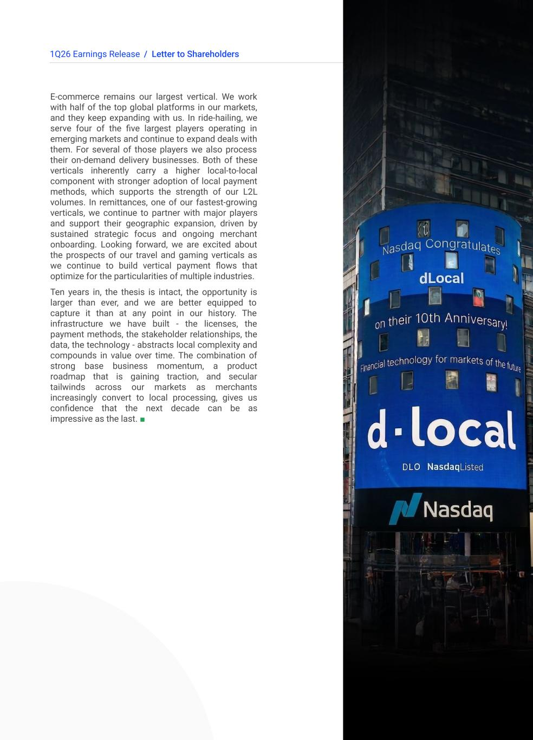
51Q26 Earnings Release / Letter to Shareholders E-commerce remains our largest vertical. We work with half of the top global platforms in our markets, and they keep expanding with us. In ride-hailing, we serve four of the five largest players operating in emerging markets and continue to expand deals with them. For several of those players we also process their on-demand delivery businesses. Both of these verticals inherently carry a higher local-to-local component with stronger adoption of local payment methods, which supports the strength of our L2L volumes. In remittances, one of our fastest-growing verticals, we continue to partner with major players and support their geographic expansion, driven by sustained strategic focus and ongoing merchant onboarding. Looking forward, we are excited about the prospects of our travel and gaming verticals as we continue to build vertical payment flows that optimize for the particularities of multiple industries. Ten years in, the thesis is intact, the opportunity is larger than ever, and we are better equipped to capture it than at any point in our history. The infrastructure we have built - the licenses, the payment methods, the stakeholder relationships, the data, the technology - abstracts local complexity and compounds in value over time. The combination of strong base business momentum, a product roadmap that is gaining traction, and secular tailwinds across our markets as merchants increasingly convert to local processing, gives us confidence that the next decade can be as impressive as the last. ■


61Q26 Earnings Release Commercial Highlights

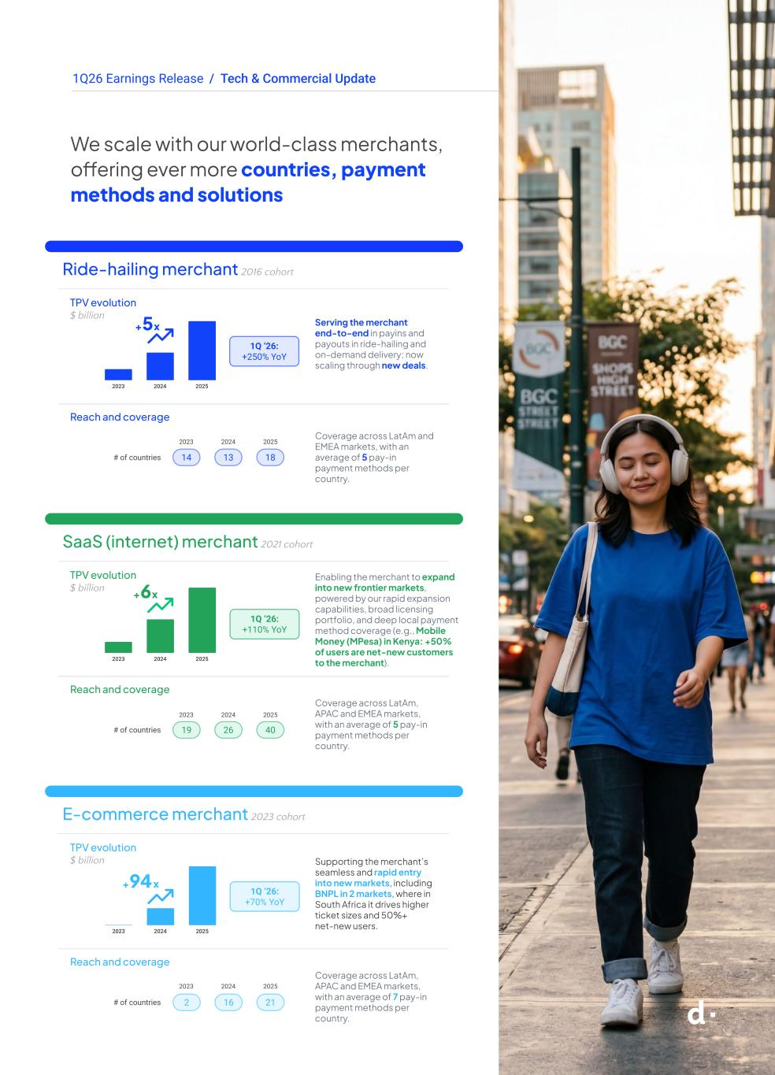
71Q26 Earnings Release We scale with our world-class merchants, offering ever more countries, payment methods and solutions / Tech & Commercial Update 2023 2024 2025 Ride-hailing merchant 2016 cohort TPV evolution $ billion Reach and coverage # of countries 14 13 18 Serving the merchant end-to-end in payins and payouts in ride-hailing and on-demand delivery; now scaling through new deals. Coverage across LatAm and EMEA markets, with an average of 5 pay-in payment methods per country. 1Q ‘26: +250% YoY SaaS (internet) merchant 2021 cohort TPV evolution $ billion Reach and coverage # of countries Enabling the merchant to expand into new frontier markets, powered by our rapid expansion capabilities, broad licensing portfolio, and deep local payment method coverage (e.g., Mobile Money (MPesa) in Kenya: +50% of users are net-new customers to the merchant). Coverage across LatAm, APAC and EMEA markets, with an average of 5 pay-in payment methods per country. E-commerce merchant 2023 cohort TPV evolution $ billion Reach and coverage # of countries Supporting the merchant’s seamless and rapid entry into new markets, including BNPL in 2 markets, where in South Africa it drives higher ticket sizes and 50%+ net-new users. Coverage across LatAm, APAC and EMEA markets, with an average of 7 pay-in payment methods per country. 2023 2024 2025 2023 2024 2025 +5x 19 26 40 +6x 1Q ‘26: +110% YoY +94x 1Q ‘26: +70% YoY 2 16 21


81Q26 Earnings Release Business highlights

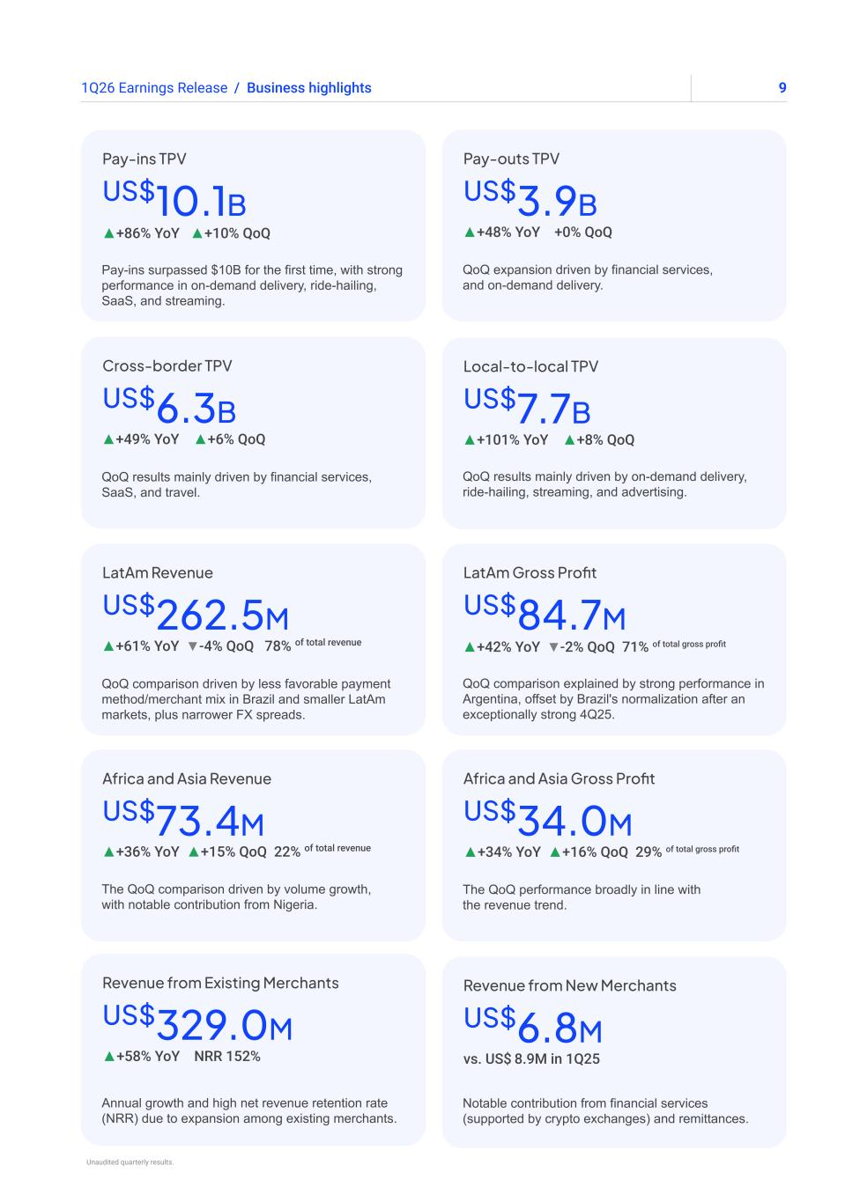
91Q26 Earnings Release Pay-ins surpassed $10B for the first time, with strong performance in on-demand delivery, ride-hailing, SaaS, and streaming. US$10.1B ▲+86% YoY ▲+10% QoQ Pay-ins TPV QoQ comparison explained by strong performance in Argentina, offset by Brazil's normalization after an exceptionally strong 4Q25. US$84.7M ▲+42% YoY ▼-2% QoQ 71% of total gross profit LatAm Gross Profit QoQ results mainly driven by financial services, SaaS, and travel. US$6.3B ▲+49% YoY ▲+6% QoQ Cross-border TPV The QoQ performance broadly in line with the revenue trend. US$34.0M Africa and Asia Gross Profit ▲+34% YoY ▲+16% QoQ 29% of total gross profit QoQ results mainly driven by on-demand delivery, ride-hailing, streaming, and advertising. US$7.7B ▲+101% YoY ▲+8% QoQ Local-to-local TPV Annual growth and high net revenue retention rate (NRR) due to expansion among existing merchants. US$329.0M Revenue from Existing Merchants ▲+58% YoY NRR 152% QoQ comparison driven by less favorable payment method/merchant mix in Brazil and smaller LatAm markets, plus narrower FX spreads. US$262.5M ▲+61% YoY ▼-4% QoQ 78% of total revenue LatAm Revenue Notable contribution from financial services (supported by crypto exchanges) and remittances. US$6.8M Revenue from New Merchants vs. US$ 8.9M in 1Q25 QoQ expansion driven by financial services, and on-demand delivery. US$3.9B ▲+48% YoY +0% QoQ Pay-outs TPV / Business highlights The QoQ comparison driven by volume growth, with notable contribution from Nigeria. Africa and Asia Revenue US$73.4M ▲+36% YoY ▲+15% QoQ 22% of total revenue Unaudited quarterly results.

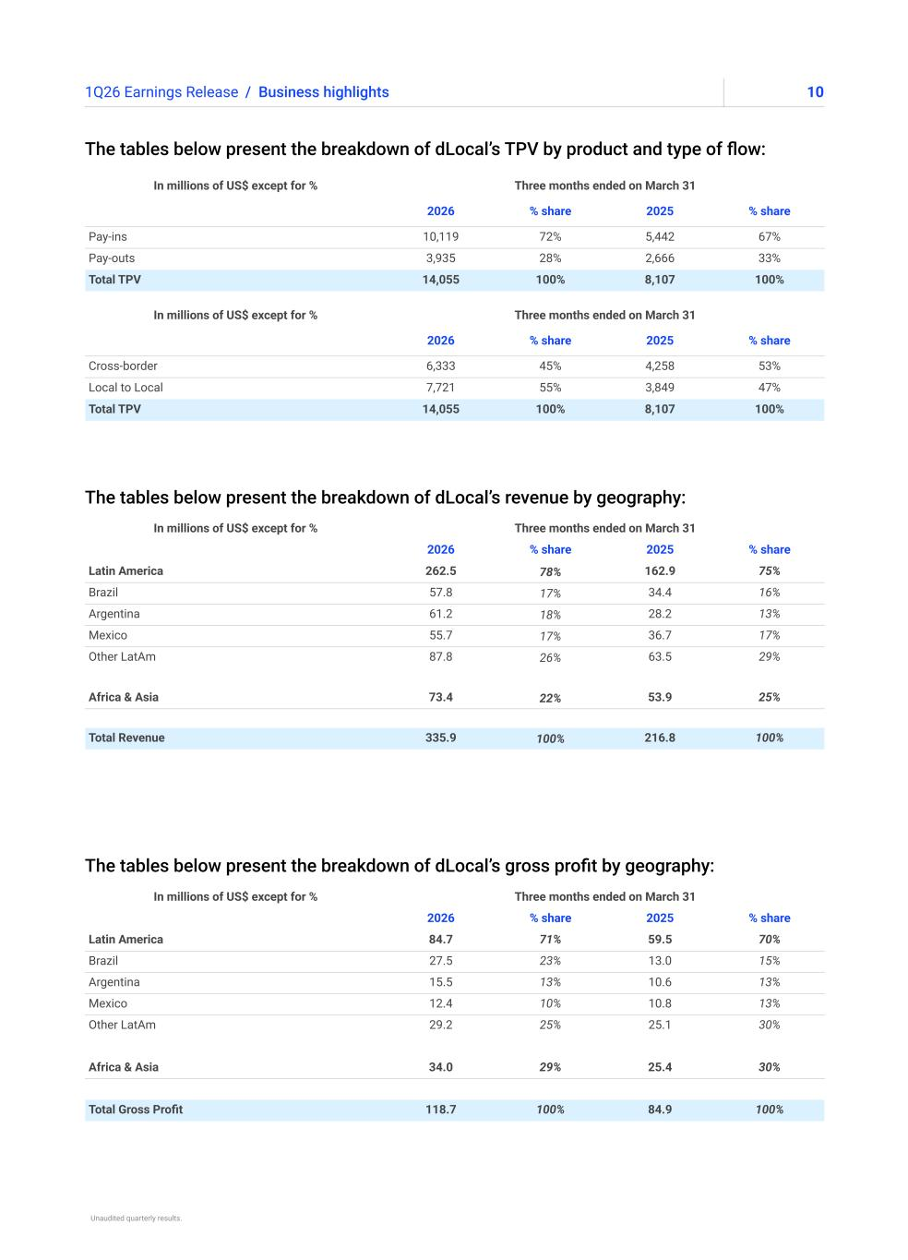
101Q26 Earnings Release The tables below present the breakdown of dLocal’s TPV by product and type of flow: The tables below present the breakdown of dLocal’s revenue by geography: The tables below present the breakdown of dLocal’s gross profit by geography: / Business highlights In millions of US$ except for % Three months ended on March 31 2026 % share 2025 % share Latin America 84.7 71% 59.5 70% Brazil 27.5 23% 13.0 15% Argentina 15.5 13% 10.6 13% Mexico 12.4 10% 10.8 13% Other LatAm 29.2 25% 25.1 30% Africa & Asia 34.0 29% 25.4 30% Total Gross Profit 118.7 100% 84.9 100% In millions of US$ except for % Three months ended on March 31 2026 % share 2025 % share Latin America 262.5 78% 162.9 75% Brazil 57.8 17% 34.4 16% Argentina 61.2 18% 28.2 13% Mexico 55.7 17% 36.7 17% Other LatAm 87.8 26% 63.5 29% Africa & Asia 73.4 22% 53.9 25% Total Revenue 335.9 100% 216.8 100% In millions of US$ except for % Three months ended on March 31 2026 % share 2025 % share Cross-border 6,333 45% 4,258 53% Local to Local 7,721 55% 3,849 47% Total TPV 14,055 100% 8,107 100% In millions of US$ except for % Three months ended on March 31 2026 % share 2025 % share Pay-ins 10,119 72% 5,442 67% Pay-outs 3,935 28% 2,666 33% Total TPV 14,055 100% 8,107 100% Unaudited quarterly results.


111Q26 Earnings Release Financial highlights 111Q26 Earnings Release

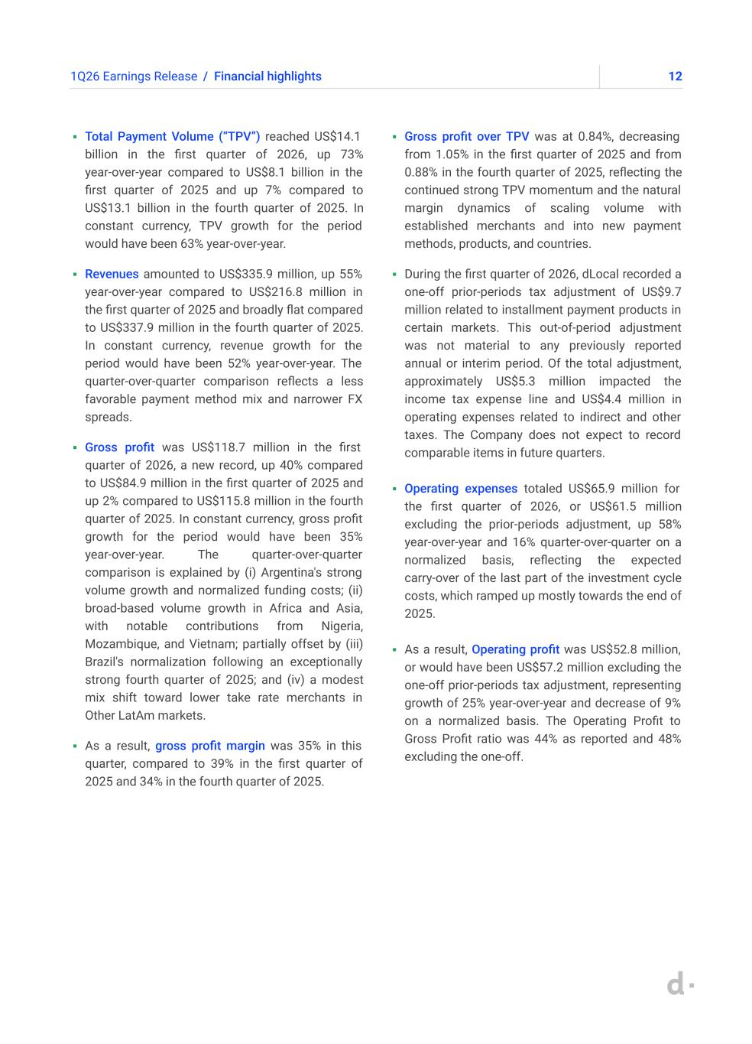
121Q26 Earnings Release / Financial highlights ▪ Total Payment Volume (“TPV”) reached US$14.1 billion in the first quarter of 2026, up 73% year-over-year compared to US$8.1 billion in the first quarter of 2025 and up 7% compared to US$13.1 billion in the fourth quarter of 2025. In constant currency, TPV growth for the period would have been 63% year-over-year. ▪ Revenues amounted to US$335.9 million, up 55% year-over-year compared to US$216.8 million in the first quarter of 2025 and broadly flat compared to US$337.9 million in the fourth quarter of 2025. In constant currency, revenue growth for the period would have been 52% year-over-year. The quarter-over-quarter comparison reflects a less favorable payment method mix and narrower FX spreads. ▪ Gross profit was US$118.7 million in the first quarter of 2026, a new record, up 40% compared to US$84.9 million in the first quarter of 2025 and up 2% compared to US$115.8 million in the fourth quarter of 2025. In constant currency, gross profit growth for the period would have been 35% year-over-year. The quarter-over-quarter comparison is explained by (i) Argentina's strong volume growth and normalized funding costs; (ii) broad-based volume growth in Africa and Asia, with notable contributions from Nigeria, Mozambique, and Vietnam; partially offset by (iii) Brazil's normalization following an exceptionally strong fourth quarter of 2025; and (iv) a modest mix shift toward lower take rate merchants in Other LatAm markets. ▪ As a result, gross profit margin was 35% in this quarter, compared to 39% in the first quarter of 2025 and 34% in the fourth quarter of 2025. ▪ Gross profit over TPV was at 0.84%, decreasing from 1.05% in the first quarter of 2025 and from 0.88% in the fourth quarter of 2025, reflecting the continued strong TPV momentum and the natural margin dynamics of scaling volume with established merchants and into new payment methods, products, and countries. ▪ During the first quarter of 2026, dLocal recorded a one-off prior-periods tax adjustment of US$9.7 million related to installment payment products in certain markets. This out-of-period adjustment was not material to any previously reported annual or interim period. Of the total adjustment, approximately US$5.3 million impacted the income tax expense line and US$4.4 million in operating expenses related to indirect and other taxes. The Company does not expect to record comparable items in future quarters. ▪ Operating expenses totaled US$65.9 million for the first quarter of 2026, or US$61.5 million excluding the prior-periods adjustment, up 58% year-over-year and 16% quarter-over-quarter on a normalized basis, reflecting the expected carry-over of the last part of the investment cycle costs, which ramped up mostly towards the end of 2025. ▪ As a result, Operating profit was US$52.8 million, or would have been US$57.2 million excluding the one-off prior-periods tax adjustment, representing growth of 25% year-over-year and decrease of 9% on a normalized basis. The Operating Profit to Gross Profit ratio was 44% as reported and 48% excluding the one-off.

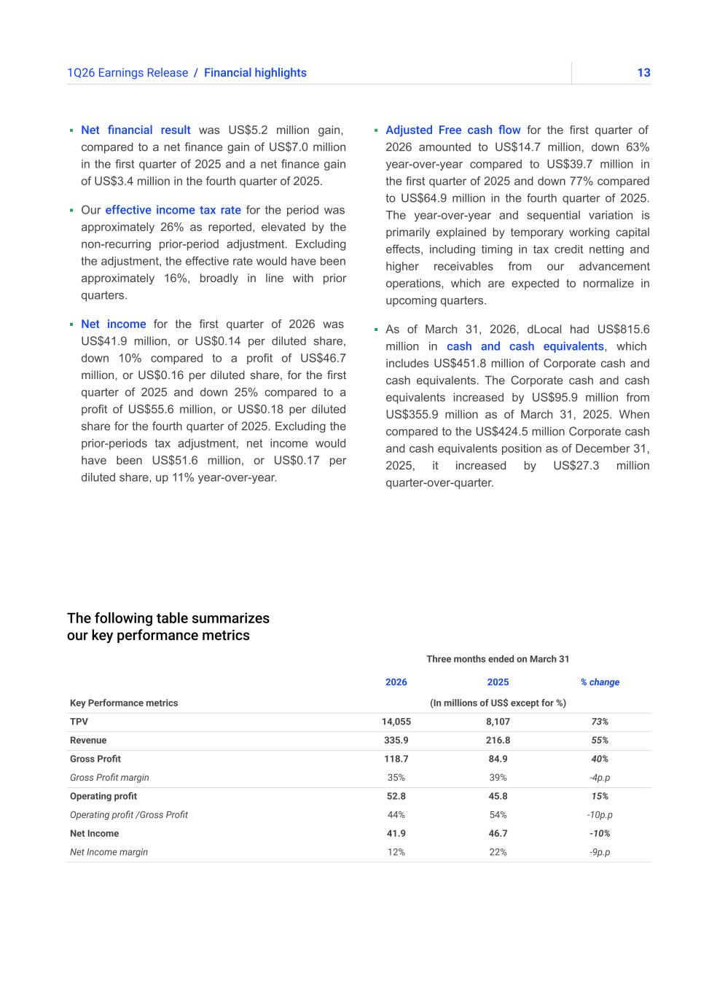
131Q26 Earnings Release The following table summarizes our key performance metrics ▪ Net financial result was US$5.2 million gain, compared to a net finance gain of US$7.0 million in the first quarter of 2025 and a net finance gain of US$3.4 million in the fourth quarter of 2025. ▪ Our effective income tax rate for the period was approximately 26% as reported, elevated by the non-recurring prior-period adjustment. Excluding the adjustment, the effective rate would have been approximately 16%, broadly in line with prior quarters. ▪ Net income for the first quarter of 2026 was US$41.9 million, or US$0.14 per diluted share, down 10% compared to a profit of US$46.7 million, or US$0.16 per diluted share, for the first quarter of 2025 and down 25% compared to a profit of US$55.6 million, or US$0.18 per diluted share for the fourth quarter of 2025. Excluding the prior-periods tax adjustment, net income would have been US$51.6 million, or US$0.17 per diluted share, up 11% year-over-year. ▪ Adjusted Free cash flow for the first quarter of 2026 amounted to US$14.7 million, down 63% year-over-year compared to US$39.7 million in the first quarter of 2025 and down 77% compared to US$64.9 million in the fourth quarter of 2025. The year-over-year and sequential variation is primarily explained by temporary working capital effects, including timing in tax credit netting and higher receivables from our advancement operations, which are expected to normalize in upcoming quarters. ▪ As of March 31, 2026, dLocal had US$815.6 million in cash and cash equivalents, which includes US$451.8 million of Corporate cash and cash equivalents. The Corporate cash and cash equivalents increased by US$95.9 million from US$355.9 million as of March 31, 2025. When compared to the US$424.5 million Corporate cash and cash equivalents position as of December 31, 2025, it increased by US$27.3 million quarter-over-quarter. / Financial highlights Three months ended on March 31 2026 2025 % change Key Performance metrics (In millions of US$ except for %) TPV 14,055 8,107 73% Revenue 335.9 216.8 55% Gross Profit 118.7 84.9 40% Gross Profit margin 35% 39% -4p.p Operating profit 52.8 45.8 15% Operating profit /Gross Profit 44% 54% -10p.p Net Income 41.9 46.7 -10% Net Income margin 12% 22% -9p.p

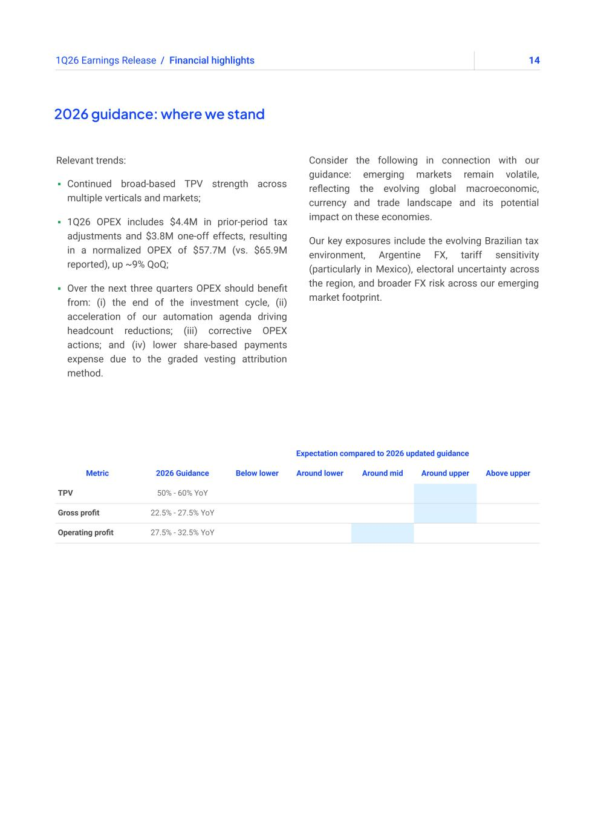
141Q26 Earnings Release / Financial highlights 2026 guidance: where we stand Relevant trends: ▪ Continued broad-based TPV strength across multiple verticals and markets; ▪ 1Q26 OPEX includes $4.4M in prior-period tax adjustments and $3.8M one-off effects, resulting in a normalized OPEX of $57.7M (vs. $65.9M reported), up ~9% QoQ; ▪ Over the next three quarters OPEX should benefit from: (i) the end of the investment cycle, (ii) acceleration of our automation agenda driving headcount reductions; (iii) corrective OPEX actions; and (iv) lower share-based payments expense due to the graded vesting attribution method. Expectation compared to 2026 updated guidance Metric 2026 Guidance Below lower Around lower Around mid Around upper Above upper TPV 50% - 60% YoY Gross profit 22.5% - 27.5% YoY Operating profit 27.5% - 32.5% YoY Consider the following in connection with our guidance: emerging markets remain volatile, reflecting the evolving global macroeconomic, currency and trade landscape and its potential impact on these economies. Our key exposures include the evolving Brazilian tax environment, Argentine FX, tariff sensitivity (particularly in Mexico), electoral uncertainty across the region, and broader FX risk across our emerging market footprint.

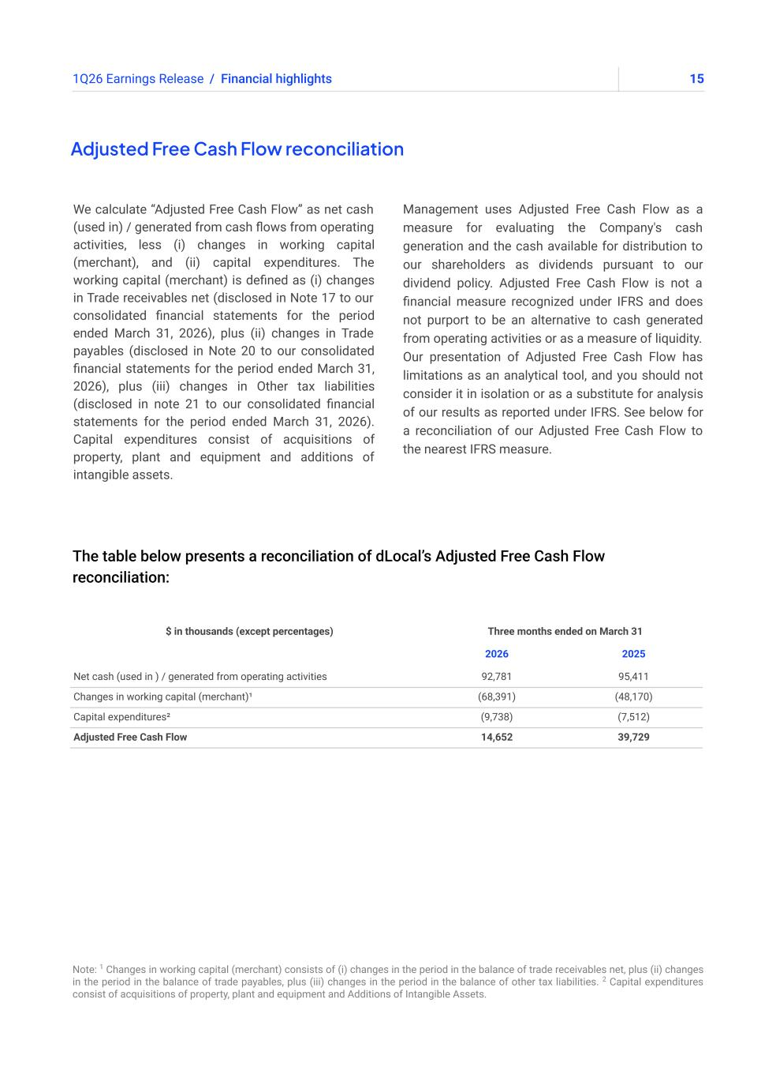
151Q26 Earnings Release Adjusted Free Cash Flow reconciliation We calculate “Adjusted Free Cash Flow” as net cash (used in) / generated from cash flows from operating activities, less (i) changes in working capital (merchant), and (ii) capital expenditures. The working capital (merchant) is defined as (i) changes in Trade receivables net (disclosed in Note 17 to our consolidated financial statements for the period ended March 31, 2026), plus (ii) changes in Trade payables (disclosed in Note 20 to our consolidated financial statements for the period ended March 31, 2026), plus (iii) changes in Other tax liabilities (disclosed in note 21 to our consolidated financial statements for the period ended March 31, 2026). Capital expenditures consist of acquisitions of property, plant and equipment and additions of intangible assets. Management uses Adjusted Free Cash Flow as a measure for evaluating the Company's cash generation and the cash available for distribution to our shareholders as dividends pursuant to our dividend policy. Adjusted Free Cash Flow is not a financial measure recognized under IFRS and does not purport to be an alternative to cash generated from operating activities or as a measure of liquidity. Our presentation of Adjusted Free Cash Flow has limitations as an analytical tool, and you should not consider it in isolation or as a substitute for analysis of our results as reported under IFRS. See below for a reconciliation of our Adjusted Free Cash Flow to the nearest IFRS measure. / Financial highlights The table below presents a reconciliation of dLocal’s Adjusted Free Cash Flow reconciliation: Note: 1 Changes in working capital (merchant) consists of (i) changes in the period in the balance of trade receivables net, plus (ii) changes in the period in the balance of trade payables, plus (iii) changes in the period in the balance of other tax liabilities. 2 Capital expenditures consist of acquisitions of property, plant and equipment and Additions of Intangible Assets. $ in thousands (except percentages) Three months ended on March 31 2026 2025 Net cash (used in ) / generated from operating activities 92,781 95,411 Changes in working capital (merchant)¹ (68,391) (48,170) Capital expenditures² (9,738) (7,512) Adjusted Free Cash Flow 14,652 39,729

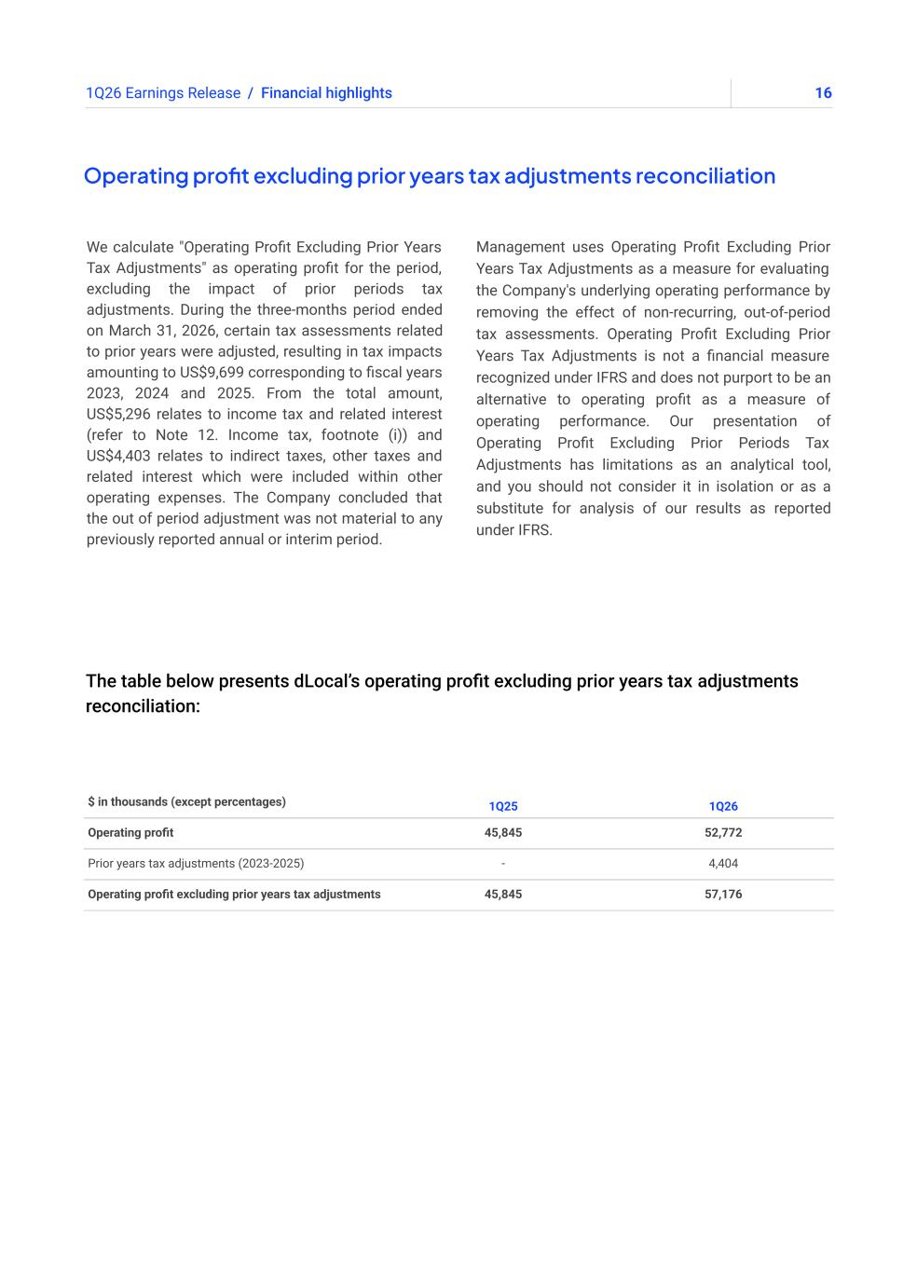
161Q26 Earnings Release The table below presents dLocal’s operating profit excluding prior years tax adjustments reconciliation: Operating profit excluding prior years tax adjustments reconciliation We calculate "Operating Profit Excluding Prior Years Tax Adjustments" as operating profit for the period, excluding the impact of prior periods tax adjustments. During the three-months period ended on March 31, 2026, certain tax assessments related to prior years were adjusted, resulting in tax impacts amounting to US$9,699 corresponding to fiscal years 2023, 2024 and 2025. From the total amount, US$5,296 relates to income tax and related interest (refer to Note 12. Income tax, footnote (i)) and US$4,403 relates to indirect taxes, other taxes and related interest which were included within other operating expenses. The Company concluded that the out of period adjustment was not material to any previously reported annual or interim period. Management uses Operating Profit Excluding Prior Years Tax Adjustments as a measure for evaluating the Company's underlying operating performance by removing the effect of non-recurring, out-of-period tax assessments. Operating Profit Excluding Prior Years Tax Adjustments is not a financial measure recognized under IFRS and does not purport to be an alternative to operating profit as a measure of operating performance. Our presentation of Operating Profit Excluding Prior Periods Tax Adjustments has limitations as an analytical tool, and you should not consider it in isolation or as a substitute for analysis of our results as reported under IFRS. / Financial highlights $ in thousands (except percentages) 1Q25 1Q26 Operating profit 45,845 52,772 Prior years tax adjustments (2023-2025) - 4,404 Operating profit excluding prior years tax adjustments 45,845 57,176

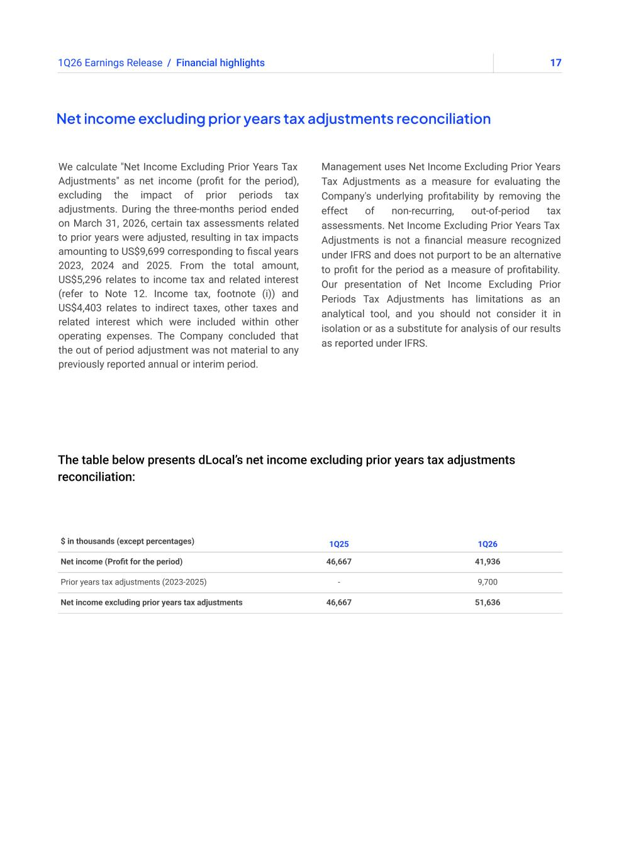
171Q26 Earnings Release The table below presents dLocal’s net income excluding prior years tax adjustments reconciliation: Net income excluding prior years tax adjustments reconciliation We calculate "Net Income Excluding Prior Years Tax Adjustments" as net income (profit for the period), excluding the impact of prior periods tax adjustments. During the three-months period ended on March 31, 2026, certain tax assessments related to prior years were adjusted, resulting in tax impacts amounting to US$9,699 corresponding to fiscal years 2023, 2024 and 2025. From the total amount, US$5,296 relates to income tax and related interest (refer to Note 12. Income tax, footnote (i)) and US$4,403 relates to indirect taxes, other taxes and related interest which were included within other operating expenses. The Company concluded that the out of period adjustment was not material to any previously reported annual or interim period. Management uses Net Income Excluding Prior Years Tax Adjustments as a measure for evaluating the Company's underlying profitability by removing the effect of non-recurring, out-of-period tax assessments. Net Income Excluding Prior Years Tax Adjustments is not a financial measure recognized under IFRS and does not purport to be an alternative to profit for the period as a measure of profitability. Our presentation of Net Income Excluding Prior Periods Tax Adjustments has limitations as an analytical tool, and you should not consider it in isolation or as a substitute for analysis of our results as reported under IFRS. / Financial highlights $ in thousands (except percentages) 1Q25 1Q26 Net income (Profit for the period) 46,667 41,936 Prior years tax adjustments (2023-2025) - 9,700 Net income excluding prior years tax adjustments 46,667 51,636

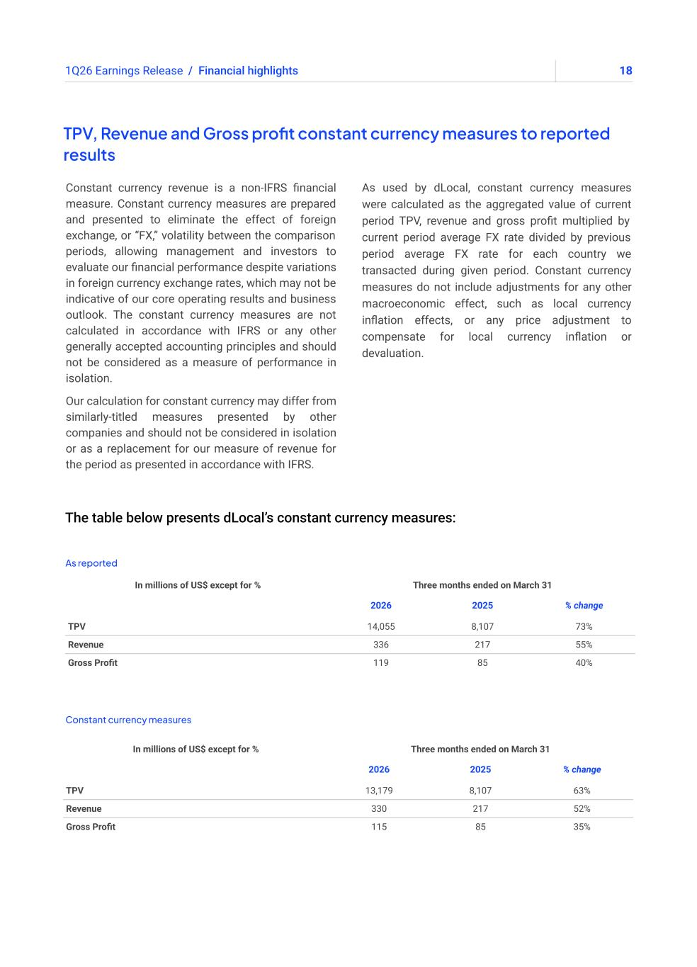
181Q26 Earnings Release The table below presents dLocal’s constant currency measures: TPV, Revenue and Gross profit constant currency measures to reported results Constant currency revenue is a non-IFRS financial measure. Constant currency measures are prepared and presented to eliminate the effect of foreign exchange, or “FX,” volatility between the comparison periods, allowing management and investors to evaluate our financial performance despite variations in foreign currency exchange rates, which may not be indicative of our core operating results and business outlook. The constant currency measures are not calculated in accordance with IFRS or any other generally accepted accounting principles and should not be considered as a measure of performance in isolation. Our calculation for constant currency may differ from similarly-titled measures presented by other companies and should not be considered in isolation or as a replacement for our measure of revenue for the period as presented in accordance with IFRS. As used by dLocal, constant currency measures were calculated as the aggregated value of current period TPV, revenue and gross profit multiplied by current period average FX rate divided by previous period average FX rate for each country we transacted during given period. Constant currency measures do not include adjustments for any other macroeconomic effect, such as local currency inflation effects, or any price adjustment to compensate for local currency inflation or devaluation. / Financial highlights As reported Constant currency measures In millions of US$ except for % Three months ended on March 31 2026 2025 % change TPV 14,055 8,107 73% Revenue 336 217 55% Gross Profit 119 85 40% In millions of US$ except for % Three months ended on March 31 2026 2025 % change TPV 13,179 8,107 63% Revenue 330 217 52% Gross Profit 115 85 35%

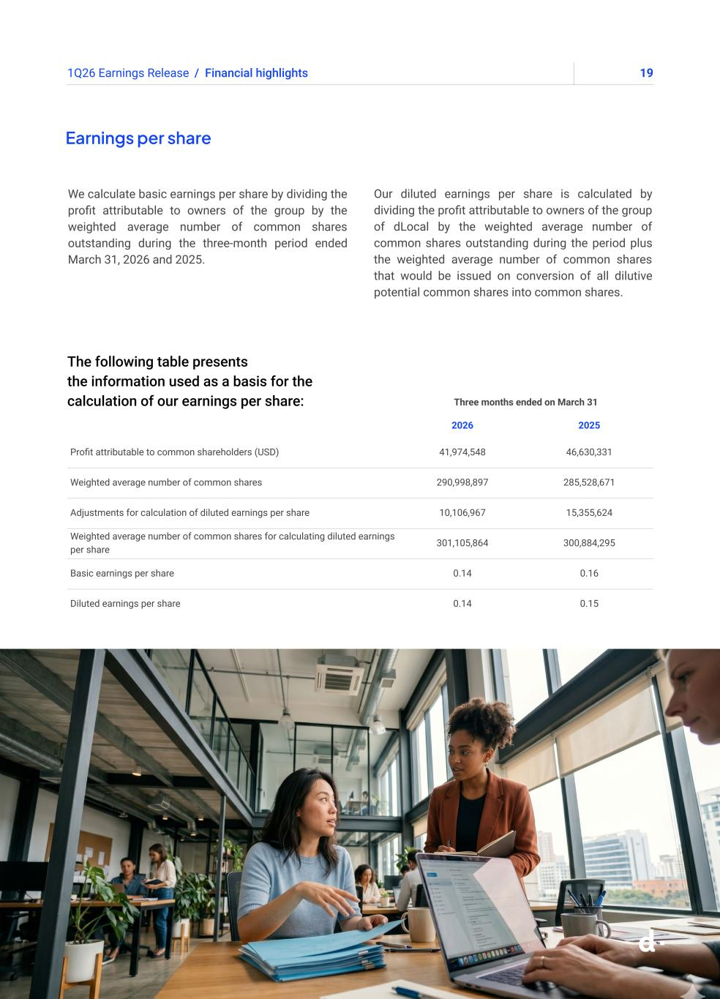
191Q26 Earnings Release Earnings per share We calculate basic earnings per share by dividing the profit attributable to owners of the group by the weighted average number of common shares outstanding during the three-month period ended March 31, 2026 and 2025. Our diluted earnings per share is calculated by dividing the profit attributable to owners of the group of dLocal by the weighted average number of common shares outstanding during the period plus the weighted average number of common shares that would be issued on conversion of all dilutive potential common shares into common shares. / Financial highlights Three months ended on March 31 2026 2025 Profit attributable to common shareholders (USD) 41,974,548 46,630,331 Weighted average number of common shares 290,998,897 285,528,671 Adjustments for calculation of diluted earnings per share 10,106,967 15,355,624 Weighted average number of common shares for calculating diluted earnings per share 301,105,864 300,884,295 Basic earnings per share 0.14 0.16 Diluted earnings per share 0.14 0.15 The following table presents the information used as a basis for the calculation of our earnings per share:


201Q26 Earnings Release Appendix

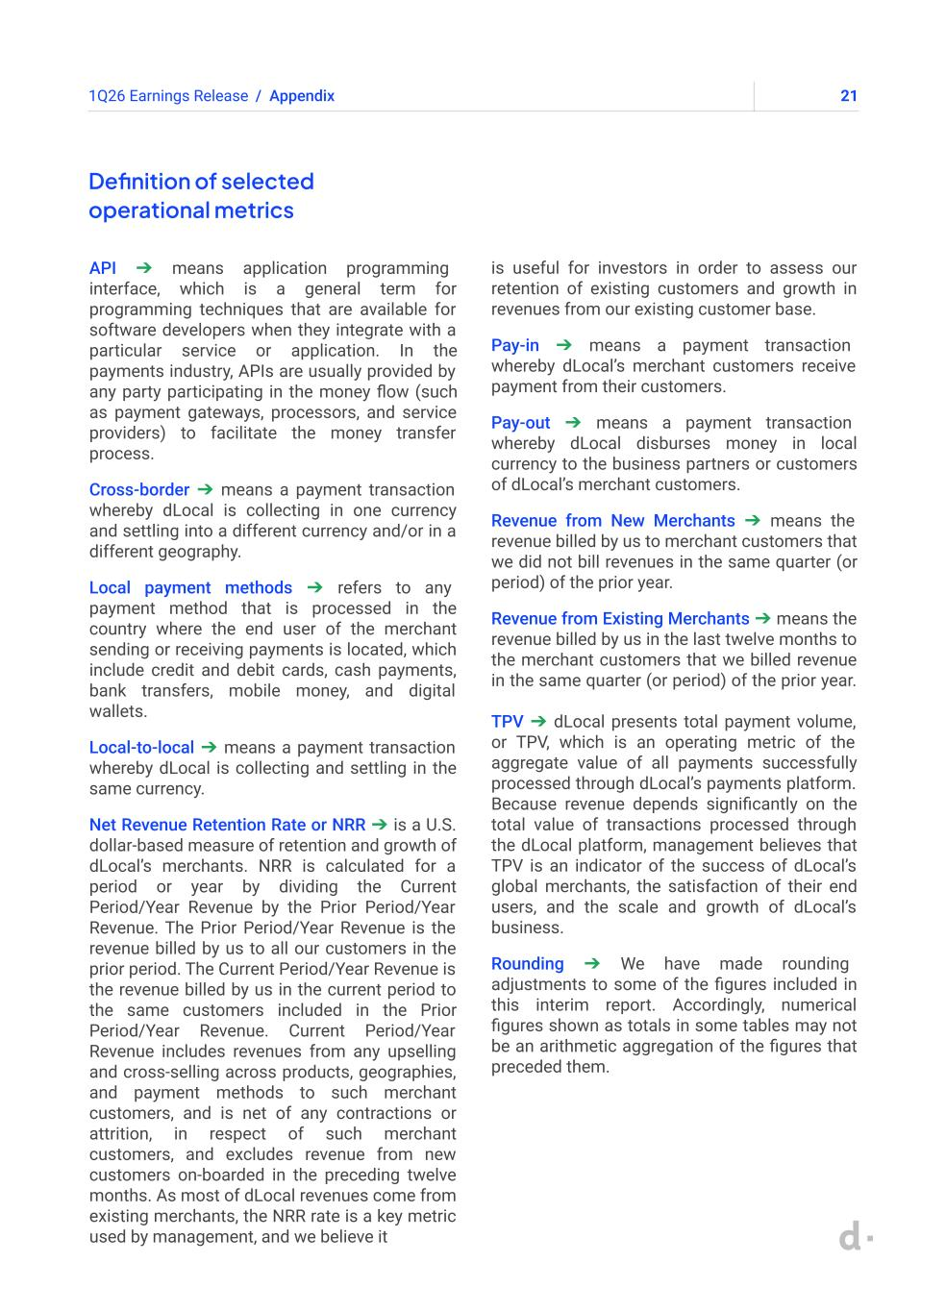
211Q26 Earnings Release Definition of selected operational metrics API ➔ means application programming interface, which is a general term for programming techniques that are available for software developers when they integrate with a particular service or application. In the payments industry, APIs are usually provided by any party participating in the money flow (such as payment gateways, processors, and service providers) to facilitate the money transfer process. Cross-border ➔ means a payment transaction whereby dLocal is collecting in one currency and settling into a different currency and/or in a different geography. Local payment methods ➔ refers to any payment method that is processed in the country where the end user of the merchant sending or receiving payments is located, which include credit and debit cards, cash payments, bank transfers, mobile money, and digital wallets. Local-to-local ➔ means a payment transaction whereby dLocal is collecting and settling in the same currency. Net Revenue Retention Rate or NRR ➔ is a U.S. dollar-based measure of retention and growth of dLocal’s merchants. NRR is calculated for a period or year by dividing the Current Period/Year Revenue by the Prior Period/Year Revenue. The Prior Period/Year Revenue is the revenue billed by us to all our customers in the prior period. The Current Period/Year Revenue is the revenue billed by us in the current period to the same customers included in the Prior Period/Year Revenue. Current Period/Year Revenue includes revenues from any upselling and cross-selling across products, geographies, and payment methods to such merchant customers, and is net of any contractions or attrition, in respect of such merchant customers, and excludes revenue from new customers on-boarded in the preceding twelve months. As most of dLocal revenues come from existing merchants, the NRR rate is a key metric used by management, and we believe it is useful for investors in order to assess our retention of existing customers and growth in revenues from our existing customer base. Pay-in ➔ means a payment transaction whereby dLocal’s merchant customers receive payment from their customers. Pay-out ➔ means a payment transaction whereby dLocal disburses money in local currency to the business partners or customers of dLocal’s merchant customers. Revenue from New Merchants ➔ means the revenue billed by us to merchant customers that we did not bill revenues in the same quarter (or period) of the prior year. Revenue from Existing Merchants ➔ means the revenue billed by us in the last twelve months to the merchant customers that we billed revenue in the same quarter (or period) of the prior year. TPV ➔ dLocal presents total payment volume, or TPV, which is an operating metric of the aggregate value of all payments successfully processed through dLocal’s payments platform. Because revenue depends significantly on the total value of transactions processed through the dLocal platform, management believes that TPV is an indicator of the success of dLocal’s global merchants, the satisfaction of their end users, and the scale and growth of dLocal’s business. Rounding ➔ We have made rounding adjustments to some of the figures included in this interim report. Accordingly, numerical figures shown as totals in some tables may not be an arithmetic aggregation of the figures that preceded them. / Appendix

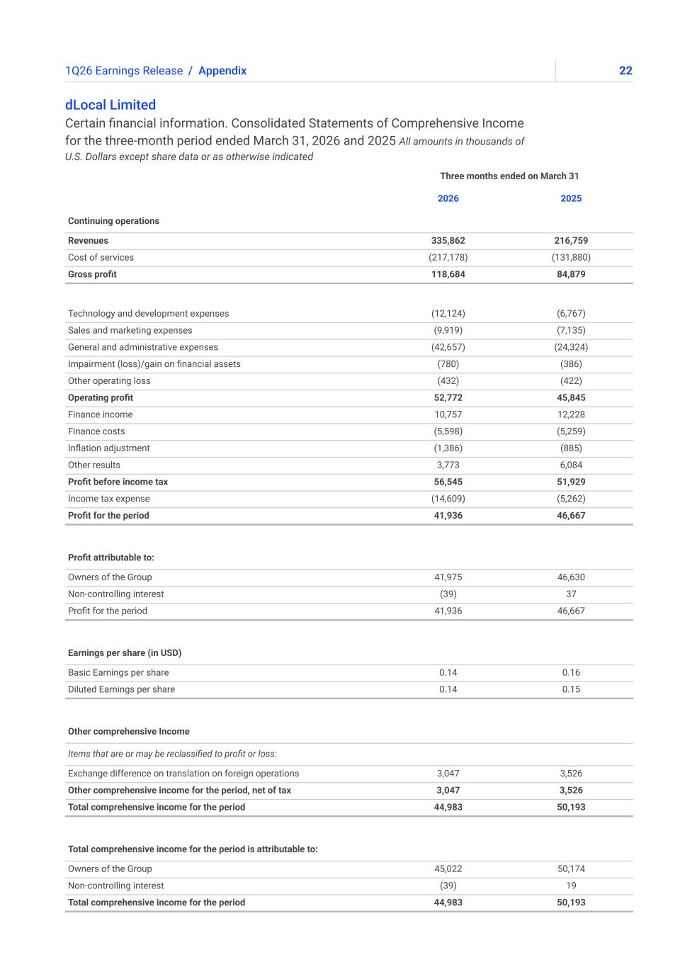
221Q26 Earnings Release / Appendix dLocal Limited Certain financial information. Consolidated Statements of Comprehensive Income for the three-month period ended March 31, 2026 and 2025 All amounts in thousands of U.S. Dollars except share data or as otherwise indicated Three months ended on March 31 2026 2025 Continuing operations Revenues 335,862 216,759 Cost of services (217,178) (131,880) Gross profit 118,684 84,879 Technology and development expenses (12,124) (6,767) Sales and marketing expenses (9,919) (7,135) General and administrative expenses (42,657) (24,324) Impairment (loss)/gain on financial assets (780) (386) Other operating loss (432) (422) Operating profit 52,772 45,845 Finance income 10,757 12,228 Finance costs (5,598) (5,259) Inflation adjustment (1,386) (885) Other results 3,773 6,084 Profit before income tax 56,545 51,929 Income tax expense (14,609) (5,262) Profit for the period 41,936 46,667 Profit attributable to: Owners of the Group 41,975 46,630 Non-controlling interest (39) 37 Profit for the period 41,936 46,667 Earnings per share (in USD) Basic Earnings per share 0.14 0.16 Diluted Earnings per share 0.14 0.15 Other comprehensive Income Items that are or may be reclassified to profit or loss: Exchange difference on translation on foreign operations 3,047 3,526 Other comprehensive income for the period, net of tax 3,047 3,526 Total comprehensive income for the period 44,983 50,193 Total comprehensive income for the period is attributable to: Owners of the Group 45,022 50,174 Non-controlling interest (39) 19 Total comprehensive income for the period 44,983 50,193

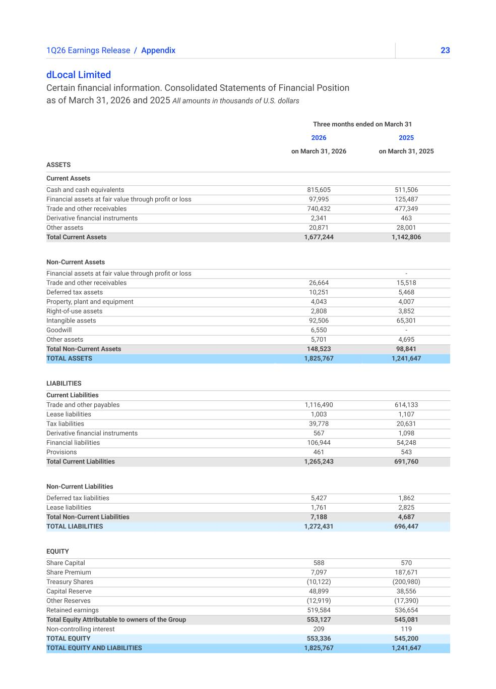
231Q26 Earnings Release / Appendix dLocal Limited Certain financial information. Consolidated Statements of Financial Position as of March 31, 2026 and 2025 All amounts in thousands of U.S. dollars Three months ended on March 31 2026 2025 on March 31, 2026 on March 31, 2025 ASSETS Current Assets Cash and cash equivalents 815,605 511,506 Financial assets at fair value through profit or loss 97,995 125,487 Trade and other receivables 740,432 477,349 Derivative financial instruments 2,341 463 Other assets 20,871 28,001 Total Current Assets 1,677,244 1,142,806 Non-Current Assets Financial assets at fair value through profit or loss - Trade and other receivables 26,664 15,518 Deferred tax assets 10,251 5,468 Property, plant and equipment 4,043 4,007 Right-of-use assets 2,808 3,852 Intangible assets 92,506 65,301 Goodwill 6,550 - Other assets 5,701 4,695 Total Non-Current Assets 148,523 98,841 TOTAL ASSETS 1,825,767 1,241,647 LIABILITIES Current Liabilities Trade and other payables 1,116,490 614,133 Lease liabilities 1,003 1,107 Tax liabilities 39,778 20,631 Derivative financial instruments 567 1,098 Financial liabilities 106,944 54,248 Provisions 461 543 Total Current Liabilities 1,265,243 691,760 Non-Current Liabilities Deferred tax liabilities 5,427 1,862 Lease liabilities 1,761 2,825 Total Non-Current Liabilities 7,188 4,687 TOTAL LIABILITIES 1,272,431 696,447 EQUITY Share Capital 588 570 Share Premium 7,097 187,671 Treasury Shares (10,122) (200,980) Capital Reserve 48,899 38,556 Other Reserves (12,919) (17,390) Retained earnings 519,584 536,654 Total Equity Attributable to owners of the Group 553,127 545,081 Non-controlling interest 209 119 TOTAL EQUITY 553,336 545,200 TOTAL EQUITY AND LIABILITIES 1,825,767 1,241,647

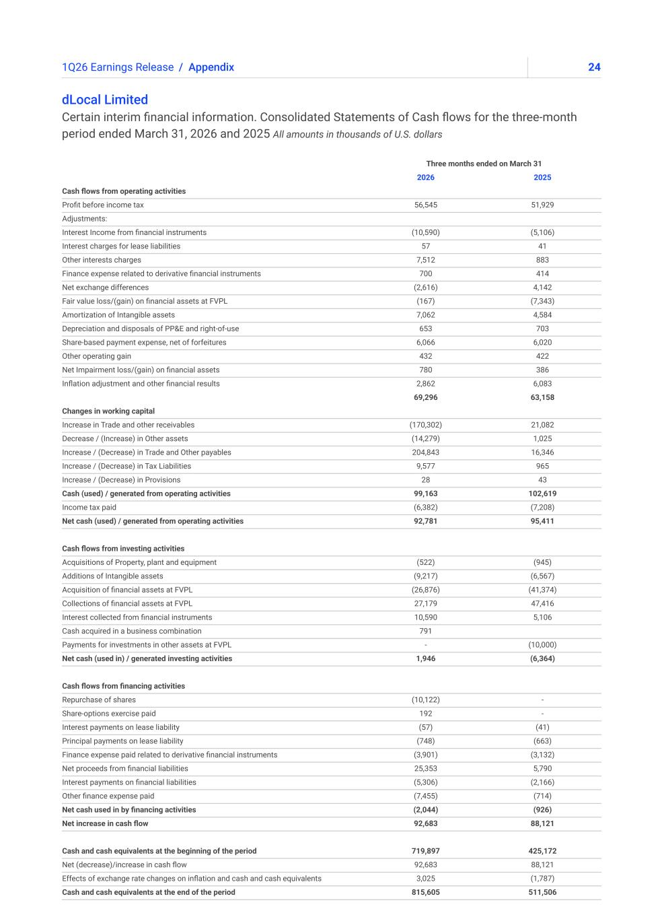
241Q26 Earnings Release / Appendix dLocal Limited Certain interim financial information. Consolidated Statements of Cash flows for the three-month period ended March 31, 2026 and 2025 All amounts in thousands of U.S. dollars Three months ended on March 31 2026 2025 Cash flows from operating activities Profit before income tax 56,545 51,929 Adjustments: Interest Income from financial instruments (10,590) (5,106) Interest charges for lease liabilities 57 41 Other interests charges 7,512 883 Finance expense related to derivative financial instruments 700 414 Net exchange differences (2,616) 4,142 Fair value loss/(gain) on financial assets at FVPL (167) (7,343) Amortization of Intangible assets 7,062 4,584 Depreciation and disposals of PP&E and right-of-use 653 703 Share-based payment expense, net of forfeitures 6,066 6,020 Other operating gain 432 422 Net Impairment loss/(gain) on financial assets 780 386 Inflation adjustment and other financial results 2,862 6,083 69,296 63,158 Changes in working capital Increase in Trade and other receivables (170,302) 21,082 Decrease / (Increase) in Other assets (14,279) 1,025 Increase / (Decrease) in Trade and Other payables 204,843 16,346 Increase / (Decrease) in Tax Liabilities 9,577 965 Increase / (Decrease) in Provisions 28 43 Cash (used) / generated from operating activities 99,163 102,619 Income tax paid (6,382) (7,208) Net cash (used) / generated from operating activities 92,781 95,411 Cash flows from investing activities Acquisitions of Property, plant and equipment (522) (945) Additions of Intangible assets (9,217) (6,567) Acquisition of financial assets at FVPL (26,876) (41,374) Collections of financial assets at FVPL 27,179 47,416 Interest collected from financial instruments 10,590 5,106 Cash acquired in a business combination 791 Payments for investments in other assets at FVPL - (10,000) Net cash (used in) / generated investing activities 1,946 (6,364) Cash flows from financing activities Repurchase of shares (10,122) - Share-options exercise paid 192 - Interest payments on lease liability (57) (41) Principal payments on lease liability (748) (663) Finance expense paid related to derivative financial instruments (3,901) (3,132) Net proceeds from financial liabilities 25,353 5,790 Interest payments on financial liabilities (5,306) (2,166) Other finance expense paid (7,455) (714) Net cash used in by financing activities (2,044) (926) Net increase in cash flow 92,683 88,121 Cash and cash equivalents at the beginning of the period 719,897 425,172 Net (decrease)/increase in cash flow 92,683 88,121 Effects of exchange rate changes on inflation and cash and cash equivalents 3,025 (1,787) Cash and cash equivalents at the end of the period 815,605 511,506


251Q26 Earnings Release dLocal builds financial infrastructure for markets of the future, connecting global enterprises with billions of emerging market consumers in more than 60 countries across high-growth markets in Africa, Asia, the Middle East, and Latin America. Through the "One dLocal" concept (one direct API, one platform, and one contract), global companies can accept payments, send payouts, and settle funds globally without the need to manage multiple local entities and integrations. For more information, visit www.dlocal.com Conference call and webcast About dLocal dLocal’s management team will host a conference call and audio webcast on May 14, 2026 at 5:00 p.m. Eastern Time. Please click here to pre-register for the conference call and obtain your dial in number and passcode. The live conference call can be accessed via audio webcast at the investor relations section of dLocal’s website, at https://investor.dlocal.com/. An archive of the webcast will be available for a year following the conclusion of the conference call. The investor presentation will also be filed on EDGAR at www.sec.gov.


261Q26 Earnings Release Forward-looking statements This presentation may contain forward-looking statements. These forward-looking statements convey dLocal’s current expectations or forecasts of future events, including guidance in respect of total payment volume, gross profit and operating profit. Forward-looking statements regarding dLocal and amounts stated as guidance involve known and unknown risks, uncertainties and other factors that may cause dLocal’s actual results, performance or achievements to be materially different from any future results, performances or achievements expressed or implied by the forward-looking statements. Certain of these risks and uncertainties are described in the “Risk Factors,” and “Cautionary Statement Regarding Forward-Looking Statements” sections of dLocal’s filings with the U.S. Securities and Exchange Commission. Unless required by law, dLocal undertakes no obligation to publicly update or revise any forward-looking statements to reflect circumstances or events after the date hereof. Starting in 2026, we provide guidance in respect of Operating Profit, which management believes is useful as a measure to compare our operating results to the operations of other companies in our industry, and to assess our operating performance independently of our capital structure, tax position, and non-cash depreciation and amortization charges.


Investor Relations Contact investor@dlocal.com Media Contact media@dlocal.com This press release does not contain sufficient information to constitute an interim financial report as defined in International Accounting Standards 34, “Interim Financial Reporting” nor a financial statement as defined by International Accounting Standards 1 “Presentation of Financial Statements”. The first quarter financial information in this press release has not been audited nor has it been subject to any limited review procedures, whereas the annual results for the year ended December 31, 2025 are audited.


1Earnings Presentation Q1'25 ➔ 1Q26Earnings Presentation


21Q26 Earnings Presentation ➔ This presentation may contain forward-looking statements. These forward-looking statements convey dLocal’s current expectations or forecasts of future events, including guidance in respect of total payment volume, gross profit and operating profit. Forward-looking statements regarding dLocal and amounts stated as guidance involve known and unknown risks, uncertainties and other factors that may cause dLocal’s actual results, performance or achievements to be materially different from any future results, performances or achievements expressed or implied by the forward-looking statements. Certain of these risks and uncertainties are described in the “Risk Factors,” and “Cautionary Statement Regarding Forward-Looking Statements” sections of dLocal’s filings with the U.S. Securities and Exchange Commission. Unless required by law, dLocal undertakes no obligation to publicly update or revise any forward-looking statements to reflect circumstances or events after the date hereof. Starting in 2026, we provide guidance in respect of Operating Profit, which management believes is useful as a measure to compare our operating results to the operations of other companies in our industry, and to assess our operating performance independently of our capital structure, tax position, and non-cash depreciation and amortization charges.


31Q26 Earnings Presentation ➔ Pedro Arnt Chief Executive Officer Guillermo Lopez Perez Chief Financial Officer


41Q26 Earnings Presentation ➔ CEO Message

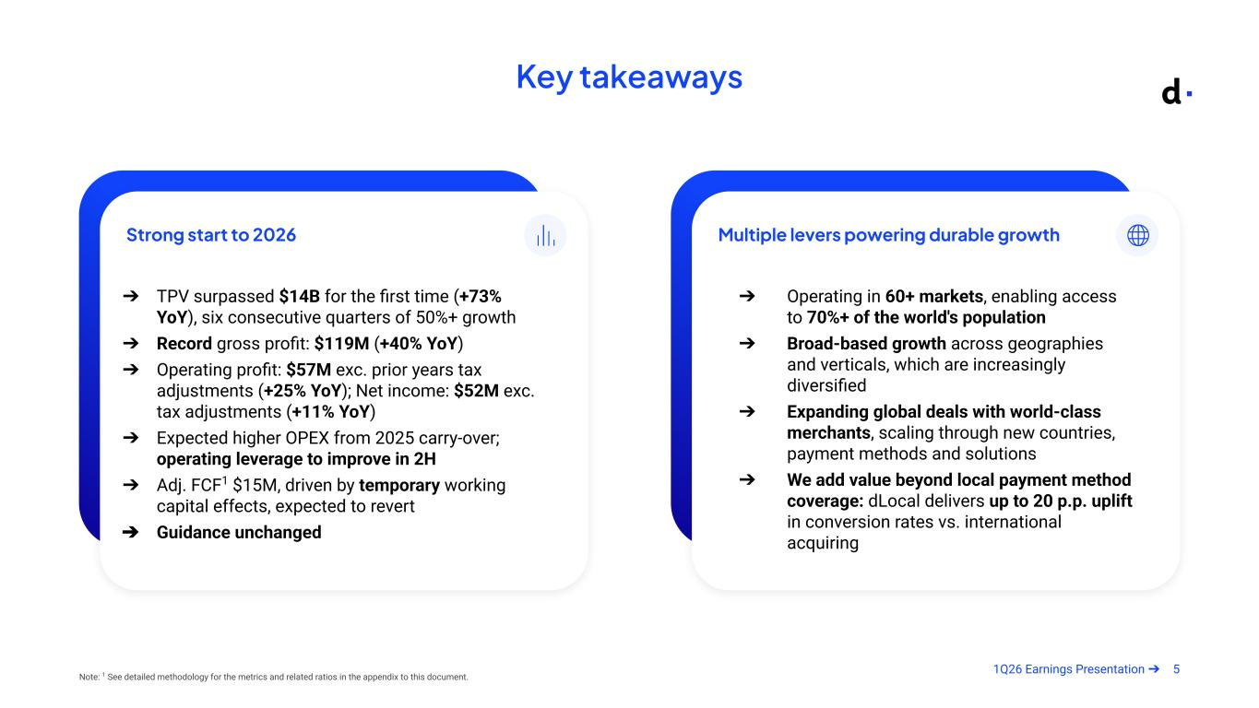
51Q26 Earnings Presentation ➔ Key takeaways Note: 1 See detailed methodology for the metrics and related ratios in the appendix to this document. Strong start to 2026 ➔ TPV surpassed $14B for the first time (+73% YoY), six consecutive quarters of 50%+ growth ➔ Record gross profit: $119M (+40% YoY) ➔ Operating profit: $57M exc. prior years tax adjustments (+25% YoY); Net income: $52M exc. tax adjustments (+11% YoY) ➔ Expected higher OPEX from 2025 carry-over; operating leverage to improve in 2H ➔ Adj. FCF1 $15M, driven by temporary working capital effects, expected to revert ➔ Guidance unchanged Multiple levers powering durable growth ➔ Operating in 60+ markets, enabling access to 70%+ of the world's population ➔ Broad-based growth across geographies and verticals, which are increasingly diversified ➔ Expanding global deals with world-class merchants, scaling through new countries, payment methods and solutions ➔ We add value beyond local payment method coverage: dLocal delivers up to 20 p.p. uplift in conversion rates vs. international acquiring



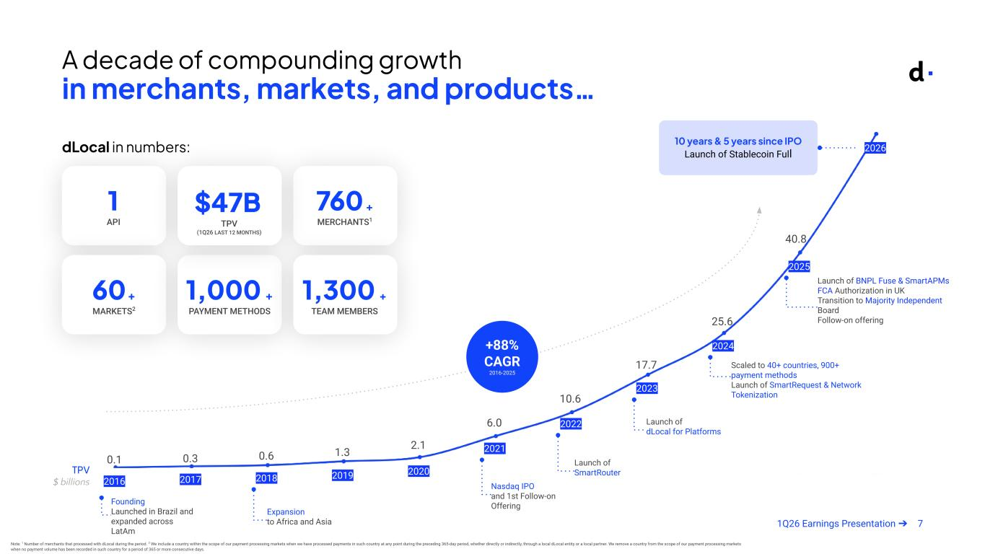
71Q26 Earnings Presentation ➔ 2016 2017 2018 2019 2020 2021 2022 2023 2024 2025 2026 Founding Launched in Brazil and expanded across LatAm Expansion to Africa and Asia Nasdaq IPO and 1st Follow-on Offering Launch of SmartRouter Launch of dLocal for Platforms Scaled to 40+ countries, 900+ payment methods Launch of SmartRequest & Network Tokenization Launch of BNPL Fuse & SmartAPMs FCA Authorization in UK Transition to Majority Independent Board Follow-on offering A decade of compounding growth in merchants, markets, and products… 0.1 40.8 10 years & 5 years since IPO Launch of Stablecoin Full 0.3 0.6 1.3 2.1 17.7 25.6 10.6 6.0 TPV $ billions +88% CAGR 2016-2025 dLocal in numbers: 60+ MARKETS2 1,000 + PAYMENT METHODS 1,300 + TEAM MEMBERS 121 API $47B TPV (1Q26 LAST 12 MONTHS) 760 + MERCHANTS1 Note: 1 Number of merchants that processed with dLocal during the period. 2 We include a country within the scope of our payment processing markets when we have processed payments in such country at any point during the preceding 365-day period, whether directly or indirectly, through a local dLocal entity or a local partner. We remove a country from the scope of our payment processing markets when no payment volume has been recorded in such country for a period of 365 or more consecutive days.

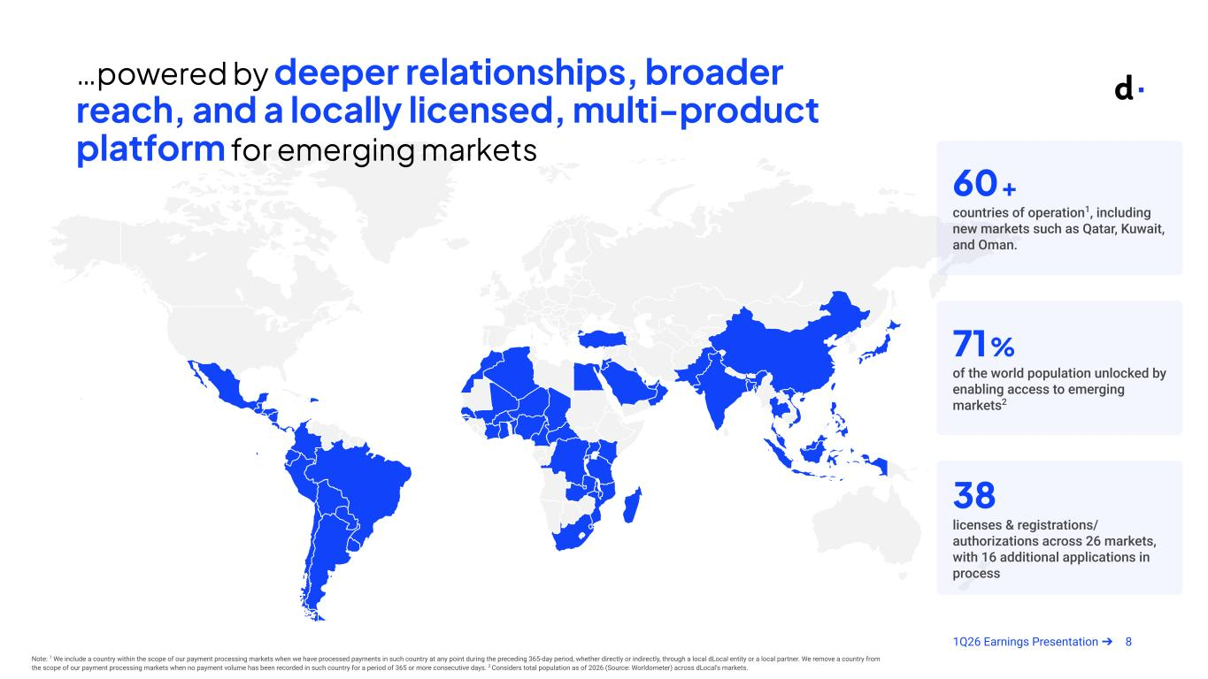
81Q26 Earnings Presentation ➔ …powered by deeper relationships, broader reach, and a locally licensed, multi-product platform for emerging markets Note: 1 We include a country within the scope of our payment processing markets when we have processed payments in such country at any point during the preceding 365-day period, whether directly or indirectly, through a local dLocal entity or a local partner. We remove a country from the scope of our payment processing markets when no payment volume has been recorded in such country for a period of 365 or more consecutive days. 2 Considers total population as of 2026 (Source: Worldometer) across dLocal's markets. 60+ countries of operation1, including new markets such as Qatar, Kuwait, and Oman. 71% of the world population unlocked by enabling access to emerging markets2 38 licenses & registrations/ authorizations across 26 markets, with 16 additional applications in process

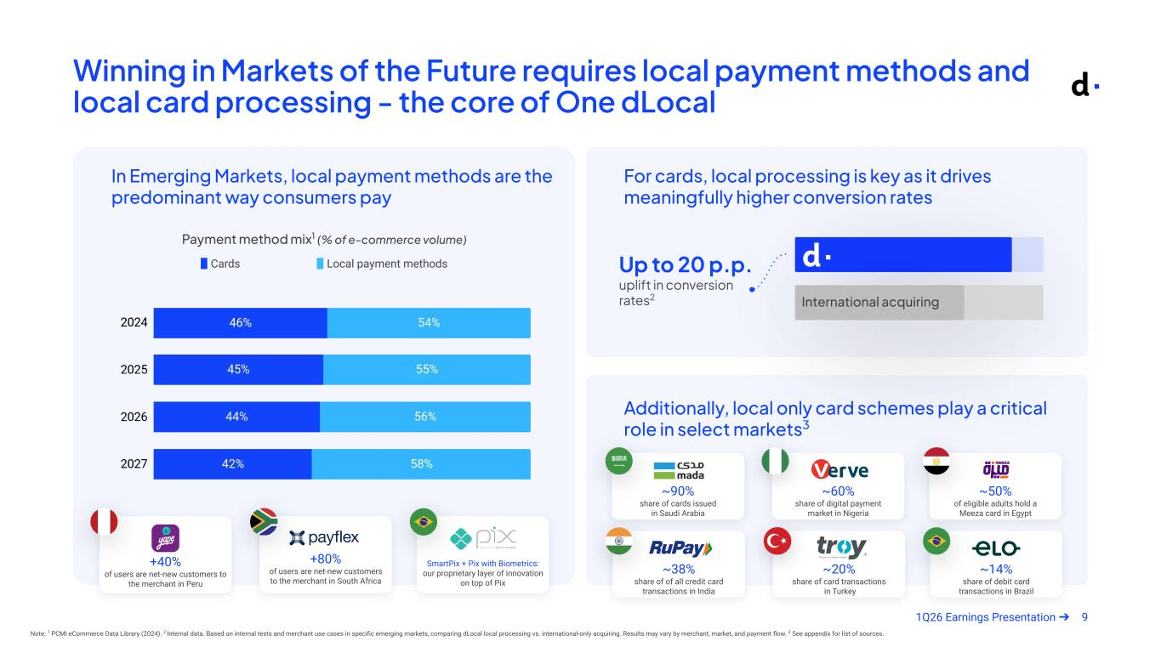
91Q26 Earnings Presentation ➔ Winning in Markets of the Future requires local payment methods and local card processing - the core of One dLocal Note: 1 PCMI eCommerce Data Library (2024). 2 Internal data. Based on internal tests and merchant use cases in specific emerging markets, comparing dLocal local processing vs. international-only acquiring. Results may vary by merchant, market, and payment flow. 3 See appendix for list of sources. Payment method mix1 (% of e-commerce volume) ▉ Cards ▉ Local payment methods In Emerging Markets, local payment methods are the predominant way consumers pay For cards, local processing is key as it drives meaningfully higher conversion rates Additionally, local only card schemes play a critical role in select markets3 Up to 20 p.p. uplift in conversion rates2 ~90% share of cards issued in Saudi Arabia ~60% share of digital payment market in Nigeria ~50% of eligible adults hold a Meeza card in Egypt +40% of users are net-new customers to the merchant in Peru +80% of users are net-new customers to the merchant in South Africa SmartPix + Pix with Biometrics: our proprietary layer of innovation on top of Pix International acquiring ~38% share of of all credit card transactions in India ~20% share of card transactions in Turkey ~14% share of debit card transactions in Brazil

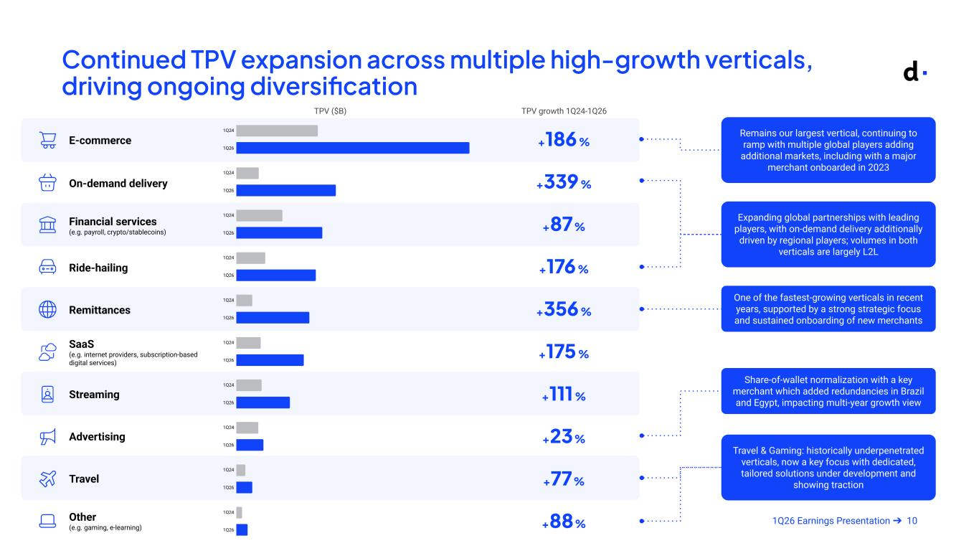
101Q26 Earnings Presentation ➔ Continued TPV expansion across multiple high-growth verticals, driving ongoing diversification E-commerce On-demand delivery Financial services (e.g. payroll, crypto/stablecoins) Ride-hailing Remittances SaaS (e.g. internet providers, subscription-based digital services) Streaming Advertising Travel Other (e.g. gaming, e-learning) TPV growth 1Q24-1Q26 +186% +339% +87% +176% +356% +175% +111% +23% +77% +88% One of the fastest-growing verticals in recent years, supported by a strong strategic focus and sustained onboarding of new merchants Remains our largest vertical, continuing to ramp with multiple global players adding additional markets, including with a major merchant onboarded in 2023 Expanding global partnerships with leading players, with on-demand delivery additionally driven by regional players; volumes in both verticals are largely L2L Travel & Gaming: historically underpenetrated verticals, now a key focus with dedicated, tailored solutions under development and showing traction TPV ($B) Share-of-wallet normalization with a key merchant which added redundancies in Brazil and Egypt, impacting multi-year growth view

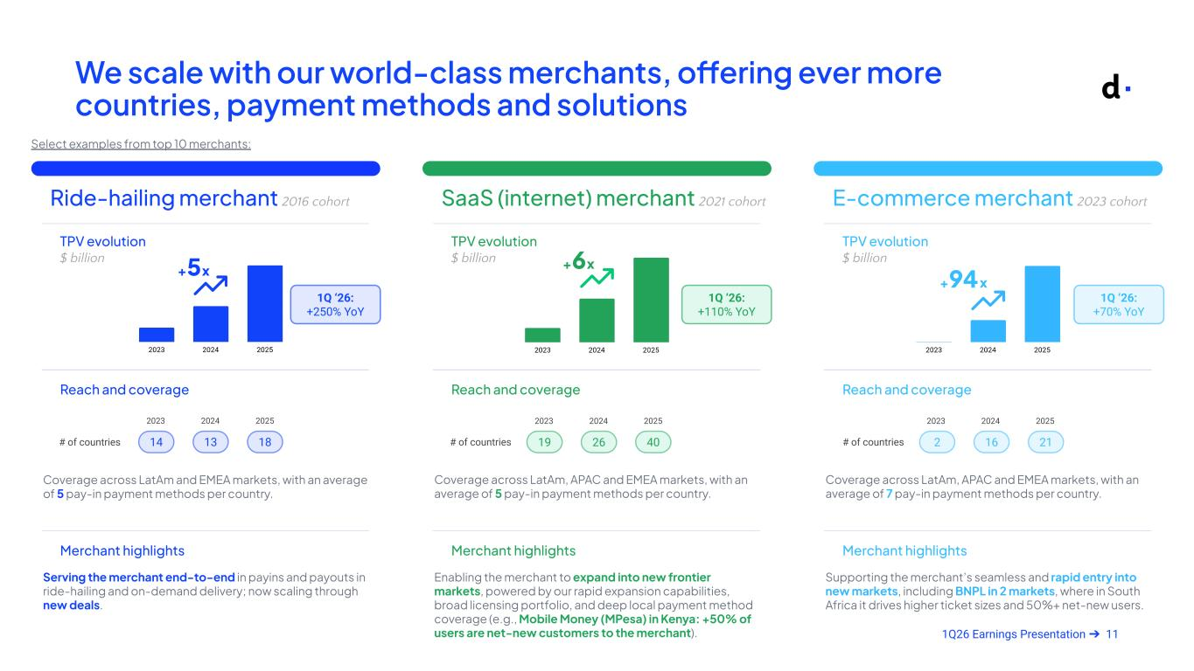
111Q26 Earnings Presentation ➔ Ride-hailing merchant 2016 cohort TPV evolution $ billion Reach and coverage Merchant highlights # of countries 14 13 18 Serving the merchant end-to-end in payins and payouts in ride-hailing and on-demand delivery; now scaling through new deals. Coverage across LatAm and EMEA markets, with an average of 5 pay-in payment methods per country. We scale with our world-class merchants, offering ever more countries, payment methods and solutions E-commerce merchant 2023 cohort TPV evolution $ billion Reach and coverage Merchant highlights # of countries 2 16 21 Supporting the merchant’s seamless and rapid entry into new markets, including BNPL in 2 markets, where in South Africa it drives higher ticket sizes and 50%+ net-new users. Coverage across LatAm, APAC and EMEA markets, with an average of 7 pay-in payment methods per country. SaaS (internet) merchant 2021 cohort TPV evolution $ billion Reach and coverage Merchant highlights # of countries 19 26 40 Enabling the merchant to expand into new frontier markets, powered by our rapid expansion capabilities, broad licensing portfolio, and deep local payment method coverage (e.g., Mobile Money (MPesa) in Kenya: +50% of users are net-new customers to the merchant). Coverage across LatAm, APAC and EMEA markets, with an average of 5 pay-in payment methods per country. +5x 1Q ‘26: +250% YoY +94x 1Q ‘26: +70% YoY 1Q ‘26: +110% YoY +6x 2023 2024 20252023 2024 2025 2023 2024 2025 Select examples from top 10 merchants:


121Q26 Earnings Presentation ➔ Financial Highlights

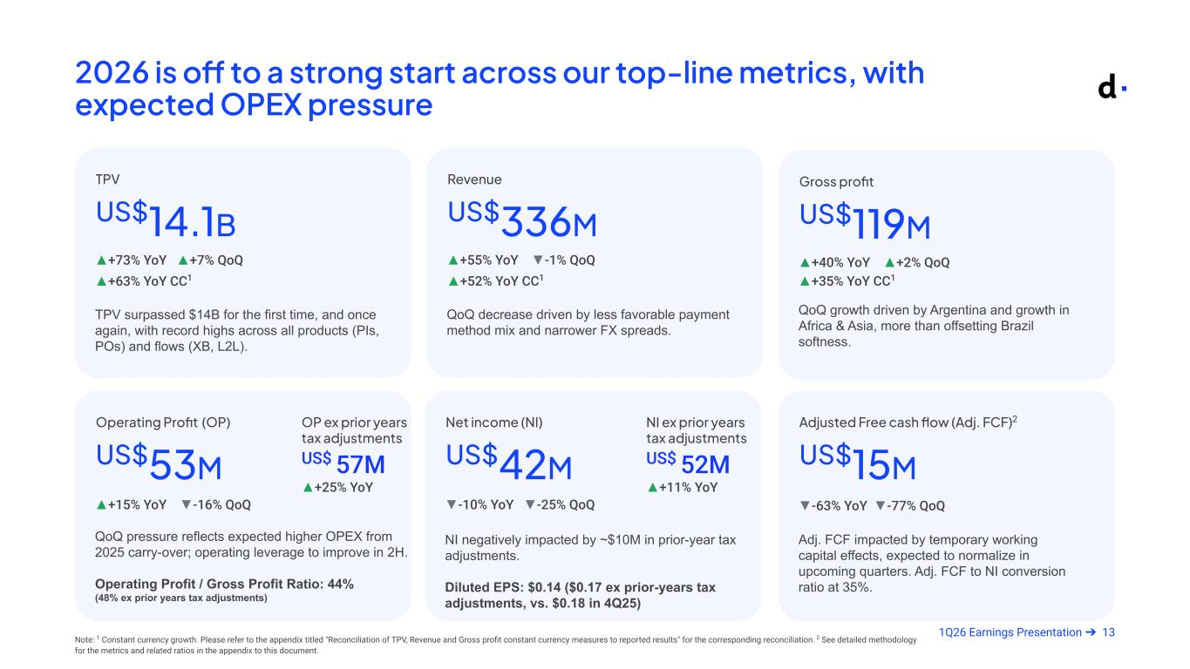
131Q26 Earnings Presentation ➔ 2026 is off to a strong start across our top-line metrics, with expected OPEX pressure TPV surpassed $14B for the first time, and once again, with record highs across all products (PIs, POs) and flows (XB, L2L). US$14.1B ▲+73% YoY ▲+7% QoQ TPV Adj. FCF impacted by temporary working capital effects, expected to normalize in upcoming quarters. Adj. FCF to NI conversion ratio at 35%. US$15M ▼-63% YoY ▼-77% QoQ Adjusted Free cash flow (Adj. FCF)2 QoQ pressure reflects expected higher OPEX from 2025 carry-over; operating leverage to improve in 2H. Operating Profit / Gross Profit Ratio: 44% (48% ex prior years tax adjustments) US$53M ▲+15% YoY ▼-16% QoQ Operating Profit (OP) QoQ growth driven by Argentina and growth in Africa & Asia, more than offsetting Brazil softness. US$119M ▲+40% YoY ▲+2% QoQ Gross profit NI negatively impacted by ~$10M in prior-year tax adjustments. Diluted EPS: $0.14 ($0.17 ex prior-years tax adjustments, vs. $0.18 in 4Q25) US$42M ▼-10% YoY ▼-25% QoQ Net income (NI) QoQ decrease driven by less favorable payment method mix and narrower FX spreads. US$336M ▲+55% YoY ▼-1% QoQ Revenue ▲+63% YoY CC1 ▲+52% YoY CC1 ▲+35% YoY CC1 Note: 1 Constant currency growth. Please refer to the appendix titled "Reconciliation of TPV, Revenue and Gross profit constant currency measures to reported results" for the corresponding reconciliation. 2 See detailed methodology for the metrics and related ratios in the appendix to this document. NI ex prior years tax adjustments US$ 52M ▲+11% YoY OP ex prior years tax adjustments US$ 57M ▲+25% YoY Armado May 7 @ 8pm

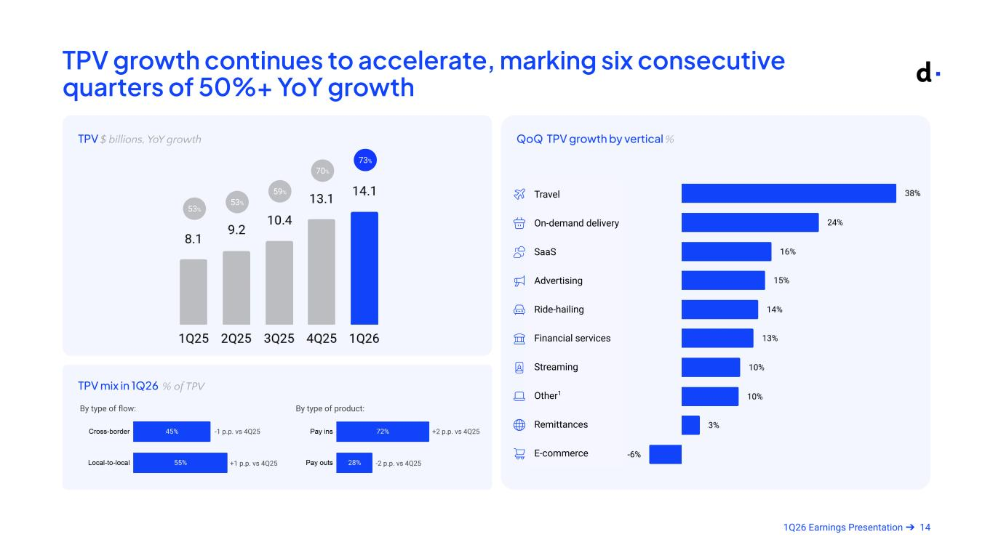
141Q26 Earnings Presentation ➔ TPV growth continues to accelerate, marking six consecutive quarters of 50%+ YoY growth TPV $ billions, YoY growth QoQ TPV growth by vertical % TPV mix in 1Q26 % of TPV 73% 70% 53% 53% 59% Travel On-demand delivery SaaS Advertising Ride-hailing Financial services Streaming Other1 Remittances E-commerce By type of product:By type of flow: +2 p.p. vs 4Q25 -2 p.p. vs 4Q25 -1 p.p. vs 4Q25 +1 p.p. vs 4Q25

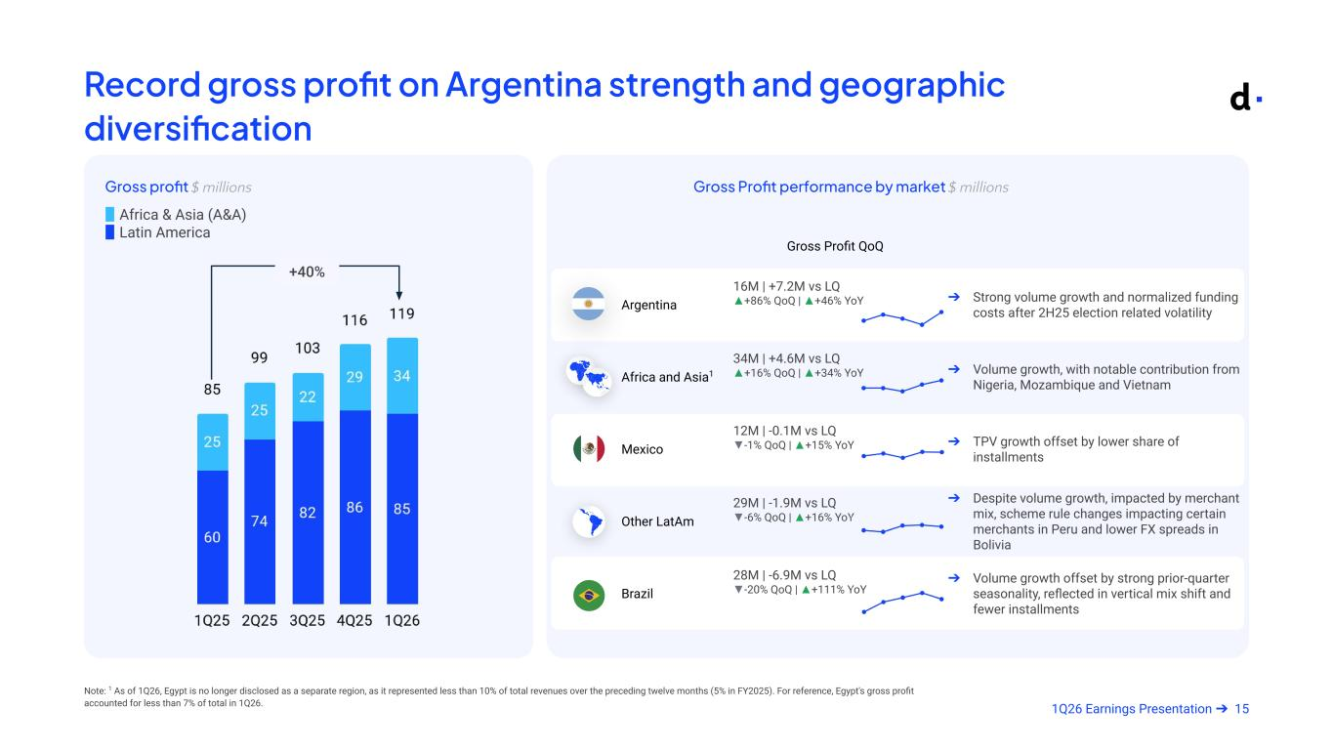
151Q26 Earnings Presentation ➔ Record gross profit on Argentina strength and geographic diversification Note: 1 As of 1Q26, Egypt is no longer disclosed as a separate region, as it represented less than 10% of total revenues over the preceding twelve months (5% in FY2025). For reference, Egypt's gross profit accounted for less than 7% of total in 1Q26. Armado May 7 @ 8pm Gross profit $ millions ▉ Africa & Asia (A&A) ▉ Latin America Gross Profit performance by market $ millions Gross Profit QoQ Argentina 16M | +7.2M vs LQ ▲+86% QoQ | ▲+46% YoY ➔ Strong volume growth and normalized funding costs after 2H25 election related volatility Africa and Asia1 34M | +4.6M vs LQ ▲+16% QoQ | ▲+34% YoY ➔ Volume growth, with notable contribution from Nigeria, Mozambique and Vietnam Mexico 12M | -0.1M vs LQ ▼-1% QoQ | ▲+15% YoY ➔ TPV growth offset by lower share of installments Other LatAm 29M | -1.9M vs LQ ▼-6% QoQ | ▲+16% YoY ➔ Despite volume growth, impacted by merchant mix, scheme rule changes impacting certain merchants in Peru and lower FX spreads in Bolivia Brazil 28M | -6.9M vs LQ ▼-20% QoQ | ▲+111% YoY ➔ Volume growth offset by strong prior-quarter seasonality, reflected in vertical mix shift and fewer installments +40%

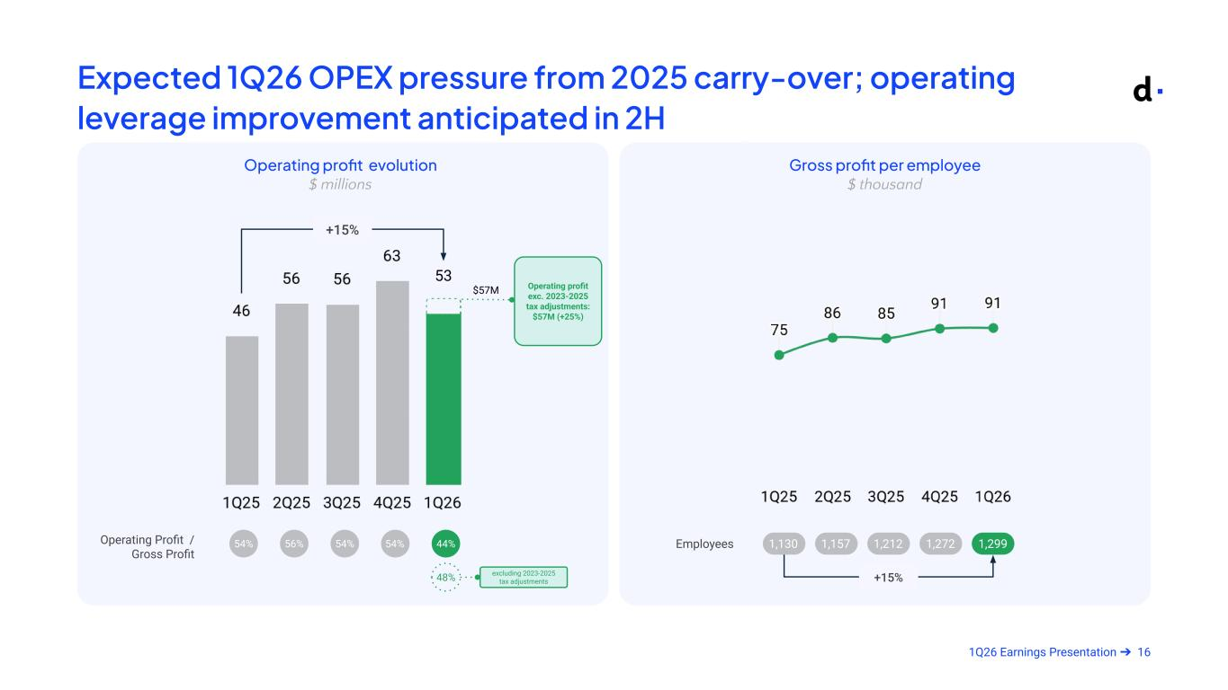
161Q26 Earnings Presentation ➔ Expected 1Q26 OPEX pressure from 2025 carry-over; operating leverage improvement anticipated in 2H Operating profit evolution $ millions 44%54%54% 56% 54%Operating Profit / Gross Profit Gross profit per employee $ thousand +15% Armado Apr 30Armado May 7 @ 8pm 53 Operating profit exc. 2023-2025 tax adjustments: $57M (+25%) 48% excluding 2023-2025 tax adjustments Employees 1,130 1,157 1,212 1,272 1,299 +15% $57M

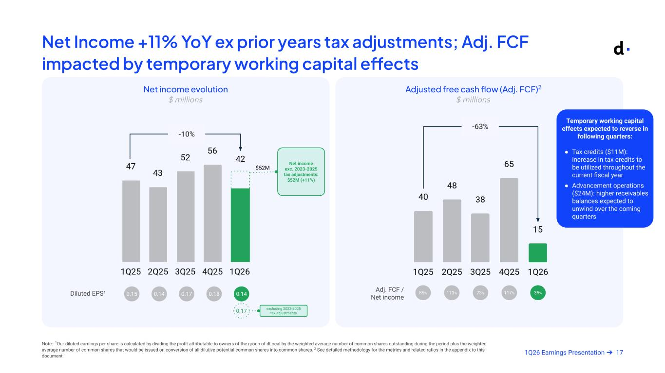
171Q26 Earnings Presentation ➔ Net Income +11% YoY ex prior years tax adjustments; Adj. FCF impacted by temporary working capital effects Net income evolution $ millions Diluted EPS¹ 0.140.180.15 0.14 0.17 Note: 1Our diluted earnings per share is calculated by dividing the profit attributable to owners of the group of dLocal by the weighted average number of common shares outstanding during the period plus the weighted average number of common shares that would be issued on conversion of all dilutive potential common shares into common shares. 2 See detailed methodology for the metrics and related ratios in the appendix to this document. -10% Adj. FCF / Net income 35%117%85% 113% 73% Adjusted free cash flow (Adj. FCF)2 $ millions -63% 42 Armado May 7 @ 8pm 0.17 excluding 2023-2025 tax adjustments Temporary working capital effects expected to reverse in following quarters: ● Tax credits ($11M): increase in tax credits to be utilized throughout the current fiscal year ● Advancement operations ($24M): higher receivables balances expected to unwind over the coming quarters Net income exc. 2023-2025 tax adjustments: $52M (+11%) $52M

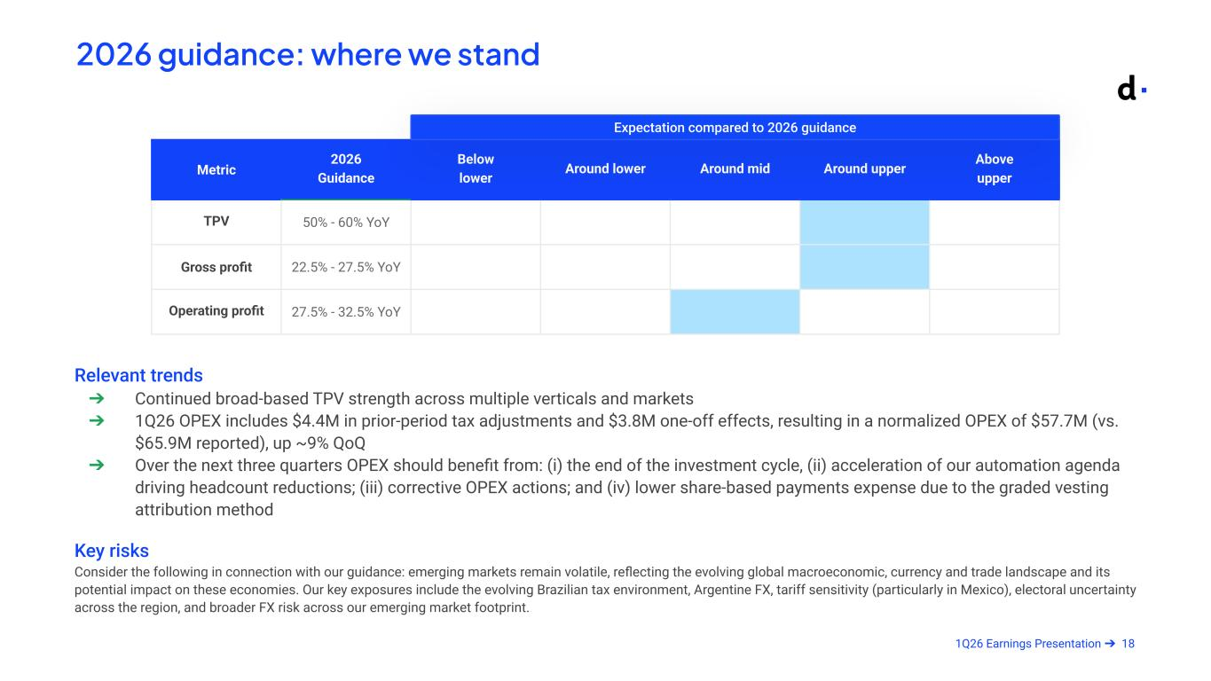
181Q26 Earnings Presentation ➔ Metric 2026 Guidance Below lower Around lower Around mid Around upper Above upper TPV 50% - 60% YoY Gross profit 22.5% - 27.5% YoY Operating profit 27.5% - 32.5% YoY Relevant trends ➔ Continued broad-based TPV strength across multiple verticals and markets ➔ 1Q26 OPEX includes $4.4M in prior-period tax adjustments and $3.8M one-off effects, resulting in a normalized OPEX of $57.7M (vs. $65.9M reported), up ~9% QoQ ➔ Over the next three quarters OPEX should benefit from: (i) the end of the investment cycle, (ii) acceleration of our automation agenda driving headcount reductions; (iii) corrective OPEX actions; and (iv) lower share-based payments expense due to the graded vesting attribution method Key risks Consider the following in connection with our guidance: emerging markets remain volatile, reflecting the evolving global macroeconomic, currency and trade landscape and its potential impact on these economies. Our key exposures include the evolving Brazilian tax environment, Argentine FX, tariff sensitivity (particularly in Mexico), electoral uncertainty across the region, and broader FX risk across our emerging market footprint. Expectation compared to 2026 guidance 2026 guidance: where we stand


191Q26 Earnings Presentation ➔ Q&A


201Q26 Earnings Presentation ➔ Appendix

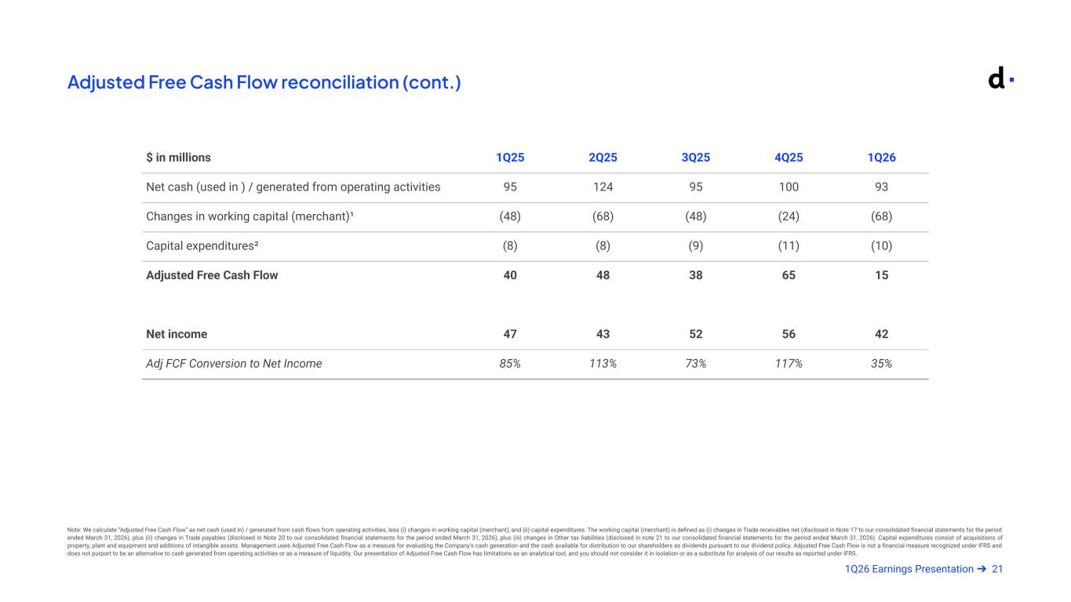
211Q26 Earnings Presentation ➔ Adjusted Free Cash Flow reconciliation (cont.) Note: We calculate “Adjusted Free Cash Flow” as net cash (used in) / generated from cash flows from operating activities, less (i) changes in working capital (merchant), and (ii) capital expenditures. The working capital (merchant) is defined as (i) changes in Trade receivables net (disclosed in Note 17 to our consolidated financial statements for the period ended March 31, 2026), plus (ii) changes in Trade payables (disclosed in Note 20 to our consolidated financial statements for the period ended March 31, 2026), plus (iii) changes in Other tax liabilities (disclosed in note 21 to our consolidated financial statements for the period ended March 31, 2026). Capital expenditures consist of acquisitions of property, plant and equipment and additions of intangible assets. Management uses Adjusted Free Cash Flow as a measure for evaluating the Company's cash generation and the cash available for distribution to our shareholders as dividends pursuant to our dividend policy. Adjusted Free Cash Flow is not a financial measure recognized under IFRS and does not purport to be an alternative to cash generated from operating activities or as a measure of liquidity. Our presentation of Adjusted Free Cash Flow has limitations as an analytical tool, and you should not consider it in isolation or as a substitute for analysis of our results as reported under IFRS. $ in millions 1Q25 2Q25 3Q25 4Q25 1Q26 Net cash (used in ) / generated from operating activities 95 124 95 100 93 Changes in working capital (merchant)¹ (48) (68) (48) (24) (68) Capital expenditures² (8) (8) (9) (11) (10) Adjusted Free Cash Flow 40 48 38 65 15 Net income 47 43 52 56 42 Adj FCF Conversion to Net Income 85% 113% 73% 117% 35% Armado May 7 @ 8pm

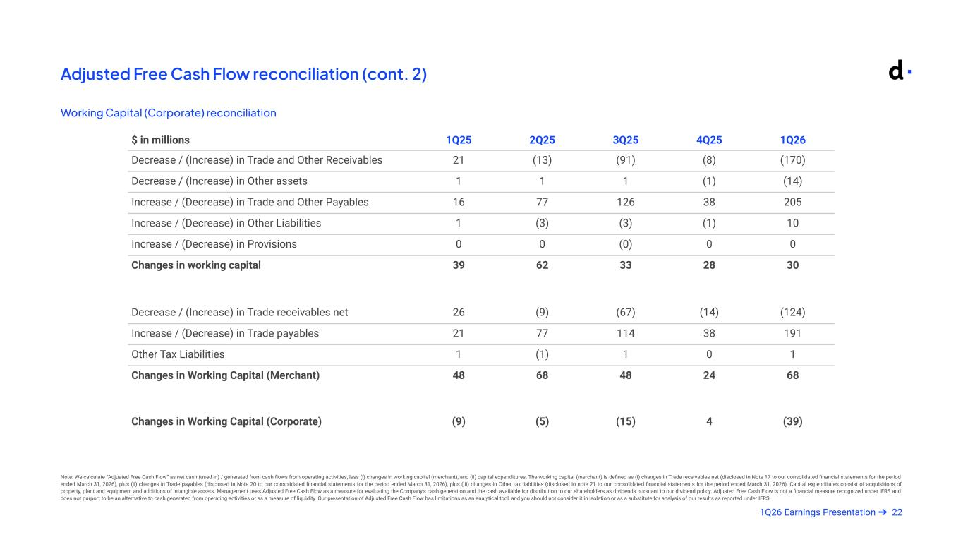
221Q26 Earnings Presentation ➔ Adjusted Free Cash Flow reconciliation (cont. 2) Working Capital (Corporate) reconciliation Note: We calculate “Adjusted Free Cash Flow” as net cash (used in) / generated from cash flows from operating activities, less (i) changes in working capital (merchant), and (ii) capital expenditures. The working capital (merchant) is defined as (i) changes in Trade receivables net (disclosed in Note 17 to our consolidated financial statements for the period ended March 31, 2026), plus (ii) changes in Trade payables (disclosed in Note 20 to our consolidated financial statements for the period ended March 31, 2026), plus (iii) changes in Other tax liabilities (disclosed in note 21 to our consolidated financial statements for the period ended March 31, 2026). Capital expenditures consist of acquisitions of property, plant and equipment and additions of intangible assets. Management uses Adjusted Free Cash Flow as a measure for evaluating the Company's cash generation and the cash available for distribution to our shareholders as dividends pursuant to our dividend policy. Adjusted Free Cash Flow is not a financial measure recognized under IFRS and does not purport to be an alternative to cash generated from operating activities or as a measure of liquidity. Our presentation of Adjusted Free Cash Flow has limitations as an analytical tool, and you should not consider it in isolation or as a substitute for analysis of our results as reported under IFRS. $ in millions 1Q25 2Q25 3Q25 4Q25 1Q26 Decrease / (Increase) in Trade and Other Receivables 21 (13) (91) (8) (170) Decrease / (Increase) in Other assets 1 1 1 (1) (14) Increase / (Decrease) in Trade and Other Payables 16 77 126 38 205 Increase / (Decrease) in Other Liabilities 1 (3) (3) (1) 10 Increase / (Decrease) in Provisions 0 0 (0) 0 0 Changes in working capital 39 62 33 28 30 Decrease / (Increase) in Trade receivables net 26 (9) (67) (14) (124) Increase / (Decrease) in Trade payables 21 77 114 38 191 Other Tax Liabilities 1 (1) 1 0 1 Changes in Working Capital (Merchant) 48 68 48 24 68 Changes in Working Capital (Corporate) (9) (5) (15) 4 (39) Armado May 7 @ 8pm

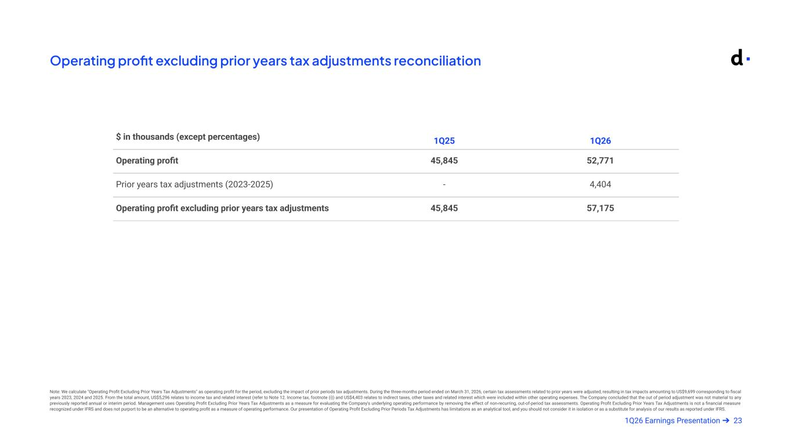
231Q26 Earnings Presentation ➔ Operating profit excluding prior years tax adjustments reconciliation Note: We calculate "Operating Profit Excluding Prior Years Tax Adjustments" as operating profit for the period, excluding the impact of prior periods tax adjustments. During the three-months period ended on March 31, 2026, certain tax assessments related to prior years were adjusted, resulting in tax impacts amounting to US$9,699 corresponding to fiscal years 2023, 2024 and 2025. From the total amount, US$5,296 relates to income tax and related interest (refer to Note 12. Income tax, footnote (i)) and US$4,403 relates to indirect taxes, other taxes and related interest which were included within other operating expenses. The Company concluded that the out of period adjustment was not material to any previously reported annual or interim period. Management uses Operating Profit Excluding Prior Years Tax Adjustments as a measure for evaluating the Company's underlying operating performance by removing the effect of non-recurring, out-of-period tax assessments. Operating Profit Excluding Prior Years Tax Adjustments is not a financial measure recognized under IFRS and does not purport to be an alternative to operating profit as a measure of operating performance. Our presentation of Operating Profit Excluding Prior Periods Tax Adjustments has limitations as an analytical tool, and you should not consider it in isolation or as a substitute for analysis of our results as reported under IFRS. $ in thousands (except percentages) 1Q25 1Q26 Operating profit 45,845 52,771 Prior years tax adjustments (2023-2025) - 4,404 Operating profit excluding prior years tax adjustments 45,845 57,175

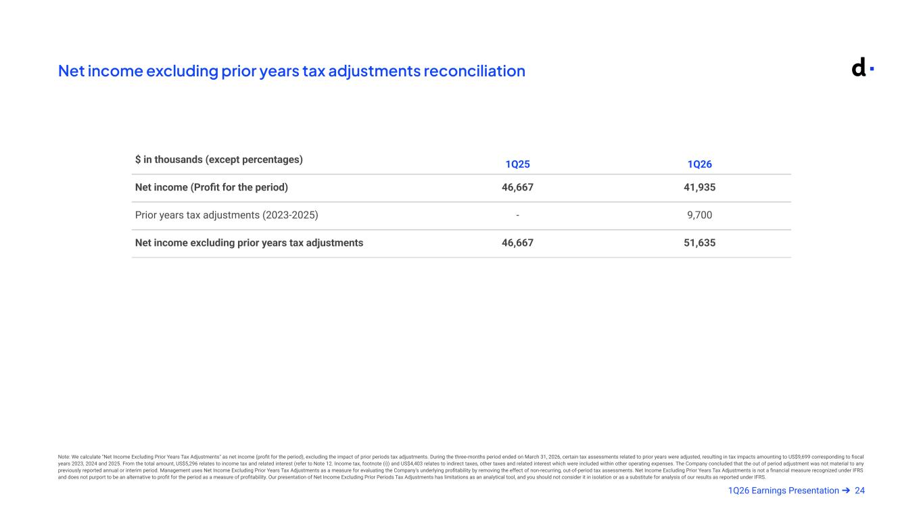
241Q26 Earnings Presentation ➔ Net income excluding prior years tax adjustments reconciliation $ in thousands (except percentages) 1Q25 1Q26 Net income (Profit for the period) 46,667 41,935 Prior years tax adjustments (2023-2025) - 9,700 Net income excluding prior years tax adjustments 46,667 51,635 Note: We calculate "Net Income Excluding Prior Years Tax Adjustments" as net income (profit for the period), excluding the impact of prior periods tax adjustments. During the three-months period ended on March 31, 2026, certain tax assessments related to prior years were adjusted, resulting in tax impacts amounting to US$9,699 corresponding to fiscal years 2023, 2024 and 2025. From the total amount, US$5,296 relates to income tax and related interest (refer to Note 12. Income tax, footnote (i)) and US$4,403 relates to indirect taxes, other taxes and related interest which were included within other operating expenses. The Company concluded that the out of period adjustment was not material to any previously reported annual or interim period. Management uses Net Income Excluding Prior Years Tax Adjustments as a measure for evaluating the Company's underlying profitability by removing the effect of non-recurring, out-of-period tax assessments. Net Income Excluding Prior Years Tax Adjustments is not a financial measure recognized under IFRS and does not purport to be an alternative to profit for the period as a measure of profitability. Our presentation of Net Income Excluding Prior Periods Tax Adjustments has limitations as an analytical tool, and you should not consider it in isolation or as a substitute for analysis of our results as reported under IFRS.

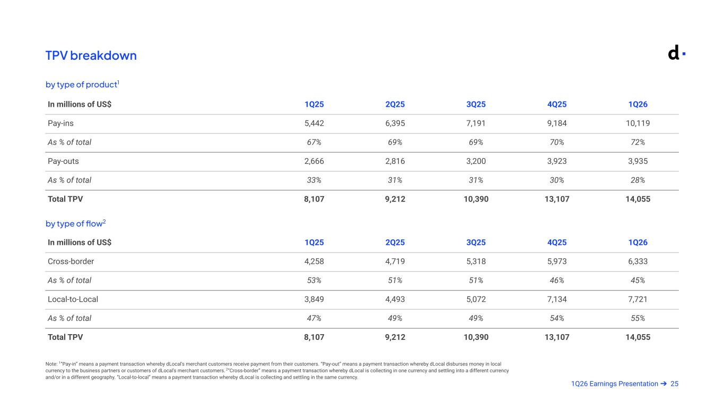
251Q26 Earnings Presentation ➔ TPV breakdown Note: 1”Pay-in” means a payment transaction whereby dLocal’s merchant customers receive payment from their customers. “Pay-out” means a payment transaction whereby dLocal disburses money in local currency to the business partners or customers of dLocal’s merchant customers. 2“Cross-border” means a payment transaction whereby dLocal is collecting in one currency and settling into a different currency and/or in a different geography. “Local-to-local” means a payment transaction whereby dLocal is collecting and settling in the same currency. by type of product1 by type of flow2 In millions of US$ 1Q25 2Q25 3Q25 4Q25 1Q26 Pay-ins 5,442 6,395 7,191 9,184 10,119 As % of total 67% 69% 69% 70% 72% Pay-outs 2,666 2,816 3,200 3,923 3,935 As % of total 33% 31% 31% 30% 28% Total TPV 8,107 9,212 10,390 13,107 14,055 In millions of US$ 1Q25 2Q25 3Q25 4Q25 1Q26 Cross-border 4,258 4,719 5,318 5,973 6,333 As % of total 53% 51% 51% 46% 45% Local-to-Local 3,849 4,493 5,072 7,134 7,721 As % of total 47% 49% 49% 54% 55% Total TPV 8,107 9,212 10,390 13,107 14,055

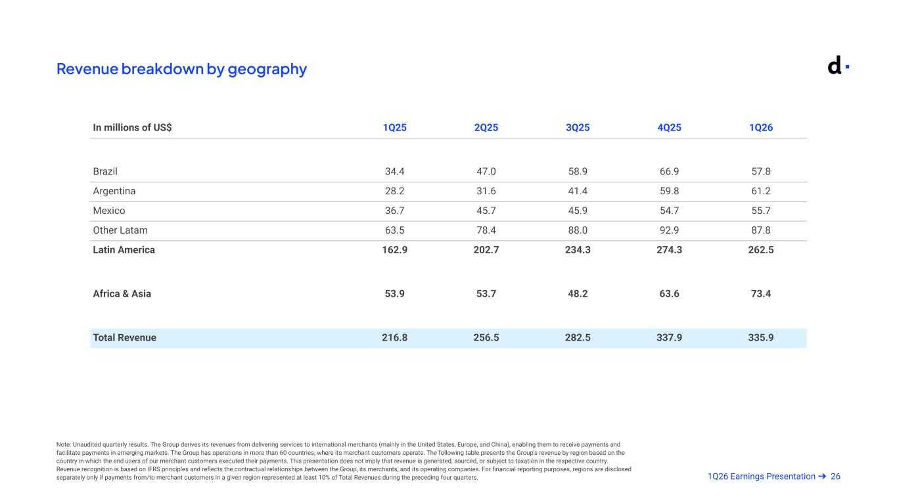
261Q26 Earnings Presentation ➔ Revenue breakdown by geography Note: Unaudited quarterly results. The Group derives its revenues from delivering services to international merchants (mainly in the United States, Europe, and China), enabling them to receive payments and facilitate payments in emerging markets. The Group has operations in more than 60 countries, where its merchant customers operate. The following table presents the Group’s revenue by region based on the country in which the end users of our merchant customers executed their payments. This presentation does not imply that revenue is generated, sourced, or subject to taxation in the respective country. Revenue recognition is based on IFRS principles and reflects the contractual relationships between the Group, its merchants, and its operating companies. For financial reporting purposes, regions are disclosed separately only if payments from/to merchant customers in a given region represented at least 10% of Total Revenues during the preceding four quarters. Armado May 7 @ 8pm In millions of US$ 1Q25 2Q25 3Q25 4Q25 1Q26 Brazil 34.4 47.0 58.9 66.9 57.8 Argentina 28.2 31.6 41.4 59.8 61.2 Mexico 36.7 45.7 45.9 54.7 55.7 Other Latam 63.5 78.4 88.0 92.9 87.8 Latin America 162.9 202.7 234.3 274.3 262.5 Africa & Asia 53.9 53.7 48.2 63.6 73.4 Total Revenue 216.8 256.5 282.5 337.9 335.9

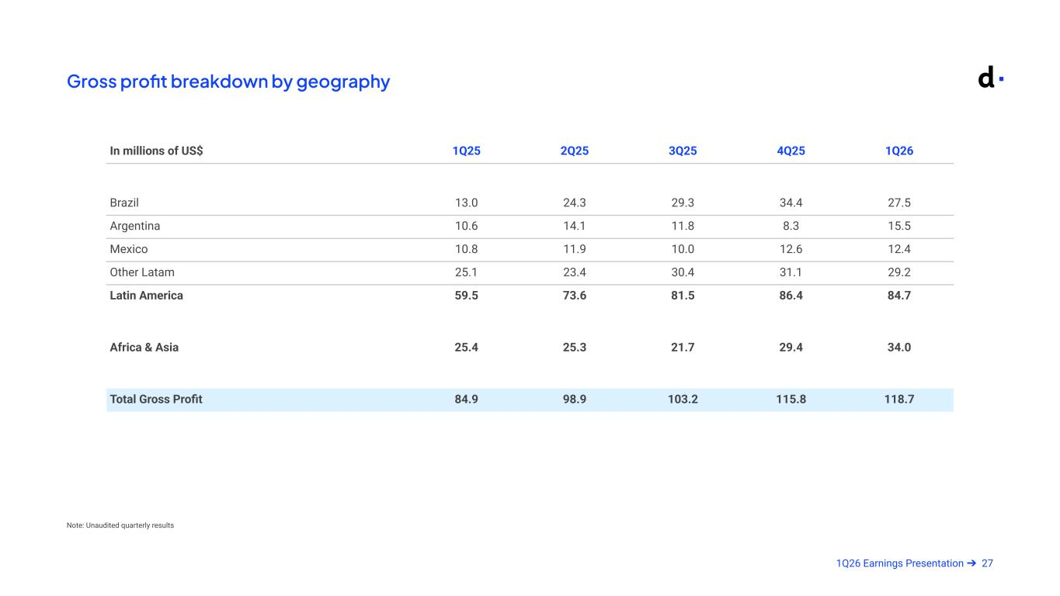
271Q26 Earnings Presentation ➔ Gross profit breakdown by geography Note: Unaudited quarterly results Armado May 7 @ 8pm In millions of US$ 1Q25 2Q25 3Q25 4Q25 1Q26 Brazil 13.0 24.3 29.3 34.4 27.5 Argentina 10.6 14.1 11.8 8.3 15.5 Mexico 10.8 11.9 10.0 12.6 12.4 Other Latam 25.1 23.4 30.4 31.1 29.2 Latin America 59.5 73.6 81.5 86.4 84.7 Africa & Asia 25.4 25.3 21.7 29.4 34.0 Total Gross Profit 84.9 98.9 103.2 115.8 118.7

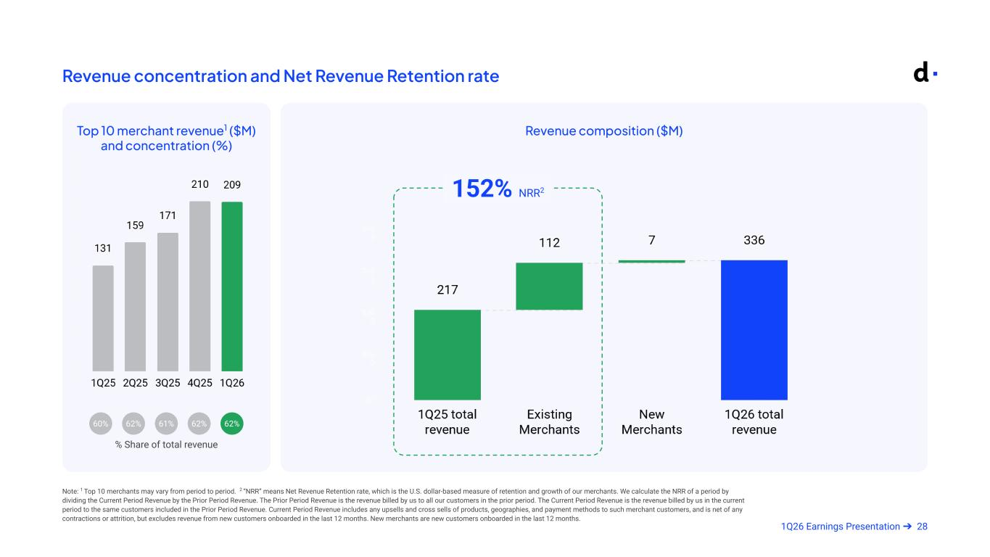
281Q26 Earnings Presentation ➔ Revenue concentration and Net Revenue Retention rate Note: 1 Top 10 merchants may vary from period to period. 2 “NRR” means Net Revenue Retention rate, which is the U.S. dollar-based measure of retention and growth of our merchants. We calculate the NRR of a period by dividing the Current Period Revenue by the Prior Period Revenue. The Prior Period Revenue is the revenue billed by us to all our customers in the prior period. The Current Period Revenue is the revenue billed by us in the current period to the same customers included in the Prior Period Revenue. Current Period Revenue includes any upsells and cross sells of products, geographies, and payment methods to such merchant customers, and is net of any contractions or attrition, but excludes revenue from new customers onboarded in the last 12 months. New merchants are new customers onboarded in the last 12 months. Top 10 merchant revenue1 ($M) and concentration (%) Revenue composition ($M) % Share of total revenue 62%62%60% 62% 61% 152% NRR2 Armado May 7 @ 8pm

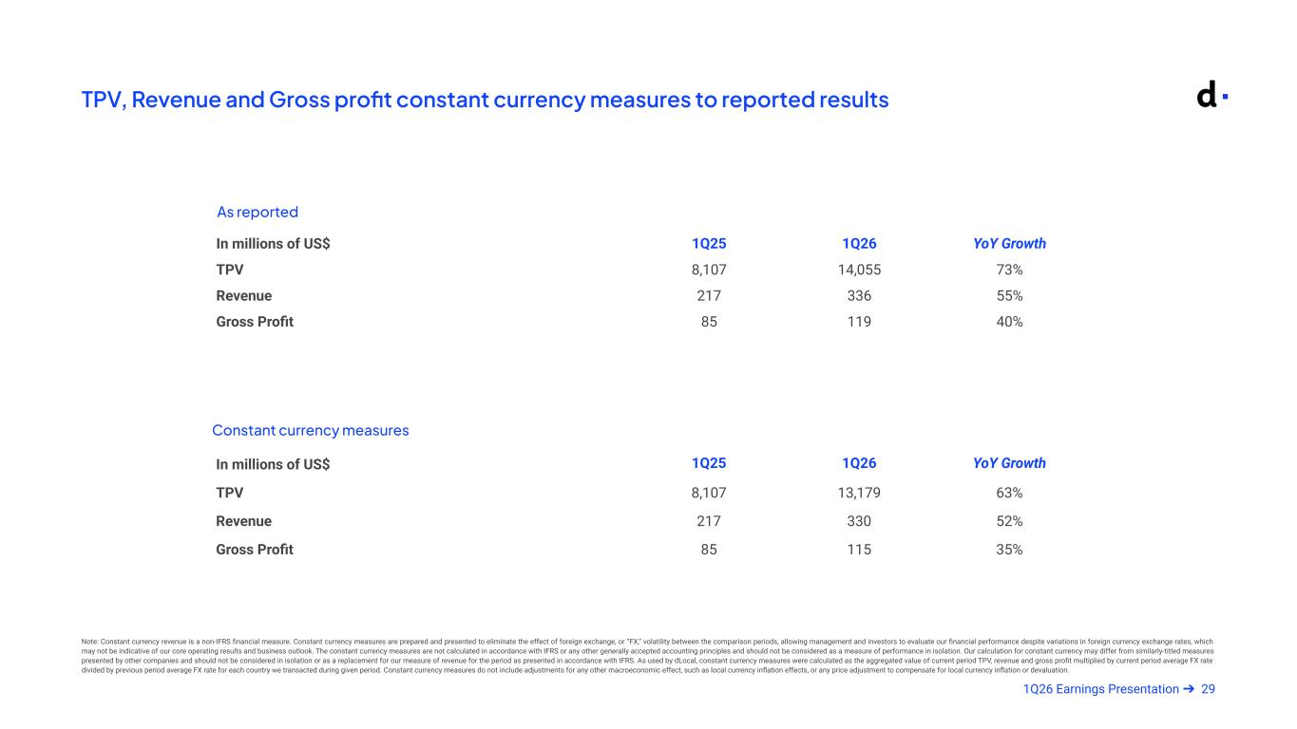
291Q26 Earnings Presentation ➔ TPV, Revenue and Gross profit constant currency measures to reported results As reported Constant currency measures Note: Constant currency revenue is a non-IFRS financial measure. Constant currency measures are prepared and presented to eliminate the effect of foreign exchange, or “FX,” volatility between the comparison periods, allowing management and investors to evaluate our financial performance despite variations in foreign currency exchange rates, which may not be indicative of our core operating results and business outlook. The constant currency measures are not calculated in accordance with IFRS or any other generally accepted accounting principles and should not be considered as a measure of performance in isolation. Our calculation for constant currency may differ from similarly-titled measures presented by other companies and should not be considered in isolation or as a replacement for our measure of revenue for the period as presented in accordance with IFRS. As used by dLocal, constant currency measures were calculated as the aggregated value of current period TPV, revenue and gross profit multiplied by current period average FX rate divided by previous period average FX rate for each country we transacted during given period. Constant currency measures do not include adjustments for any other macroeconomic effect, such as local currency inflation effects, or any price adjustment to compensate for local currency inflation or devaluation. In millions of US$ 1Q25 1Q26 YoY Growth TPV 8,107 14,055 73% Revenue 217 336 55% Gross Profit 85 119 40% In millions of US$ 1Q25 1Q26 YoY Growth TPV 8,107 13,179 63% Revenue 217 330 52% Gross Profit 85 115 35%

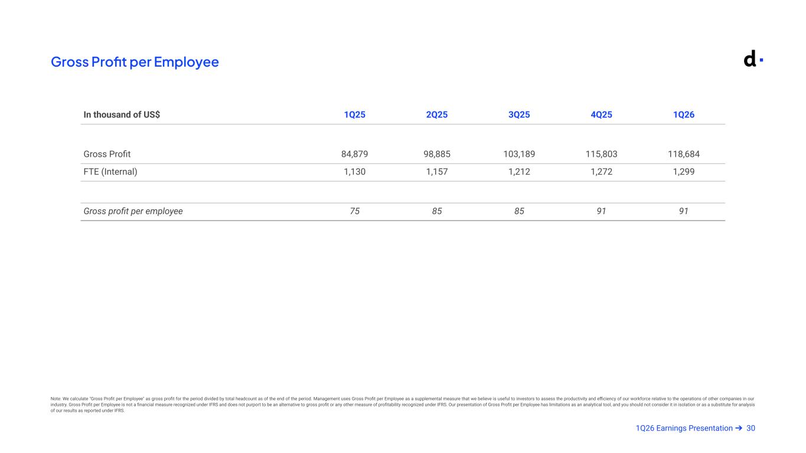
301Q26 Earnings Presentation ➔ Gross Profit per Employee Note: We calculate "Gross Profit per Employee" as gross profit for the period divided by total headcount as of the end of the period. Management uses Gross Profit per Employee as a supplemental measure that we believe is useful to investors to assess the productivity and efficiency of our workforce relative to the operations of other companies in our industry. Gross Profit per Employee is not a financial measure recognized under IFRS and does not purport to be an alternative to gross profit or any other measure of profitability recognized under IFRS. Our presentation of Gross Profit per Employee has limitations as an analytical tool, and you should not consider it in isolation or as a substitute for analysis of our results as reported under IFRS. Armado May 7 @ 8pm In thousand of US$ 1Q25 2Q25 3Q25 4Q25 1Q26 Gross Profit 84,879 98,885 103,189 115,803 118,684 FTE (Internal) 1,130 1,157 1,212 1,272 1,299 Gross profit per employee 75 85 85 91 91

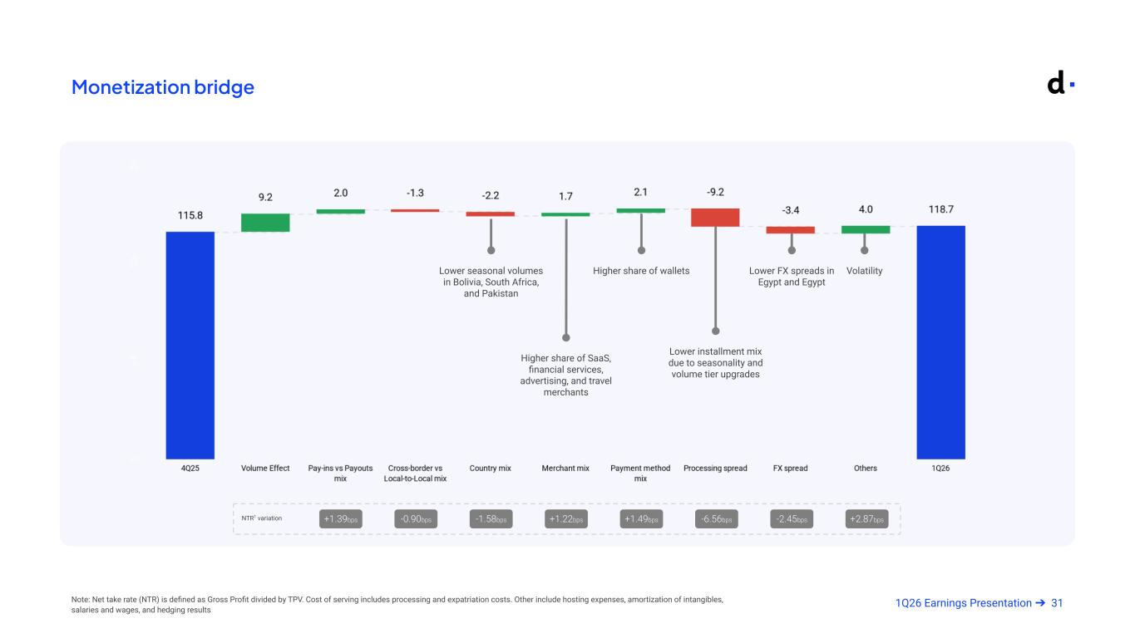
311Q26 Earnings Presentation ➔Note: Net take rate (NTR) is defined as Gross Profit divided by TPV. Cost of serving includes processing and expatriation costs. Other include hosting expenses, amortization of intangibles, salaries and wages, and hedging results Monetization bridge +1.39bps -1.58bps +1.22bps +1.49bps -6.56bps -2.45bps +2.87bpsNTR1 variation -0.90bps Lower FX spreads in Egypt and Egypt Lower seasonal volumes in Bolivia, South Africa, and Pakistan Higher share of SaaS, financial services, advertising, and travel merchants Higher share of wallets Lower installment mix due to seasonality and volume tier upgrades Volatility

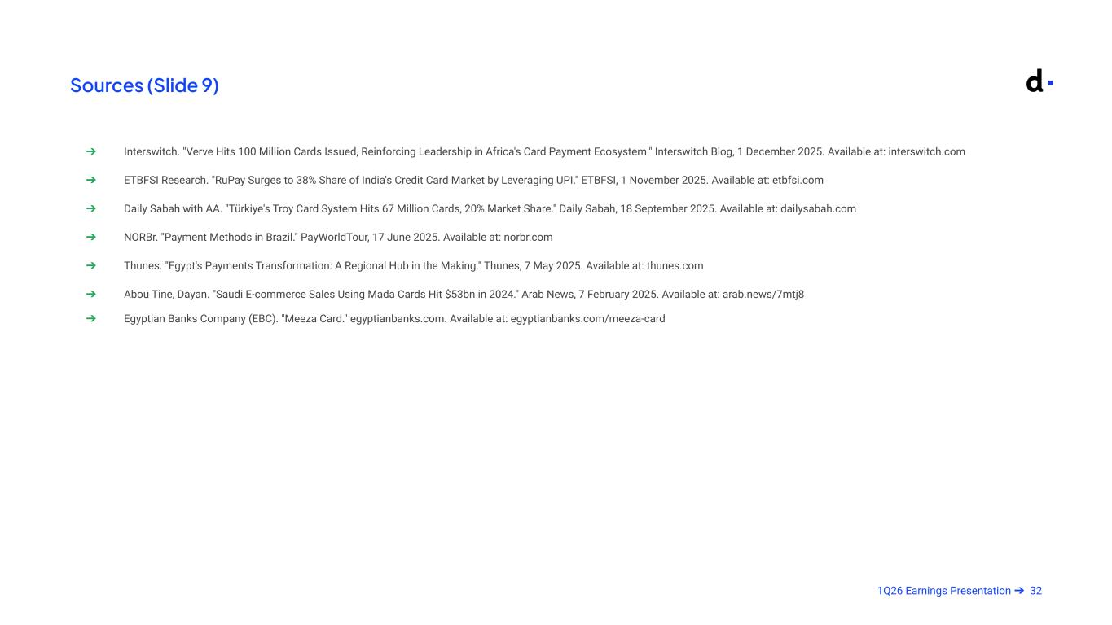
321Q26 Earnings Presentation ➔ Sources (Slide 9) ➔ Interswitch. "Verve Hits 100 Million Cards Issued, Reinforcing Leadership in Africa's Card Payment Ecosystem." Interswitch Blog, 1 December 2025. Available at: interswitch.com ➔ ETBFSI Research. "RuPay Surges to 38% Share of India's Credit Card Market by Leveraging UPI." ETBFSI, 1 November 2025. Available at: etbfsi.com ➔ Daily Sabah with AA. "Türkiye's Troy Card System Hits 67 Million Cards, 20% Market Share." Daily Sabah, 18 September 2025. Available at: dailysabah.com ➔ NORBr. "Payment Methods in Brazil." PayWorldTour, 17 June 2025. Available at: norbr.com ➔ Thunes. "Egypt's Payments Transformation: A Regional Hub in the Making." Thunes, 7 May 2025. Available at: thunes.com ➔ Abou Tine, Dayan. "Saudi E-commerce Sales Using Mada Cards Hit $53bn in 2024." Arab News, 7 February 2025. Available at: arab.news/7mtj8 ➔ Egyptian Banks Company (EBC). "Meeza Card." egyptianbanks.com. Available at: egyptianbanks.com/meeza-card


Investor Relations Contact investor@dlocal.com Media Contact media@dlocal.com This presentation does not contain sufficient information to constitute an interim financial report as defined in International Accounting Standards 34, “Interim Financial Reporting” nor a financial statement as defined by International Accounting Standards 1 “Presentation of Financial Statements”. The first quarter financial information in this press release has not been audited nor has it been subject to any limited review procedures, whereas the annual results for the year ended December 31, 2025 are audited.

