UNITED STATES

SECURITIES AND EXCHANGE COMMISSION

Washington, D.C. 20549

FORM 6-K

REPORT OF FOREIGN PRIVATE ISSUER

PURSUANT TO RULE 13a-16 OR 15d-16
UNDER THE SECURITIES EXCHANGE ACT OF 1934

For the month of November 2022

Commission File Number: 001-40451

DLocal Limited

(Exact name of registrant as specified in its charter)

Dr. Luis Bonavita 1294

Montevideo
Uruguay 11300
+1 (424) 392-7437

(Address of principal executive office)

Indicate by check mark whether the registrant files or will file annual reports under cover of Form 20-F or Form 40-F:

Form 20-F ☒ Form 40-F ☐

Indicate by check mark if the registrant is submitting the Form 6-K in paper as permitted by Regulation S-T Rule 101(b)(1):

Yes ☐ No ☒

Indicate by check mark if the registrant is submitting the Form 6-K in paper as permitted by Regulation S-T Rule 101(b)(7):

Yes ☐ No ☒

TABLE OF CONTENTS

EXHIBIT

99.1 Press release dated November 14, 2022 - DLocal Limited Reports 2022 Third Quarter Results

99.2 DLocal Limited Unaudited Consolidated Condensed Interim Financial Statements as of September 30, 2022 and for the nine-month and three-month periods ended September 30, 2022 and 2021

99.3 Quaterly Report 2022 - dLocal Reports 2022 Third Quarter Financial results

99.4 dLocal Q3 2022 Earnings Presentation

SIGNATURE

Pursuant to the requirements of the Securities Exchange Act of 1934, the registrant has duly caused this report to be signed on its behalf by the undersigned, thereunto duly authorized.

DLocal Limited

By: | /s/ Diego Cabrera Canay
Name: | Diego Cabrera Canay
Title: | Chief Financial Officer

Date: November 15, 2022

Exhibit 99.1


dLocal Limited Reports 2022 Third Quarter Financial Results

Third Quarter 2022

US$2.7 billion Total Payment Volume, up 51% year-over-year
Revenues of US$112 million, up 63% year-over-year
152% Net Revenue Retention Rate

37% Adjusted EBITDA Margin

dLocal reports in US dollars and in accordance with IFRS as issued by the IASB

Montevideo, Uruguay November 14, 2022 — DLocal Limited (“dLocal”, “we”, “us”, and “our”) (NASDAQ:DLO), a technology- first payments platform, announced its financial results today for the third quarter ended September 30, 2022.

“We delivered another quarter of record results, reaching U$2.7 billion in TPV and US$112 million in revenues. We saw robust growth in TPV increasing by 51% and revenues further accelerating 63% year-over-year, despite the high comparison base from last year, and both metrics increasing by 12% and 11%, respectively, quarter-over-quarter. The growth has been supported by our disciplined execution and lean culture, in addition to our business strength of continuous diversification across verticals, regions, and products. Throughout recent quarters, we have been committed to growing outside Latin America, and we are very pleased to announce the impressive results we reached in Q3 2022. Revenues from Africa and Asia increased by four times year-over-year and 80% quarter-over-quarter, reaching US$25 million. These strong results over just a three-month period surpassed the US$21 million recorded in the entire twelve months of 2021. In Q3 2022, Africa and Asia revenues already contributed to 22% of our total revenues, which is a proven record that our strategic decision making is paying off.

We continue to deliver on our strategy of maximizing gross profit and EBITDA dollars. During the third quarter, gross profit increased to US$54 million, up by 56% year-over-year, whereas Adjusted EBITDA was up by 58% year-over-year to US$42 million. Both metrics increased by 9% quarter-over-quarter. This was reflected in a solid adjusted EBITDA margin of 37%, in line with the 38% recorded in the past four quarters, while we continue to invest in our business with discipline by increasing our headcount 34% year-over-year to 712 employees.

We continue to drive our expansion across emerging markets, launching operations in two new countries, Nicaragua and Saudi Arabia, bringing the total number of countries in which we operate to 39, as we balance the expansion of our operations into new countries with strengthening our presence in existing markets.

Our track record of disciplined, high profitable growth and our strong balance sheet, give us confidence that we are uniquely positioned to fulfill our long-term growth strategy while navigating a challenging global macro environment. We will seek to continue building the best financial infrastructure across multiple emerging markets for our merchants through the One dLocal model: one contract, one single platform, and one API,” said Sebastian Kanovich.

Third Quarter 2022 Financial Highlights

- Total Payment Volume (“TPV”) reached US$2.7 billion in the quarter, representing 51% year-over-year growth compared to US$1.8 billion in the third quarter of 2021 and 12% growth compared to $2.4 billion in the second quarter of 2022.

- Revenues in the third quarter of 2022 amounted to US$111.9 million, up 63% year-over-year compared to US$68.6 million in the third quarter of 2021 and up 11% compared to $101.2 million in the second quarter of 2022.

- Gross profit was US$53.9 million in the third quarter of 2022, up 56% year-over-year compared to US$34.4 million in the third quarter of 2021 and up 9% compared to US$49.6 million in the second quarter of 2022.

- Gross profit margin was 48% in the third quarter of 2022, compared to 49% in the second quarter of 2022 and 50% in the third quarter of 2021. The slight decrease in gross margin is mainly attributable to country mix and product mix.

- Adjusted EBITDA was US$41.6 million in the third quarter of 2022, up 58% year-over-year compared to US$26.3 million in the third quarter of 2021 and up 9% compared to US$38.2 million in the second quarter of 2022.

- Adjusted EBITDA margin was 37% in the third quarter of 2022, compared to 38% in both the third quarter of 2021 and the second quarter of 2022.

- Profit for the third quarter of 2022 was US$32.3 million, or US$0.10 per diluted share, up 64% compared to a profit of US$19.7 million, or US$0.06 per diluted share, for the third quarter of 2021 and up 5% compared to a profit of US$30.7 million, or US$0.10 per diluted share, for the second quarter of 2022. Profit for the third quarter of 2022 included higher net financial losses of US$2.5 million, mainly driven by higher cost of hedges, as a result of adapting to changes in FX regulations, in addition to higher interest rates.

- As of September 30, 2022, dLocal had US$542.3 million in cash, cash equivalents and marketable securities, compared to US$454.0 million as of June 30, 2022 and US$293.1 million as of September 30, 2021. The quarter-over-quarter increase of US$88.3 million reflects an increase of US$49.8 million in our funds and an increase of US$38.5 million in merchants’ funds with respect to the second quarter of 2022.

The following table summarizes our key performance metrics:

 | Three months ended |  |  | Nine months ended
 | September 30, | September 30, |  | September 30, | September 30,
 | 2022 | 2021 | 2022 |  | 2021
 |  | (in millions of US$ except for %)
Key Performance Metrics
TPV | 2,734 | 1,812 | 7,271 |  | 4,193
TPV growth YoY | 51% | 217% | 73% |  | 221%
Revenue | 111.9 | 68.6 | 300.5 |  | 167.9
Revenue growth YoY | 63% | 123% | 79% |  | 142%
Adj. EBITDA | 41.6 | 26.3 | 112.7 |  | 70.1
Adj. EBITDA Margin | 37% | 38% | 37% |  | 42%

Third quarter 2022 Business Highlights

- dLocal is well diversified across verticals, so its business does not depend on the performance of any single industry vertical. During the third quarter of 2022, dLocal saw strong year-over-year and quarter-over-quarter growth in TPV driven by the performance and continued growth of its merchants across most verticals, particularly in commerce, on-demand delivery, travel, SaaS (“software as a service”), advertising and financial services.

- dLocal is also well diversified across geographies. In Q3 2022 dLocal continued to focus on its expansion efforts and added Nicaragua and Saudi Arabia to its geographic network, bringing the total number of countries in which dLocal operates to 39, out of which 23 countries are outside Latin America.

- Revenue increased across all regions during the quarter. LatAm grew 39% compared to the third quarter of 2021 to US$87.3 million, while flat quarter-over-quarter, accounting for 78% of total revenue. If we exclude Argentina’s cross-border business, where the market faced some limitations imposed by the Argentine Central Bank to access the foreign exchange market for the payment of certain imports of goods and services, LatAm revenue increased by 43% year-over-year and 7% quarter-over-quarter. Asia & Africa revenue increased by 312% year-over-year and 80% quarter-over-quarter to US$24.5 million, accounting for the remaining 22% (compared to 9% of total revenue in the third quarter of 2021).

- During the quarter, dLocal continued delivering strong revenue growth both from existing and from new customers. Revenue from Existing Merchants increased by US$35.1 million in the third quarter of 2022 to US$104.1 million. The net revenue retention rate, or NRR, in the third quarter of 2022 reached 152%. Revenue from New Merchants was US$7.8 million for the third quarter of 2022.

Special Note Regarding Adjusted EBITDA and Adjusted EBITDA Margin

dLocal has only one operating segment. dLocal measures its operating segment’s performance by Revenues, Adjusted EBITDA and Adjusted EBITDA Margin, and uses these metrics to make decisions about allocating resources.

Adjusted EBITDA as used by dLocal is defined as the profit from operations before financing and taxation for the year or period, as applicable, before depreciation of property, plant and equipment, amortization of right-of-use assets and intangible assets, and further excluding the changes in fair value of financial assets and derivative instruments carried at fair value through profit or loss, impairment gains/(losses) on financial assets, transaction costs, share-based payment non-cash charges, secondary offering expenses, and inflation adjustment. dLocal defines Adjusted EBITDA Margin as the Adjusted EBITDA divided by consolidated revenues.

Although Adjusted EBITDA and Adjusted EBITDA Margin may be commonly viewed as non-IFRS measures in other contexts, pursuant to IFRS 8, (“Operating Segments”), Adjusted EBITDA and Adjusted EBITDA Margin are treated by dLocal as IFRS measures based on the manner in which dLocal utilizes these measures. Nevertheless, dLocal’s Adjusted EBITDA and Adjusted EBITDA Margin metrics should not be viewed in isolation or as a substitute for net income for the periods presented under IFRS. dLocal also believes that its Adjusted EBITDA and Adjusted EBITDA Margin metrics are useful metrics used by analysts and investors, although these measures are not explicitly defined under IFRS. Additionally, the way dLocal calculates operating segment’s performance measures may be different from the calculations used by other entities, including competitors, and therefore, dLocal’s performance measures may not be comparable to those of other

entities.

The table below presents a reconciliation of dLocal’s Adjusted EBITDA and Adjusted EBITDA Margin to net income:

In thousands of US$ except for % | Three-months ended September 30 |  |  | Nine-months ended
In thousands of US$ except for % |  |  |  | September 30
 | 2022 | 2021 | 2022 |  | 2021
Profit for the period | 32,338 | 19,669 | 89,333 |  | 54,304

Income tax expense | 2,287 | 2,558
Depreciation and amortization | 2,110 | 1,381
Finance income and costs, net | 2,479 | (865)
Share-based payment non-cash charges | 1,599 | 2,673
Other operating loss/(gain) | 18 | —
Secondary offering expenses¹ | — | 695
Transaction costs | — | 211
Other charges, net | 791 | (3)
Adjusted EBITDA | 41,622 | 26,319
Revenues | 111,864 | 68,646
Adjusted EBITDA | 41,622 | 26,319
Adjusted EBITDA Margin | 37.2% | 38.3%

7,651 | 5,533
5,690 | 3,240
3,519 | (762)
4,874 | 5,354
706 | (2,896)
89 | 4,442

—665

- 205

112,66170,085

300,497 167,863

112,661 70,085

37.5% 41.8%

- Secondary expenses for the nine-months ended September 30, 2022 corresponds to expenses assumed by dLocal in relation to the secondary offering of its shares occurred in 2021.

Earnings per share:

We calculate basic earnings per share by dividing the profit attributable to equity holders by the weighted average number of common shares issued and outstanding during the three-months and nine-months periods ended September 30, 2022 and 2021.

Our diluted earnings per share is calculated by dividing the profit attributable to equity holders of dLocal by the weighted average number of common shares outstanding during the period plus the weighted average number of common shares that would be issued on conversion of all dilutive potential common shares into common shares.

The following table presents the information used as basis for the calculation of our earnings per share:

 | For the three-month period ended |  |  |  |  | For the nine-month period ended
 | September 30 |  |  |  |  | September 30
 | 2022 |  |  | 2021 | 2022 |  | 2021
Profit attributable to common shareholders (U.S. | 32,461,922 |  |  | 19,663,000 | 89,325,969 |  | 54,291,000
Dollars)
Weighted average number of common shares | 295,918,751 |  |  | 293,558,997 | 295,455,429 |  | 284,456,779
Adjustments for calculation of diluted earnings | 17,246,606 |  |  | 19,646,000 | 17,783,776 |  | 19,609,500
per share
Weighted average number of common shares for | 313,165,357 |  |  | 313,204,997 | 313,239,205 |  | 304,066,279
calculating diluted earnings per share
Basic earnings per share | 0.11 |  |  | 0.07 | 0.30 |  | 0.19
Diluted earnings per share | 0.10 |  |  | 0.06 | 0.29 |  | 0.18

This press release does not contain sufficient information to constitute an interim financial report as defined in International Accounting Standards 34, “Interim Financial Reporting” nor a financial statement as defined by International Accounting Standards 1 “Presentation of Financial Statements”. The financial information in this press release has not been audited.

Conference Call and Webcast

dLocal’s management team will host a conference call and audio webcast on November 15, 2022 at 8:30 a.m. Eastern Time. Please click here to pre-register for the conference call and obtain your dial in number and passcode.

The live conference call can be accessed via audio webcast at the investor relations section of dLocal’s website, at https://investor.dlocal.com/. An archive of the webcast will be available for a year following the conclusion of the conference call. The investor presentation will also be filed on EDGAR at www.sec.gov.

About dLocal

dLocal powers local payments in emerging markets, connecting global enterprise merchants with billions of emerging market consumers in 39 countries across APAC, the Middle East, Latin America, and Africa. Through the “One dLocal” platform (one direct API, one platform, and one contract), global companies can accept payments, send pay-outs and settle funds globally without the need to manage separate pay-in and pay-out processors, set up numerous local entities, and integrate multiple acquirers and payment methods in each market.

Definition of Selected Operational Metrics

“API” means application programming interface, which is a general term for programming techniques that are available for software developers when they integrate with a particular service or application. In the payments industry, APIs are usually provided by any party participating in the money flow (such as payment gateways, processors, and service providers) to facilitate the money transfer process.

“Enterprise Global Merchants” means merchants with at least US$6 million of annual TPV processed through our platform.

“Local payment methods” refers to any payment method that is processed in the country where the end user of the merchant sending or receiving payments is located, which include credit and debit cards, cash payments, bank transfers, mobile money, and digital wallets.

“NRR” means net revenue retention rate, which is the U.S. dollar-based measure of retention and growth of our merchants. We calculate the NRR of a period by dividing the current period revenue by the prior period revenue. The prior period revenue is the revenue billed by us to all of our merchant customers in the corresponding period for the prior fiscal year. The current period revenue is the revenue billed by us in the corresponding period for the current fiscal year to the same merchant customers included in the calculation of the prior period revenue. Current period revenue includes any upsells and cross sells of products, geographies, and payment methods to such merchant customers, and is net of any contractions or attrition, but excludes revenue from new customers on-boarded during the last 12 months.

“Pay-in” means a payment transaction whereby dLocal’s merchant customers receive payment from their customers.

“Pay-out” means a payment transaction whereby dLocal disburses money in local currency to the business partners or customers of dLocal’s merchant customers.

“Revenue from New Merchants” means the revenue billed by us to merchant customers that we did not bill revenues in the same quarter (or period) of the prior year.

“Revenue from Existing Merchants” means the revenue billed by us in the last twelve months to the merchant customers that we billed revenue in the same quarter (or period) of the prior year.

Forward Looking Statements

This press release contains certain forward-looking statements. These forward-looking statements convey dLocal’s current expectations or forecasts of future events. Forward-looking statements regarding dLocal involve known and unknown risks, uncertainties and other factors that may cause dLocal’s actual results, performance or achievements to be materially different from any future results, performances or achievements expressed or implied by the forward-looking statements. Certain of these risks and uncertainties are described in the “Risk Factors,” “Forward-Looking Statements” and “Cautionary Statement Regarding Forward-Looking Statements” sections of dLocal’s filings with the U.S. Securities and Exchange Commission. Unless required by law, dLocal undertakes no obligation to publicly update or revise any forward-looking statements to reflect circumstances or events after the date hereof.

DLocal Limited

Certain interim financial information

Consolidated Condensed Interim Statements of Comprehensive Income for the three-month and nine-month periods ended September 30, 2022 and 2021

(In thousands of U.S. dollars, except per share amounts, unaudited)

 | Three months ended |  |  |  | Nine months ended
 | September 30, |  | September 30, |  | September 30, |  | September 30,
 | 2022 |  | 2021 |  | 2022 |  | 2021
Continuing operations
Revenues | 111,864 |  | 68,646 |  | 300,497 |  | 167,863
Cost of services | (57,992 ) |  | (34,202 ) |  | (153,432 ) |  | (76,361 )
Gross profit | 53,872 |  | 34,444 |  | 147,065 |  | 91,502
Technology and development expenses | (1,692 | ) | (1,116 | ) | (4,741 | ) | (2,232 | )
Sales and marketing expenses | (3,472 ) |  | (1,255 ) |  | (9,444 ) |  | (3,424 )
General and administrative expenses | (11,483 ) |  | (10,887 ) |  | (30,872 ) |  | (30,080 )
Impairment gain/(loss) on financial assets | 24 |  | 159 |  | 106 |  | (8 )
Other operating (loss)/gain | (18 ) |  | 224 |  | (706 ) |  | 3,514
Operating profit | 37,231 |  | 21,569 |  | 101,408 |  | 59,272
Finance income | 6,810 |  | 1,089 |  | 12,346 |  | 1,273
Finance costs | (9,289 ) |  | (275 ) |  | (15,865 ) |  | (511 )
Inflation adjustment | (127 ) |  | (156 ) |  | (905 ) |  | (197 )
Other results | (2,606 ) |  | 658 |  | (4,424 ) |  | 565
Profit before income tax | 34,625 |  | 22,227 |  | 96,984 |  | 59,837
Income tax expense | (2,287 ) |  | (2,558 ) |  | (7,651 ) |  | (5,533 )
Profit for the period | 32,338 |  | 19,669 |  | 89,333 |  | 54,304
Profit attributable to:
Owners of the Group | 32,462 |  | 19,663 |  | 89,326 |  | 54,291
Non-controlling interest | (124 ) |  | 6 |  | 7 |  | 13
Profit for the period | 32,338 |  | 19,669 |  | 89,333 |  | 54,304
Earnings per share
Basic Earnings per share | 0.11 |  | 0.07 |  | 0.30 |  | 0.19
Diluted Earnings per share | 0.10 |  | 0.06 |  | 0.29 |  | 0.18
Other comprehensive Income
Items that may be reclassified to profit or loss:
Exchange difference on translation on foreign operations | (405 ) |  | (391 ) |  | (488 ) |  | 477
Other comprehensive income for the period, net of tax | (405 ) |  | (391 ) |  | (488 ) |  | 477
Total comprehensive income for the period | 31,933 |  | 19,278 |  | 88,845 |  | 54,781
Total comprehensive income for the period is attributable to:
Owners of the Group | 32,057 |  | 19,252 |  | 88,838 |  | 54,759
Non-controlling interest | (124 ) |  | 26 |  | 7 |  | 22
Total comprehensive income for the period | 31,933 |  | 19,278 |  | 88,845 |  | 54,781

DLocal Limited

Certain interim financial information

Consolidated Condensed Interim Statements of Financial Position as of September 30, 2022 and December 31, 2021 (In thousands of U.S. dollars, except per share amounts, unaudited)

 | September 30, 2022 |  | December 31, 2021
ASSETS
Current Assets
Cash and cash equivalents | 542,298 | 336,197
Financial assets at fair value through profit or loss | 1,065 | 1,004
Trade and other receivables | 228,895 | 190,966
Derivative financial instruments | 657 |  | —
Other assets | 3,937 |  | 1,339
Total Current Assets | 776,852 | 529,506
Non-Current Assets
Deferred tax assets | 1,101 | 133
Property, plant and equipment | 2,814 | 2,485
Right-of-use assets | 3,938 | 3,915
Intangible assets | 49,875 |  | 46,969
Total Non-Current Assets | 57,728 | 53,502
TOTAL ASSETS | 834,580 |  | 583,008
LIABILITIES
Current Liabilities
Trade and other payables | 423,606 | 277,160
Borrowings | 14,782 | 5,014
Lease liabilities | 625 | 502
Tax liabilities | 11,885 | 13,126
Derivative financial instruments | 446 | 221
Provisions | 1,540 | 1,710
Contingent consideration liability | — | 665
Total Current Liabilities | 452,884 |  | 298,398
Non-Current Liabilities
Deferred tax liabilities | 503 | 883
Lease liabilities | 3,449 | 3,426
Total Non-Current Liabilities | 3,952 |  | 4,309
TOTAL LIABILITIES | 456,836 | 302,707
EQUITY
Share Capital | 592 | 590
Share Premium | 165,318 | 157,151
Capital Reserve | 13,170 | 12,741
Other Reserves | (1,785) | (30)
Retained earnings | 200,460 | 109,867
Total Equity Attributable to owners of the Group | 377,755 |  | 280,319
Non-controlling interest | (11) | (18)
TOTAL EQUITY | 377,744 |  | 280,301

dLocal was incorporated on February 10, 2021, as a Cayman Islands exempted company with limited liability, duly registered with the Cayman Islands Registrar of

Companies. The contribution of dLocal Group Limited (a limited liability company incorporated in Malta, the former holding entity or “dLocal Malta”) shares to dLocal has been finalized as of April 14, 2021. Until the contribution of dLocal Malta shares to it, dLocal had not commenced operations, consequently the historical information previous to that date presented in here corresponds to dLocal Malta, our predecessor. This reorganization was done, among other things, to facilitate the initial public offering of the Group. dLocal had no prior assets, holdings or operations.

Investor Relations Contact:

investor@dlocal.com

Media Contact:

marketing@dlocal.com

Exhibit 99.2

DLocal Limited

Unaudited Consolidated Condensed Interim Financial Statements as of September 30, 2022 and for the nine-month and three-month periods ended September 30, 2022 and 2021

DLocal Limited

Consolidated Condensed Interim Statements of Comprehensive Income

For the nine-month and three-month periods ended September 30, 2022 and 2021 (All amounts in thousands of U.S. Dollars except share data or as otherwise indicated)

 |  |  | Nine months ended |  |  |  | Three months ended
 | Notes |  | September |  | September |  | September |  | September 30,
 | Notes | 30, 2022 |  |  | 30, 2021 |  | 30, 2022 |  | 2021
Continuing operations
Revenues | 6 | 300,497 |  |  | 167,863 |  | 111,864 |  | 68,646
Cost of services | 6 |  | (153,432 ) |  | (76,361 ) |  | (57,992 ) |  | (34,202 )
Gross profit |  |  | 147,065 |  | 91,502 |  | 53,872 |  | 34,444
Technology and development expenses | 7 |  | (4,741 | ) | (2,232 | ) | (1,692 | ) | (1,116 | )
Sales and marketing expenses | 8 | (9,444 ) |  |  | (3,424 ) |  | (3,472 ) |  | (1,255 )
General and administrative expenses | 8 | (30,872 ) |  |  | (30,080 ) |  | (11,483 ) |  | (10,887 )
Impairment gain/(loss) on financial assets | 14 | 106 |  |  | (8 ) |  | 24 |  | 159
Other operating (loss)/gain |  |  | (706 ) |  | 3,514 |  | (18 ) |  | 224
Operating profit |  |  | 101,408 |  | 59,272 |  | 37,231 |  | 21,569
Finance income |  |  | 12,346 |  | 1,273 |  | 6,810 |  | 1,089
Finance costs |  | (15,865 ) |  |  | (511 ) |  | (9,289 ) |  | (275 )
Inflation adjustment |  |  | (905 ) |  | (197 ) |  | (127 ) |  | (156 )
Other results |  |  | (4,424 ) |  | 565 |  | (2,606 ) |  | 658
Profit before income tax |  |  | 96,984 |  | 59,837 |  | 34,625 |  | 22,227
Income tax expense | 11 | (7,651 ) |  |  | (5,533 ) |  | (2,287 ) |  | (2,558 )
Profit for the period |  |  | 89,333 |  | 54,304 |  | 32,338 |  | 19,669
Profit attributable to:
Owners of the Group |  | 89,326 |  |  | 54,291 |  | 32,462 |  | 19,663
Non-controlling interest |  | 7 |  |  | 13 |  | (124 ) |  | 6
Profit for the period |  |  | 89,333 |  | 54,304 |  | 32,338 |  | 19,669
Earnings per share
Basic Earnings per share | 12 | 0.30 |  |  | 0.19 |  | 0.11 |  | 0.07
Diluted Earnings per share | 12 | 0.29 |  |  | 0.18 |  | 0.10 |  | 0.06
Other comprehensive Income
Items that may be reclassified to profit or loss:
Exchange difference on translation on foreign operations |  |  | (488 ) |  | 477 |  | (405 ) |  | (391 )
Other comprehensive income for the period, net of tax |  |  | (488 ) |  | 477 |  | (405 ) |  | (391 )
Total comprehensive income for the period |  |  | 88,845 |  | 54,781 |  | 31,933 |  | 19,278
Total comprehensive income for the period is attributable to:
Owners of the Group |  | 88,838 |  |  | 54,759 |  | 32,057 |  | 19,252
Non-controlling interest |  | 7 |  |  | 22 |  | (124 ) |  | 26
Total comprehensive income for the period |  |  | 88,845 |  | 54,781 |  | 31,933 |  | 19,278

The accompanying notes are an integral part of these Consolidated Condensed Interim Financial Statements.

DLocal Limited

Consolidated Condensed Interim Statements of Financial Position

As of September 30, 2022 and December 31, 2021

(All amounts in thousands of U.S. Dollars except share data or as otherwise indicated)

 | Notes |  | September 30, 2022 |  | December 31, 2021
ASSETS
Current Assets
Cash and cash equivalents | 13 | 542,298 |  | 336,197
Financial assets at fair value through profit or loss |  | 1,065 |  | 1,004
Trade and other receivables | 14 | 228,895 |  | 190,966
Derivative financial instruments | 20 | 657 |  |  | —
Other assets | 15 |  | 3,937 |  | 1,339
Total Current Assets |  | 776,852 |  | 529,506
Non-Current Assets
Deferred tax assets |  | 1,101 |  | 133
Property, plant and equipment |  | 2,814 |  | 2,485
Right-of-use assets |  | 3,938 |  | 3,915
Intangible assets | 16 |  | 49,875 |  | 46,969
Total Non-Current Assets |  | 57,728 |  | 53,502
TOTAL ASSETS |  |  | 834,580 |  | 583,008
LIABILITIES
Current Liabilities
Trade and other payables | 17 | 423,606 |  | 277,160
Borrowings | 18 | 14,782 |  | 5,014
Lease liabilities |  | 625 |  | 502
Tax liabilities | 19 | 11,885 |  | 13,126
Derivative financial instruments | 20 | 446 |  | 221
Provisions | 21 | 1,540 |  | 1,710
Contingent consideration liability |  |  | — | 665
Total Current Liabilities |  |  | 452,884 |  | 298,398
Non-Current Liabilities
Deferred tax liabilities |  | 503 |  | 883
Lease liabilities |  | 3,449 |  | 3,426
Total Non-Current Liabilities |  |  | 3,952 |  | 4,309
TOTAL LIABILITIES |  | 456,836 |  | 302,707
EQUITY
Share Capital | 12 | 592 |  | 590
Share Premium | 12 | 165,318 |  | 157,151
Capital Reserve | 12 | 13,170 |  | 12,741
Other Reserves | 12 | (1,785) |  | (30)
Retained earnings | 12 | 200,460 |  | 109,867
Total Equity Attributable to owners of the Group |  |  | 377,755 |  | 280,319
Non-controlling interest |  | (11) |  | (18)
TOTAL EQUITY |  |  | 377,744 |  | 280,301

The accompanying notes are an integral part of these Consolidated Condensed Interim Financial Statement

DLocal Limited

Consolidated Condensed Interim Statements of Changes in Equity
For the nine-month periods ended September 30, 2022 and 2021

(All amounts in thousands of U.S. Dollars except share data or as otherwise indicated)

 |  |  |  |  |  |  |  |  |  |  |  |  |  | Non-
 |  | Share |  | Share |  | Capital |  | Other |  | Retained |  |  |  | controlling |  | Total
 | Notes | Capital |  | Premium |  | Reserve |  | Reserves |  | Earnings |  | Total |  | interest |  | equity
Balance as of January 1st, 2022 |  | 590 |  | 157,151 |  | 12,741 |  | (30) |  | 109,867 |  | 280,319 |  | (18) |  | 280,301
Comprehensive Income for the period
Profit of the period |  | — |  | — |  | — |  | — | 89,326 |  | 89,326 |  | 7 |  | 89,333
Exchange difference on translation on foreign |  | — |  | — |  | — | (1,755) |  | 1,267 |  | (488) |  |  | — | (488)
operations |  | — |  | — |  |  |  |  |  |  |  |  |  | —
Total Comprehensive Income for the period |  | — |  | — |  | — |  | (1,755) |  | 90,593 |  | 88,838 |  | 7 |  | 88,845
Transactions with Group owners in their
capacity as owners
Share-options exercise | 12 | 2 | 8,167 |  | (4,445) |  |  | — |  | — | 3,724 |  |  | — | 3,724
Forfeitures | 12 | — |  | — | (720) |  |  | — |  | — | (720) |  |  | — | (720)
Share-based payments | 9 | — |  | — |  | 5,594 |  | — |  | — |  | 5,594 |  | — |  | 5,594
Transactions with Group owners in their |  | 2 | 8,167 |  | 429 |  |  | — |  | — | 8,598 |  |  | — | 8,598
capacity as owners |  | 2 |  |  |  |  |  | — |  | — |  |  |  | —
Balance as of September 30, 2022 |  | 592 |  | 165,318 |  | 13,170 |  | (1,785) |  | 200,460 |  | 377,755 |  | (11) |  | 377,744
Balance as of January 1st, 2021 |  | 602 |  | — | 12,582 |  | 119 |  | 31,749 |  | 45,052 |  | (4) |  | 45,048
Comprehensive Income for the period
Profit of the period |  | — |  | — |  | — |  | — | 54,291 |  | 54,291 |  | 13 |  | 54,304
Exchange difference on translation on foreign |  | — |  | — |  | — |  | 304 |  | 164 |  | 468 |  | 9 |  | 477
operations |  | — |  | —
Total Comprehensive Income for the period |  | — |  | — |  | — | 304 |  | 54,455 |  | 54,759 |  | 22 |  | 54,781
Transactions with Group owners in their
capacity as owners
Initial public offering, net of underwriting discount and |  | 9 | 86,441 |  |  | — |  | — |  | — | 86,450 |  |  | — | 86,450
incremental and direct costs |  | 9 |  |  |  | — |  | — |  | — |  |  |  | —
Issue of ordinary shares | 12 | 45 | 63,132 |  |  |  |  | — |  | — | 63,177 |  |  | — | 63,177
Par value change from 1.1211 U.S. Dollars to 1 U.S. |  | (70) | 70
Dollars |  | (70)
Share-options exercise | 12 | — | 6,979 |  | (6,898) |  |  | — |  | — | 81 |  |  | — | 81
Share-based payments | 9 | — |  | — | 5,360 |  |  | — |  | — | 5,360 |  |  | — | 5,360
Forfeitures | 12 | — |  | — | (6) |  |  | — |  | — | (6) |  |  | — | (6)
Warrant exercise | 12 | 4 |  | 529 |  | (533) |  | — |  | — |  | — |  | — |  | —
Transactions with Group owners in their |  | (12) |  | 157,151 |  | (2,077) |  | — |  | — |  | 155,062 |  | — |  | 155,062
capacity as owners |  |  |  |  |  |  |  | — |  | — |  | 155,062 |  | — |  | 155,062
Balance as of September 30, 2021 |  | 590 |  | 157,151 |  | 10,505 |  | 423 |  | 86,204 |  | 254,873 |  | 18 |  | 254,891

The accompanying notes are an integral part of these Consolidated Condensed Interim Financial Statements.

DLocal Limited

Consolidated Condensed Interim Statements of Cash Flows

For the nine-month periods ended September 30, 2022 and 2021

(All amounts in thousands of U.S. Dollars except share data or as otherwise indicated)

 |  |  | Nine months ended
 | Notes |  | September 30, 2022 |  | September 30, 2021
Cash flows from operating activities
Profit before income tax |  | 96,984 |  | 59,837
Adjustments:
Interest income from financial instruments |  | (12,371) |  | (1,289)
Interest charges for lease liabilities |  | 133 |  | 97
Other finance expense |  | 15,732 |  | 414
Amortization of Intangible assets | 10 | 4,809 |  | 2,594
Depreciation of Property, plant and equipment | 10 | 530 |  | 309
Amortization of Right-of-use asset | 10 | 351 |  | 337
Revenue reduction related to prepaid assets | 15 | 457 |  | 150
Share-based payment expense, net of forfeitures | 9 | 4,874 |  | 5,354
Net exchange differences |  | (10,434) |  | 528
Fair value loss on financial assets at fair value through profit or loss |  | 25 |  | 16
Other operating loss/(gain) | 20 |  | — | (2,896)
Net Impairment (gain)/loss on financial assets | 14 |  | (106) |  | 8
 |  | 100,984 |  | 65,459
Changes in working capital
Increase in Trade and other receivables | 14 | (37,873) |  | (91,964)
(Increase)/decrease in Other assets | 15 | (3,328) |  | 146
Increase in Trade and other payables | 17 | 146,446 |  | 101,611
(Decrease)/increase in Tax Liabilities | 19 | (3,284) |  | 847
(Decrease)/increase in Provisions | 21 | (170) |  | 1,016
Cash from operating activities |  |  | 202,775 |  | 77,115
Income tax paid | 12 | (6,956) |  | (7,975)
Net cash from operating activities |  |  | 195,819 |  | 69,140
Cash flows from investing activities
Acquisitions of Property, plant and equipment |  | (859) |  | (1,639)
Additions of Intangible assets | 16 | (7,715) |  | (43,575)
Net collections of financial assets at FVPL |  | (518) |  | 7,237
Interest collected from financial instruments |  | 12,371 |  | 1,289
Payments of contingent consideration |  |  | (665) |  | —
Net cash from/(used in) investing activities |  | 2,614 |  | (36,688)
Cash flows from financing activities
Proceeds from issuance of shares | 12 |  | — | 63,177
Proceeds from initial public offering |  |  | — | 87,088
Initial public offering expenses paid |  |  | — | (638)
Proceeds from transaction between shareholders |  |  | — | 149,411
Increase in Restricted cash |  |  | — | (149,411)
Share-options exercise |  | 3,724 |  | 81
Borrowings proceeds |  | 14,782 |  |  | —
Borrowings repayments |  | (5,364) |  |  | —
Interest payments on lease liability |  | (133) |  | (97)
Principal payments on lease liability |  | (125) |  | (326)
Other finance expense paid |  | (4,360) |  | (414)
Net cash provided by financing activities |  |  | 8,524 |  | 148,871
Net increase in cash flow |  | 206,957 |  | 181,323
Cash and cash equivalents at the beginning of the period |  | 336,197 |  | 111,733
Effects of exchange rate changes on cash and cash equivalents |  | (856) |  | (1)
Cash and cash equivalents at the end of the period |  |  | 542,298 |  | 293,055

The accompanying notes are an integral part of these Consolidated Condensed Interim Financial Statements.

DLocal Limited

Notes to the Consolidated Condensed Interim Financial Statements

At September 30, 2022

(All amounts in thousands of U.S. Dollars except share data or as otherwise indicated)

- General information and Significant Events during the period

1.1. General information

DLocal Limited (“dLocal” or the “Company”) is a holding company, referred to together with its subsidiaries as the “Group”. dLocal is a limited liability company. The Group was established on October 5, 2016, under the holding company dLocal Group Limited, domiciled and incorporated in Malta, and on April 14, 2021 it was reorganized under dLocal, domiciled and incorporated in the Cayman Islands. The Company is the ultimate controlling party of the Group.

The Group processes online payment transactions, enabling enterprise merchants located in developed economies (mainly United States, Europe and China) to get paid (“payins”) from customers in emerging markets and to make payments (“payouts”) to customers in emerging markets. As of the date of issuance of this Consolidated Condensed Interim Financial Statements, the Group continued to focus on its expansion efforts bringing the total number of countries in the geographic network to 39.

In order to conduct its business, the Group has direct connections with banks, acquirers and payments processors to process payments locally in emerging markets. It also operates with financial institutions to expatriate/ repatriate the funds to/from the developed economies where the merchant customers elect to settle their funds in the currency of their preference (mainly U.S. Dollar and Euro). These consolidated condensed interim financial statements include dLocal’s subsidiaries and details of the structure are included under Note 4: Consolidation of subsidiaries.

The Group is licensed and regulated in the EU as an Electronic Money Issuer, or EMI, and Payment Institution, or PI, and registered as a Money Service Business with the Financial Crimes Enforcement Network of the U.S. Department of the Treasury, or FinCEN, and we operate and are licensed, as applicable, in 39 in emerging markets, primarily in the Americas, Asia and Africa.

In addition, the Group is subject to laws aimed at preventing money laundering, corruption and the financing of terrorism. This regulatory landscape is constantly changing, including as a consequence of the implementation of the Fourth Anti-Money Laundering Directive (Directive 2015/849/EU, “MLD4”) and the proposed amendments to the MLD4, often referred to as the fourth Anti-Money Laundering Directive.

1.2. Significant events during the period

- Filing of Form 20-F

On May 2, 2022, the Group filed its annual report on Form 20-F as of December 31, 2021, and 2020 and for the years ended December 31, 2021, 2020, and 2019.

- Collateralized Credit Facility

On March 3, 2022, DLocal Group Limited (the “Borrower”) entered into a Credit Agreement (the “Agreement”) with Bank J. Safra Sarasin (Gibraltar) Ltd, acting through its London Branch (the “Bank”), pursuant to which the Bank grants a facility to the Borrower of a maximum amount of a total of U$S 4,000 (the “Credit Facility”). The Borrower may utilize the Credit Facility for options and futures transactions as well as structured products subject to margin requirements.

- Change in Management

On August 10, 2022, Alberto Almeida was appointed as the new Chief Technology Officer of the Company, effective immediately, following the decision of Hernan Di Chello to step down from that position to pursue an outside opportunity.

- Presentation and preparation of the Consolidated Condensed Interim Financial Statements and significant accounting policies

- Basis of preparation of consolidated condensed interim financial information

These Consolidated Condensed Interim Financial Statements for the nine months ended September 30, 2022 have been prepared in accordance with International Accounting Standard 34, “Interim Financial Reporting” as issued by the International Accounting Standard Board.

These Consolidated Condensed Interim Financial Statements do not include all the notes of the type normally included in an annual consolidated financial statement. Accordingly, this report should be read in conjunction with the annual consolidated financial statements for the year ended December 31, 2021 (the “Annual Financial Statements”).

The accounting policies and critical accounting estimates and judgments adopted, except for those explicitly indicated on these Consolidated Condensed Interim Financial Statements, are consistent with those of the previous financial year and corresponding interim reporting period.

All amounts are presented in thousands of U.S. Dollars except share data or as otherwise indicated.

These Consolidated Condensed Interim Financial Statements for the nine months ended September 30, 2022 were authorized for issuance by the dLocal’s Board of Directors on November 14, 2022.

2.2. Share-based payments

During the nine months ended September 30, 2022 , the Group granted new share options and restricted share units under the Amended and Restated 2020 Global Share Incentive Plan to executives and employees in return for their services, which represented changes in the composition of share options outstanding at the end of the period.

2.2.1. Employee Share Purchase Plan (“ESPP”)

Set out below are summaries of restricted share units and share options granted under the plan:

 | September 30, 2022 |  |  |  | December 31, 2021 *
 | Average |  |  |  | Average
 | exercise price |  |  |  | exercise price
 | per share |  |  |  | per share
 | option |  | Number of |  | option |  | Number of
 | (U.S. Dollars) |  | options and |  | (U.S. Dollars) |  | options and
 | (U.S. Dollars) |  | RSUs |  | (U.S. Dollars) |  | RSUs
At the beginning of the period | 1.16 |  | 4,032,345 |  | 1.22 |  | 17,361,000
Granted during the period | 24.26 | 1,104,677 |  | 3.69 |  | 2,371,345
Exercised during the period | 3.91 | (956,650) |  | 2.03 |  | (15,685,000)
Forfeited during the period | 11.01 | (681,741) |  | 4.15 |  | (15,000)
At the end of the period | 8.45 |  | 3,498,631 |  | 1.16 |  | 4,032,345
Vested and exercisable at the end of the period | 3.66 | 317,350 |  | 3.54 |  | 486,750

- Retroactively adjusted to reflect the effect of the stock split described in Note 1 to the Annual Financial Statements for the year ended December 31, 2021.

No options expired during the periods covered by the above table.

Share options and restricted share units outstanding at the end of the period have the following expiry dates and exercise prices:

 |  |  |  |  |  |  |  | Share options |  | Share options
 |  |  |  |  |  | Exercise price |  | and |  | and
 |  |  |  |  |  | Exercise price |  | RSUs |  | RSUs December
Grant date |  | Vesting period |  | Last vesting date |  | (U.S. Dollars |  | September 30, |  | 31,
Grant date |  | Vesting period |  | Last vesting date |  | per A Share) | 2022 |  |  | 2021 *
August 1st, 2018 |  | 3 years |  | August 1st, 2021 |  | 0.74 |  | — |  | 90,500
October 1st, 2019 |  | 3 years |  | October 1st, 2022 | 2.18 |  | 77,000 |  |  | 90,000
August 24th, 2020 |  | 5 years |  | August 24th, 2025 | 3.30 |  | 700,000 |  |  | 835,000
November 15th, 2020 |  | 4 years |  | November 15th, 2024 | 4.15 |  | 87,750 |  |  | 135,000
November 23rd, 2020 |  | 5 years |  | November 23rd, 2025 | 3.88 |  |  | — |  | 525,500
January 1st, 2021 |  | 5 years |  | January 1st, 2026 | 3.88 |  | 133,000 |  |  | 210,000
March 1st, 2021 |  | 1 year |  | March 1st, 2022 | 0.002 |  | 5,500 |  | * | 5,500
 |  | 1 year |  | March 1st, 2022 |  |  |  |  | * | 5,500
March 2nd, 2021 |  | 5 years |  | March 2nd, 2026 | 7.44 |  | 8,000 |  |  | 10,000
March 11th, 2021 |  | 5 years |  | March 11th, 2026 | 0.002 |  | 54,600 |  | * | 1,031,000
 |  | 5 years |  | March 11th, 2026 |  |  |  |  | * | 1,031,000
March 11th, 2021 |  | 3 years |  | July 31st, 2024 | 0.002 |  | 772,000 |  | * | —
 |  | 3 years |  | July 31st, 2024 |  |  |  |  | * | —
March 11th, 2021 |  | 5 years |  | March 11th, 2026 | 7.44 |  | 28,500 |  |  | 36,000
March 12nd, 2021 |  | 5 years |  | March 12nd, 2026 | 7.44 |  |  | — |  | 7,000
March 15th, 2021 |  | 5 years |  | March 15th, 2026 | 7.44 |  |  | — |  | 7,500
March 29th, 2021 |  | 5 years |  | March 29th, 2026 | 7.44 |  |  | — |  | 10,000
May 11th, 2021 |  | 5 years |  | May 11th, 2026 | 7.44 |  | 603,500 |  |  | 927,500
May 11th, 2021 |  | 3 years |  | May 11th, 2024 | 0.002 |  | 22,500 |  | * | 22,500
 |  | 3 years |  | May 11th, 2024 |  |  |  |  | * | 22,500
May 18th, 2021 |  | 5 years |  | May 18th, 2026 | 16.17 |  | 10,000 |  |  | 10,000
December 9th, 2021 |  | 5 years |  | December 9th, 2026 | 0.002 |  | 73,366 |  | * | 79,345
 |  | 5 years |  | December 9th, 2026 |  |  |  |  | * | 79,345
February 21st, 2022 |  | 5 years |  | February 21st, 2027 | 0.002 |  | 6,930 |  | * | —
 |  | 5 years |  |  |  |  |  |  | * | —
March 16th, 2022 |  | 5 years |  | March 16th, 2027 | 30.47 |  | 20,000 |  |  | —
March 28th, 2022 |  | 5 years |  | March 28th, 2027 | 30.27 |  | 55,256 |  |  | —
April 1st, 2022 |  | 5 years |  | April 1st, 2027 | 0.002 |  | 4,886 |  | * | —
 |  | 5 years |  |  |  |  |  |  | * | —
May 1st, 2022 |  | 5 years |  | May 1st, 2027 | 0.002 |  | 57,665 |  | * | —
 |  | 5 years |  |  |  |  |  |  | * | —
May 1st, 2022 |  | 5 years |  | May 1st, 2027 | 26.01 |  | 240,000 |  |  | —
May 18th, 2022 |  | 5 years |  | May 18th, 2027 | 19.72 |  | 160,000 |  |  | —
May 26th, 2022 |  | 5 years |  | May 26th, 2027 | 21.02 |  | 20,000 |  |  | —
July 1st, 2022 |  | 6 years |  | July 1st, 2028 | 26.70 |  | 88,500 |  |  | —
July 1st, 2022 |  | 3 years |  | July 1st, 2025 | 0.002 |  | 13,428 |  | * | —
 |  | 3 years |  |  |  |  |  |  | * | —
August 15th, 2022 |  | 5 years |  | August 15th, 2027 | 0.002 |  | 20,000 |  | * | —
 |  | 5 years |  |  |  |  |  |  | * | —
August 15th, 2022 |  | 5 years |  | August 15th, 2027 | 29.23 |  | 80,000 |  |  | —
August 15th, 2022 |  | 5 years |  | August 15th, 2027 | 29.23 |  | 101,250 |  |  | —
August 15th, 2022 |  | 5 years |  | August 15th, 2027 | 29.23 |  | 25,000 |  |  | —

*

*

*

*

*

*

*

*

September 6th, 2022 | 5 years | September 6th, 2027 | 26.51 | 30,000 |  | —
Total |  |  |  | 3,498,631 | 4,032,345
Weighted average remaining contractual life of restricted share units and share options outstanding at end |  |  |  | 3.12 years |  | 4.24 years
of the year |  |  |  | 3.12 years

- Retroactively adjusted to reflect the effect of the stock split described in Note 1 to the Annual Financial Statements for the year ended December 31, 2021.
** It corresponds to Restricted Share Units (RSUs) granted.

2.3. New accounting pronouncements

The Group has not early adopted the following standards, interpretations or amendments that have been issued but are not yet effective:

- Amendments to IAS 1 - Classification of Liabilities as Current or Non-current

- Amendments to IAS 1 and IFRS Practice Statement 2 - Disclosure of Accounting Policies

- Amendments to IAS 8 - Definition of Accounting Estimates

- Amendments to IAS 12 - Deferred Tax related to Assets and Liabilities arising from a Single Transaction

- On January 23, 2020, the IASB issued narrow-scope amendments to IAS 1 Presentation of Financial Statements to clarify how to classify debt and other liabilities as current or non-current. The amendments aim to promote consistency in applying the requirements by helping companies determine whether, in the statement of financial position, debt and other liabilities with an uncertain settlement date should be classified as current (due or potentially due to be settled within one year) or non-current. The amendments include clarifying the classification requirements for debt a company might settle by converting it into equity. The amendments clarify, not change, existing requirements, and so are not expected to affect Group’s financial statements significantly. This amendment is effective for annual reporting periods beginning on or after January 1, 2023 and is to be applied retrospectively. Earlier application is permitted.

- On February 12, 2021, the IASB issued 'Disclosure of Accounting Policies (Amendments to IAS 1 and IFRS Practice Statement 2)' to help preparers in deciding which accounting policies to disclose in their financial statements. The management of the Company does not anticipate that the application of this amendment will have a material impact on the Company's consolidated financial statements. This amendment is effective for annual periods beginning on or after January 1, 2023. Earlier application is permitted. The Company has not opted for early application.

- On February 12, 2021, the IASB issued 'Definition of Accounting Estimates (Amendments to IAS 8)' providing a new definition of accounting estimates to help entities to distinguish between accounting policies and accounting estimates. The management of the Company does not anticipate that the application of this amendment will have a material impact on the Company's consolidated financial statements. This amendment is effective for annual periods beginning on or after January 1, 2023. Earlier application is permitted. The Company has not opted for early application.

- On May 7, 2021, the IASB issued 'Deferred Tax related to Assets and Liabilities arising from a Single Transaction (Amendments to IAS 12)' clarifying that the initial recognition exemption does not apply to transactions in which equal amounts of deductible and taxable temporary differences arise on initial recognition. This amendment is effective for annual periods beginning on or after January 1, 2023. Earlier application is permitted. The Company has not opted for early application.

The Group did not change its accounting policies or make retrospective adjustments as a result of new accounting standards made applicable on January 1, 2022.

- Accounting estimates and judgments

Accounting estimates and judgments are continually evaluated and are based on historical experience and other factors, including expectations of future events that are believed to be reasonable under the circumstances.

The critical accounting estimates and judgments adopted on these Consolidated Condensed Interim Financial Statements are consistent with those of the previous financial year and corresponding interim reporting period.

- Consolidation of subsidiaries

DLocal Limited, located in Cayman Islands, is the parent company of the Group and acts as a holding company for subsidiaries whose main activity is cross-border and local payments, enabling international merchants to access end customers in emerging markets. Its revenue comes from dividends receivable from subsidiaries and share of profit from subsidiary partnership.

The consolidated financial statements of the Group include the following subsidiaries:

 |  |  | % of equity interest held by Dlocal
Entity name | Country of incorporation | Principal activities | September 30, | December 31, 2021
Entity name | Country of incorporation | Principal activities | 2022 | December 31, 2021

Dlocal Group Limited |  | Malta |  | Holding Company |  | 100%
Dlocal Limited |  | Malta |  | Payments provider | 99.999%
Dlocal Markets Limited |  | Malta |  | Holding Company | 100%
Dlocal Hold Ops Limited |  | Cayman Islands |  | Holding Company | 100%
Dlocal LLP |  | United Kingdom |  | Payments provider | 99.999%
Dlocal Corp LLP |  | United Kingdom |  | Payments provider | 99.99%
Dlocal OpCo UK LTD |  | United Kingdom |  | Payments provider | 100%
Dlocal Inc. |  | United States of America |  | Holding Company | 100%
Dlocal Technologies S.A. |  | Uruguay |  | Service provider | 100%
Dlocal Uruguay S.A. |  | Uruguay |  | Collection agent | 100%
Dlocal PTE Limited |  | Singapore |  | Holding Company | 100%
Dlocal Argentina S.A. |  | Argentina |  | Collection agent | 100%
Demerge Argentina S.A. |  | Argentina |  | Service provider | 100%
Dlocal Services Arg S.A. |  | Argentina |  | Service provider | 100%
DLocal Bangladesh Limited |  | Bangladesh |  | Collection agent | 100%
Demerge Bolivia S.R.L. |  | Bolivia |  | Collection agent | 100%
Dlocal Brasil Holding Financeira |  | Brazil |  | Holding Company | 100%
Dlocal Brasil Instituição de Pagamento S.A. |  | Brazil |  | Collection agent | 100%
Demerge Brasil Facilitadora de Pagamentos Ltda. |  | Brazil |  | Collection agent | 100%
Webpay Brasil Pagamentos Ltda. |  | Brazil |  | Collection agent | 100%
Demerge Cameroun SARL |  | Cameroon |  | Collection agent | 100%
Dlocal Chile SPA |  | Chile |  | Collection agent | 100%
Demerge Chile SPA |  | Chile |  | Collection agent | 100%
Pagos y Servicios Limitada |  | Chile |  | Collection agent | 99%
FCA Chile 2 Spa |  | Chile |  | Collection agent | 100%
Dlocal Colombia S.A.S. |  | Colombia |  | Collection agent | 100%
Demerge Colombia S.A.S. |  | Colombia |  | Collection agent | 100%
W-Collect S.A.S. |  | Colombia |  | Collection agent | -
BH Collect S.A.S. |  | Colombia |  | Collection agent | -
Kupa Colombia S.A.S. |  | Colombia |  | Collection agent | 100%
Dlocal Costa Rica SRL |  | Costa Rica |  | Collection agent | 100%
Demerege Ecuador S.A. ⁽¹⁾ |  | Ecuador |  | Collection agent | 100%
Dlocal Egypt LLC |  | Egypt |  | Collection agent | 100%
Dlocal El Salvador S.A de C.V. |  | El Salvador |  | Collection agent | 100%
Demerge Guatemala S.A. |  | Guatemala |  | Collection agent | 100%
Dlocal Honduras S.A. |  | Honduras |  | Collection agent | 100%
Depansum Solutions Private Limited |  | India |  | Collection agent | 99%
Dlocal India Pvt Limited |  | India |  | Collection agent | 99.99%

 | 100%
 | 99.999%
(3) | 100%
(3) | -
 | 99.999%
(3) | 99.99%
(3) | -
 | 100%
 | 100%
 | 100%
 | 100%
 | 100%
 | 100%
 | 100%
(3) | 100%
(3) | -
 | 100%
 | 100%
(3) | 100%
(3) | -
- ₋
 | 100%
 | 100%
(3) | 100%
(3) | -
 | 100%
(4) | 100%
(4) | 100%
(4) | 100%
(4) | 100%
(3) | 100%
(3) | -
(3) | -
(3) | -
 | 0.15%
(3) | 100%
(3) | -
  - ₋
- ₋
99%

99.99%

Guisol Solutions Private Limited | India | Collection agent | 100%
PT Dlocal Solutions Indonesia | Indonesia | Collection agent | 100%
Dlocal Israel Limited | Israel | Service provider | 100%
Dlocal SARL | Ivory Coast | Collection agent | 100%
Demerge Japan Ltd | Japan | Collection agent | 66.6%
Dlocal Payments Kenya Limited | Kenya | Collection agent | 100%
Depansum Malaysia SDN. BHD. | Malaysia | Collection agent | 100.0%
Demerge Mexico S.A. de C.V. | Mexico | Collection agent | 99.999%
Dlocal Mexico S.A. DE C.V. | Mexico | Collection agent | 99.999%
Dlocal Technologies Mexico S.A. DE C.V. | Mexico | Service provider | 100%
DLocal Morocco SARL AU | Morocco | Collection agent | 100%
Demerge Nigeria Limited | Nigeria | Collection agent | 100%
Dlocal Panama S.A. | Panama | Collection agent | 100%
Dlocal Paraguay S.A. | Paraguay | Collection agent | 100%
Demerge Peru S.A.C. | Peru | Collection agent | 99%
Demerge República Dominicana SAS | República Dominicana | Collection agent | 99.99%
Dlocal Rwanda Ltd. | Rwanda | Collection agent | 100%
Depansum PTY Limited | South Africa | Collection agent | 100%
DLP South Africa PTY Ltd. | South Africa | Collection agent | 100%
Dlocal Tanzania LTD | Tanzania | Collection agent | 100%
Demerge (Thailand) Co. LTD ⁽²⁾ | Thailand | Collection agent | 49%
Dlocal Uganda LTD | Uganda | Collection agent | 100%
Dlocal Payment Services L.L.C. | United Arab Emirates | Collection agent | 100%
Dlocal US LLC | United States of America | Service provider | 100%
CILFUR S.A. | Uruguay | Service provider | 100%
Dlocal Vietnam Company Limited | Vietnam | Collection agent | 100%

 | -
 | 100%
(3) | 100%
(3) | -
(3) | -
(3) | -
(3) | -
(3) | -
(3) | -
(3) | -
 | 99.999%
 | 99.999%
 | 100%
 | 100%
 | 100%
 | 100%
 | 100%
 | 99%
(3) | 99.99%
(3) | -
(3) | 100%
(3) | -
(3) | -
(3) | -
(3) | -
(3) | -
(3) | -
(3) | -
(3) | -
(3) | -
(3) | -
(3) | -
(3) | -
(3) | -
(3) | -
(3) | -

- Although Dlocal was the owner of 0.15% of Demerege Ecuador S.A., the Group controls its operations according to the guidelines in IFRS 10. On July
- 1, 2022, Dlocal acquired the remaining 99.85%.
- Although Dlocal is the owner of 49% of Demerge (Thailand) Co. LTD, the Group controls its operations according to the guidelines in IFRS 10.
- The Group has determined that the acquisition or incorporation of these subsidiaries during 2022 does not constitute a business according to IFRS 3. The subsidiary was liquidated during 2022.

- Segment reporting

The Group operates in a single operating segment, which is “payment processing”. Operating segments are defined as components of an enterprise for which separate financial information is regularly evaluated by the chief operating decision maker, who in the Group’s case is the Executive Team, in deciding how to allocate resources and assess performance. The Executive Team is composed of the Chief Executive Officer (“CEO”), the Chief Operating Officer (“COO”), the Chief Financial Officer (“CFO”) and the President of Dlocal Limited.

The Executive Team evaluates the Group’s financial information and resources and assesses the financial performance of these resources on a consolidated basis on the basis of Revenues, Adjusted EBITDA and Adjusted EBITDA margin as further described below.

The Group’s revenue, results and assets for this one reportable segment can be determined by reference to the Consolidated Condensed Statement of Comprehensive Income and Consolidated Condensed Statement of Financial Position.

As required by IFRS 8 Operating Segments, below are presented applicable entity-wide disclosures related to dLocal’s revenues.

Revenue breakdown by region

The Group’s revenues arise from operations in 39 countries, where the merchants´ customers are based.

Based on the region where payments from/to such customers are processed this is the revenue breakdown:

 |  | Nine months ended |  |  |  |  |  |  | Three months ended
 | September |  |  | September |  |  | YoY% |  | September |  | September |  |  | YoY%
 | 30, 2022 | 30, 2021 |  |  |  |  | YoY% | 30, 2022 |  | 30, 2021 |  |  |  | YoY%
LatAm | 252,507 |  |  | 152,239 |  |  | 65.9% |  | 87,329 |  | 62,684 |  |  | 39.3%
Asia and Africa | 47,990 | 15,624 |  |  |  |  | 207.2% | 24,535 |  | 5,962 |  |  |  | 311.5%
Revenues | 300,497 |  |  | 167,863 |  |  | 79.0% |  | 111,864 |  | 68,646 |  |  | 63.0%

Revenue with large customers

During the nine months ended September 30, 2022 the Group operated with more than 600 merchants, excluding merchants from DLocal Go & Marketplaces (more than 400 merchants in the nine months ended September 30, 2021).

For the nine months ended September 30, 2022, the Group’s revenue from its top 10 merchants represented 52% of revenue (60% of revenue for the nine months ended September 30, 2021). For the nine months ended September 30, 2022 there are no customers (two for the nine months ended September 30, 2021) that on an individual level accounted for more than 10% of the total revenue.

Adjusted EBITDA and Adjusted EBITDA Margin

The Executive Team assesses the financial performance of the Group’s sole segment by Revenues, Adjusted EBITDA and Adjusted EBITDA Margin. The Adjusted EBITDA is defined as the consolidated profit from operations before financing and taxation for the year or period, as applicable, before depreciation of property, plant and equipment, amortization of right-of-use assets and intangible assets, and further excluding the changes in fair value of financial assets and derivative financial instruments carried at fair value through profit or loss, impairment gain/loss on financial assets, transaction costs, share-based payment non-cash charges, secondary offering expenses and inflation adjustment. The Group defines Adjusted EBITDA Margin as the Adjusted EBITDA divided by consolidated revenues.

The Group reconciles the segment’s performance measure to profit for the period as presented in the Consolidated Condensed Interim Statements of

Comprehensive Income as follows:

 |  | Nine months ended |  |  |  | Three months ended
 |  | September 30, |  | September 30, |  | September 30, |  | September 30,
 | Note | 2022 | 2021 |  | 2022 |  | 2021
Profit for the period |  | 89,333 |  | 54,304 |  | 32,338 |  | 19,669
Income tax expense | 11 | 7,651 | 5,533 |  | 2,287 |  | 2,558
Inflation adjustment |  | 905 | 197 |  | 127 |  | 156
Interest charges on leases |  | 133 | 97 |  | (45) |  | 46
Interest income from financial assets at FVPL |  | (12,371) | (1,289) |  | (6,835) |  | (1,095)
Fair value losses on financial assets at FVPL |  | 25 | 16 |  | 25 |  | 6
Other operating loss / (gain) | 19 | 706 | (2,896) |  | 18 |  |  | —
Other finance expense |  | 15,732 | 414 |  | 10,022 |  | 178
Impairment (gain) / loss on financial assets | 14 | (106) | 8 |  | (24) |  | (159)
Depreciation and amortization | 10 | 5,690 | 3,240 |  | 2,110 |  | 1,381
Secondary offering expenses (i) | 8 | 89 | 4,442 |  |  | — | 695
Transaction costs (ii) | 8 | — | 665 |  |  | — | 211
Share-based payment non-cash charges, net of forfeitures | 9 | 4,874 |  | 5,354 |  | 1,599 |  | 2,673
Adjusted EBITDA |  | 112,661 | 70,085 |  | 41,622 |  | 26,319
Revenues | 6 | 300,497 |  | 167,863 |  | 111,864 |  | 68,646
Adjusted EBITDA |  | 112,661 | 70,085 |  | 41,622 |  | 26,319
Adjusted EBITDA Margin |  | 37.5% |  | 41.8% |  | 37.2% |  | 38.3%

- Corresponds to expenses assumed by dLocal in relation to the secondary offering of its shares occurred in 2021.

- Corresponds to costs related to the acquisition of assets of Primeiropay as more fully explained in Note 20 to the Annual Financial Statements for the year ended December 31, 2021.

- Revenues and Cost of Services

(a) Revenue and Gross profit description

dLocal derives revenue from processing payments for international merchants to enable them to operate in selected emerging markets.

The breakdown of revenue from contracts with customers per type of service is as follows:

 | Nine months ended |  |  |  | Three months ended
 | September 30, |  | September 30, |  | September 30, |  | September 30,
 | 2022 | 2021 |  | 2022 |  | 2021
Transaction revenues (i) | 278,771 |  | 162,078 |  | 97,336 |  | 66,430
Other revenues (ii) | 21,726 | 5,785 |  | 14,528 |  | 2,216
Revenues from payment processing (iii) | 300,497 |  | 167,863 |  | 111,864 |  | 68,646
Cost of services | (153,432) | (76,361) |  | (57,992) |  | (34,202)
Gross profit | 147,065 |  | 91,502 |  | 53,872 |  | 34,444

- Transaction revenues are comprised of transaction fees, defined either as percentage of the transaction value or a fixed amount per transaction, as well as foreign exchange service fee, usually established as a percentage of the transaction value. These fees are recognized as revenue at a point in time when a payment transaction has been processed.

- Other revenues are mainly comprised of minor fees, such as initial setup fees, installment fee, minimum monthly fees, chargebacks fees, refunds fees, invoicing processing service fees and small transfer fees.

- For the nine months ended September 30, 2022 revenues include an amortization charge of USD 457 (USD 150 for the nine months ended September 30, 2021) related to prepaid assets, as detailed in Note 15: Other assets. For the three months ended September 30, 2022 revenues include an amortization charge of USD 246 (USD 357 for the three months ended September 30, 2021) related to prepaid assets, as detailed in Note 15: Other assets.

(b) Revenue recognized at a point in time and over time

Transaction revenues are recognized at a point in time when the payment transaction is processed. Other revenues are recognized as revenue at a point in time when the respective performance obligation is satisfied. The Group did not recognize revenues over time for the nine months ended September 30, 2022 and 2021.

(c) Cost of services

Cost of services are composed of the following:

 | Nine months ended |  |  |  | Three months ended
 | September 30, |  | September 30, |  | September 30, |  | September 30,
 | 2022 | 2021 |  | 2022 |  | 2021
Processing costs (i) (1) | 146,190 |  | 72,109 |  | 55,280 |  | 32,371
Hosting expenses (ii) | 3,008 | 2,253 |  | 1,053 |  | 1,046
Salaries and wages (iii) | 998 | 454 |  | 390 |  | 195
Amortization of intangible assets (iv) | 3,236 | 1,545 |  | 1,269 |  | 590
Cost of services | 153,432 |  | 76,361 |  | 57,992 |  | 34,202

  - Mainly corresponds to fees that financial institutions (banks, local acquirers, payment methods or brokers) charge the Group, which are typically a percentage of the transaction value but in some instances, they also could be a fixed fee and are related to payment processing, cash advances, and installment payments.

  - Expenses related to hosting services for the Group’s payment platform.

  - Consist of salaries and wages of the operations department directly involved in the day-to-day operations. For further detail refer to Note 9: Employee Benefits.

  - Amortization of intangible assets corresponds to the amortization of the internally generated software (i.e., dLocal’s payment platform) by the Group. For further detail refer to Note 16: Intangible Assets.

- For the nine months ended September 30, 2022, the amount includes USD 950 of foreign exchange losses (net of hedges) on the processed volume between the processing date and the expatriation or repatriation of funds date (USD 1,460 for the nine months ended September 30, 2021). For the three months ended September 30, 2022, the amount includes USD 386 of foreign exchange gain (net of hedges) on the processed volume between the processing date and the expatriation or repatriation of funds date (a net loss of USD 1,655 for the three months ended September 30, 2021).

- Technology and development expenses

Technology and development expenses are composed of the following:

 | Nine months ended |  |  |  | Three months ended
 | September 30, |  | September 30, |  | September 30, |  | September 30,
 | 2022 | 2021 |  | 2022 |  | 2021
Salaries and wages (i) | 2,351 |  | 880 |  | 682 |  | 495
Software licenses (ii) | 866 | 270 |  | 419 |  | 110
Infrastructure expenses (iii) | 1,063 | 562 |  | 341 |  | 261
Information and technology security expenses (iv) | 261 | 135 |  | 185 |  | 62
Other technology expenses | 200 |  | 385 |  | 65 |  | 188
Total Technology and development expenses | 4,741 |  | 2,232 |  | 1,692 |  | 1,116

- Consist primarily of FTEs compensation related to technology related roles. For further detail on total salaries and wages refer to Note 9: Employee Benefits
- Consist of software licenses used by the technology development department for the development and maintenance of the platform.

- Corresponds to information technology costs to support our infrastructure and back-office operations.

- Comprises expenses of overall monitoring and security of our network and platform.

- Sales and marketing expenses and General and administrative expenses

Sales and marketing expenses and General and administrative expenses are composed of the following:

 |  | Nine months ended |  |  |  | Three months ended
Sales and marketing expenses |  | September 30, |  | September 30, |  | September 30, |  | September 30,
Sales and marketing expenses | 2022 |  | 2021 |  | 2022 |  | 2021
Salaries and wages (i) |  | 7,618 |  | 3,023 |  | 3,026 |  | 1,098
Marketing expenses (ii) | 1,826 |  | 401 |  | 446 |  | 157
Total Sales and marketing expenses |  | 9,444 |  | 3,424 |  | 3,472 |  | 1,255
General and administrative expenses |  | September 30, |  | September 30, |  | September 30, |  | September 30,
General and administrative expenses | 2022 |  | 2021 |  | 2022 |  | 2021
Salaries and wages (iii) |  | 16,058 |  | 16,151 |  | 5,813 |  | 6,230
Third-party services (iv) | 7,010 |  | 8,863 |  | 2,852 |  | 2,733
Office expenses (v) | 2,214 |  | 2,022 |  | 879 |  | 732
Travel and other operating expenses | 3,136 |  | 1,349 |  | 1,098 |  | 401
Amortization and depreciation (vi) |  | 2,454 |  | 1,695 |  | 841 |  | 791
Total General and administrative expenses |  | 30,872 |  | 30,080 |  | 11,483 |  | 10,887


- Salaries and wages related to Full Time Equivalents (“FTE”) engaged in the Sales and marketing department of the Group. For further detail on total salaries and wages refer to Note 9: Employee Benefits.
- Expenses related to the distribution and production of marketing and advertising, public relations expenses, commissions to third-party sales force, online performance marketing and partners and expenses incurred in relation to trade marketing at events.
- Salaries and wages related to administrative FTEs. For further detail on total salaries and wages refer to Note 9: Employee Benefits.

- This includes Advisors’ fees, Legal fees, Auditors’ fees and Human resources’ fees. Third-party services, for the nine months ended September 30, 2021, also include USD 4,441 of Secondary offering expenses and USD 665 of Transaction costs (USD 694 and USD 211, respectively, for the three months ended September 30, 2021).

- Consist of office rent and related expenses.

- Corresponds to amortization of right-of-use assets as well as depreciation of property, plant and equipment. For further detail on total amortization and depreciation charges refer to Note 10: Amortization and Depreciation.

- Employee Benefits

As of September 30, 2022, the Group’s FTEs were 712 (532 as of September 30, 2021) where 40% corresponded to information technology and product engineers and related roles (39% as of September 30, 2021). As of September 30, 2022, 566 FTEs were located in America and 146 were located in Africa and Asia (460 and 72, respectively, as of September 30, 2021).

Employee benefits is composed of the following:

 | Nine months ended |  |  |  | Three months ended
 | September 30, |  | September 30, |  | September 30, |  | September 30,
 | 2022 | 2021 |  | 2022 |  | 2021
Salaries, wages and contractor fees (i) | 29,857 |  | 19,858 |  | 11,102 |  | 7,504
Share-based payments (ii) | 4,874 | 5,354 |  | 1,599 |  | 2,673
Total employee benefits | 34,731 |  | 25,212 |  | 12,701 |  | 10,177

- Salaries, wages and contractor fees include social security costs as well as annual bonuses compensations. This line also includes USD 7,706 for the nine months ended September 30, 2022 (USD 4,704 for the nine months ended September 30, 2021) and USD 2,790 for the three months ended September 30, 2022 (USD 2,159 for the three months ended September 30, 2021) related to capitalized salaries and wages.

- The share-based payments relate to equity-settled compensation expenses, net of forfeitures if any. For further information refer to Note 2.2: Share-based payments.

10. Amortization and Depreciation

Amortization and depreciation expenses are composed of the following:

 | Nine months ended |  |  |  | Three months ended
 | September 30, |  | September 30, |  | September 30, |  | September 30,
 | 2022 | 2021 |  | 2022 |  | 2021
Amortization of intangible assets | 4,809 |  | 2,594 |  | 1,793 |  | 1,115
Right-of-use asset amortization | 351 | 337 |  | 128 |  | 129
Depreciation of Property, plant & equipment | 530 |  | 309 |  | 189 |  | 137
Total Amortization and Depreciation | 5,690 | 3,240 |  | 2,110 |  | 1,381

For further information related to amortization of intangible assets refer to Note 16: Intangible Assets.

11. Income Tax

Income tax expense is recognized based on management’s estimate of the weighted average effective annual income tax rate expected for the full financial year. The estimated average income tax rate used for the nine months ended September 30, 2022 is 7.9%, compared to 9.2% for the nine months ended September 30, 2021.

The income tax charge recognized in profit and losses is the following:

 |  | Nine months ended |  |  |  | Three months ended
Current Income Tax |  | September 30, |  | September 30, |  | September 30, |  | September 30,
Current Income Tax | 2022 |  | 2021 |  | 2022 |  | 2021
Current Income Tax on profits for the period |  | (8,999) |  | (5,173) |  | (2,889) |  | (2,723)
Total Current Income Tax expense | (8,999) |  | (5,173) |  | (2,889) |  | (2,723)
Deferred income tax |  | September 30, |  | September 30, |  | September 30, |  | September 30,
Deferred income tax | 2022 |  | 2021 |  | 2022 |  | 2021
Increase/(decrease) in deferred income tax assets |  | 968 |  | 36 |  | 660 |  | 176
Decrease/(increase) in deferred income tax liabilities | 380 |  | (396) |  | (58) |  | (11)
Total Deferred income tax benefit/(expense) |  | 1,348 |  | (360) |  | 602 |  | 165
Income Tax expense | (7,651) |  | (5,533) |  | (2,287) |  | (2,558)

- Capital management

(a) Share capital

Authorized shares, as well as issued and fully paid-up shares, are presented below:

 | September 30, 2022 |  |  |  |  | September 30, 2021
 | Amount |  | USD |  |  | Amount |  | USD
Authorized Shares of USD 0.002 USD each
Class A common shares | 1,000,000,000 |  |  | 2,000 | 1,000,000,000 |  | 2,000
Class B common shares | 250,000,000 |  |  | 500 | 250,000,000 |  | 500
Undesignated shares | 250,000,000 |  |  | 500 | 250,000,000 |  | 500
 | 1,500,000,000 |  |  | 3,000 |  | 1,500,000,000 |  | 3,000
Issued and Fully Paid Up Shares of USD 0.002 each
Class A Common Shares | 161,930,899 |  |  | 324 | 149,065,490 |  | 298
Class B Common Shares | 134,054,192 |  |  | 268 | 145,962,951 |  | 292
 | 295,985,091 |  |  | 592 |  | 295,028,441 |  | 590
Share Capital evolution
Share Capital as at January 1 | 295,028,441 |  |  | 590 | 268,598,000 |  | 602
i) Issue of common shares at USD 0.002 | 956,650 |  |  | 2 | 19,906,000 |  | 45
ii) Par value change | — |  |  | — |  | — | (70)
iii) Issue of ordinary shares at the IPO | — |  |  | — | 4,411,765 |  | 9
iv) Warrant exercise | — |  |  | — |  | 2,112,676 |  | 4
Share capital as of September 30 | 295,985,091 |  |  | 592 | 295,028,441 |  | 590

The rights of the holders of Class A Common Shares and Class B Common Shares are identical, except with respect to voting, conversion and transfer restrictions applicable to the Class B Common Shares. Each Class A Common Share is entitled to one vote while Class B Common Shares are entitled to five votes each. Each Class B Common Share is convertible into one Class A Common Share automatically upon transfer, subject to certain exceptions. Holders of Class A Common Shares and Class B Common Shares vote together as a single class on all matters unless otherwise required by law.

- For the nine months ended September 30, 2022 dLocal issued 956,650 new Class A Common Shares receiving total proceeds of USD 3,724, related to the exercise of share-options. For the nine months ended September 30, 2021 and prior to the IPO date (June 3, 2021) dLocal issued 19,906,000 new Class A Common Shares receiving total proceeds of USD 63,177, according to the following details: i) 15,640,000 shares related to the exercise of share-options where dLocal received payments for USD 31,678; ii) 45,000 shares related to the exercise of share-options where dLocal received payments for USD 98; and iii) 4,221,000 shares, issued on March 3rd, 2021, where dLocal received payments for USD 31,401.

- On April 14, 2021 existing shareholders of dLocal Group Limited contributed the outstanding shares, with par value of 1.1211 U.S. Dollars, to dLocal, and received the same number of shares with par value of 1 U.S. Dollars.

- On June 3, 2021 the following transactions took place related to the Group’s IPO: i) the Group made a 500-for-1 share split where the shareholders of

dLocal exchanged 577,008 shares with par value of 1 U.S. Dollars for 288,504,000 shares of par value 0.002 U.S. Dollars of the same entity; ii) 4,411,765 shares were issued as part of the initial public offering where dLocal received a payment, net of issuance costs, of USD 86,450 based on a market price of 21.0 U.S. Dollars per share.
- On September 2, 2021 a holder of warrants exercised its net issuance right resulting in a net issuance on September 7, 2021 of 2,112,676 shares at a Fair

Market Value of U.S. Dollars 65.14 per share, calculated using the average price of 5 business days before the exercise date.

(b) Capital reserve

The Capital reserve corresponds to reserves related to the share-based plans, as described in Note 2.11: Share-based payments and warrants to the Annual Financial Statements for the year ended December 31, 2021. Accordingly, this reserve is related to share-based payment compensation plans of the Group.

The following table shows a breakdown of the consolidated condensed interim statement of financial position line item ‘Capital Reserves’ and the movements in these reserves during the periods.

2022 |  |  | 2021
Balances as of January 1 |  | 12,741 |  | 12,582
Share-options exercise (i) |  | (4,445) | (6,898)
Share-based payments charges |  | 5,594 | 5,360
Forfeitures |  | (720) | (6)
Warrant exercise |  | — |  | (533)
Balance as at September 30 |  | 13,170 | 10,505

  - During the nine months ended September 30, 2022 and 2021, a total of 956,650 and 15,685,000 share-options under the share-based payments plan were exercised, respectively. Consequently, the correspondent charge to Capital reserve was recycled into the Share premium line item within equity.

- Other Reserves

The reserves for the Group relate to cumulative translation adjustment representing differences on conversion of assets and liabilities at the reporting date.

The following table shows a breakdown of the consolidated statement of financial position line item ‘Other Reserves’ and the movements in these reserves during the periods.

 | 2022 | 2021
 | Cumulative Translation |  | Cumulative Translation
 | Adjustment |  | Adjustment
Balances as of January 1 | (30) |  | 119
Movement of other reserves | (1,755) | 304
Balance as at September 30 | (1,785) |  | 423

(d) Retained Earnings

Movements in retained earnings were as follows:

2022 |  |  | 2021
Balance as at January 1 |  | 109,867 |  | 31,749
Comprehensive income for the period |  | 90,593 | 54,455
Balance as at September 30 |  | 200,460 |  | 86,204

(e) Earnings per share

dLocal calculates basic earnings per share by dividing the profit attributable to equity holders by the weighted average number of common shares issued and outstanding during the nine months ended September 30, 2022 and 2021.

For diluted earnings per share is calculated by dividing the profit attributable to equity holders of dLocal by the weighted average number of common shares outstanding during the period plus the weighted average number of common shares that would be issued on conversion of all dilutive potential common shares into common shares.

The next table presents the information used as base for such calculation:

 | Nine months ended |  |  |  | Three months ended
 | September 30, |  | September 30, |  | September 30, |  | September 30,
 | 2022 | 2021 |  | 2022 |  | 2021
Profit attributable to common shareholders (U.S. Dollars) | 89,326,469 |  | 54,291,000 |  | 32,462,422 |  | 19,663,000
Weighted average number of common shares | 295,455,429 | 284,456,779 |  | 295,918,751 |  | 293,558,997
Adjustments for calculation of diluted earnings per share(1) | 17,783,776 | 19,609,500 |  | 17,246,606 |  | 19,646,000
Weighted average number of common shares for calculating diluted earnings per share | 313,239,205 | 304,066,279 |  | 313,165,357 |  | 313,204,997
Basic earnings per share | 0.30 |  | 0.19 |  | 0.11 |  | 0.07
Diluted earnings per share | 0.29 |  | 0.18 |  | 0.10 |  | 0.06

- For the nine months ended September 30, 2022, the adjustment corresponds to the dilutive effect of i) 14,896,831 average shares related to share-based payment warrants described in Note 2.11: Share-based payments and warrants to the Annual Financial Statements for the year ended December 31, 2021; and ii) 2,886,945 average shares related to share-based payment plans with employees (16,208,500 and 3,401,000 respectively for the nine months ended September 30, 2021). For the three months ended September 30, 2022, the adjustment corresponds to the dilutive effect of i) 14,887,078 average shares related to share-based payment warrants; and ii) 2,359,528 average shares related to share-based payment plans with employees (16,456,000 and 3,190,000 respectively for the three months ended September 30, 2021).

13. Cash and cash equivalents

Cash and cash equivalents breakdown is presented below:

 | September 30, 2022 |  | December 31, 2021
Own Balances | 319,987 |  | 227,913
Merchant Clients Funds | 222,311 | 108,284
 | 542,298 |  | 336,197

As of September 30, 2022, USD 542,298 (USD 336,197 on December 31, 2021) represents cash on hand, demand deposits with financial institutions and other short-term liquid financial instruments.

Own Balances correspond to cash and cash equivalents of the Group while Merchant Clients Funds correspond to freely available funds collected from the merchants’ customers, that can be invested in secure, liquid low-risk assets until they are transferred to the merchants in accordance with the agreed conditions with them or transferred to Own Funds accounts for the portion that corresponds to the Group fees. As of September 30, 2022 , Merchant Clients Funds includes USD 13,757 pending to be transferred to Own Funds accounts (USD 7,827 as of December 31, 2021).

14. Trade and other receivables

Trade and Other Receivables of the Group are composed of the following:

 | September 30, 2022 |  | December 31, 2021
Trade receivables | 206,479 |  | 179,199
Loss allowance | (216) | (322)
Trade receivables net | 206,263 |  | 178,877
Advances and other receivables | 22,632 | 12,089
 | 228,895 |  | 190,966

Trade Receivables correspond to uncollateralized gross amounts due from acquirers, processors, merchants and preferred suppliers for services performed that will be collected in less than one year, so they are classified as current. No financial assets are past-due and all Trade and other receivables are categorized as within “normal” credit risk rating.

Loss allowance and impairment losses

The following table presents the evolution of the loss allowance:

2022 |  |  | 2021
Opening book value as at January 1 |  | (322) |  | (341)
Decrease/(increase) in loss allowance for trade receivables |  | 106 | (8)
Write-offs |  | — |  | 52
Total as at September 30 |  | (216) | (297)
Net impairment gain/(loss) on financial assets |  | 106 |  | (8)

Initial recognition and subsequent measurement the Group applies the simplified approach to determine expected credit losses on trade receivables.

To measure the expected credit losses, trade and other receivables have been grouped based on shared credit risk characteristics and the days past due (only 0-30 past due bucket as of September 30, 2022 and December 31, 2021 because there are no other material buckets of the outstanding receivables).

The expected loss rates are based on the payment profiles of debtors over a period of 36 months before year end and the corresponding historical credit losses experienced within this period. The historical loss rate is adjusted to reflect current and forward-looking information on credit risk ratings of the countries in which the Group sells its services which affects the ability of the debtors to settle the receivables. On that basis, the average expected credit loss rate of the 0-30 past due bucket was determined at 0.2% for the nine months ended September 30, 2022 (0.1% in the nine months ended September 30, 2021).

15. Other Assets

Other assets are composed of the following:

Current | September 30, 2022 |  | December 31, 2021
Money held in escrow for: (i) | 3,153 |  | 211
-Requirements for other processors | 3,022 | 80
-Credit card requirements | 131 | 131
Rental guarantees | 637 | 561
Prepaid assets (ii) | 108 | 567
Others | 39 |  | —
Total current Other Assets | 3,937 |  | 1,339

- Comprises money held in escrow in order to constitute a fund required by processors.

- In 2020 the Group signed with a Merchant a letter of agreement (the “Agreement”) where the Group agreed to pay USD 400 to the Merchant in exchange of a minimum amount of revenue in the period between August 24th, 2020 and September 30th, 2022. During the nine months ended September 30, 2022 and 2021, this asset was reduced in USD 457 and USD 150, respectively, and accounted for as a reduction of revenues. Additionally, the Group signed an agreement with another Merchant where the Group agreed to pay USD 360 to the Merchant in exchange of a minimum amount of revenue during 2021 and for being retained as the provider of at least the 90% of the transacted volume in all markets where dLocal offers a complete payment solution in the same. Such agreement was already paid in 2021 and included within “Prepaid Assets”.

16. Intangible Assets

Intangible assets of the Group correspond to acquired software as well as to capitalized expenses related to internally generated software and are stated at cost less accumulated amortization.

 |  | 2022 |  |  |  |  |  | 2021
 | Internally |  | Acquired |  | Total |  | Internally |  | Acquired |  | Total
 | generated |  | intangible |  | Total |  | generated |  | intangible |  | Total
 | software |  | assets |  |  |  | software |  | assets (ii)
Cost | 12,387 |  | 39,335 |  | 51,722 |  | 4,987 |  | — |  | 4,987
Accumulated amortization | (3,179) | (1,574) |  | (4,753) |  | (834) |  |  | — | (834)
Opening book value as at January 1 | 9,208 |  | 37,761 |  | 46,969 |  | 4,153 |  | — |  | 4,153
Additions (i) | 7,715 |  | — | 7,715 |  | 4,905 |  | 39,335 |  | 44,240
Amortization of the period | (3,236) |  | (1,573) |  | (4,809) |  | (1,545) |  | (1,049) |  | (2,594)
Total as at September 30 | 13,687 | 36,188 |  | 49,875 |  | 7,513 |  | 38,286 |  | 45,799
Cost | 20,102 |  | 39,335 |  | 59,437 |  | 9,892 |  | 39,335 |  | 49,227
Accumulated amortization | (6,415) | (3,147) |  | (9,562) |  | (2,379) |  | (1,049) |  | (3,428)

- The additions of the nine months ended September 30, 2022 include USD 7,706 related to capitalized salaries and wages (USD 4,704 as of September 30, 2021).

 | As of September 30, |  | As of December 31, 2021
 | 2022 |  | As of December 31, 2021
Cost | 59,437 |  | 51,722
Accumulated amortization | (9,562) |  | (4,753)
Net book amount | 49,875 |  | 46,969

As of September 30, 2022 , and December 31, 2021 no indicator of impairment related to intangible assets existed, so the Group did not perform an impairment test.

17. Trade and other payables

Trade and Other Payables are composed of the following:

 | September 30, 2022 |  | December 31, 2021
Trade Payables | 405,243 |  | 269,227
Accrued Liabilities | 5,741 | 3,173
Other Payables | 12,622 |  | 4,760
Total Trade and other payables | 423,606 | 277,160

These payables are classified as current liabilities as the payment is due within one year or less. Moreover, the carrying amounts are considered to be the same as fair values, due to their short – term nature.

Trade Payables correspond to liabilities with Merchants, either related to payin transactions processed or payout transactions to be processed at their request. Accrued Liabilities mainly correspond to obligations with legal and tax advisors, and auditors. Other Payables mainly correspond to obligations related to processors´ costs and the acquisitions of office goods and services necessary for the ordinary course of the business.

18. Borrowings

During the year 2021, dLocal has received borrowings from a financial institution in Brazilian Reais (BRZ) amounting to USD 5,000 (BRZ 27 million) for working capital, with expiration date on April 19, 2022 and accruing interest at an annual fixed interest rate of 1.85%. The total outstanding as of December 31, 2021 amounts to USD 5,014 and is disclosed in the line "Borrowings". Such borrowings were repaid during April 2022.

On April 19, 2022, dLocal has received two borrowings from a financial institution in Brazilian Reais (BRZ 37.5 million each) amounting to a total of USD 15.8 million, with expiration date on January 16, 2023 and accruing interest at an annual variable interest rate equivalent to the Brazilian Interbank Deposit (Certificado de Depósito Interbancário, or “CDI”) rate plus 1.70% and 118.14% of the CDI, respectively. The total outstanding as of September 30, 2022 amounts to USD 14,782 and is disclosed in the line "Borrowings".

19. Tax Liabilities

The tax liabilities breakdown is as follows:

 | September 30, 2022 |  | December 31, 2021
Income tax payable | 3,983 |  | 1,940
Other tax liabilities | 7,902 | 11,186
Income tax perception | 6,084 |  | 7,490
Digital services withholding VAT | 1,180 | 2,796
Other Taxes | 638 |  | 900
Total Tax Liabilities | 11,885 | 13,126

- Derivative financial instruments Other derivative financial instruments

During the nine months ended September 30, 2022 and the year-ended December 31, 2021, dLocal entered into short-term derivative contracts (delivery and non-delivery forwards) with different counterparties in different countries in which the Group operates, according to the following detail:

 |  |  |  |  |  |  |  | Outstanding
 |  |  |  |  |  | Outstanding |  | balance as of |  | Outstanding |  | Outstanding
 |  |  |  |  |  | notional amount in |  | September30, 2022 |  | notional amount |  | balance as of
 |  |  |  |  |  | USD as of |  | - Derivative |  | in USD as of |  | December 31, 2021
Transaction |  | Type of Forward |  | Local currency |  | September 30, |  | financial assets / |  | December 31, |  | - Derivative
Transaction |  | Transaction |  | Local currency | 2022 |  |  | (liabilities) | 2021 |  |  | financial liabilities
Non-delivery forwards ⁽¹⁾ |  | Buy USD |  | Brazilian Reais |  | 11,646,399 |  | 328 |  | 5,500,000 |  | (152)
Non-delivery forwards ⁽¹⁾ |  | Sell USD |  | Brazilian Reais | (2,390,000) |  | (1) |  |  | — |  | —
Non-delivery forwards ⁽¹⁾ |  | Buy USD |  | Argentine Peso | 21,000,000 |  | (263) |  | 2,500,000 |  |  | —
Non-delivery forwards ⁽¹⁾ |  | Sell USD |  | Argentine Peso | (2,000,000) |  | 208 |  |  | — |  | —
Delivery forwards ⁽¹⁾⁽²⁾ |  | Buy USD |  | Chilean Peso | 12,821,515 |  | (140) |  | 12,391,928 |  | (8)
Delivery forwards ⁽¹⁾ |  | Buy USD |  | Uruguayan Peso | 1,875,602 |  | 30 |  |  | — |  | —
Non-delivery forwards ⁽¹⁾ |  | Buy USD |  | Egyptian Pound | 13,881,637 |  | 21 |  |  | — |  | —
Non-delivery forwards |  | Buy EUR |  | Moroccan Dirham | 5,715,126 |  | 48 |  |  | — |  | —
Non-delivery forwards ⁽¹⁾ |  | Buy USD |  | Nigerian naira | 10,306,138 |  | (42) |  |  | — |  | —
Non-delivery forwards ⁽¹⁾ |  | Buy USD |  | Indian Rupee | 2,949,743 |  | 2 |  | 1,000,000 |  | (14)
Non-delivery forwards ⁽¹⁾ |  | Buy USD |  | South African Rand | 5,737,156 |  |  | 20 | 4,000,000 |  |  | (47)
Total |  |  |  |  |  |  | 211 |  |  |  | (221)

- During the nine months ended September 30, 2022, dLocal entered into hedge operations of trade and other receivables in Brazilian Reais, Argentine Peso, Chilean Peso, Uruguayan Peso, Egyptian Pound, Nigerian Naira, Indian Rupee, and South African Rand subject to foreign exchange exposure using delivery and non-delivery forward contracts. The transactions have been elected for hedge accounting and classified as fair value hedge in accordance with IFRS 9. The Group has elected to designate only the spot element of these forward contracts as the hedging instrument, except in hedges of Uruguayan Peso and Chilean Peso. During the nine months ended September 30, 2022, dLocal recognized a net gain of USD 11,071 included in the line item "Costs of services" related to the effective portion of the change in the spot rate of the hedged currency and a net loss of USD 11,912 included in the line item "Finance costs" related to the implicit interest rate (a net gain of USD 6,856 and a net loss of USD 7,691, respectively, for the three months ended September 30, 2022).

- During the last quarter of the year-ended December 31, 2021, dLocal entered into hedge operations of trade and other receivables in Chilean Peso

subject to foreign exchange exposure using the delivery forward contracts. The transactions have been elected for hedge accounting and classified as fair value hedge in accordance with IFRS 9.

Option to purchase common shares

As of the beginning of the nine months ended September 30, 2021, DLocal Limited had an option agreement in place with one shareholder (“Investor”), pursuant to which the Investor had outstanding options to purchase up to 18,068,000 common shares from certain existing shareholders, or by direct issuance of Company shares, which could be exercised by the Investor on or before December 16, 2021.

On March 3, 2021, the investor exercised the right to purchase 18,068,000 Class A Ordinary shares in DLocal Group Limited, by acquiring them from other existing shareholders, without being required the issuance of new shares by dLocal. In this sense, as of March 3, 2021 the obligations of dLocal under this agreement have ceased.

Considering that as of December 31, 2020 the derivative financial instrument represented a liability for dLocal of USD 2,896, a gain for the same amount was recognized within Operating profit in the line item “Other operating gain/(loss)” in the Consolidated Condensed Interim Statements of Comprehensive Income for the nine months ended September 30, 2021.

21. Provisions

(a) Current or potential proceedings

Provisions for the period are related to current or potential proceedings where the management understands, based on the Group’s legal advisors’ assessment, that it is more likely than not that an outflow of resources will be required to settle the obligation and a reliable estimate can be made of the amount of the obligation.

(b) Movements in current or potential proceedings

Movements in current or potential proceedings are set out below:

2022 |  |  | 2021
Carrying amount as at January 1 |  | 1,710 |  | 1,393
Reversal to labor provision |  | (296) |  | —
Interest charges for labor provision |  | 126 |  | 1,016
Carrying amount as at September 30 |  | 1,540 | 2,409

22. Related parties

(a) Related Party Transactions

Related party transactions are linked to the options agreement that is reflected in Note 20 of these financial statements.

(b) Key Management compensation

The compensation of the Executive Team during the period can be analyzed as follows:

 | Nine months ended |  |  |  | Three months ended
 | September 30, |  | September 30, |  | September 30, |  | September 30,
 | 2022 | 2021 |  | 2022 |  | 2021
Short-term employee benefits – Salaries and wages | 2,806 |  | 1,527 |  | 280 |  | 406
Long-term employee benefits – Share-based payment | 4,874 | 4,789 |  | 1,599 |  | 2,673
 | 7,680 |  | 6,316 |  | 1,879 |  | 3,079

(c) Transactions with other related parties

The following transactions occurred with related parties:

 | Nine months ended |  |  |  | Three months ended
 | September 30, |  | September 30, |  | September 30, |  | September 30,
 | 2022 | 2021 |  | 2022 |  | 2021
Transactions with merchants – Revenues | — |  | 1,177 |  | (8) |  | 660
Transactions with preferred suppliers (Collection agents) – Costs | (581) | (232) |  | (408) |  | (28)

(d) Outstanding balances arising from transactions with other related parties

The following balances are outstanding at the end of the reporting period in relation to transactions with related parties:

 | September 30, 2022 |  | December 31, 2021
Transactions with merchants – accounts payable | — |  | (622)
Transactions with preferred suppliers (Collection agents) – accounts payable | 0 | (125)
Transactions with preferred suppliers (Collection agents) – accounts receivable | 7,969 | 6,058

All transactions with related parties were made on normal commercial terms and conditions and at market rates. Outstanding balances are unsecured and are repayable in cash.

23. Cash flow disclosures

The most significant non-cash transactions are detailed below:

 | Nine months ended
 | September 30, 2022 |  | September 30, 2021
Right-of-use asset recognition with an increase in Lease liabilities | (110) |  | (3,915)

24. Fair value hierarchy

The following tables show financial instruments recognized at fair value for the period ended September 30, 2022 and December 31, 2021, analyzed between those whose fair value is based on:

- Level 1: quoted (unadjusted) prices in active markets for identical assets or liabilities.

- Level 2: other techniques for which all inputs which have a significant effect on the recorded fair value are observable, either directly or indirectly.

- Level 3: techniques which use inputs which have a significant effect on the recorded fair value that are not based upon observable market data.

The table also includes financial instruments measured at amortized cost. The Group understands that the book value of such instruments approximates their fair value.

September 30, 2022 |  | FVPL |  | Amortized |  | Total |  | Level 1 |  | Level 2 |  | Level 3
September 30, 2022 |  | FVPL |  | cost |  | Total |  | Level 1 |  | Level 2 |  | Level 3
Assets
Financial Assets at Fair Value through Profit or Loss | 1,065 |  |  | — | 1,065 |  | 1,065 |  |  | — |  | —
Other Assets |  | — | 3,937 |  | 3,937 |  |  | — |  | — |  | —
Trade and Other Receivables |  | — | 228,895 |  | 228,895 |  |  | — |  | — |  | —
Derivative financial instruments | 657 |  |  | — | 657 |  |  | — | 657 |  |  | —
Cash and Cash Equivalents |  | — | 542,298 |  | 542,298 |  |  | — |  | — |  | —
 |  | 1,722 |  | 775,130 |  | 776,852 |  | 1,065 |  | 657 |  | —
December 31, 2021 |  | FVPL |  | Amortized |  | Total |  | Level 1 |  | Level 2 |  | Level 3
December 31, 2021 |  | FVPL |  | cost |  | Total |  | Level 1 |  | Level 2 |  | Level 3
Assets
Financial Assets at Fair Value through Profit or Loss | 1,004 |  |  | — | 1,004 |  | 1,004 |  |  | — |  | —
Other Assets |  | — | 1,339 |  | 1,339 |  |  | — |  | — |  | —
Trade and Other Receivables |  | — | 190,966 |  | 190,966 |  |  | — |  | — |  | —
Cash and Cash Equivalents |  | — |  | 336,197 |  | 336,197 |  | — |  | — |  | —
 | 1,004 |  | 528,502 |  | 529,506 |  | 1,004 |  |  | — |  | —
September 30, 2022 |  | FVPL |  | Amortized |  | Total |  | Level 1 |  | Level 2 |  | Level 3
September 30, 2022 |  | FVPL |  | cost |  | Total |  | Level 1 |  | Level 2 |  | Level 3
Liabilities
Trade and Other Payables |  | — | (423,606) |  | (423,606) |  |  | — |  | — |  | —
Financial liabilities |  | — | (14,782) |  | (14,782) |  |  | — |  | — |  | —
Derivative financial instruments | (446) |  |  | — | (446) |  |  | — | (446) |  |  | —
Contingent consideration liability |  | — |  | — |  | — |  | — |  | — |  | —
 | (446) |  | (438,388) |  | (438,834) |  |  | — | (446) |  |  | —

December 31, 2021 |  | FVPL |  | Amortized |  | Total |  | Level 1 |  | Level 2 |  | Level 3
December 31, 2021 |  | FVPL |  | cost |  | Total |  | Level 1 |  | Level 2 |  | Level 3
Liabilities
Trade and Other Payables |  | — | (277,160) |  | (277,160) |  |  | — |  | — |  | —
Financial liabilities |  | — | (5,014) |  | (5,014) |  |  | — |  | — |  | —
Derivative financial instruments | (221) |  |  | — | (221) |  |  | — | (221) |  |  | —
Contingent consideration liability |  | (665) |  | — |  | (665) |  | — |  | — |  | (665)
 | (886) |  | (282,174) |  | (283,060) |  |  | — | (221) |  | (665)

Level 3 Financial Instruments

As of September 30, 2022 and December 31, 2021., the Group has recognized a contingent consideration liability amounting to USD 665, classified in Level 3. The amount of the Level 3 contingent consideration was calculated by the finance team of the Group, using a discounted cash flow analysis, considering the expected cash flows based on terms of the contract, the entity’s knowledge of the business and how the current conditions are likely to impact it. As described in note 1.3.e to the Annual Consolidated Financial Statements, such contingent liability is capped in USD 665 thousands, and was paid on July 29, 2022.

There were no changes in level 3 items for the periods ended September 30, 2022 and December 31, 2021. Also, there were no transfer of items between level 2 and level 3, acquisitions, disposals nor gains or losses recognized in profit for the period related to level 3 instruments.

25. Subsequent events

On October 26, 2022, the shareholders of the Company held the Annual General Meeting and approved the following resolutions: (1) to resolve, as an ordinary resolution, that Ms. Mariam Toulan shall be elected as director of the Company, following her appointment as interim director by the board of directors of the Company on June 2, 2022; and (2) to resolve, as an ordinary resolution, that the Company’s financial statements and the auditor’s report for the fiscal year ended December 31, 2021 be approved and ratified.

On October 27, 2022, Sumita Pandit step down as dLocal's Chief Operating Officer to pursue other opportunities. Ms. Pandit will serve as a consultant for dLocal on an interim basis, ensuring a smooth transition and supporting the company as her responsibilities are effectively transitioned to other team members. Jacobo Singer has been appointed as the new President and Chief Operating Officer of the Company, effective immediately, following the decision of Sumita to step down from that position.

In early November 2022, the Company utilized FTX Trading Ltd. (“FTX”) banking services and had deposits of USD 5.6 million whose withdrawals were not processed by FTX yet. On November 11, 2022, FTX filed for Chapter 11 bankruptcy in the United States. dLocal´s management is closely monitoring this situation and assessing the recoverability of this cash position. As of the date of the issuance of these financial statements, we are not working with any other crypto exchange as banking service, and our exposure to the crypto ecosystem is minimal as processing FIA payments for crypto exchanges represented less than 0.3% of our TPV in the third quarter of 2022.

Exhibit 99.3



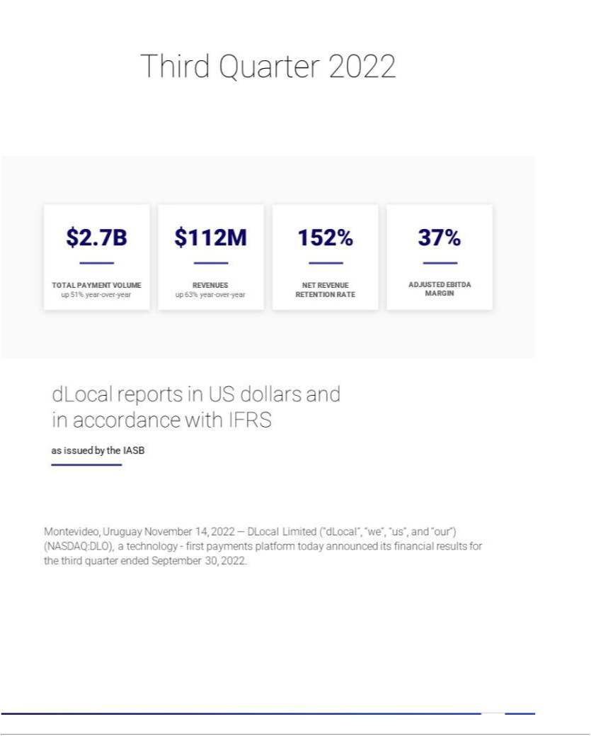





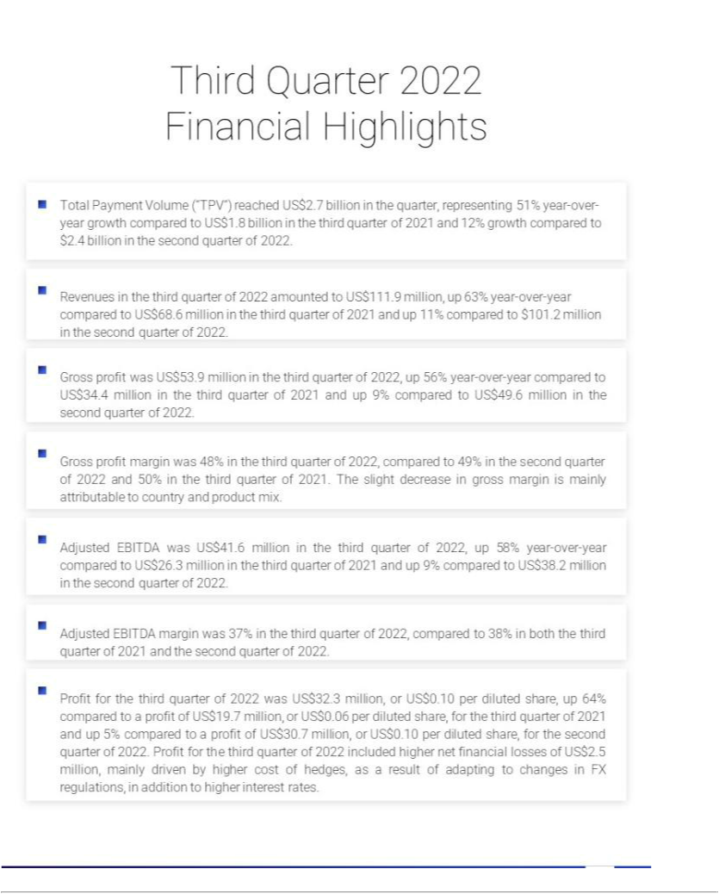

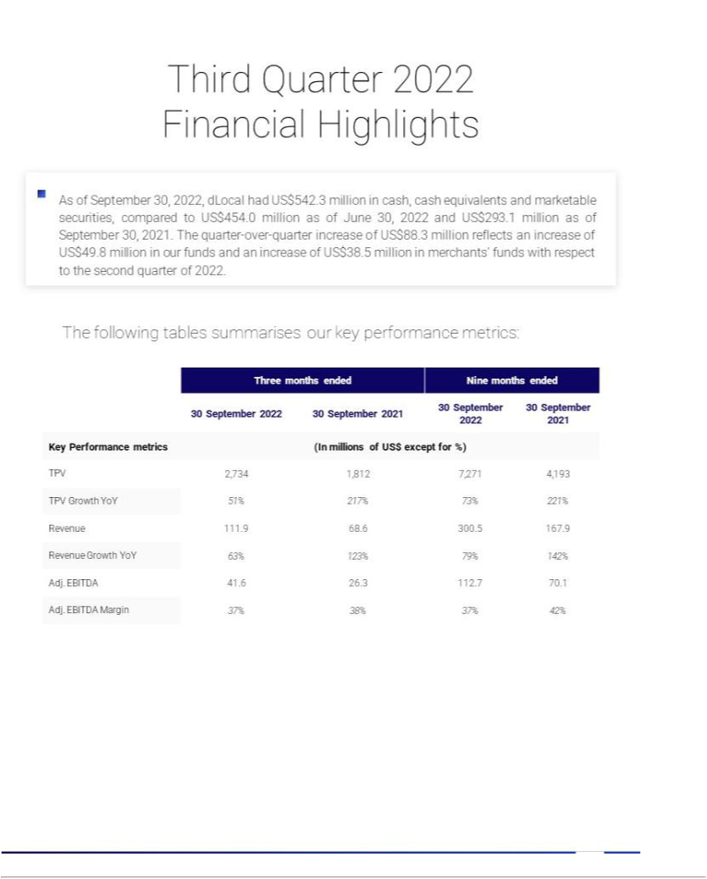

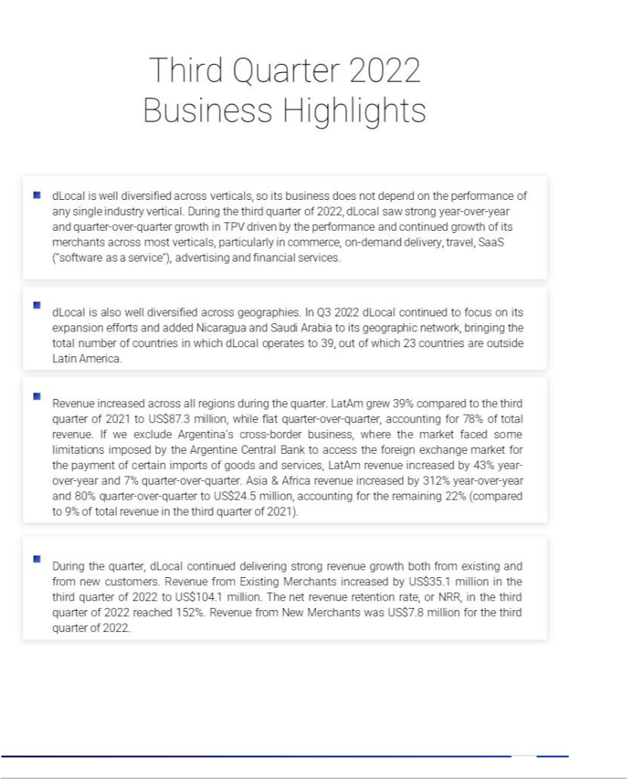

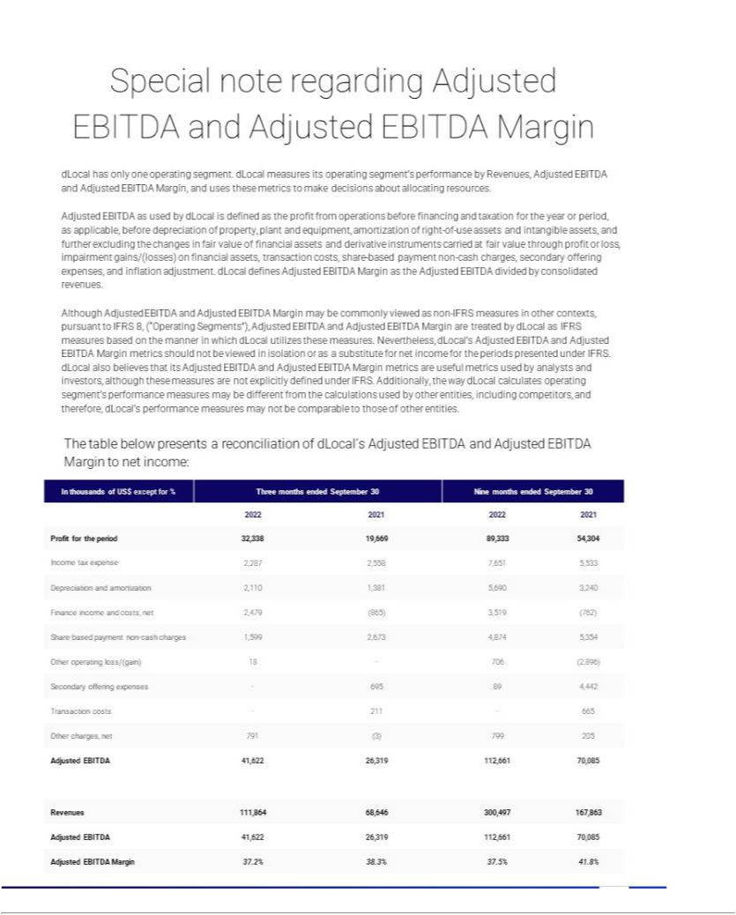

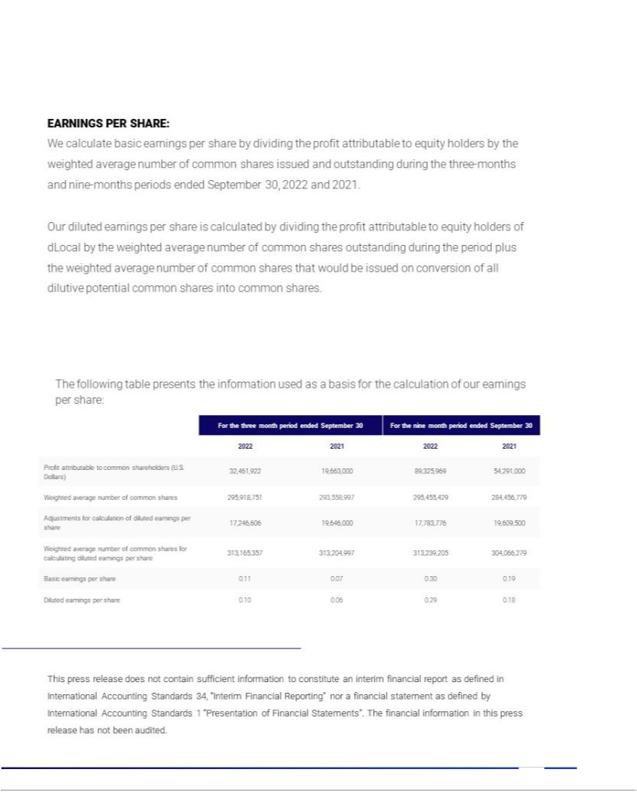

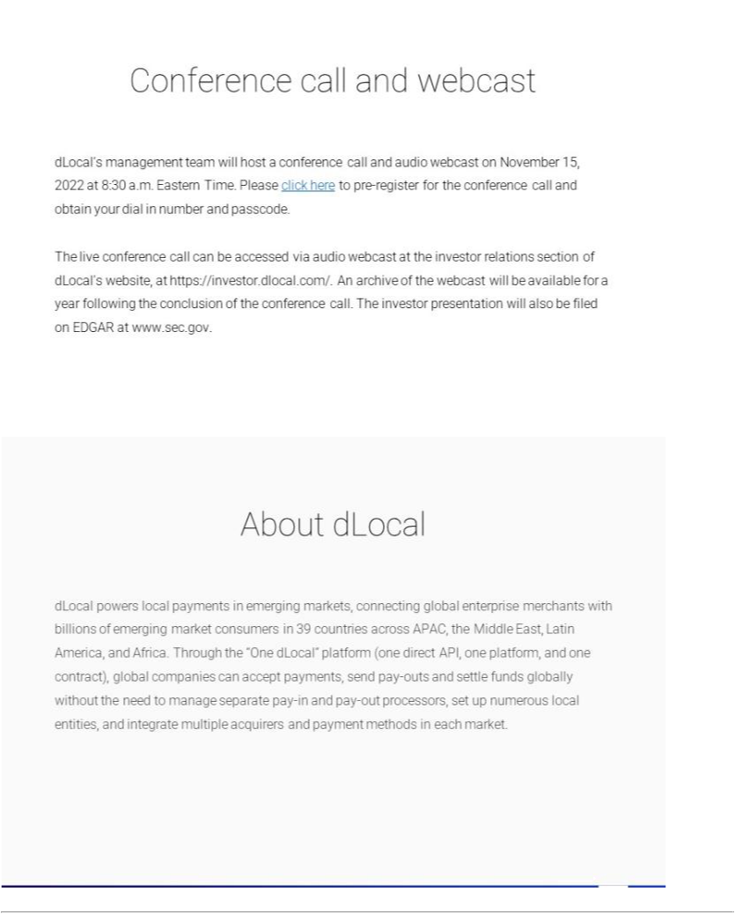

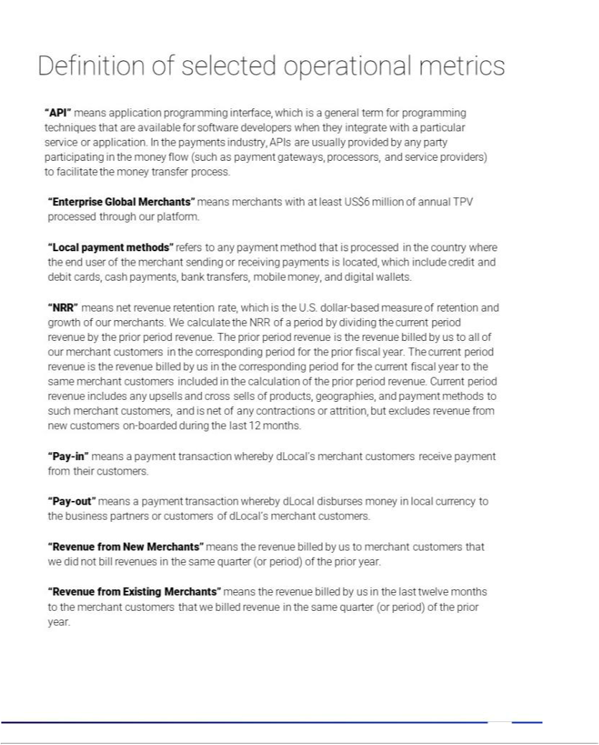



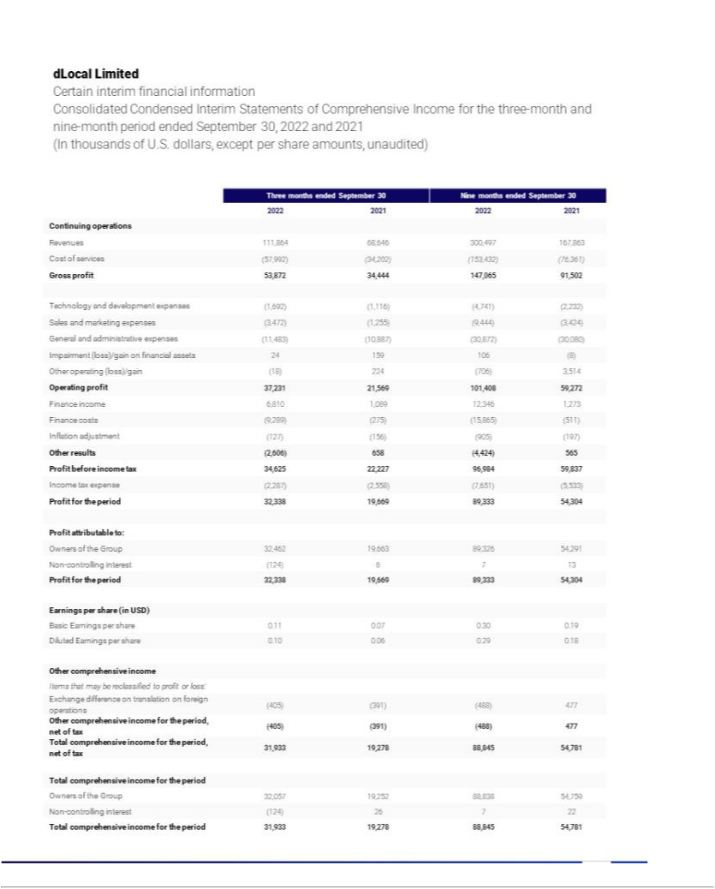

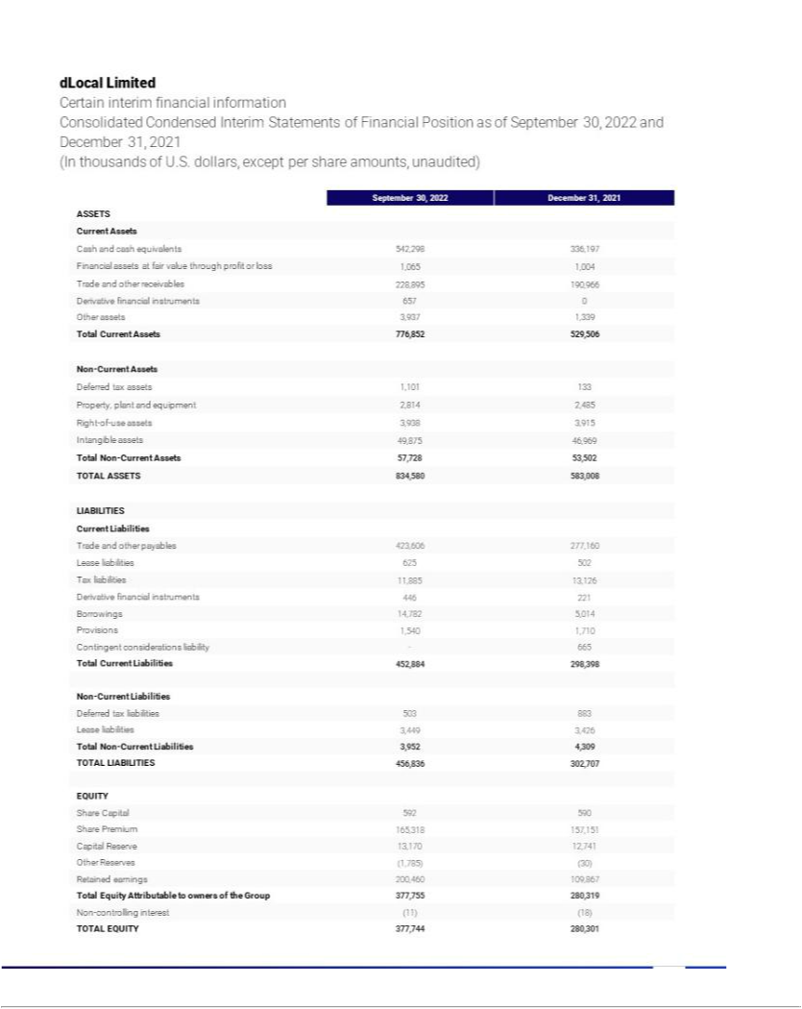





Exhibit 99.4








