UNITED STATES
SECURITIES AND EXCHANGE COMMISSION
Washington, D.C. 20549
FORM 6-K
REPORT OF FOREIGN PRIVATE ISSUER
PURSUANT TO RULE 13a-16 OR 15d-16
UNDER THE SECURITIES EXCHANGE ACT OF 1934
For the month of March 2026
Commission File Number: 001-40451
DLocal Limited
(Exact name of registrant as specified in its charter)

PO Box 1093, Boundary Hall,
Cricket Square, Grand Cayman
KY1-1102
Cayman Islands
(Address of principal executive office)
Indicate by check mark whether the registrant files or will file annual reports under cover of Form 20-F or Form 40-F:
Form 20-F ☒ Form 40-F ☐

TABLE OF CONTENTS
EXHIBIT
99.1 |  |  |  |  |  | Press release dated March 18, 2026 - dLocal Reports 2025 Fourth Quarter and Full year Financial Results
99.2 |  |  |  |  |  | Annual Report 2025 - dLocal Financial Results Full Year and 4th Quarter of 2025
99.3 |  |  |  |  |  | dLocal Q4 2025 Earnings Presentation
99.4 |  |  |  |  |  | Press release dated March 18, 2026 - Dlocal Limited Declares Dividend Distribution

SIGNATURE
Pursuant to the requirements of the Securities Exchange Act of 1934, the registrant has duly caused this report to be signed on its behalf by the undersigned, thereunto duly authorized.

 |  |  | DLocal Limited
 |  |  | By: |  |  | /s/ Guillermo López Pérez
 |  |  | Name: |  |  | Guillermo López Pérez
 |  |  | Title: |  |  | Chief Financial Officer

Date: March 18, 2026

Exhibit 99.1



dLocal Reports 2025 Fourth Quarter Financial Results

Ending the year with strong growth momentum, with broad-based acceleration across key metrics.
TPV at an all-time quarterly high of US$13.1 billion, growing 70% year-over-year, the fifth straight quarter above 50% year-over-year.
Revenue up +65% year-over-year reaching US$338 million for the quarter.
Gross profit reached US$116 million, up +38% year-over-year.
Adjusted EBITDA up +38% year-over-year, representing 68% of gross profit, underscoring best-in-class operating leverage and disciplined cost management.
Net income growth at +87% year-over-year.
Solid free cash generation, with adjusted free cash flow to net income ratio at 117%.

Demonstrated the scale of the emerging markets opportunity: record TPV of US$41 billion, up 60% year-over-year with revenue crossing the $1 billion milestone for the first time.
Gross profit reached US$403 million, +37% year-over-year.
Adjusted EBITDA up 47% year-over-year, with significant margin improvement (+5 p.p. in Adjusted EBITDA / Gross Profit) despite being in an investment year.
Net income up 63% year-over-year to US$197 million.
Strong cash generation: adjusted free cash flow reached $191 million, up 110% year-over-year, with a 97% conversion ratio. Expected dividend payment of US$57 million.

Montevideo, Uruguay, March 18, 2026 — DLocal Limited (“dLocal”, “we”, “us”, and “our”) (NASDAQ:DLO), a technology - first payments platform, today announced its financial results for the fourth quarter ended December 31, 2025.
dLocal’s management team will host a conference call and audio webcast on March 18, 2026 at 5:00 p.m. Eastern Time. Please click here to pre-register for the conference call and obtain your dial in number and passcode.
The live conference call can be accessed via audio webcast at the investor relations section of dLocal’s website, at https://investor.dlocal.com/. An archive of the webcast will be available for a year following the conclusion of the conference call. The investor presentation will also be filed on EDGAR at www.sec.gov.

“2025 was a year of exceptional execution, one that proved the strength of our business as we continue to build a world-leading financial infrastructure platform for emerging markets. Our flywheel is accelerating: high growth in a massive and expanding TAM, strong customer loyalty and retention, a growing capacity to innovate, and an asset-light, high-cash-conversion financial model,” said Pedro Arnt, CEO of dLocal.

Fourth quarter 2025 financial highlights
dLocal reports in US dollars and in accordance with IFRS as issued by the IASB

●Total Payment Volume (“TPV”) reached a record US$13.1 billion in the fourth quarter, up 70% year-over-year compared to US$7.7 billion in the fourth quarter of 2024 and up 26% compared to US$10.4 billion in the third quarter of 2025. In constant currency, TPV growth for the period would have been 64% year-over-year.
●Revenues amounted to US$337.9 million, up 65% year-over-year compared to US$204.5 million in the fourth quarter of 2024 and up 20% compared to US$282.5 million in the third quarter of 2025. In constant currency, revenue growth for the period would have been 69% year-over-year.
●Gross profit was US$115.8 million in the fourth quarter of 2025, up 38% compared to US$83.7 million in the fourth quarter of 2024 and up 12% compared to US$103.2 million in the third quarter of 2025. The quarter-over-quarter comparison is explained by the (i) strong seasonal e-commerce growth in Brazil, supported by solid trends across streaming, advertising, financial services and remittances; (ii) partial recovery in Egypt, reflecting the return of a large merchant and ramp-up of new e-commerce, streaming, and ride-hailing merchants; (iii) strong volume growth in

Mexico across e-commerce, on-demand delivery and ride-hailing; and (iv) broad-based growth in Other Africa & Asia, with notable South Africa contribution. These results were partially offset by Argentina, given higher costs amid election-related FX and rate volatility. In constant currency, gross profit growth for the period would have been 34% year-over-year.
●As a result, gross profit margin was 34% in this quarter, compared to 41% in the fourth quarter of 2024 and 37% in the third quarter of 2025.
●Gross profit over TPV was at 0.88%, decreasing from 1.09% in the fourth quarter of 2024 and 0.99% compared to the third quarter of 2025, reflecting our the strong TPV momentum and the natural margin pressure dynamic of scaling volume with established merchants and into new payment methods, products and countries.
●Operating profit was US$62.7 million, up 48% compared to US$42.3 million in the fourth quarter of 2024 and up 13% compared to US$55.6 million in the third quarter of 2025. Operating expenses grew by 28% year-over-year, as we continue to invest in our capabilities. On the sequential comparison, operating expenses increased by 12% quarter-over-quarter, driven primarily by headcount growth and the merit salary cycle.
●As a result, Adjusted EBITDA was US$78.4 million, up 38% compared to US$56.9 million in the fourth quarter of 2024 and up 9% compared to US$71.7 million in the third quarter of 2025.
●Adjusted EBITDA margin was 23%, compared to the 28% recorded in the fourth quarter of 2024 and 25% in the third quarter of 2025. Adjusted EBITDA over gross profit of 68% increased compared to 68% in the fourth quarter of 2024 and decreased compared to 69% in the third quarter of 2025.
●Net financial result was US$3.4 million gain, compared to a net finance loss of US$1.1 million in the fourth quarter of 2024 and a net finance gain of US$6.4 million in the third quarter of 2025.
●Our effective income tax rate for the period was 14%, broadly in line with the prior quarters.
●Net income for the fourth quarter of 2025 was US$55.6 million, or US$0.18 per diluted share, up 87% compared to a profit of US$29.7 million, or US$0.10 per diluted share, for the fourth quarter of 2024 and up 7% compared to a profit of US$51.8 million, or US$0.17 per diluted share for the third quarter of 2025. During the current period, net income was driven by continued operating profit expansion.
●Adjusted Free cash flow for the fourth quarter of 2025 amounted to US$64.9 million, up 100% year-over-year compared to US$32.5 million in the fourth quarter of 2024 and up 73% compared to US$37.6 million in the third quarter of 2025. The variation quarter-over-quarter is mostly explained by higher net cash from operating activities. As mentioned in the last earnings release, the third quarter 2025 was negatively affected by a short term impact of $13.1 million related to the structuring used to expatriate flows from Argentina after regulatory changes.
●As of December 31, 2025, dLocal had US$719.9 million in cash and cash equivalents, which includes US$424.5 million of Corporate cash and cash equivalents. The Corporate cash and cash equivalents increased by US$106.7 million from US$317.8 million as of December 31, 2024. When compared to the US$333.1 million Corporate cash and cash equivalents position as of September 30, 2025, it increased by US$91.4 million quarter-over-quarter.

The following table summarizes our key performance metrics:

 |  |  | Three months ended on December 31 |  |  |  |  |  |  |  |  | Year ended on December 31
 |  |  | 2025 |  |  | 2024 |  |  | % change |  |  | 2025 |  |  | 2024 |  |  | % change
Key Performance metrics |  |  | (In millions of US$ except for %)
TPV |  |  | 13,107 |  |  | 7,714 |  |  | 70% |  |  | 40,816 |  |  | 25,575 |  |  | 60%
Revenue |  |  | 337.9 |  |  | 204.5 |  |  | 65% |  |  | 1,093.6 |  |  | 746.0 |  |  | 47%
Gross Profit |  |  | 115.8 |  |  | 83.7 |  |  | 38% |  |  | 402.8 |  |  | 294.7 |  |  | 37%
Gross Profit margin |  |  | 34% |  |  | 41% |  |  | -7p.p |  |  | 37% |  |  | 40% |  |  | -3p.p
Adjusted EBITDA |  |  | 78.4 |  |  | 56.9 |  |  | 38% |  |  | 278.1 |  |  | 188.7 |  |  | 47%
Adjusted EBITDA margin |  |  | 23% |  |  | 28% |  |  | -5p.p |  |  | 25% |  |  | 25% |  |  | 0p.p
Adjusted EBITDA/Gross Profit |  |  | 68% |  |  | 68% |  |  | 0p.p |  |  | 69% |  |  | 64% |  |  | 5p.p
Net income |  |  | 55.6 |  |  | 29.7 |  |  | 87% |  |  | 196.9 |  |  | 120.5 |  |  | 63%
Net income margin |  |  | 16% |  |  | 15% |  |  | 2p.p |  |  | 18% |  |  | 16% |  |  | 2p.p

Full year 2026 outlook
For 2026, dLocal provides the following financial guidance:
Metric |  |  | 2025 |  |  | 2026 Guidance |  |  | Key considerations
TPV |  |  | $40.8B |  |  | 50% - 60% YoY |  |  | ●Strong commercial traction with large merchants scaling across geographies  ●Expansion deals with APMs  ●Aggregation theory benefits create flywheel: pricing pressure downstream, FX liquidity and better data to aid conversion rates leads to more customer acquisition
Gross Profit |  |  | $403M |  |  | 22.5% – 27.5% YoY |  |  | ●Some structural volume-based discounting expected, which is a sign of scale and of our long-term merchant relationships
Operating Profit |  |  | $220M |  |  | 27.5% – 32.5% YoY |  |  | ●We will use Operating Profit a measure beginning in 2026 to assess our operating performance  ●New OPEX baseline post-2025 investment cycle, temporarily pressuring 1H26 margins but driving operating leverage improvements in 2H26

Consider the following in connection with our guidance: emerging markets remain volatile, reflecting the evolving global macroeconomic, currency and trade landscape and its potential impact on these economies. Our key exposures include the

evolving Brazilian tax environment, Argentine FX, tariff sensitivity (particularly in Mexico), electoral uncertainty across the region, and broader FX risk across our emerging market footprint.

Dividend payment and share repurchase program
Following our dividend policy of 30% of the prior year's free cash flow, the Board of Directors declared a cash dividend of an aggregate of US$57.2 million, equivalent to approximately US$0.1939 per share, to shareholders of record as of the close of business on May 27, 2026, to be paid on June 10, 2026. Per-share amount is subject to adjustment according to the number of shares outstanding as of the record date.

Additionally, given our confidence that the business will generate significant cash in the medium term beyond our minimum liquidity requirements and dividend policy commitments, and rather than hold excess cash on our balance sheet, the Board authorized a new share repurchase program to purchase up to US$300 million of Class A common shares, expiring at the earliest of March 2027 or upon reaching the repurchase limit.

Special note regarding Adjusted EBITDA and Adjusted EBITDA Margin

dLocal has only one operating segment. dLocal measures its operating segment’s performance by Revenues, Adjusted EBITDA and Adjusted EBITDA Margin, and uses these metrics to make decisions about allocating resources. Adjusted EBITDA as used by dLocal is defined as the profit from operations before financing and taxation for the year or period, as applicable, before depreciation of property, plant and equipment, amortization of right-of-use assets and intangible assets, and further excluding the finance income and costs, impairment gains/(losses) on financial assets, transaction costs, share-based payment non-cash charges,other operating gain/loss,other non-recurring costs, and inflation adjustment. dLocal defines Adjusted EBITDA Margin as the Adjusted EBITDA divided by consolidated revenues. dLocal defines Adjusted EBITDA to Gross Profit Ratio as Adjusted EBITDA divided by Gross Profit. Although Adjusted EBITDA, Adjusted EBITDA Margin and Adjusted EBITDA to Gross Profit Ratio may be commonly viewed as non-IFRS measures in other contexts, pursuant to IFRS 8, (“Operating Segments”), Adjusted EBITDA, Adjusted EBITDA Margin and Adjusted EBITDA to Gross Profit Ratio are treated by dLocal as IFRS measures based on the manner in which dLocal utilizes these measures. Nevertheless, dLocal’s Adjusted EBITDA, Adjusted EBITDA Margin and Adjusted EBITDA to Gross Profit Ratio metrics should not be viewed in isolation or as a substitute for net income for the periods presented under IFRS. dLocal also believes that its Adjusted EBITDA, Adjusted EBITDA Margin and Adjusted EBITDA to Gross Profit Ratio metrics are useful metrics used by analysts and investors, although these measures are not explicitly defined under IFRS. Additionally, the way dLocal calculates operating segment’s performance measures may be different from the calculations used by other entities, including competitors, and therefore, dLocal’s performance measures may not be comparable to those of other entities.

The table below presents a reconciliation of dLocal’s Adjusted EBITDA to net income:

$ in thousands |  |  | Three months ended on December 31 |  |  |  |  |  | Year ended on December 31
 |  |  | 2025 |  |  | 2024 |  |  | 2025 |  |  | 2024
Profit for the period |  |  | 55,637 |  |  | 29,701 |  |  | 196,902 |  |  | 120,469
Income tax expense |  |  | 8,915 |  |  | 11,090 |  |  | 31,752 |  |  | 30,550
Depreciation and amortization |  |  | 9,527 |  |  | 4,888 |  |  | 26,260 |  |  | 17,177
Finance income and costs, net |  |  | (3,376) |  |  | 1,085 |  |  | (12,943) |  |  | (17,174)
Share-based payment non-cash charges |  |  | 6,365 |  |  | 6,339 |  |  | 24,136 |  |  | 23,780
Other operating loss¹ |  |  | (584) |  |  | 1,307 |  |  | 4,715 |  |  | 5,257
Secondary offering expenses |  |  | - |  |  | - |  |  | 739 |  |  | -
Impairment loss / (gain) on financial assets |  |  | 392 |  |  | 533 |  |  | 2,189 |  |  | 440
Inflation adjustment |  |  | 1,541 |  |  | 392 |  |  | 4,204 |  |  | 6,655
Other non-recurring costs |  |  | - |  |  | 1,571 |  |  | 124 |  |  | 1,571
Adjusted EBITDA |  |  | 78,417 |  |  | 56,906 |  |  | 278,078 |  |  | 188,725

Note: 1 The Company wrote off certain amounts primarily related to merchants and processors that have been off-boarded or for which the balances are no longer considered recoverable by dLocal.

Adjusted Free Cash Flow reconciliation

We calculate “Adjusted Free Cash Flow” as net cash (used in) / generated from cash flows from operating activities, less (i) changes in working capital (merchant), and (ii) capital expenditures. The working capital (merchant) is defined as (i) changes in Trade receivables net (disclosed in Note 16 to our consolidated financial statements for the year ended December 31, 2025 and Note 21 to our financial statements for the year ended December 31, 2024 (“FY25 Financial statements” and “FY24 Financial Statements”, respectively)), plus (ii) changes in Trade payables (disclosed in Note 21 to our FY25 and FY24 Financial Statements), plus (iii) changes in Other tax liabilities (disclosed in note 23 to our FY25 and FY24 Financial Statements). Capital expenditures consist of acquisitions of property, plant and equipment and additions of intangible assets.

Management uses Adjusted Free Cash Flow as a measure for evaluating the Company's cash generation and the cash available for distribution to our shareholders as dividends pursuant to our dividend policy. Adjusted Free Cash Flow is not a financial measure recognized under IFRS and does not purport to be an alternative to cash generated from operating activities or as a measure of liquidity. Our presentation of Adjusted Free Cash Flow has limitations as an analytical tool, and you should not consider it in isolation or as a substitute for analysis of our results as reported under IFRS. See below for a reconciliation of our Adjusted Free Cash Flow to the nearest IFRS measure.

The table below presents a reconciliation of dLocal’s Adjusted Free Cash Flow reconciliation:

$ in thousands (except percentages) |  |  | Three months ended on December 31 |  |  |  |  |  | Year ended on December 31
 |  |  | 2025 |  |  | 2024 |  |  | 2025 |  |  | 2024
Net cash (used in ) / generated from operating activities |  |  | 100,413 |  |  | (141,132) |  |  | 415,457 |  |  | (32,784)
Changes in working capital (merchant)¹ |  |  | (24,007) |  |  | 179,760 |  |  | (187,981) |  |  | 146,034
Capital expenditures² |  |  | (11,490) |  |  | (6,126) |  |  | (36,785) |  |  | (22,647)
Adjusted Free Cash Flow |  |  | 64,915 |  |  | 32,503 |  |  | 190,690 |  |  | 90,602

Note: 1 Changes in working capital (merchant) consists of (i) changes in the period in the balance of trade receivables net, plus (ii) changes in the period in the balance of trade payables, plus (iii) changes in the period in the balance of other tax liabilities. 2 Capital expenditures consist of acquisitions of property, plant and equipment and Additions of Intangible Assets.

dLocal Limited
Certain financial information
Consolidated Statements of Comprehensive Income for the three-month and twelve-month periods December 31, 2025 and 2024
(All amounts in thousands of U.S. Dollars except share data or as otherwise indicated)

 |  |  | Three months ended on December 31 |  |  |  |  |  | Year ended on December 31
 |  |  | 2025 |  |  | 2024 |  |  | 2025 |  |  | 2024
Continuing operations
Revenues |  |  | 337,888 |  |  | 204,491 |  |  | 1,093,587 |  |  | 745,974
Cost of services |  |  | (222,084) |  |  | (120,780) |  |  | (690,831) |  |  | (451,301)
Gross profit |  |  | 115,803 |  |  | 83,711 |  |  | 402,756 |  |  | 294,673
Technology and development expenses |  |  | (7,715) |  |  | (6,822) |  |  | (30,707) |  |  | (25,625)
Sales and marketing expenses |  |  | (6,341) |  |  | (5,598) |  |  | (26,457) |  |  | (21,626)
General and administrative expenses |  |  | (39,223) |  |  | (27,183) |  |  | (118,773) |  |  | (101,225)
Impairment (loss)/gain on financial assets |  |  | (392) |  |  | (533) |  |  | (2,189) |  |  | (440)
Other operating loss |  |  | 584 |  |  | (1,307) |  |  | (4,715) |  |  | (5,257)
Operating profit |  |  | 62,716 |  |  | 42,268 |  |  | 219,915 |  |  | 140,500
Finance income |  |  | 7,043 |  |  | 12,036 |  |  | 40,798 |  |  | 66,875
Finance costs |  |  | (3,666) |  |  | (13,121) |  |  | (27,855) |  |  | (49,701)
Inflation adjustment |  |  | (1,541) |  |  | (392) |  |  | (4,204) |  |  | (6,655)
Other results |  |  | 1,835 |  |  | (1,477) |  |  | 8,739 |  |  | 10,519
Profit before income tax |  |  | 64,551 |  |  | 40,791 |  |  | 228,654 |  |  | 151,019
Income tax expense |  |  | (8,915) |  |  | (11,090) |  |  | (31,752) |  |  | (30,550)
Profit for the period |  |  | 55,637 |  |  | 29,701 |  |  | 196,902 |  |  | 120,469
Profit attributable to:
Owners of the Group |  |  | 55,536 |  |  | 29,682 |  |  | 196,801 |  |  | 120,416
Non-controlling interest |  |  | 101 |  |  | 19 |  |  | 101 |  |  | 53
Profit for the period |  |  | 55,637 |  |  | 29,701 |  |  | 196,902 |  |  | 120,469
Earnings per share (in USD)
Basic Earnings per share |  |  | 0.19 |  |  | 0.11 |  |  | 0.68 |  |  | 0.42
Diluted Earnings per share |  |  | 0.18 |  |  | 0.10 |  |  | 0.65 |  |  | 0.39
Other comprehensive Income
Items that are or may be reclassified to profit or loss:
Exchange difference on translation on foreign operations |  |  | (194) |  |  | (4,417) |  |  | 5,016 |  |  | (11,188)
Other comprehensive income for the period, net of tax |  |  | (194) |  |  | (4,417) |  |  | 5,016 |  |  | (11,188)
Total comprehensive income for the period |  |  | 55,442 |  |  | 25,284 |  |  | 201,918 |  |  | 109,281
Total comprehensive income for the period is attributable to:
Owners of the Group |  |  | 50,360 |  |  | 25,311 |  |  | 196,801 |  |  | 109,290
Non-controlling interest |  |  | 67 |  |  | (27) |  |  | 101 |  |  | (9)
Total comprehensive income for the period |  |  | 55,442 |  |  | 25,284 |  |  | 201,918 |  |  | 109,281

dLocal Limited
Certain financial information
Consolidated Condensed Interim Statements of Financial Position as of December 31, 2025 and September 30, 2025
(All amounts in thousands of U.S. dollars)

 |  |  | Three months ended on December 31
 |  |  | 2025 |  |  | 2025
 |  |  | on December 31, 2025 |  |  | September 30, 2025
ASSETS
Current Assets
Cash and cash equivalents |  |  | 719,897 |  |  | 604,467
Financial assets at fair value through profit or loss |  |  | 99,089 |  |  | 95,026
Trade and other receivables |  |  | 572,024 |  |  | 576,389
Derivative financial instruments |  |  | 140 |  |  | 828
Other assets |  |  | 29,607 |  |  | 30,328
Total Current Assets |  |  | 1,420,757 |  |  | 1,307,038
Non-Current Assets
Trade and other receivables |  |  | 25,982 |  |  | 13,823
Deferred tax assets |  |  | 7,666 |  |  | 5,429
Property, plant and equipment |  |  | 3,985 |  |  | 4,116
Right-of-use assets |  |  | 2,995 |  |  | 3,212
Intangible assets |  |  | 73,965 |  |  | 71,754
Other assets |  |  | 5,614 |  |  | 3,383
Total Non-Current Assets |  |  | 120,207 |  |  | 101,715
TOTAL ASSETS |  |  | 1,540,964 |  |  | 1,408,753
LIABILITIES
Current Liabilities
Trade and other payables |  |  | 854,436 |  |  | 816,729
Lease liabilities |  |  | 1,076 |  |  | 1,147
Tax liabilities |  |  | 21,500 |  |  | 14,806
Derivative financial instruments |  |  | 1,567 |  |  | 1,606
Financial liabilities |  |  | 86,898 |  |  | 63,079
Provisions |  |  | 433 |  |  | 388
Total Current Liabilities |  |  | 965,910 |  |  | 897,754
Non-Current Liabilities
Deferred tax liabilities |  |  | 3,316 |  |  | 3,768
Lease liabilities |  |  | 2,309 |  |  | 2,566
Total Non-Current Liabilities |  |  | 5,625 |  |  | 6,334
TOTAL LIABILITIES |  |  | 971,535 |  |  | 904,088
EQUITY
Share Capital |  |  | 590 |  |  | 588
Share Premium |  |  | 7,097 |  |  | -
Treasury Shares |  |  | - |  |  | -
Capital Reserve |  |  | 42,641 |  |  | 40,418
Other Reserves |  |  | (15,885) |  |  | (15,758)
Retained earnings |  |  | 534,818 |  |  | 479,283
Total Equity Attributable to owners of the Group |  |  | 569,261 |  |  | 504,531
Non-controlling interest |  |  | 168 |  |  | 134

TOTAL EQUITY |  |  | 569,429 |  |  | 504,665
TOTAL EQUITY AND LIABILITIES |  |  | 1,540,964 |  |  | 1,408,753

dLocal Limited
Certain interim financial information.
Consolidated Statements of Cash flows for the three-month and twelve-month periods December 31, 2025 and 2024
(All amounts in thousands of U.S. dollars)

 |  |  | Three months ended on December 31 |  |  |  |  |  | Year ended on December 31
 |  |  | 2025 |  |  | 2024 |  |  | 2025 |  |  | 2024
Cash flows from operating activities
Profit before income tax |  |  | 64,551 |  |  | 40,791 |  |  | 228,654 |  |  | 151,019
Adjustments:
Interest Income from financial instruments |  |  | (6,747) |  |  | (6,921) |  |  | (26,253) |  |  | (28,266)
Interest charges for lease liabilities |  |  | 108 |  |  | 370 |  |  | 254 |  |  | 501
Other interests charges |  |  | (314) |  |  | 739 |  |  | 1,971 |  |  | 3,758
Finance expense related to derivative financial instruments |  |  | 1,835 |  |  | (627) |  |  | 6,924 |  |  | 19,462
Net exchange differences |  |  | 2,053 |  |  | 5,914 |  |  | 18,592 |  |  | 24,787
Fair value loss/(gain) on financial assets at FVPL |  |  | (295) |  |  | (3,922) |  |  | (14,545) |  |  | (37,416)
Amortization of Intangible assets |  |  | 8,677 |  |  | 4,364 |  |  | 23,857 |  |  | 15,511
Depreciation and disposals of PP&E and right-of-use |  |  | (29) |  |  | 652 |  |  | 2,403 |  |  | 1,884
Share-based payment expense, net of forfeitures |  |  | 6,365 |  |  | 6,339 |  |  | 24,136 |  |  | 23,780
Other operating gain |  |  | (584) |  |  | 786 |  |  | 4,715 |  |  | 4,736
Net Impairment loss/(gain) on financial assets |  |  | 392 |  |  | 533 |  |  | 2,189 |  |  | 440
Inflation adjustment and other financial results |  |  | 797 |  |  | (5,704) |  |  | 6,490 |  |  | (17,063)
 |  |  | 76,810 |  |  | 43,314 |  |  | 279,387 |  |  | 163,133
Changes in working capital
Increase in Trade and other receivables |  |  | (7,602) |  |  | (109,487) |  |  | (90,153) |  |  | (162,645)
Decrease / (Increase) in Other assets |  |  | (1,000) |  |  | 4,128 |  |  | 2,250 |  |  | 5,427
Increase / (Decrease) in Trade and Other payables |  |  | 37,707 |  |  | (70,700) |  |  | 256,649 |  |  | (6,957)
Increase / (Decrease) in Tax Liabilities |  |  | (915) |  |  | (3,835) |  |  | (5,573) |  |  | (3,184)
Increase / (Decrease) in Provisions |  |  | 45 |  |  | 222 |  |  | (67) |  |  | 138
Cash (used) / generated from operating activities |  |  | 105,046 |  |  | (136,359) |  |  | 442,493 |  |  | (4,088)
Income tax paid |  |  | (4,633) |  |  | (4,773) |  |  | (27,036) |  |  | (28,696)
Net cash (used) / generated from operating activities |  |  | 100,413 |  |  | (141,132) |  |  | 415,457 |  |  | (32,784)
Cash flows from investing activities
Acquisitions of Property, plant and equipment |  |  | (602) |  |  | (427) |  |  | (2,282) |  |  | (1,705)
Additions of Intangible assets |  |  | (10,888) |  |  | (5,699) |  |  | (34,503) |  |  | (20,942)
Acquisition of financial assets at FVPL |  |  | (136,168) |  |  | (14,852) |  |  | (283,536) |  |  | (121,468)
Collections of financial assets at FVPL |  |  | 132,854 |  |  | - |  |  | 311,881 |  |  | 108,097
Interest collected from financial instruments |  |  | (32,007) |  |  | 6,921 |  |  | (12,501) |  |  | 28,266
Payments for investments in other assets at FVPL |  |  | 38,753 |  |  | (10,000) |  |  | 26,253 |  |  | (10,000)
Net cash (used in) / generated investing activities |  |  | (8,058) |  |  | (24,057) |  |  | 5,312 |  |  | (17,752)
Cash flows from financing activities

Repurchase of shares |  |  | - |  |  | - |  |  | - |  |  | (101,067)
Share-options exercise paid |  |  | 2,957 |  |  | 358 |  |  | 4,371 |  |  | 1,853
Dividends paid |  |  | - |  |  | - |  |  | (149,982) |  |  | -
Interest payments on lease liability |  |  | (108) |  |  | (370) |  |  | (254) |  |  | (501)
Principal payments on lease liability |  |  | 896 |  |  | (112) |  |  | (601) |  |  | (552)
Finance expense paid related to derivative financial instruments |  |  | (1,185) |  |  | (8) |  |  | (8,849) |  |  | (15,017)
Net proceeds from financial liabilities |  |  | 28,888 |  |  | 33,653 |  |  | 51,796 |  |  | 50,428
Interest payments on financial liabilities |  |  | (5,241) |  |  | (1,633) |  |  | (15,864) |  |  | (2,281)
Other finance expense paid |  |  | 448 |  |  | (327) |  |  | (1,690) |  |  | (1,450)
Net cash used in by financing activities |  |  | 26,655 |  |  | 31,561 |  |  | (121,073) |  |  | (68,587)
Net increase in cash flow |  |  | 119,010 |  |  | (133,628) |  |  | 299,695 |  |  | (119,123)
Cash and cash equivalents at the beginning of the period |  |  | 604,467 |  |  | 560,533 |  |  | 425,172 |  |  | 536,160
Net (decrease)/increase in cash flow |  |  | 119,010 |  |  | (133,628) |  |  | 299,695 |  |  | (119,123)
Effects of exchange rate changes on inflation and cash and cash equivalents |  |  | (3,580) |  |  | (1,732) |  |  | (4,970) |  |  | 8,135
Cash and cash equivalents at the end of the period |  |  | 719,897 |  |  | 425,172 |  |  | 719,897 |  |  | 425,172

About dLocal
dLocal powers local payments in emerging markets, connecting global enterprise merchants with billions of emerging market consumers across APAC, the Middle East, Latin America, and Africa. Through the “One dLocal” concept (one direct API, one platform, and one contract), global companies can accept payments, send payouts, and settle funds globally without the need to manage multiple local entities and integrations. For more information, visit www.dlocal.com

Forward-looking statements
This presentation may contain forward-looking statements. These forward-looking statements convey dLocal’s current expectations or forecasts of future events, including guidance in respect of total payment volume, gross profit and operating profit. Forward-looking statements regarding dLocal and amounts stated as guidance involve known and unknown risks, uncertainties and other factors that may cause dLocal’s actual results, performance or achievements to be materially different from any future results, performances or achievements expressed or implied by the forward-looking statements. Certain of these risks and uncertainties are described in the “Risk Factors,” and “Cautionary Statement Regarding Forward-Looking Statements” sections of dLocal’s filings with the U.S. Securities and Exchange Commission.

Unless required by law, dLocal undertakes no obligation to publicly update or revise any forward-looking statements to reflect circumstances or events after the date hereof.

Beginning in 2026, we expect to provide guidance in respect of operating profit, which management believes is useful as a measure to compare our operating results to the operations of other companies in our industry, and to assess our operating performance independently of our capital structure, tax position, and non-cash depreciation and amortization charges.

Investor Relations Contact:
investor@dlocal.com

Media Contact:
media@dlocal.com

This press release does not contain sufficient information to constitute an interim financial report as defined in International Accounting Standards 34, “Interim Financial Reporting” nor a financial statement as defined by International Accounting Standards 1 “Presentation of Financial Statements”. The fourth quarter financial information in this press release has not been audited nor has it been subject to any limited review procedures, whereas the annual results for the year ended December 31, 2025 are audited.


4Q25 Earnings Release


4Q25 Earnings Release dLocal reports in US dollars and in accordance with IFRS as issued by the IASB Montevideo, Uruguay, March 18, 2026 — DLocal Limited (“dLocal”, “we”, “us”, and “our”) (NASDAQ:DLO), the leading cross-border payment platform connecting global merchants to emerging markets today announced its financial results for the fourth quarter ended December 31, 2025. Key Business Highlights Letter to Shareholders Business Highlights Financial Highlights Tech & Commercial Highlights Appendix

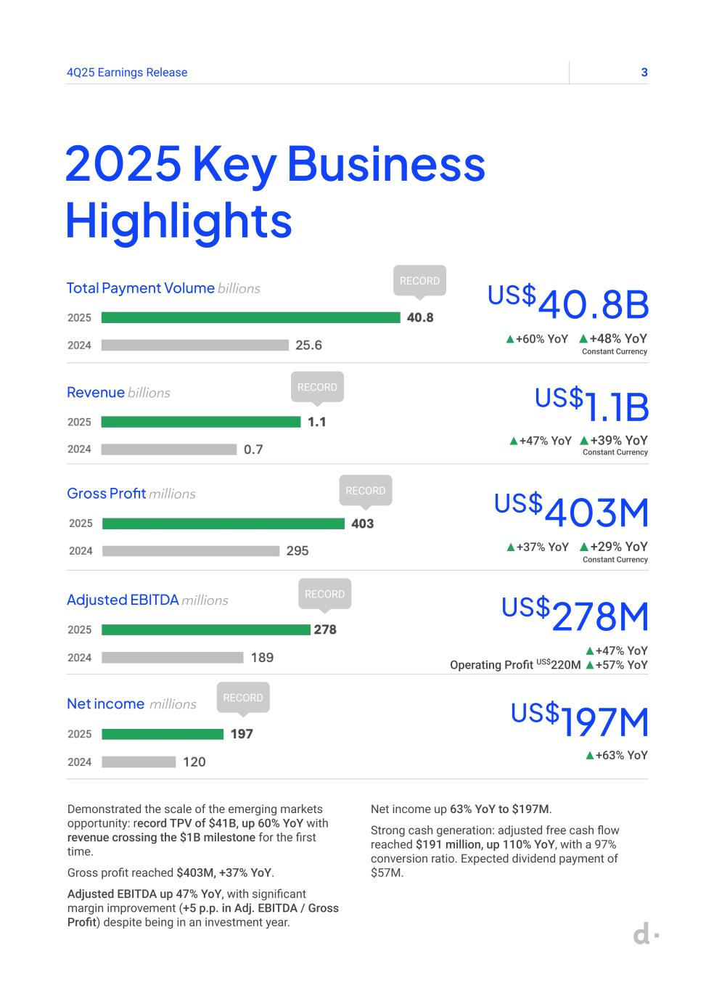
34Q25 Earnings Release 2025 Key Business Highlights Total Payment Volume billions US$40.8B ▲+60% YoY ▲+48% YoY Constant Currency Demonstrated the scale of the emerging markets opportunity: record TPV of $41B, up 60% YoY with revenue crossing the $1B milestone for the first time. Gross profit reached $403M, +37% YoY. Adjusted EBITDA up 47% YoY, with significant margin improvement (+5 p.p. in Adj. EBITDA / Gross Profit) despite being in an investment year. Net income up 63% YoY to $197M. Strong cash generation: adjusted free cash flow reached $191 million, up 110% YoY, with a 97% conversion ratio. Expected dividend payment of $57M. Revenue billions US$1.1B ▲+47% YoY ▲+39% YoY Constant Currency Gross Profit millions US$403M ▲+37% YoY ▲+29% YoY Constant Currency Adjusted EBITDA millions US$278M ▲+47% YoY Operating Profit US$220M ▲+57% YoY Net income millions US$197M ▲+63% YoY RECORD RECORD RECORD RECORD RECORD

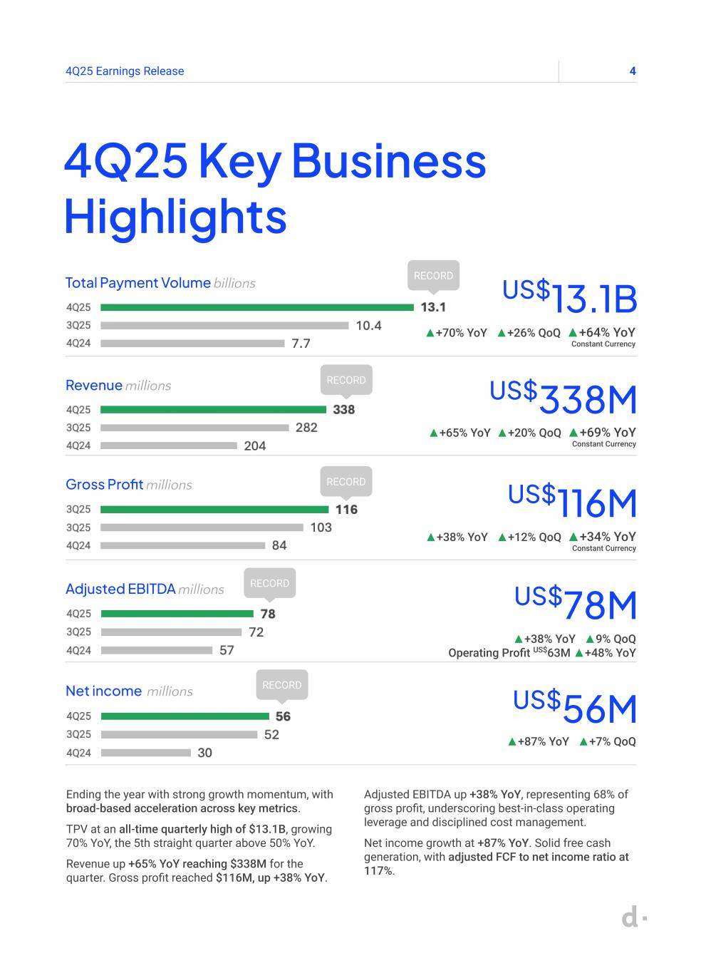
44Q25 Earnings Release 4Q25 Key Business Highlights Total Payment Volume billions US$13.1B ▲+70% YoY ▲+26% QoQ ▲+64% YoY Constant Currency RECORD Ending the year with strong growth momentum, with broad-based acceleration across key metrics. TPV at an all-time quarterly high of $13.1B, growing 70% YoY, the 5th straight quarter above 50% YoY. Revenue up +65% YoY reaching $338M for the quarter. Gross profit reached $116M, up +38% YoY. Adjusted EBITDA up +38% YoY, representing 68% of gross profit, underscoring best-in-class operating leverage and disciplined cost management. Net income growth at +87% YoY. Solid free cash generation, with adjusted FCF to net income ratio at 117%. Revenue millions US$338M ▲+65% YoY ▲+20% QoQ ▲+69% YoY Constant Currency Gross Profit millions US$116M ▲+38% YoY ▲+12% QoQ ▲+34% YoY Constant Currency Adjusted EBITDA millions US$78M ▲+38% YoY ▲9% QoQ Operating Profit US$63M ▲+48% YoY Net income millions US$56M ▲+87% YoY ▲+7% QoQ RECORD RECORD RECORD RECORD

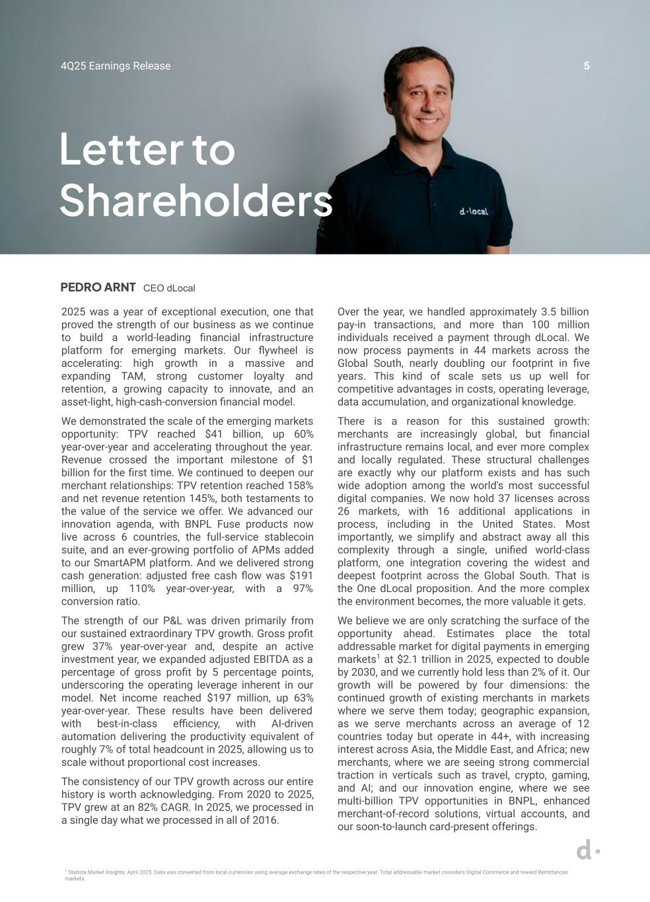
54Q25 Earnings Release 2025 was a year of exceptional execution, one that proved the strength of our business as we continue to build a world-leading financial infrastructure platform for emerging markets. Our flywheel is accelerating: high growth in a massive and expanding TAM, strong customer loyalty and retention, a growing capacity to innovate, and an asset-light, high-cash-conversion financial model. We demonstrated the scale of the emerging markets opportunity: TPV reached $41 billion, up 60% year-over-year and accelerating throughout the year. Revenue crossed the important milestone of $1 billion for the first time. We continued to deepen our merchant relationships: TPV retention reached 158% and net revenue retention 145%, both testaments to the value of the service we offer. We advanced our innovation agenda, with BNPL Fuse products now live across 6 countries, the full-service stablecoin suite, and an ever-growing portfolio of APMs added to our SmartAPM platform. And we delivered strong cash generation: adjusted free cash flow was $191 million, up 110% year-over-year, with a 97% conversion ratio. The strength of our P&L was driven primarily from our sustained extraordinary TPV growth. Gross profit grew 37% year-over-year and, despite an active investment year, we expanded adjusted EBITDA as a percentage of gross profit by 5 percentage points, underscoring the operating leverage inherent in our model. Net income reached $197 million, up 63% year-over-year. These results have been delivered with best-in-class efficiency, with AI-driven automation delivering the productivity equivalent of roughly 7% of total headcount in 2025, allowing us to scale without proportional cost increases. The consistency of our TPV growth across our entire history is worth acknowledging. From 2020 to 2025, TPV grew at an 82% CAGR. In 2025, we processed in a single day what we processed in all of 2016. 1 Statista Market Insights, April 2025. Data was converted from local currencies using average exchange rates of the respective year. Total addressable market considers Digital Commerce and Inward Remittances markets. Letter to Shareholders PEDRO ARNT CEO dLocal Over the year, we handled approximately 3.5 billion pay-in transactions, and more than 100 million individuals received a payment through dLocal. We now process payments in 44 markets across the Global South, nearly doubling our footprint in five years. This kind of scale sets us up well for competitive advantages in costs, operating leverage, data accumulation, and organizational knowledge. There is a reason for this sustained growth: merchants are increasingly global, but financial infrastructure remains local, and ever more complex and locally regulated. These structural challenges are exactly why our platform exists and has such wide adoption among the world's most successful digital companies. We now hold 37 licenses across 26 markets, with 16 additional applications in process, including in the United States. Most importantly, we simplify and abstract away all this complexity through a single, unified world-class platform, one integration covering the widest and deepest footprint across the Global South. That is the One dLocal proposition. And the more complex the environment becomes, the more valuable it gets. We believe we are only scratching the surface of the opportunity ahead. Estimates place the total addressable market for digital payments in emerging markets1 at $2.1 trillion in 2025, expected to double by 2030, and we currently hold less than 2% of it. Our growth will be powered by four dimensions: the continued growth of existing merchants in markets where we serve them today; geographic expansion, as we serve merchants across an average of 12 countries today but operate in 44+, with increasing interest across Asia, the Middle East, and Africa; new merchants, where we are seeing strong commercial traction in verticals such as travel, crypto, gaming, and AI; and our innovation engine, where we see multi-billion TPV opportunities in BNPL, enhanced merchant-of-record solutions, virtual accounts, and our soon-to-launch card-present offerings.


64Q25 Earnings Release / Letter to Shareholders Our model has a clear, self-reinforcing logic: high growth drives scale, scale drives efficiency, and efficiency generates the cash we reinvest to extend our lead or return to shareholders. We have a business that is growing rapidly, highly profitable on a cash basis, with low leverage and high return on equity. That combination of growth, profitability, and financial strength is rare. We enter 2026 with a clear strategy, a strong platform, and a proven track record. This year also marks two milestones: five years as a listed company and ten years since our founding, a reminder of how far we have come, in so little time, and how much of the opportunity still lies ahead. We remain fully focused on the long game: disciplined growth, continued product innovation, and sustainable value creation for our merchants and our shareholders. ■ Dividend payment and share repurchase program Following our dividend policy of 30% of the prior year's free cash flow, the Board of Directors declared a cash dividend of an aggregate of US$57.2 million, equivalent to approximately US$0.1939 per share, to shareholders of record as of the close of business on May 27, 2026, to be paid on June 10, 2026. Per-share amount is subject to adjustment according to the number of shares outstanding as of the record date. Additionally, given our confidence that the business will generate significant cash in the medium term beyond our minimum liquidity requirements and dividend policy commitments, and rather than hold excess cash on our balance sheet, the Board authorized a new share repurchase program to purchase up to US$300 million of Class A common shares, expiring at the earliest of March 2027 or upon reaching the repurchase limit. ■


74Q25 Earnings Release Tech & Commercial Highlights


84Q25 Earnings Release Stablecoin Solutions. We now offer merchants a complete stablecoin infrastructure solution, from treasury and FX through on- and off-ramps, all the way to checkout and direct transfers in stablecoins. BNPL Fuse. Our proprietary BNPL aggregator is now live in 6 countries, growing 88% quarter-over-quarter in Q4 2025. The product consistently attracts new demand: 93% of BNPL users are new customers, and average order value increases by approximately 40%. We take no credit risk, deploying via a revenue-share model with local partners. Alternative Payment Methods (APMs). Our APM on-file capabilities continue to grow rapidly, replicating card-on-file convenience to reduce checkout friction and lift conversion. Our SmartAPM platform continues to add new rails, with tokenization and biometric authentication enabling step-change conversion improvements across markets and use cases. We launched Pix with Biometrics in Brazil, Bre-B instant payments went live in Colombia, and Yape TPV grew 5.5× between 1Q25 and 4Q25. DHL Express Brazil and Open English are among the latest merchants to go live with these capabilities. We continue to innovate on product, with our business following / Tech & Commercial Update Select merchants and partners:


94Q25 Earnings Release Business highlights

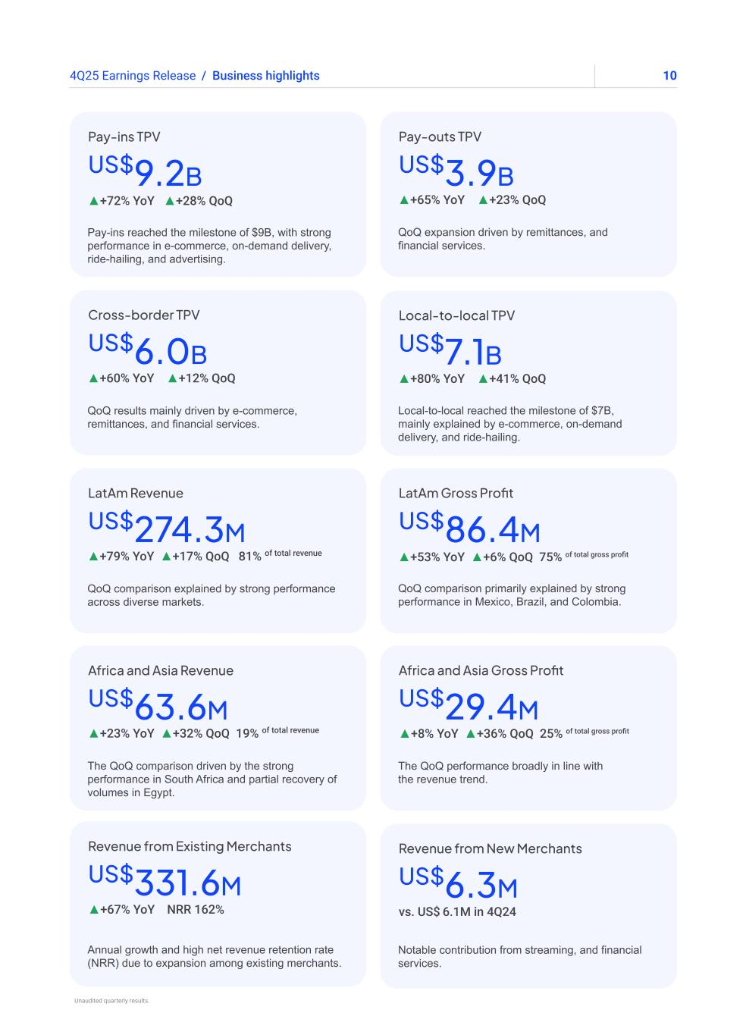
104Q25 Earnings Release Pay-ins reached the milestone of $9B, with strong performance in e-commerce, on-demand delivery, ride-hailing, and advertising. US$9.2B ▲+72% YoY ▲+28% QoQ Pay-ins TPV QoQ comparison primarily explained by strong performance in Mexico, Brazil, and Colombia. US$86.4M ▲+53% YoY ▲+6% QoQ 75% of total gross profit LatAm Gross Profit QoQ results mainly driven by e-commerce, remittances, and financial services. US$6.0B ▲+60% YoY ▲+12% QoQ Cross-border TPV The QoQ performance broadly in line with the revenue trend. US$29.4M Africa and Asia Gross Profit ▲+8% YoY ▲+36% QoQ 25% of total gross profit Local-to-local reached the milestone of $7B, mainly explained by e-commerce, on-demand delivery, and ride-hailing. US$7.1B ▲+80% YoY ▲+41% QoQ Local-to-local TPV Annual growth and high net revenue retention rate (NRR) due to expansion among existing merchants. US$331.6M Revenue from Existing Merchants ▲+67% YoY NRR 162% QoQ comparison explained by strong performance across diverse markets. US$274.3M ▲+79% YoY ▲+17% QoQ 81% of total revenue LatAm Revenue Notable contribution from streaming, and financial services. US$6.3M Revenue from New Merchants vs. US$ 6.1M in 4Q24 QoQ expansion driven by remittances, and financial services. US$3.9B ▲+65% YoY ▲+23% QoQ Pay-outs TPV / Business highlights The QoQ comparison driven by the strong performance in South Africa and partial recovery of volumes in Egypt. Africa and Asia Revenue US$63.6M ▲+23% YoY ▲+32% QoQ 19% of total revenue Unaudited quarterly results.

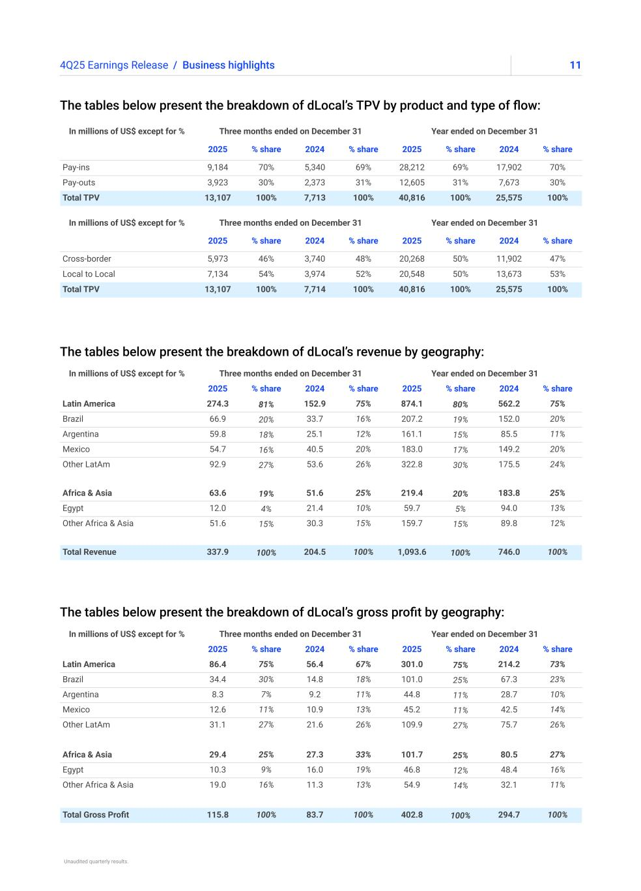
114Q25 Earnings Release The tables below present the breakdown of dLocal’s TPV by product and type of flow: The tables below present the breakdown of dLocal’s revenue by geography: The tables below present the breakdown of dLocal’s gross profit by geography: / Business highlights In millions of US$ except for % Three months ended on December 31 Year ended on December 31 2025 % share 2024 % share 2025 % share 2024 % share Latin America 86.4 75% 56.4 67% 301.0 75% 214.2 73% Brazil 34.4 30% 14.8 18% 101.0 25% 67.3 23% Argentina 8.3 7% 9.2 11% 44.8 11% 28.7 10% Mexico 12.6 11% 10.9 13% 45.2 11% 42.5 14% Other LatAm 31.1 27% 21.6 26% 109.9 27% 75.7 26% Africa & Asia 29.4 25% 27.3 33% 101.7 25% 80.5 27% Egypt 10.3 9% 16.0 19% 46.8 12% 48.4 16% Other Africa & Asia 19.0 16% 11.3 13% 54.9 14% 32.1 11% Total Gross Profit 115.8 100% 83.7 100% 402.8 100% 294.7 100% In millions of US$ except for % Three months ended on December 31 Year ended on December 31 2025 % share 2024 % share 2025 % share 2024 % share Latin America 274.3 81% 152.9 75% 874.1 80% 562.2 75% Brazil 66.9 20% 33.7 16% 207.2 19% 152.0 20% Argentina 59.8 18% 25.1 12% 161.1 15% 85.5 11% Mexico 54.7 16% 40.5 20% 183.0 17% 149.2 20% Other LatAm 92.9 27% 53.6 26% 322.8 30% 175.5 24% Africa & Asia 63.6 19% 51.6 25% 219.4 20% 183.8 25% Egypt 12.0 4% 21.4 10% 59.7 5% 94.0 13% Other Africa & Asia 51.6 15% 30.3 15% 159.7 15% 89.8 12% Total Revenue 337.9 100% 204.5 100% 1,093.6 100% 746.0 100% In millions of US$ except for % Three months ended on December 31 Year ended on December 31 2025 % share 2024 % share 2025 % share 2024 % share Cross-border 5,973 46% 3,740 48% 20,268 50% 11,902 47% Local to Local 7,134 54% 3,974 52% 20,548 50% 13,673 53% Total TPV 13,107 100% 7,714 100% 40,816 100% 25,575 100% In millions of US$ except for % Three months ended on December 31 Year ended on December 31 2025 % share 2024 % share 2025 % share 2024 % share Pay-ins 9,184 70% 5,340 69% 28,212 69% 17,902 70% Pay-outs 3,923 30% 2,373 31% 12,605 31% 7,673 30% Total TPV 13,107 100% 7,713 100% 40,816 100% 25,575 100% Unaudited quarterly results.


124Q25 Earnings Release Financial highlights Earnings Release Q125

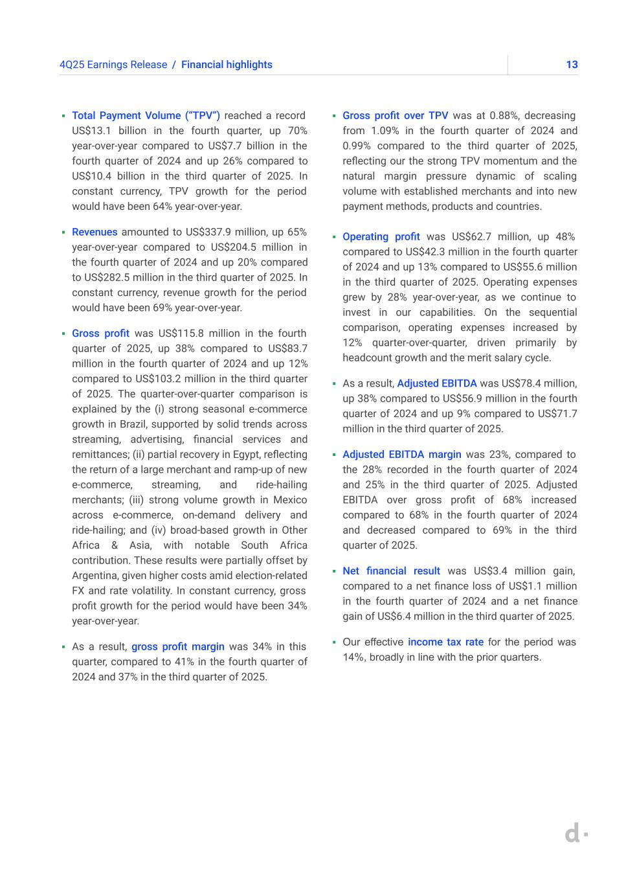
134Q25 Earnings Release / Financial highlights ▪ Total Payment Volume (“TPV”) reached a record US$13.1 billion in the fourth quarter, up 70% year-over-year compared to US$7.7 billion in the fourth quarter of 2024 and up 26% compared to US$10.4 billion in the third quarter of 2025. In constant currency, TPV growth for the period would have been 64% year-over-year. ▪ Revenues amounted to US$337.9 million, up 65% year-over-year compared to US$204.5 million in the fourth quarter of 2024 and up 20% compared to US$282.5 million in the third quarter of 2025. In constant currency, revenue growth for the period would have been 69% year-over-year. ▪ Gross profit was US$115.8 million in the fourth quarter of 2025, up 38% compared to US$83.7 million in the fourth quarter of 2024 and up 12% compared to US$103.2 million in the third quarter of 2025. The quarter-over-quarter comparison is explained by the (i) strong seasonal e-commerce growth in Brazil, supported by solid trends across streaming, advertising, financial services and remittances; (ii) partial recovery in Egypt, reflecting the return of a large merchant and ramp-up of new e-commerce, streaming, and ride-hailing merchants; (iii) strong volume growth in Mexico across e-commerce, on-demand delivery and ride-hailing; and (iv) broad-based growth in Other Africa & Asia, with notable South Africa contribution. These results were partially offset by Argentina, given higher costs amid election-related FX and rate volatility. In constant currency, gross profit growth for the period would have been 34% year-over-year. ▪ As a result, gross profit margin was 34% in this quarter, compared to 41% in the fourth quarter of 2024 and 37% in the third quarter of 2025. ▪ Gross profit over TPV was at 0.88%, decreasing from 1.09% in the fourth quarter of 2024 and 0.99% compared to the third quarter of 2025, reflecting our the strong TPV momentum and the natural margin pressure dynamic of scaling volume with established merchants and into new payment methods, products and countries. ▪ Operating profit was US$62.7 million, up 48% compared to US$42.3 million in the fourth quarter of 2024 and up 13% compared to US$55.6 million in the third quarter of 2025. Operating expenses grew by 28% year-over-year, as we continue to invest in our capabilities. On the sequential comparison, operating expenses increased by 12% quarter-over-quarter, driven primarily by headcount growth and the merit salary cycle. ▪ As a result, Adjusted EBITDA was US$78.4 million, up 38% compared to US$56.9 million in the fourth quarter of 2024 and up 9% compared to US$71.7 million in the third quarter of 2025. ▪ Adjusted EBITDA margin was 23%, compared to the 28% recorded in the fourth quarter of 2024 and 25% in the third quarter of 2025. Adjusted EBITDA over gross profit of 68% increased compared to 68% in the fourth quarter of 2024 and decreased compared to 69% in the third quarter of 2025. ▪ Net financial result was US$3.4 million gain, compared to a net finance loss of US$1.1 million in the fourth quarter of 2024 and a net finance gain of US$6.4 million in the third quarter of 2025. ▪ Our effective income tax rate for the period was 14%, broadly in line with the prior quarters.

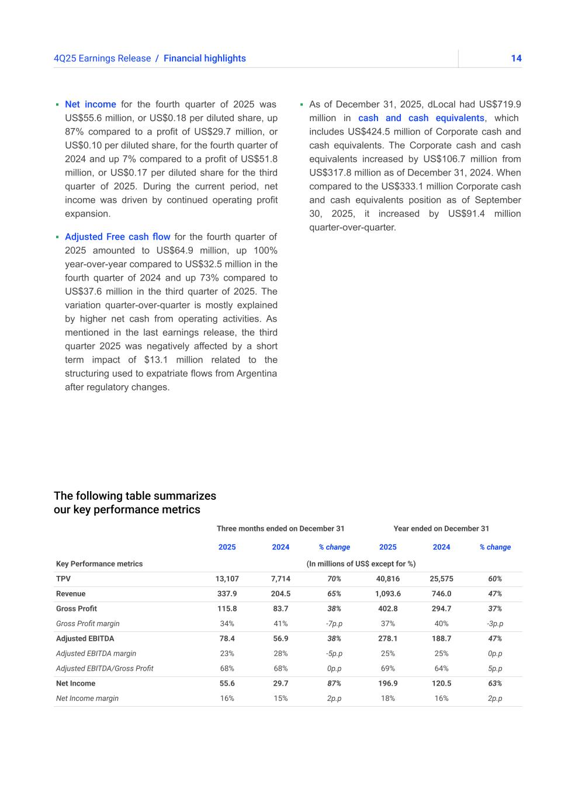
144Q25 Earnings Release The following table summarizes our key performance metrics ▪ Net income for the fourth quarter of 2025 was US$55.6 million, or US$0.18 per diluted share, up 87% compared to a profit of US$29.7 million, or US$0.10 per diluted share, for the fourth quarter of 2024 and up 7% compared to a profit of US$51.8 million, or US$0.17 per diluted share for the third quarter of 2025. During the current period, net income was driven by continued operating profit expansion. ▪ Adjusted Free cash flow for the fourth quarter of 2025 amounted to US$64.9 million, up 100% year-over-year compared to US$32.5 million in the fourth quarter of 2024 and up 73% compared to US$37.6 million in the third quarter of 2025. The variation quarter-over-quarter is mostly explained by higher net cash from operating activities. As mentioned in the last earnings release, the third quarter 2025 was negatively affected by a short term impact of $13.1 million related to the structuring used to expatriate flows from Argentina after regulatory changes. ▪ As of December 31, 2025, dLocal had US$719.9 million in cash and cash equivalents, which includes US$424.5 million of Corporate cash and cash equivalents. The Corporate cash and cash equivalents increased by US$106.7 million from US$317.8 million as of December 31, 2024. When compared to the US$333.1 million Corporate cash and cash equivalents position as of September 30, 2025, it increased by US$91.4 million quarter-over-quarter. / Financial highlights Three months ended on December 31 Year ended on December 31 2025 2024 % change 2025 2024 % change Key Performance metrics (In millions of US$ except for %) TPV 13,107 7,714 70% 40,816 25,575 60% Revenue 337.9 204.5 65% 1,093.6 746.0 47% Gross Profit 115.8 83.7 38% 402.8 294.7 37% Gross Profit margin 34% 41% -7p.p 37% 40% -3p.p Adjusted EBITDA 78.4 56.9 38% 278.1 188.7 47% Adjusted EBITDA margin 23% 28% -5p.p 25% 25% 0p.p Adjusted EBITDA/Gross Profit 68% 68% 0p.p 69% 64% 5p.p Net Income 55.6 29.7 87% 196.9 120.5 63% Net Income margin 16% 15% 2p.p 18% 16% 2p.p

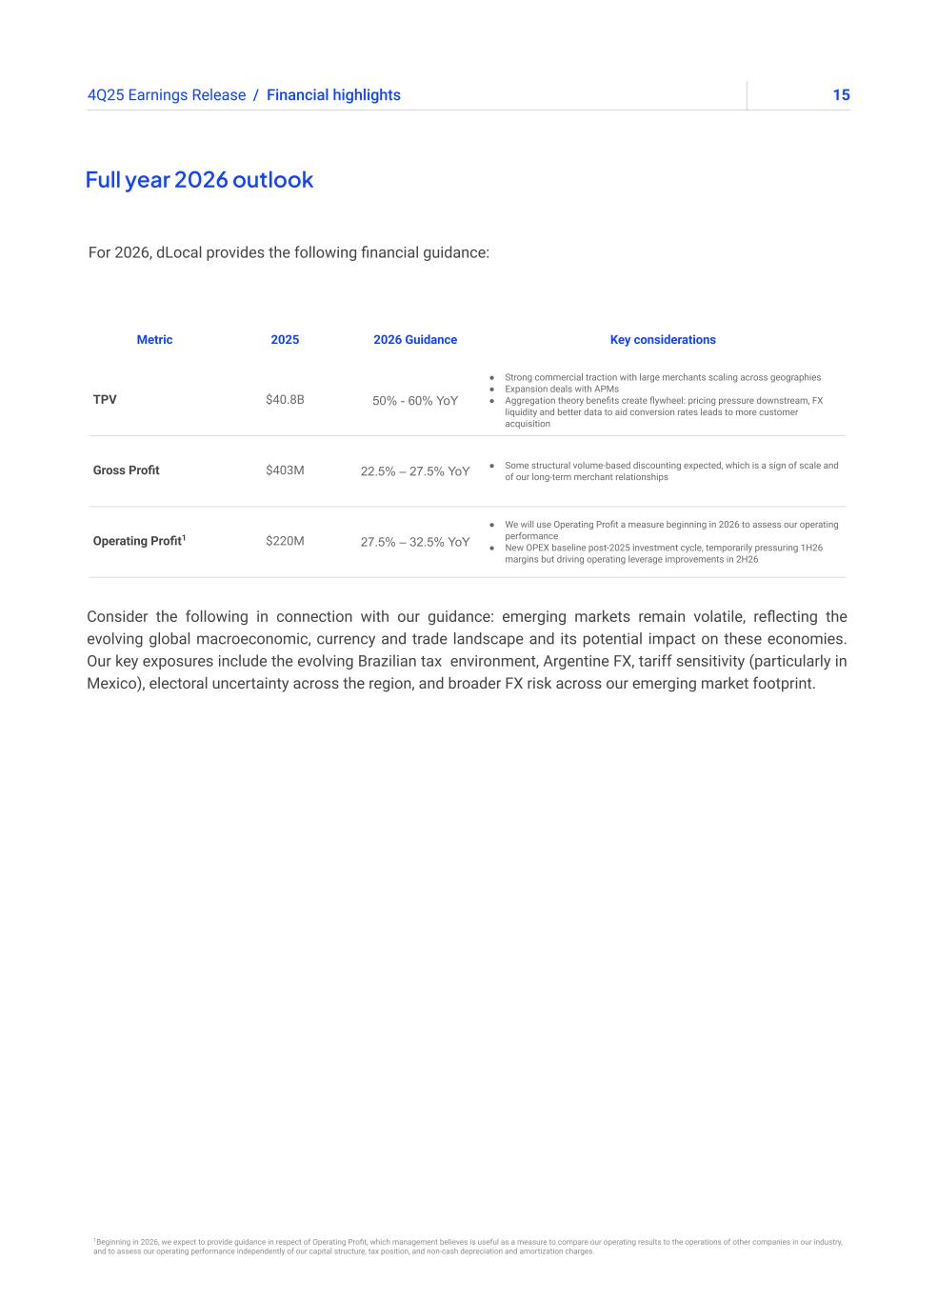
154Q25 Earnings Release / Financial highlights Full year 2026 outlook Metric 2025 2026 Guidance Key considerations TPV $40.8B 50% - 60% YoY ● Strong commercial traction with large merchants scaling across geographies ● Expansion deals with APMs ● Aggregation theory benefits create flywheel: pricing pressure downstream, FX liquidity and better data to aid conversion rates leads to more customer acquisition Gross Profit $403M 22.5% – 27.5% YoY ● Some structural volume-based discounting expected, which is a sign of scale and of our long-term merchant relationships Operating Profit1 $220M 27.5% – 32.5% YoY ● We will use Operating Profit a measure beginning in 2026 to assess our operating performance ● New OPEX baseline post-2025 investment cycle, temporarily pressuring 1H26 margins but driving operating leverage improvements in 2H26 For 2026, dLocal provides the following financial guidance: Consider the following in connection with our guidance: emerging markets remain volatile, reflecting the evolving global macroeconomic, currency and trade landscape and its potential impact on these economies. Our key exposures include the evolving Brazilian tax environment, Argentine FX, tariff sensitivity (particularly in Mexico), electoral uncertainty across the region, and broader FX risk across our emerging market footprint. 1Beginning in 2026, we expect to provide guidance in respect of Operating Profit, which management believes is useful as a measure to compare our operating results to the operations of other companies in our industry, and to assess our operating performance independently of our capital structure, tax position, and non-cash depreciation and amortization charges.

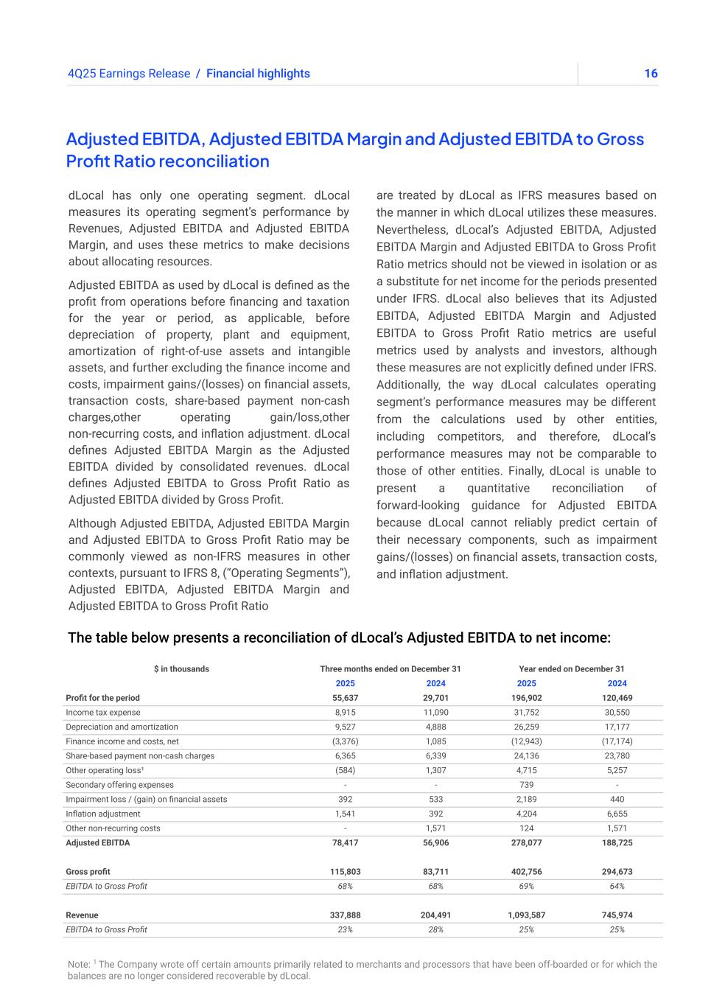
164Q25 Earnings Release The table below presents a reconciliation of dLocal’s Adjusted EBITDA to net income: Note: 1 The Company wrote off certain amounts primarily related to merchants and processors that have been off-boarded or for which the balances are no longer considered recoverable by dLocal. Adjusted EBITDA, Adjusted EBITDA Margin and Adjusted EBITDA to Gross Profit Ratio reconciliation / Financial highlights dLocal has only one operating segment. dLocal measures its operating segment’s performance by Revenues, Adjusted EBITDA and Adjusted EBITDA Margin, and uses these metrics to make decisions about allocating resources. Adjusted EBITDA as used by dLocal is defined as the profit from operations before financing and taxation for the year or period, as applicable, before depreciation of property, plant and equipment, amortization of right-of-use assets and intangible assets, and further excluding the finance income and costs, impairment gains/(losses) on financial assets, transaction costs, share-based payment non-cash charges,other operating gain/loss,other non-recurring costs, and inflation adjustment. dLocal defines Adjusted EBITDA Margin as the Adjusted EBITDA divided by consolidated revenues. dLocal defines Adjusted EBITDA to Gross Profit Ratio as Adjusted EBITDA divided by Gross Profit. Although Adjusted EBITDA, Adjusted EBITDA Margin and Adjusted EBITDA to Gross Profit Ratio may be commonly viewed as non-IFRS measures in other contexts, pursuant to IFRS 8, (“Operating Segments”), Adjusted EBITDA, Adjusted EBITDA Margin and Adjusted EBITDA to Gross Profit Ratio are treated by dLocal as IFRS measures based on the manner in which dLocal utilizes these measures. Nevertheless, dLocal’s Adjusted EBITDA, Adjusted EBITDA Margin and Adjusted EBITDA to Gross Profit Ratio metrics should not be viewed in isolation or as a substitute for net income for the periods presented under IFRS. dLocal also believes that its Adjusted EBITDA, Adjusted EBITDA Margin and Adjusted EBITDA to Gross Profit Ratio metrics are useful metrics used by analysts and investors, although these measures are not explicitly defined under IFRS. Additionally, the way dLocal calculates operating segment’s performance measures may be different from the calculations used by other entities, including competitors, and therefore, dLocal’s performance measures may not be comparable to those of other entities. Finally, dLocal is unable to present a quantitative reconciliation of forward-looking guidance for Adjusted EBITDA because dLocal cannot reliably predict certain of their necessary components, such as impairment gains/(losses) on financial assets, transaction costs, and inflation adjustment. $ in thousands Three months ended on December 31 Year ended on December 31 2025 2024 2025 2024 Profit for the period 55,637 29,701 196,902 120,469 Income tax expense 8,915 11,090 31,752 30,550 Depreciation and amortization 9,527 4,888 26,259 17,177 Finance income and costs, net (3,376) 1,085 (12,943) (17,174) Share-based payment non-cash charges 6,365 6,339 24,136 23,780 Other operating loss¹ (584) 1,307 4,715 5,257 Secondary offering expenses - - 739 - Impairment loss / (gain) on financial assets 392 533 2,189 440 Inflation adjustment 1,541 392 4,204 6,655 Other non-recurring costs - 1,571 124 1,571 Adjusted EBITDA 78,417 56,906 278,077 188,725 Gross profit 115,803 83,711 402,756 294,673 EBITDA to Gross Profit 68% 68% 69% 64% Revenue 337,888 204,491 1,093,587 745,974 EBITDA to Gross Profit 23% 28% 25% 25%

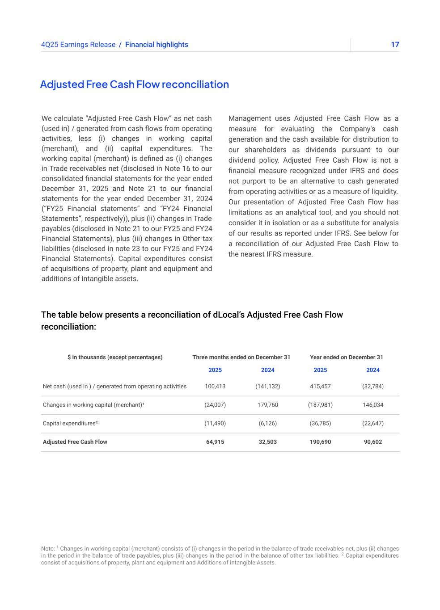
174Q25 Earnings Release Adjusted Free Cash Flow reconciliation We calculate “Adjusted Free Cash Flow” as net cash (used in) / generated from cash flows from operating activities, less (i) changes in working capital (merchant), and (ii) capital expenditures. The working capital (merchant) is defined as (i) changes in Trade receivables net (disclosed in Note 16 to our consolidated financial statements for the year ended December 31, 2025 and Note 21 to our financial statements for the year ended December 31, 2024 (“FY25 Financial statements” and “FY24 Financial Statements”, respectively)), plus (ii) changes in Trade payables (disclosed in Note 21 to our FY25 and FY24 Financial Statements), plus (iii) changes in Other tax liabilities (disclosed in note 23 to our FY25 and FY24 Financial Statements). Capital expenditures consist of acquisitions of property, plant and equipment and additions of intangible assets. Management uses Adjusted Free Cash Flow as a measure for evaluating the Company's cash generation and the cash available for distribution to our shareholders as dividends pursuant to our dividend policy. Adjusted Free Cash Flow is not a financial measure recognized under IFRS and does not purport to be an alternative to cash generated from operating activities or as a measure of liquidity. Our presentation of Adjusted Free Cash Flow has limitations as an analytical tool, and you should not consider it in isolation or as a substitute for analysis of our results as reported under IFRS. See below for a reconciliation of our Adjusted Free Cash Flow to the nearest IFRS measure. / Financial highlights The table below presents a reconciliation of dLocal’s Adjusted Free Cash Flow reconciliation: $ in thousands (except percentages) Three months ended on December 31 Year ended on December 31 2025 2024 2025 2024 Net cash (used in ) / generated from operating activities 100,413 (141,132) 415,457 (32,784) Changes in working capital (merchant)¹ (24,007) 179,760 (187,981) 146,034 Capital expenditures² (11,490) (6,126) (36,785) (22,647) Adjusted Free Cash Flow 64,915 32,503 190,690 90,602 Note: 1 Changes in working capital (merchant) consists of (i) changes in the period in the balance of trade receivables net, plus (ii) changes in the period in the balance of trade payables, plus (iii) changes in the period in the balance of other tax liabilities. 2 Capital expenditures consist of acquisitions of property, plant and equipment and Additions of Intangible Assets.

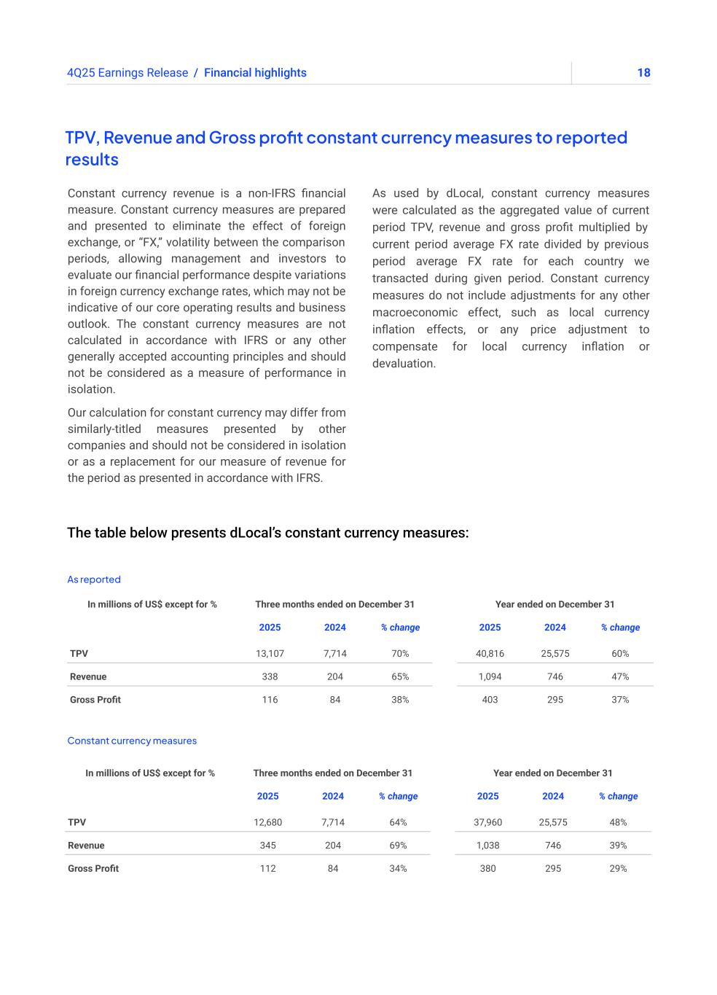
184Q25 Earnings Release The table below presents dLocal’s constant currency measures: TPV, Revenue and Gross profit constant currency measures to reported results Constant currency revenue is a non-IFRS financial measure. Constant currency measures are prepared and presented to eliminate the effect of foreign exchange, or “FX,” volatility between the comparison periods, allowing management and investors to evaluate our financial performance despite variations in foreign currency exchange rates, which may not be indicative of our core operating results and business outlook. The constant currency measures are not calculated in accordance with IFRS or any other generally accepted accounting principles and should not be considered as a measure of performance in isolation. Our calculation for constant currency may differ from similarly-titled measures presented by other companies and should not be considered in isolation or as a replacement for our measure of revenue for the period as presented in accordance with IFRS. As used by dLocal, constant currency measures were calculated as the aggregated value of current period TPV, revenue and gross profit multiplied by current period average FX rate divided by previous period average FX rate for each country we transacted during given period. Constant currency measures do not include adjustments for any other macroeconomic effect, such as local currency inflation effects, or any price adjustment to compensate for local currency inflation or devaluation. / Financial highlights As reported Constant currency measures In millions of US$ except for % Three months ended on December 31 Year ended on December 31 2025 2024 % change 2025 2024 % change TPV 13,107 7,714 70% 40,816 25,575 60% Revenue 338 204 65% 1,094 746 47% Gross Profit 116 84 38% 403 295 37% In millions of US$ except for % Three months ended on December 31 Year ended on December 31 2025 2024 % change 2025 2024 % change TPV 12,680 7,714 64% 37,960 25,575 48% Revenue 345 204 69% 1,038 746 39% Gross Profit 112 84 34% 380 295 29%

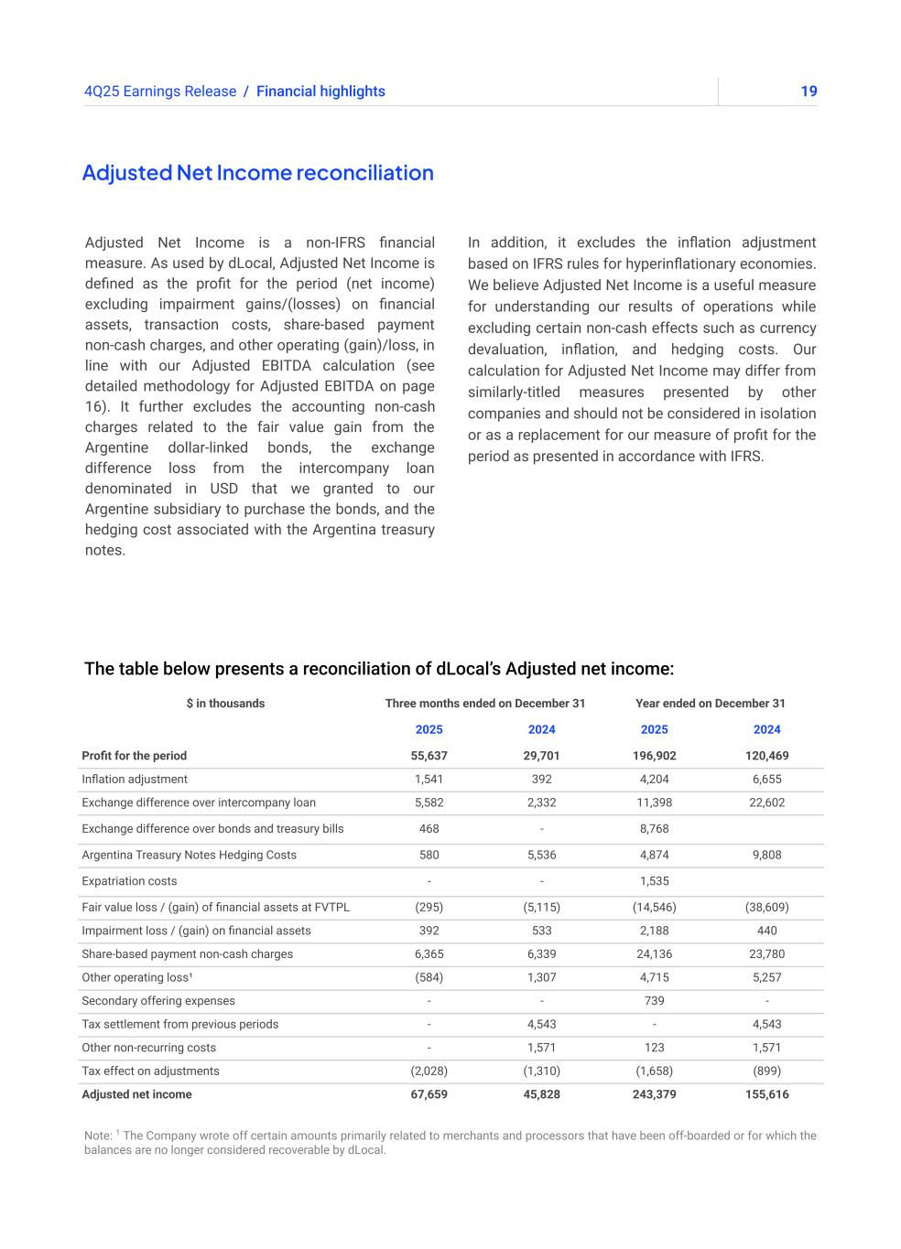
194Q25 Earnings Release The table below presents a reconciliation of dLocal’s Adjusted net income: Note: 1 The Company wrote off certain amounts primarily related to merchants and processors that have been off-boarded or for which the balances are no longer considered recoverable by dLocal. Adjusted Net Income reconciliation Adjusted Net Income is a non-IFRS financial measure. As used by dLocal, Adjusted Net Income is defined as the profit for the period (net income) excluding impairment gains/(losses) on financial assets, transaction costs, share-based payment non-cash charges, and other operating (gain)/loss, in line with our Adjusted EBITDA calculation (see detailed methodology for Adjusted EBITDA on page 16). It further excludes the accounting non-cash charges related to the fair value gain from the Argentine dollar-linked bonds, the exchange difference loss from the intercompany loan denominated in USD that we granted to our Argentine subsidiary to purchase the bonds, and the hedging cost associated with the Argentina treasury notes. In addition, it excludes the inflation adjustment based on IFRS rules for hyperinflationary economies. We believe Adjusted Net Income is a useful measure for understanding our results of operations while excluding certain non-cash effects such as currency devaluation, inflation, and hedging costs. Our calculation for Adjusted Net Income may differ from similarly-titled measures presented by other companies and should not be considered in isolation or as a replacement for our measure of profit for the period as presented in accordance with IFRS. / Financial highlights $ in thousands Three months ended on December 31 Year ended on December 31 2025 2024 2025 2024 Profit for the period 55,637 29,701 196,902 120,469 Inflation adjustment 1,541 392 4,204 6,655 Exchange difference over intercompany loan 5,582 2,332 11,398 22,602 Exchange difference over bonds and treasury bills 468 - 8,768 Argentina Treasury Notes Hedging Costs 580 5,536 4,874 9,808 Expatriation costs - - 1,535 Fair value loss / (gain) of financial assets at FVTPL (295) (5,115) (14,546) (38,609) Impairment loss / (gain) on financial assets 392 533 2,188 440 Share-based payment non-cash charges 6,365 6,339 24,136 23,780 Other operating loss¹ (584) 1,307 4,715 5,257 Secondary offering expenses - - 739 - Tax settlement from previous periods - 4,543 - 4,543 Other non-recurring costs - 1,571 123 1,571 Tax effect on adjustments (2,028) (1,310) (1,658) (899) Adjusted net income 67,659 45,828 243,379 155,616

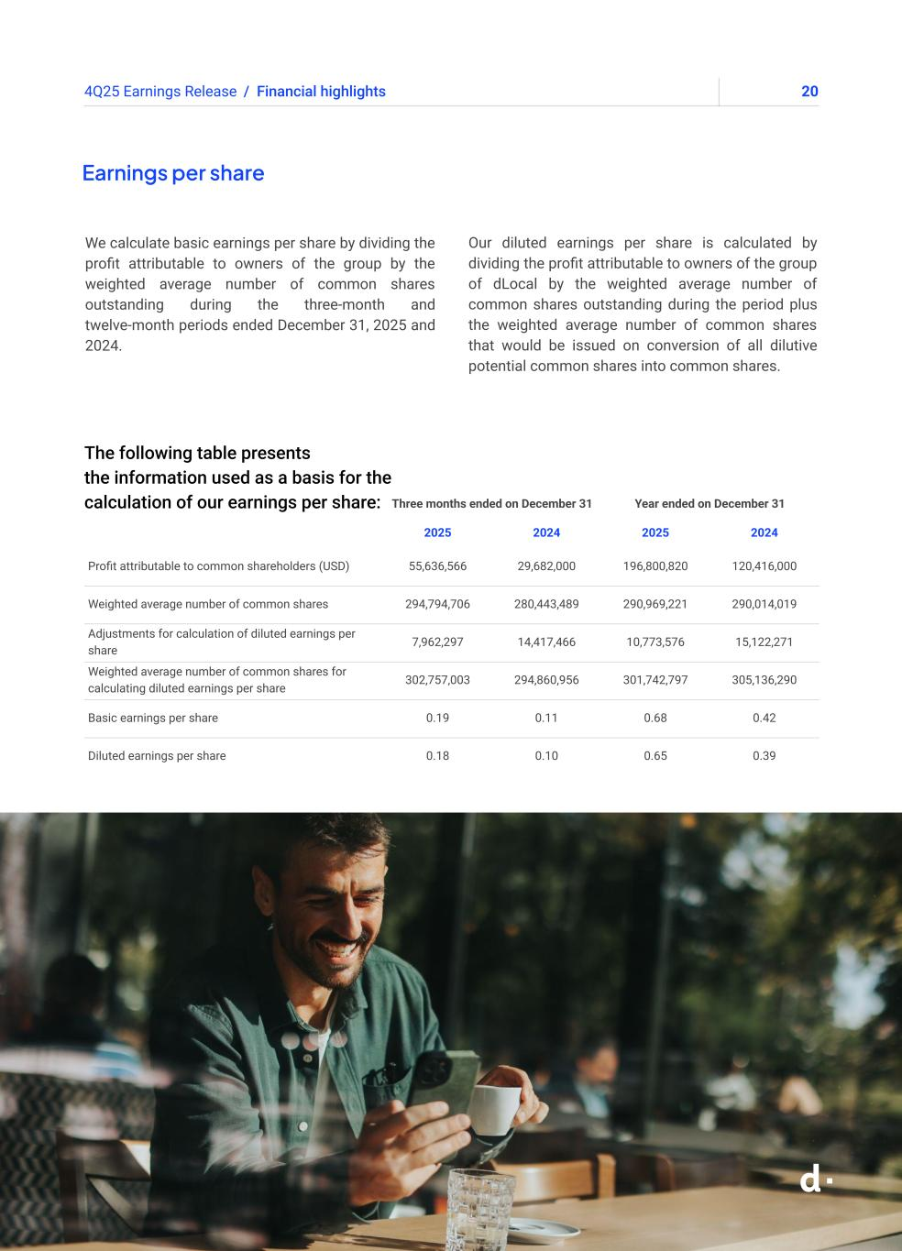
204Q25 Earnings Release Earnings per share We calculate basic earnings per share by dividing the profit attributable to owners of the group by the weighted average number of common shares outstanding during the three-month and twelve-month periods ended December 31, 2025 and 2024. Our diluted earnings per share is calculated by dividing the profit attributable to owners of the group of dLocal by the weighted average number of common shares outstanding during the period plus the weighted average number of common shares that would be issued on conversion of all dilutive potential common shares into common shares. / Financial highlights Three months ended on December 31 Year ended on December 31 2025 2024 2025 2024 Profit attributable to common shareholders (USD) 55,636,566 29,682,000 196,800,820 120,416,000 Weighted average number of common shares 294,794,706 280,443,489 290,969,221 290,014,019 Adjustments for calculation of diluted earnings per share 7,962,297 14,417,466 10,773,576 15,122,271 Weighted average number of common shares for calculating diluted earnings per share 302,757,003 294,860,956 301,742,797 305,136,290 Basic earnings per share 0.19 0.11 0.68 0.42 Diluted earnings per share 0.18 0.10 0.65 0.39 The following table presents the information used as a basis for the calculation of our earnings per share:


214Q25 Earnings Release Appendix

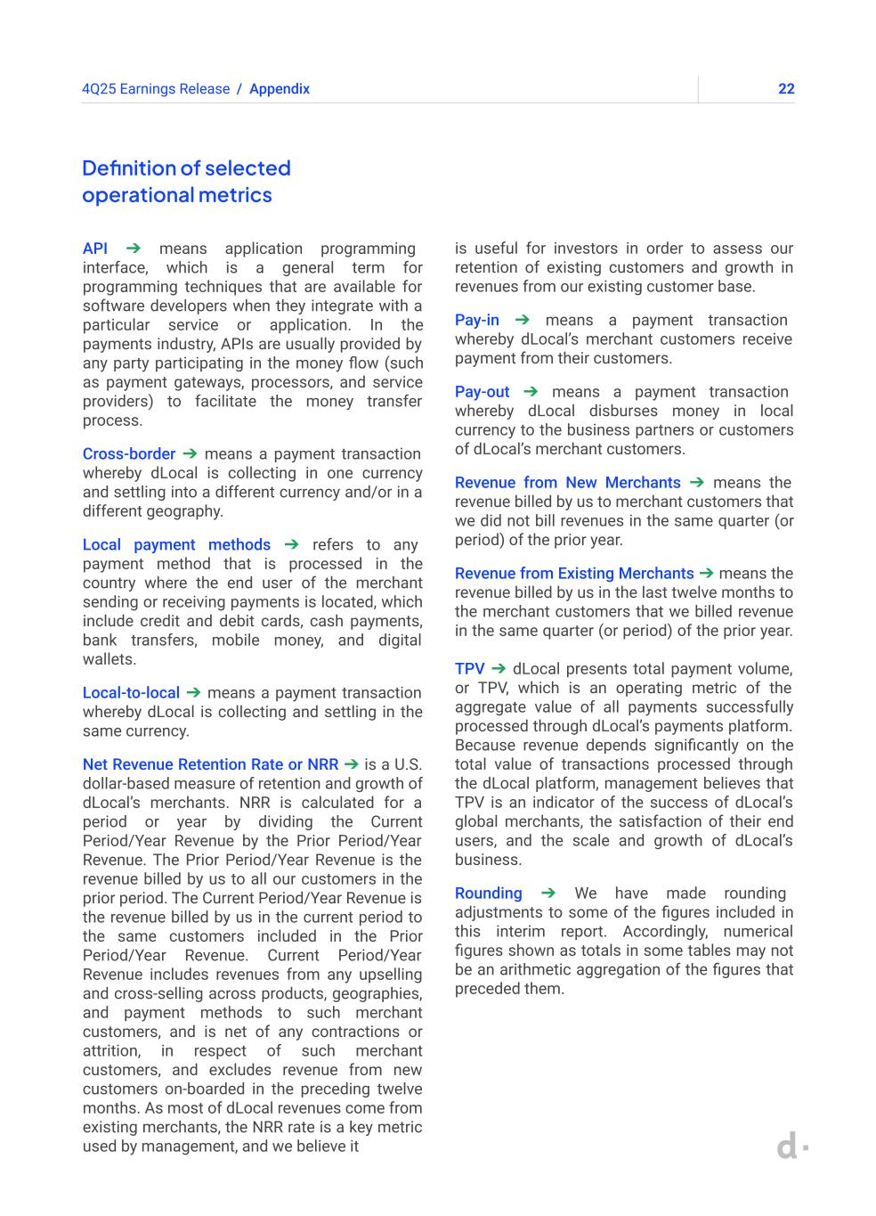
224Q25 Earnings Release Definition of selected operational metrics API ➔ means application programming interface, which is a general term for programming techniques that are available for software developers when they integrate with a particular service or application. In the payments industry, APIs are usually provided by any party participating in the money flow (such as payment gateways, processors, and service providers) to facilitate the money transfer process. Cross-border ➔ means a payment transaction whereby dLocal is collecting in one currency and settling into a different currency and/or in a different geography. Local payment methods ➔ refers to any payment method that is processed in the country where the end user of the merchant sending or receiving payments is located, which include credit and debit cards, cash payments, bank transfers, mobile money, and digital wallets. Local-to-local ➔ means a payment transaction whereby dLocal is collecting and settling in the same currency. Net Revenue Retention Rate or NRR ➔ is a U.S. dollar-based measure of retention and growth of dLocal’s merchants. NRR is calculated for a period or year by dividing the Current Period/Year Revenue by the Prior Period/Year Revenue. The Prior Period/Year Revenue is the revenue billed by us to all our customers in the prior period. The Current Period/Year Revenue is the revenue billed by us in the current period to the same customers included in the Prior Period/Year Revenue. Current Period/Year Revenue includes revenues from any upselling and cross-selling across products, geographies, and payment methods to such merchant customers, and is net of any contractions or attrition, in respect of such merchant customers, and excludes revenue from new customers on-boarded in the preceding twelve months. As most of dLocal revenues come from existing merchants, the NRR rate is a key metric used by management, and we believe it is useful for investors in order to assess our retention of existing customers and growth in revenues from our existing customer base. Pay-in ➔ means a payment transaction whereby dLocal’s merchant customers receive payment from their customers. Pay-out ➔ means a payment transaction whereby dLocal disburses money in local currency to the business partners or customers of dLocal’s merchant customers. Revenue from New Merchants ➔ means the revenue billed by us to merchant customers that we did not bill revenues in the same quarter (or period) of the prior year. Revenue from Existing Merchants ➔ means the revenue billed by us in the last twelve months to the merchant customers that we billed revenue in the same quarter (or period) of the prior year. TPV ➔ dLocal presents total payment volume, or TPV, which is an operating metric of the aggregate value of all payments successfully processed through dLocal’s payments platform. Because revenue depends significantly on the total value of transactions processed through the dLocal platform, management believes that TPV is an indicator of the success of dLocal’s global merchants, the satisfaction of their end users, and the scale and growth of dLocal’s business. Rounding ➔ We have made rounding adjustments to some of the figures included in this interim report. Accordingly, numerical figures shown as totals in some tables may not be an arithmetic aggregation of the figures that preceded them. / Appendix

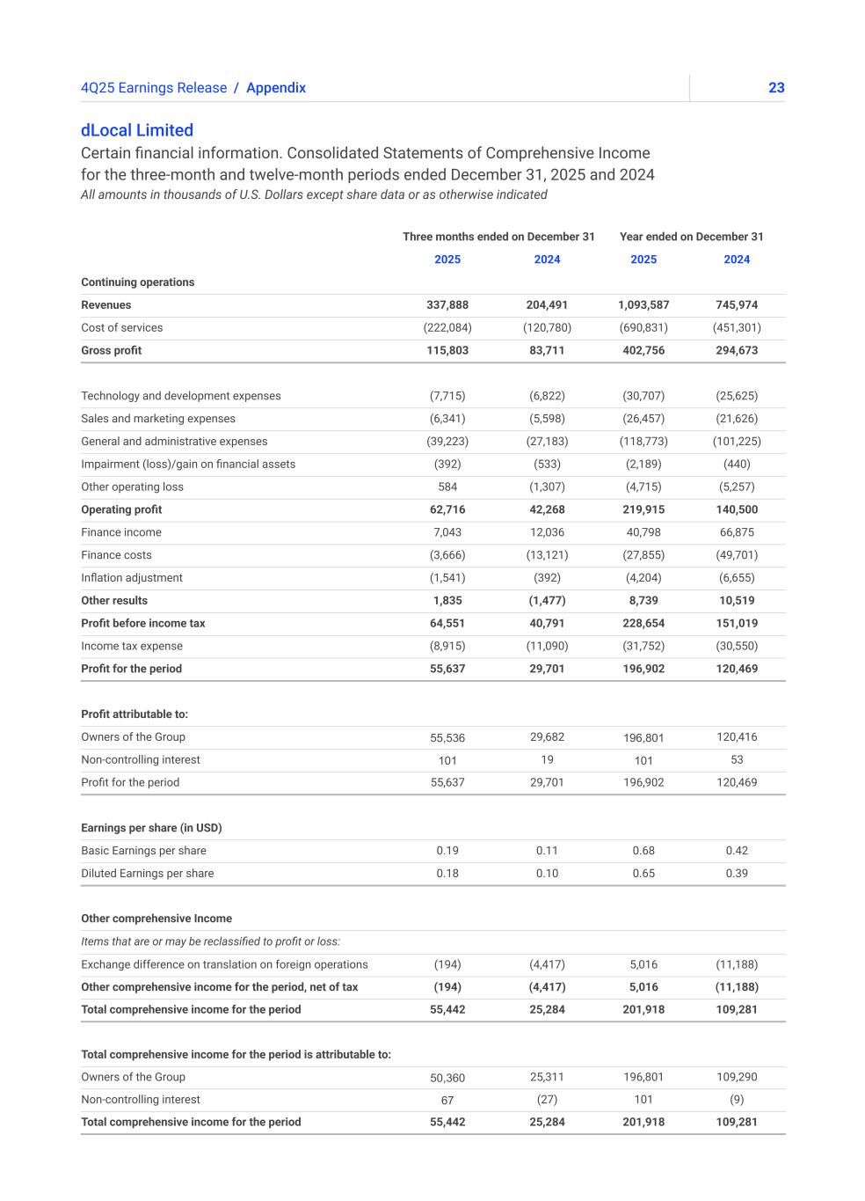
234Q25 Earnings Release / Appendix dLocal Limited Certain financial information. Consolidated Statements of Comprehensive Income for the three-month and twelve-month periods ended December 31, 2025 and 2024 All amounts in thousands of U.S. Dollars except share data or as otherwise indicated Three months ended on December 31 Year ended on December 31 2025 2024 2025 2024 Continuing operations Revenues 337,888 204,491 1,093,587 745,974 Cost of services (222,084) (120,780) (690,831) (451,301) Gross profit 115,803 83,711 402,756 294,673 Technology and development expenses (7,715) (6,822) (30,707) (25,625) Sales and marketing expenses (6,341) (5,598) (26,457) (21,626) General and administrative expenses (39,223) (27,183) (118,773) (101,225) Impairment (loss)/gain on financial assets (392) (533) (2,189) (440) Other operating loss 584 (1,307) (4,715) (5,257) Operating profit 62,716 42,268 219,915 140,500 Finance income 7,043 12,036 40,798 66,875 Finance costs (3,666) (13,121) (27,855) (49,701) Inflation adjustment (1,541) (392) (4,204) (6,655) Other results 1,835 (1,477) 8,739 10,519 Profit before income tax 64,551 40,791 228,654 151,019 Income tax expense (8,915) (11,090) (31,752) (30,550) Profit for the period 55,637 29,701 196,902 120,469 Profit attributable to: Owners of the Group 55,536 29,682 196,801 120,416 Non-controlling interest 101 19 101 53 Profit for the period 55,637 29,701 196,902 120,469 Earnings per share (in USD) Basic Earnings per share 0.19 0.11 0.68 0.42 Diluted Earnings per share 0.18 0.10 0.65 0.39 Other comprehensive Income Items that are or may be reclassified to profit or loss: Exchange difference on translation on foreign operations (194) (4,417) 5,016 (11,188) Other comprehensive income for the period, net of tax (194) (4,417) 5,016 (11,188) Total comprehensive income for the period 55,442 25,284 201,918 109,281 Total comprehensive income for the period is attributable to: Owners of the Group 50,360 25,311 196,801 109,290 Non-controlling interest 67 (27) 101 (9) Total comprehensive income for the period 55,442 25,284 201,918 109,281

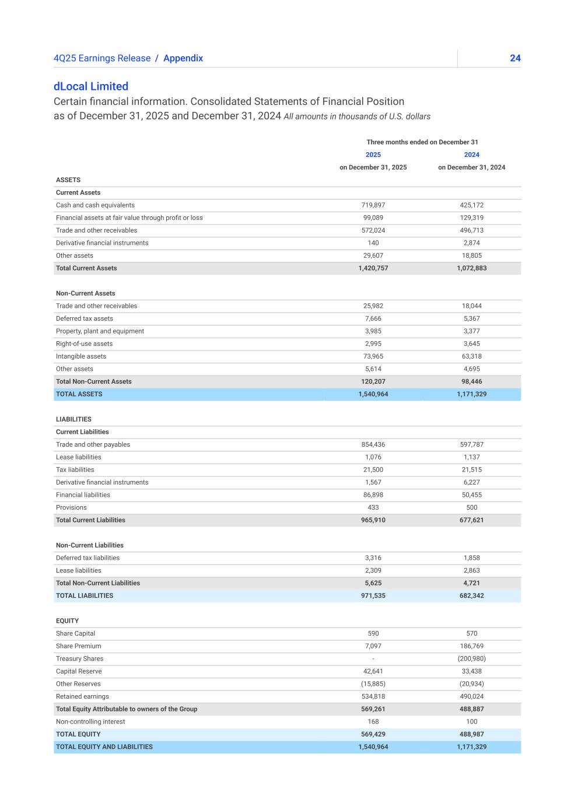
244Q25 Earnings Release / Appendix dLocal Limited Certain financial information. Consolidated Statements of Financial Position as of December 31, 2025 and December 31, 2024 All amounts in thousands of U.S. dollars Three months ended on December 31 2025 2024 on December 31, 2025 on December 31, 2024 ASSETS Current Assets Cash and cash equivalents 719,897 425,172 Financial assets at fair value through profit or loss 99,089 129,319 Trade and other receivables 572,024 496,713 Derivative financial instruments 140 2,874 Other assets 29,607 18,805 Total Current Assets 1,420,757 1,072,883 Non-Current Assets Trade and other receivables 25,982 18,044 Deferred tax assets 7,666 5,367 Property, plant and equipment 3,985 3,377 Right-of-use assets 2,995 3,645 Intangible assets 73,965 63,318 Other assets 5,614 4,695 Total Non-Current Assets 120,207 98,446 TOTAL ASSETS 1,540,964 1,171,329 LIABILITIES Current Liabilities Trade and other payables 854,436 597,787 Lease liabilities 1,076 1,137 Tax liabilities 21,500 21,515 Derivative financial instruments 1,567 6,227 Financial liabilities 86,898 50,455 Provisions 433 500 Total Current Liabilities 965,910 677,621 Non-Current Liabilities Deferred tax liabilities 3,316 1,858 Lease liabilities 2,309 2,863 Total Non-Current Liabilities 5,625 4,721 TOTAL LIABILITIES 971,535 682,342 EQUITY Share Capital 590 570 Share Premium 7,097 186,769 Treasury Shares - (200,980) Capital Reserve 42,641 33,438 Other Reserves (15,885) (20,934) Retained earnings 534,818 490,024 Total Equity Attributable to owners of the Group 569,261 488,887 Non-controlling interest 168 100 TOTAL EQUITY 569,429 488,987 TOTAL EQUITY AND LIABILITIES 1,540,964 1,171,329

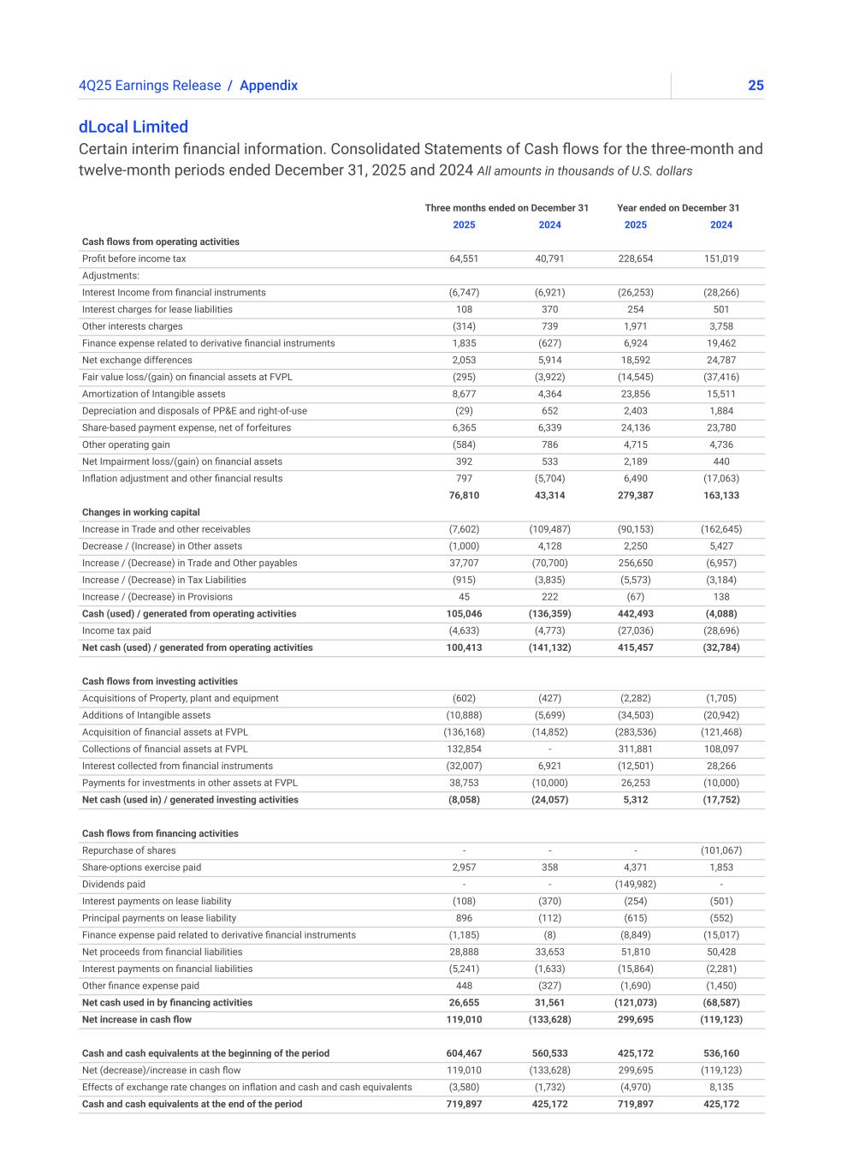
254Q25 Earnings Release / Appendix dLocal Limited Certain interim financial information. Consolidated Statements of Cash flows for the three-month and twelve-month periods ended December 31, 2025 and 2024 All amounts in thousands of U.S. dollars Three months ended on December 31 Year ended on December 31 2025 2024 2025 2024 Cash flows from operating activities Profit before income tax 64,551 40,791 228,654 151,019 Adjustments: Interest Income from financial instruments (6,747) (6,921) (26,253) (28,266) Interest charges for lease liabilities 108 370 254 501 Other interests charges (314) 739 1,971 3,758 Finance expense related to derivative financial instruments 1,835 (627) 6,924 19,462 Net exchange differences 2,053 5,914 18,592 24,787 Fair value loss/(gain) on financial assets at FVPL (295) (3,922) (14,545) (37,416) Amortization of Intangible assets 8,677 4,364 23,856 15,511 Depreciation and disposals of PP&E and right-of-use (29) 652 2,403 1,884 Share-based payment expense, net of forfeitures 6,365 6,339 24,136 23,780 Other operating gain (584) 786 4,715 4,736 Net Impairment loss/(gain) on financial assets 392 533 2,189 440 Inflation adjustment and other financial results 797 (5,704) 6,490 (17,063) 76,810 43,314 279,387 163,133 Changes in working capital Increase in Trade and other receivables (7,602) (109,487) (90,153) (162,645) Decrease / (Increase) in Other assets (1,000) 4,128 2,250 5,427 Increase / (Decrease) in Trade and Other payables 37,707 (70,700) 256,650 (6,957) Increase / (Decrease) in Tax Liabilities (915) (3,835) (5,573) (3,184) Increase / (Decrease) in Provisions 45 222 (67) 138 Cash (used) / generated from operating activities 105,046 (136,359) 442,493 (4,088) Income tax paid (4,633) (4,773) (27,036) (28,696) Net cash (used) / generated from operating activities 100,413 (141,132) 415,457 (32,784) Cash flows from investing activities Acquisitions of Property, plant and equipment (602) (427) (2,282) (1,705) Additions of Intangible assets (10,888) (5,699) (34,503) (20,942) Acquisition of financial assets at FVPL (136,168) (14,852) (283,536) (121,468) Collections of financial assets at FVPL 132,854 - 311,881 108,097 Interest collected from financial instruments (32,007) 6,921 (12,501) 28,266 Payments for investments in other assets at FVPL 38,753 (10,000) 26,253 (10,000) Net cash (used in) / generated investing activities (8,058) (24,057) 5,312 (17,752) Cash flows from financing activities Repurchase of shares - - - (101,067) Share-options exercise paid 2,957 358 4,371 1,853 Dividends paid - - (149,982) - Interest payments on lease liability (108) (370) (254) (501) Principal payments on lease liability 896 (112) (615) (552) Finance expense paid related to derivative financial instruments (1,185) (8) (8,849) (15,017) Net proceeds from financial liabilities 28,888 33,653 51,810 50,428 Interest payments on financial liabilities (5,241) (1,633) (15,864) (2,281) Other finance expense paid 448 (327) (1,690) (1,450) Net cash used in by financing activities 26,655 31,561 (121,073) (68,587) Net increase in cash flow 119,010 (133,628) 299,695 (119,123) Cash and cash equivalents at the beginning of the period 604,467 560,533 425,172 536,160 Net (decrease)/increase in cash flow 119,010 (133,628) 299,695 (119,123) Effects of exchange rate changes on inflation and cash and cash equivalents (3,580) (1,732) (4,970) 8,135 Cash and cash equivalents at the end of the period 719,897 425,172 719,897 425,172


264Q25 Earnings Release dLocal powers local payments in emerging markets, connecting global enterprise merchants with billions of emerging market consumers across APAC, the Middle East, Latin America, and Africa. Through the “One dLocal” concept (one direct API, one platform, and one contract), global companies can accept payments, send payouts, and settle funds globally without the need to manage multiple local entities and integrations. For more information, visit www.dlocal.com Conference call and webcast About dLocal dLocal’s management team will host a conference call and audio webcast on March 18, 2026 at 5:00 p.m. Eastern Time. Please click here to pre-register for the conference call and obtain your dial in number and passcode. The live conference call can be accessed via audio webcast at the investor relations section of dLocal’s website, at https://investor.dlocal.com/. An archive of the webcast will be available for a year following the conclusion of the conference call. The investor presentation will also be filed on EDGAR at www.sec.gov.


274Q25 Earnings Release Forward-looking statements This presentation may contain forward-looking statements. These forward-looking statements convey dLocal’s current expectations or forecasts of future events, including guidance in respect of total payment volume, gross profit and Operating Profit. Forward-looking statements regarding dLocal and amounts stated as guidance involve known and unknown risks, uncertainties and other factors that may cause dLocal’s actual results, performance or achievements to be materially different from any future results, performances or achievements expressed or implied by the forward-looking statements. Certain of these risks and uncertainties are described in the “Risk Factors,” and “Cautionary Statement Regarding Forward-Looking Statements” sections of dLocal’s filings with the U.S. Securities and Exchange Commission. Unless required by law, dLocal undertakes no obligation to publicly update or revise any forward-looking statements to reflect circumstances or events after the date hereof. Beginning in 2026, we expect to provide guidance in respect of Operating Profit, which management believes is useful as a measure to compare our operating results to the operations of other companies in our industry, and to assess our operating performance independently of our capital structure, tax position, and non-cash depreciation and amortization charges.


Investor Relations Contact investor@dlocal.com Media Contact media@dlocal.com This press release does not contain sufficient information to constitute an interim financial report as defined in International Accounting Standards 34, “Interim Financial Reporting” nor a financial statement as defined by International Accounting Standards 1 “Presentation of Financial Statements”. The fourth quarter financial information in this press release has not been audited nor has it been subject to any limited review procedures, whereas the annual results for the year ended December 31, 2025 are audited.


1Earnings Presentation Q1'25 ➔ 4Q25Earnings Presentation


24Q25 Earnings Presentation ➔ This presentation may contain forward-looking statements. These forward-looking statements convey dLocal’s current expectations or forecasts of future events, including guidance in respect of total payment volume, gross profit and Operating Profit. Forward-looking statements regarding dLocal and amounts stated as guidance involve known and unknown risks, uncertainties and other factors that may cause dLocal’s actual results, performance or achievements to be materially different from any future results, performances or achievements expressed or implied by the forward-looking statements. Certain of these risks and uncertainties are described in the “Risk Factors,” and “Cautionary Statement Regarding Forward-Looking Statements” sections of dLocal’s filings with the U.S. Securities and Exchange Commission. Unless required by law, dLocal undertakes no obligation to publicly update or revise any forward-looking statements to reflect circumstances or events after the date hereof. Beginning in 2026, we expect to provide guidance in respect of Operating Profit, which management believes is useful as a measure to compare our operating results to the operations of other companies in our industry, and to assess our operating performance independently of our capital structure, tax position, and non-cash depreciation and amortization charges.


34Q25 Earnings Presentation ➔ Pedro Arnt Chief Executive Officer Guillermo Lopez Perez Chief Financial Officer


44Q25 Earnings Presentation ➔ CEO Message

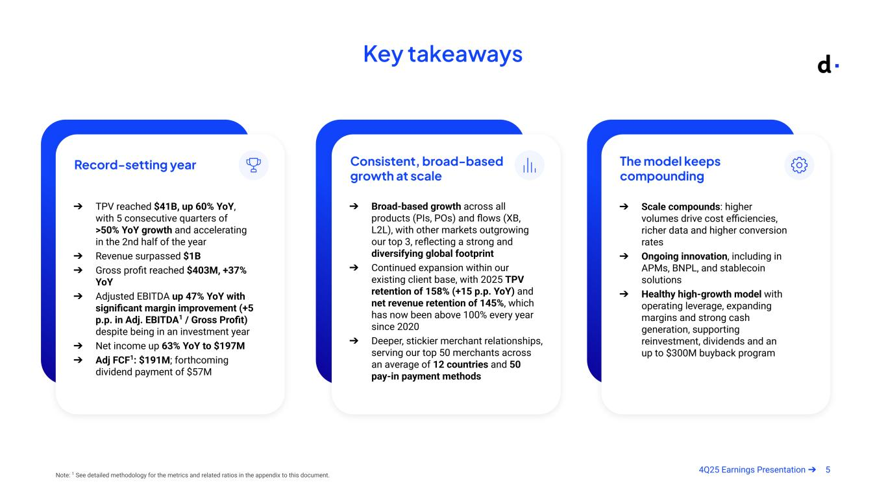
54Q25 Earnings Presentation ➔ Key takeaways Note: 1 See detailed methodology for the metrics and related ratios in the appendix to this document. Record-setting year ➔ TPV reached $41B, up 60% YoY, with 5 consecutive quarters of >50% YoY growth and accelerating in the 2nd half of the year ➔ Revenue surpassed $1B ➔ Gross profit reached $403M, +37% YoY ➔ Adjusted EBITDA up 47% YoY with significant margin improvement (+5 p.p. in Adj. EBITDA1 / Gross Profit) despite being in an investment year ➔ Net income up 63% YoY to $197M ➔ Adj FCF1: $191M; forthcoming dividend payment of $57M Consistent, broad-based growth at scale ➔ Broad-based growth across all products (PIs, POs) and flows (XB, L2L), with other markets outgrowing our top 3, reflecting a strong and diversifying global footprint ➔ Continued expansion within our existing client base, with 2025 TPV retention of 158% (+15 p.p. YoY) and net revenue retention of 145%, which has now been above 100% every year since 2020 ➔ Deeper, stickier merchant relationships, serving our top 50 merchants across an average of 12 countries and 50 pay-in payment methods The model keeps compounding ➔ Scale compounds: higher volumes drive cost efficiencies, richer data and higher conversion rates ➔ Ongoing innovation, including in APMs, BNPL, and stablecoin solutions ➔ Healthy high-growth model with operating leverage, expanding margins and strong cash generation, supporting reinvestment, dividends and an up to $300M buyback program

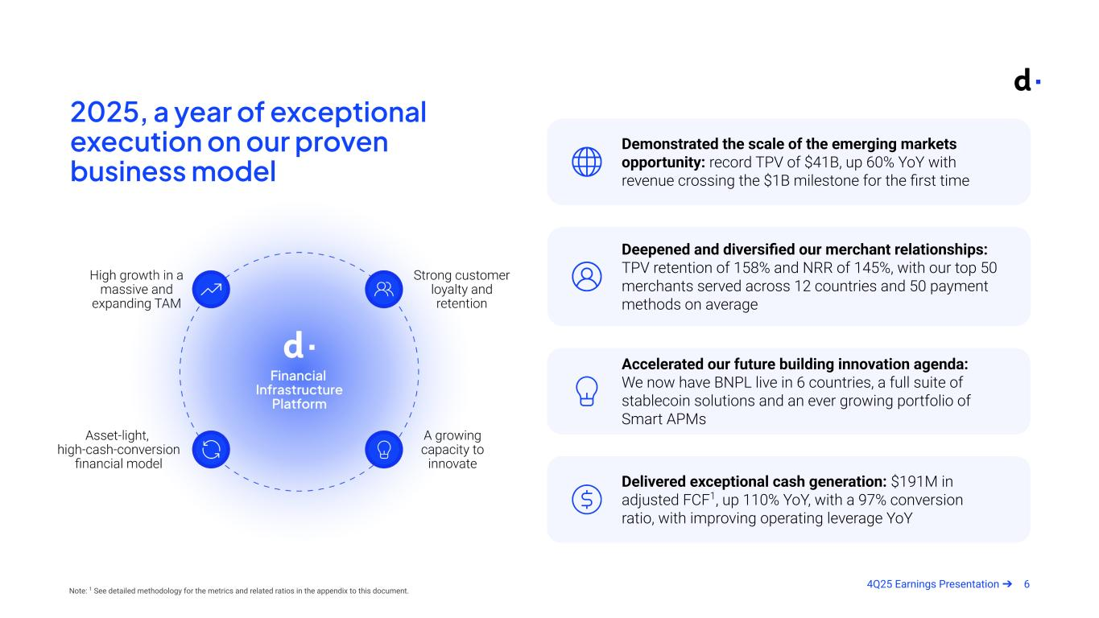
64Q25 Earnings Presentation ➔ 2025, a year of exceptional execution on our proven business model Demonstrated the scale of the emerging markets opportunity: record TPV of $41B, up 60% YoY with revenue crossing the $1B milestone for the first time Deepened and diversified our merchant relationships: TPV retention of 158% and NRR of 145%, with our top 50 merchants served across 12 countries and 50 payment methods on average Accelerated our future building innovation agenda: We now have BNPL live in 6 countries, a full suite of stablecoin solutions and an ever growing portfolio of Smart APMs Delivered exceptional cash generation: $191M in adjusted FCF1, up 110% YoY, with a 97% conversion ratio, with improving operating leverage YoY Note: 1 See detailed methodology for the metrics and related ratios in the appendix to this document.

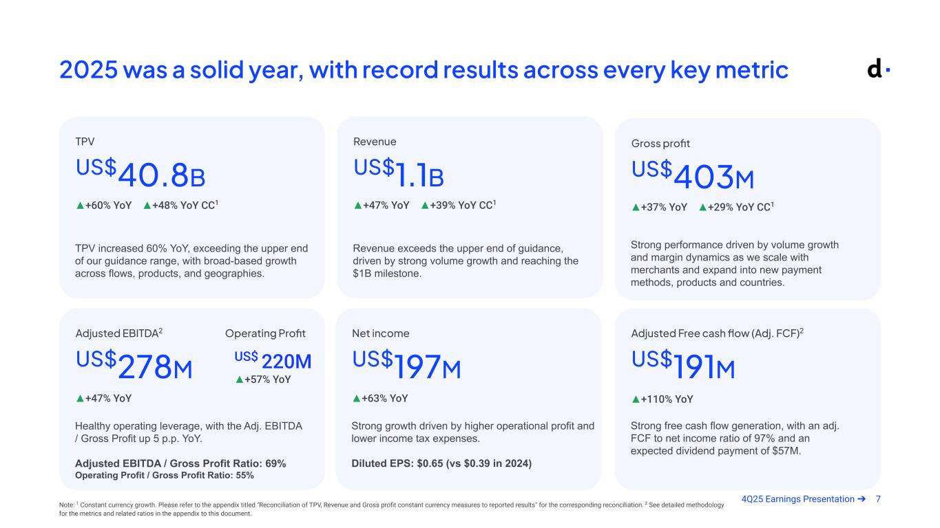
74Q25 Earnings Presentation ➔ 2025 was a solid year, with record results across every key metric TPV increased 60% YoY, exceeding the upper end of our guidance range, with broad-based growth across flows, products, and geographies. US$40.8B ▲+60% YoY ▲+48% YoY CC1 TPV Strong free cash flow generation, with an adj. FCF to net income ratio of 97% and an expected dividend payment of $57M. US$191M ▲+110% YoY Adjusted Free cash flow (Adj. FCF)2 Healthy operating leverage, with the Adj. EBITDA / Gross Profit up 5 p.p. YoY. Adjusted EBITDA / Gross Profit Ratio: 69% Operating Profit / Gross Profit Ratio: 55% US$278M ▲+47% YoY Adjusted EBITDA2 Strong performance driven by volume growth and margin dynamics as we scale with merchants and expand into new payment methods, products and countries. US$403M ▲+37% YoY ▲+29% YoY CC1 Gross profit Strong growth driven by higher operational profit and lower income tax expenses. Diluted EPS: $0.65 (vs $0.39 in 2024) US$197M ▲+63% YoY Net income Revenue exceeds the upper end of guidance, driven by strong volume growth and reaching the $1B milestone. US$1.1B ▲+47% YoY ▲+39% YoY CC1 Revenue Note: 1 Constant currency growth. Please refer to the appendix titled "Reconciliation of TPV, Revenue and Gross profit constant currency measures to reported results" for the corresponding reconciliation. 2 See detailed methodology for the metrics and related ratios in the appendix to this document. Operating Profit US$ 220M ▲+57% YoY

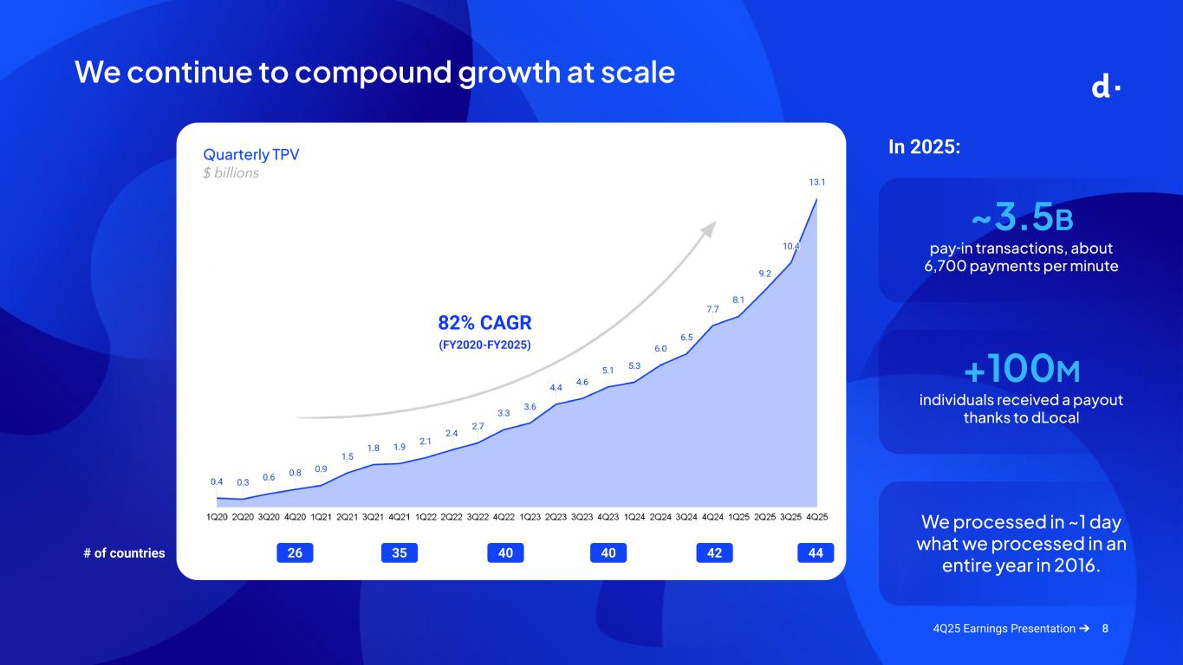
8 # of countries We continue to compound growth at scale 26 35 40 40 42 44 82% CAGR (FY2020-FY2025) ~3.5B pay-in transactions, about 6,700 payments per minute +100M individuals received a payout thanks to dLocal In 2025: We processed in ~1 day what we processed in an entire year in 2016. Quarterly TPV $ billions 4Q25 Earnings Presentation ➔

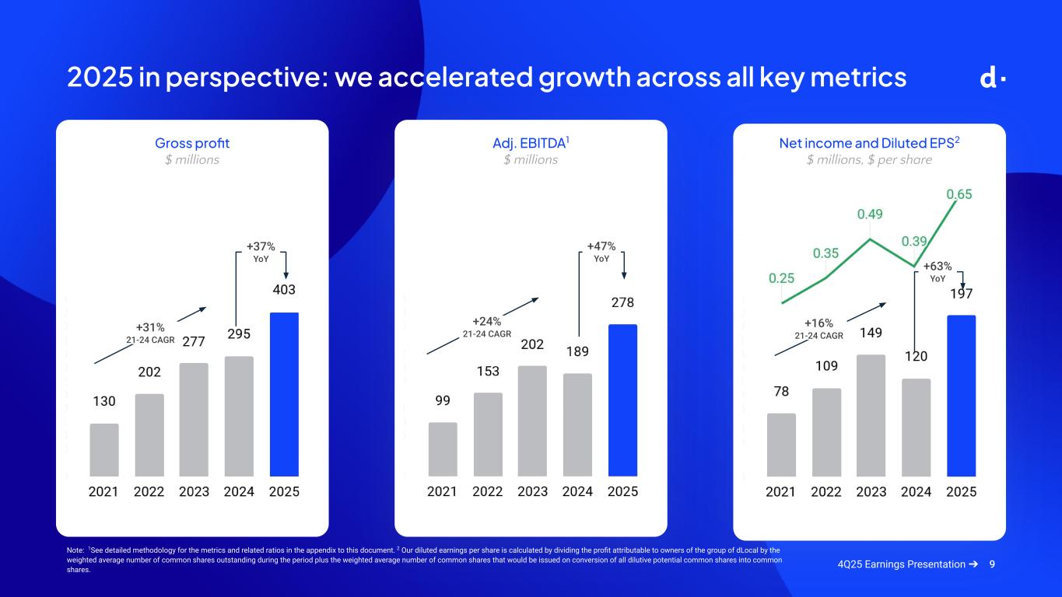
9 2025 in perspective: we accelerated growth across all key metrics Gross profit $ millions Adj. EBITDA1 $ millions Net income and Diluted EPS2 $ millions, $ per share +37% YoY +31% 21-24 CAGR +47% YoY +24% 21-24 CAGR +63% YoY +16% 21-24 CAGR 4Q25 Earnings Presentation ➔ Note: 1See detailed methodology for the metrics and related ratios in the appendix to this document. 2 Our diluted earnings per share is calculated by dividing the profit attributable to owners of the group of dLocal by the weighted average number of common shares outstanding during the period plus the weighted average number of common shares that would be issued on conversion of all dilutive potential common shares into common shares.

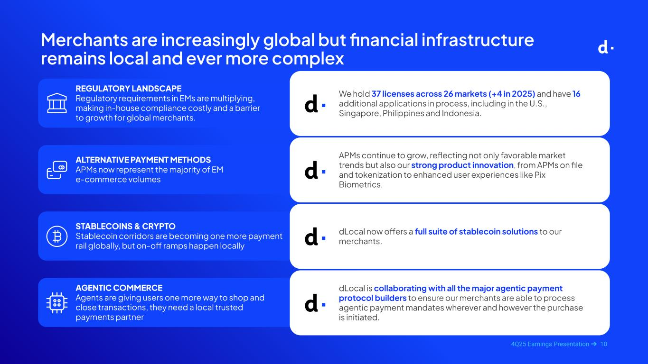
104Q25 Earnings Presentation ➔ Merchants are increasingly global but financial infrastructure remains local and ever more complex REGULATORY LANDSCAPE Regulatory requirements in EMs are multiplying, making in-house compliance costly and a barrier to growth for global merchants. We hold 37 licenses across 26 markets (+4 in 2025) and have 16 additional applications in process, including in the U.S., Singapore, Philippines and Indonesia. ALTERNATIVE PAYMENT METHODS APMs now represent the majority of EM e-commerce volumes APMs continue to grow, reflecting not only favorable market trends but also our strong product innovation, from APMs on file and tokenization to enhanced user experiences like Pix Biometrics. STABLECOINS & CRYPTO Stablecoin corridors are becoming one more payment rail globally, but on-off ramps happen locally dLocal now offers a full suite of stablecoin solutions to our merchants. AGENTIC COMMERCE Agents are giving users one more way to shop and close transactions, they need a local trusted payments partner dLocal is collaborating with all the major agentic payment protocol builders to ensure our merchants are able to process agentic payment mandates wherever and however the purchase is initiated.

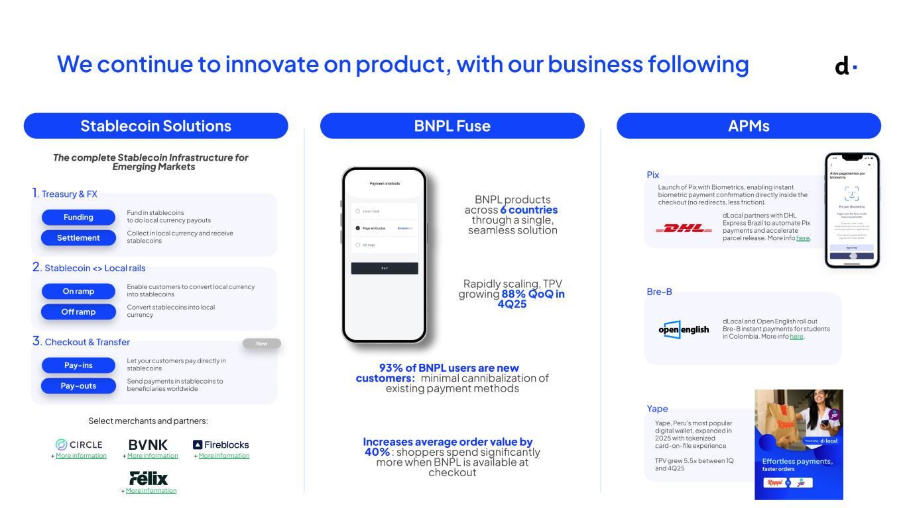
114Q25 Earnings Presentation ➔ We continue to innovate on product, with our business following Stablecoin Solutions APMsBNPL Fuse The complete Stablecoin Infrastructure for Emerging Markets Settlement Funding Fund in stablecoins to do local currency payouts 1. Treasury & FX Collect in local currency and receive stablecoins O ramp On ramp Enable customers to convert local currency into stablecoins 2. Stablecoin <> Local rails Convert stablecoins into local currency Pay-outs Pay-ins Let your customers pay directly in stablecoins 3. Checkout & Transfer Send payments in stablecoins to beneficiaries worldwide Select merchants and partners: + More information + More information + More information+ More information Launch of Pix with Biometrics, enabling instant biometric payment confirmation directly inside the checkout (no redirects, less friction). Pix Yape, Peru's most popular digital wallet, expanded in 2025 with tokenized card-on-file experience TPV grew 5.5× between 1Q and 4Q25 Yape Bre-B dLocal and Open English roll out Bre-B instant payments for students in Colombia. More info here. Rapidly scaling, TPV growing 88% QoQ in 4Q25 dLocal partners with DHL Express Brazil to automate Pix payments and accelerate parcel release. More info here. 93% of BNPL users are new customers: minimal cannibalization of existing payment methods Increases average order value by 40% : shoppers spend significantly more when BNPL is available at checkout New BNPL products across 6 countries through a single, seamless solution

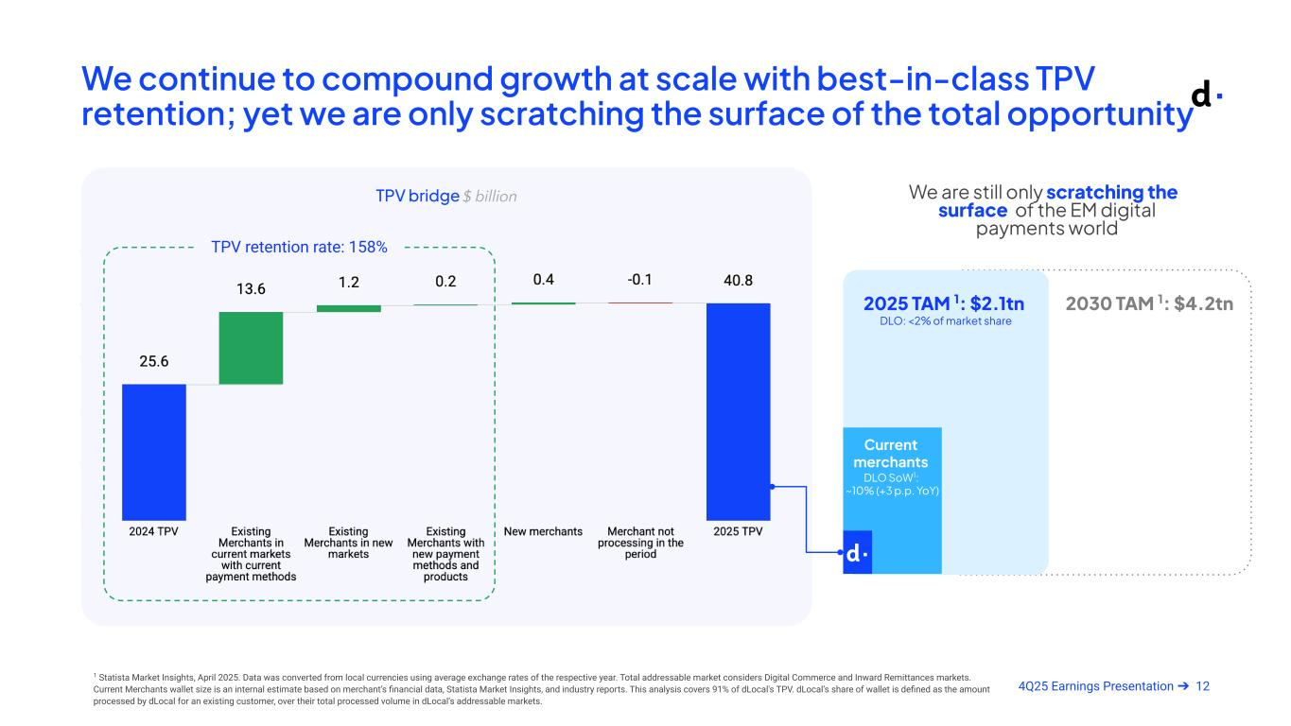
124Q25 Earnings Presentation ➔ We continue to compound growth at scale with best-in-class TPV retention; yet we are only scratching the surface of the total opportunity TPV bridge $ billion TPV retention rate: 158% 1 Statista Market Insights, April 2025. Data was converted from local currencies using average exchange rates of the respective year. Total addressable market considers Digital Commerce and Inward Remittances markets. Current Merchants wallet size is an internal estimate based on merchant’s financial data, Statista Market Insights, and industry reports. This analysis covers 91% of dLocal's TPV. dLocal’s share of wallet is defined as the amount processed by dLocal for an existing customer, over their total processed volume in dLocal’s addressable markets. We are still only scratching the surface of the EM digital payments world 2025 TAM 1: $2.1tn DLO: <2% of market share Current merchants 2030 TAM 1: $4.2tn DLO SoW1: ~10% (+3 p.p. YoY)

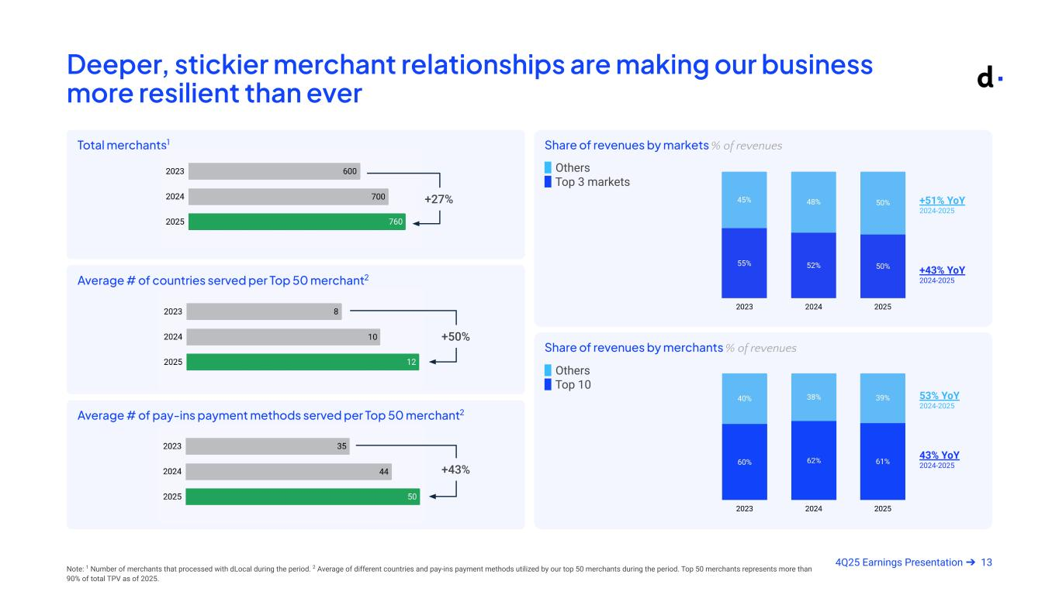
134Q25 Earnings Presentation ➔ Deeper, stickier merchant relationships are making our business more resilient than ever Total merchants1 Average # of countries served per Top 50 merchant2 Average # of pay-ins payment methods served per Top 50 merchant2 Share of revenues by markets % of revenues Share of revenues by merchants % of revenues +51% YoY 2024-2025 +43% YoY 2024-2025 53% YoY 2024-2025 43% YoY 2024-2025 ▉ Others ▉ Top 3 markets ▉ Others ▉ Top 10 Note: 1 Number of merchants that processed with dLocal during the period. 2 Average of different countries and pay-ins payment methods utilized by our top 50 merchants during the period. Top 50 merchants represents more than 90% of total TPV as of 2025. +27% +50% +43%

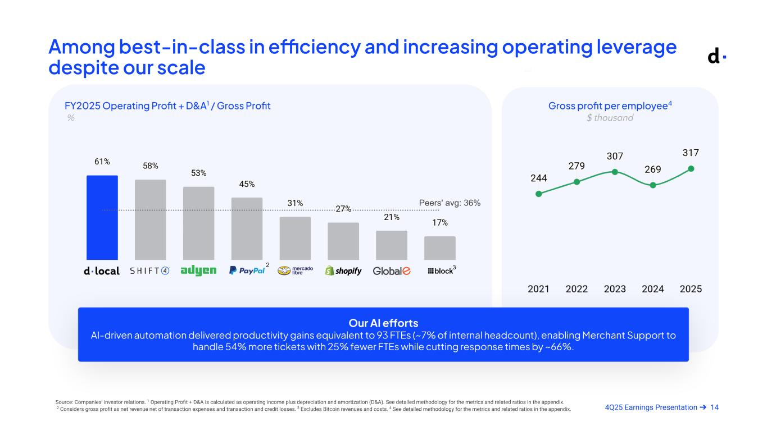
144Q25 Earnings Presentation ➔ Among best-in-class in efficiency and increasing operating leverage despite our scale FY2025 Operating Profit + D&A1 / Gross Profit % Our AI e orts AI-driven automation delivered productivity gains equivalent to 93 FTEs (~7% of internal headcount), enabling Merchant Support to handle 54% more tickets with 25% fewer FTEs while cutting response times by ~66%. Peers' avg: 36% Source: Companies’ investor relations. 1 Operating Profit + D&A is calculated as operating income plus depreciation and amortization (D&A). See detailed methodology for the metrics and related ratios in the appendix. 2 Considers gross profit as net revenue net of transaction expenses and transaction and credit losses. 3 Excludes Bitcoin revenues and costs. 4 See detailed methodology for the metrics and related ratios in the appendix. 2 3 Gross profit per employee4 $ thousand

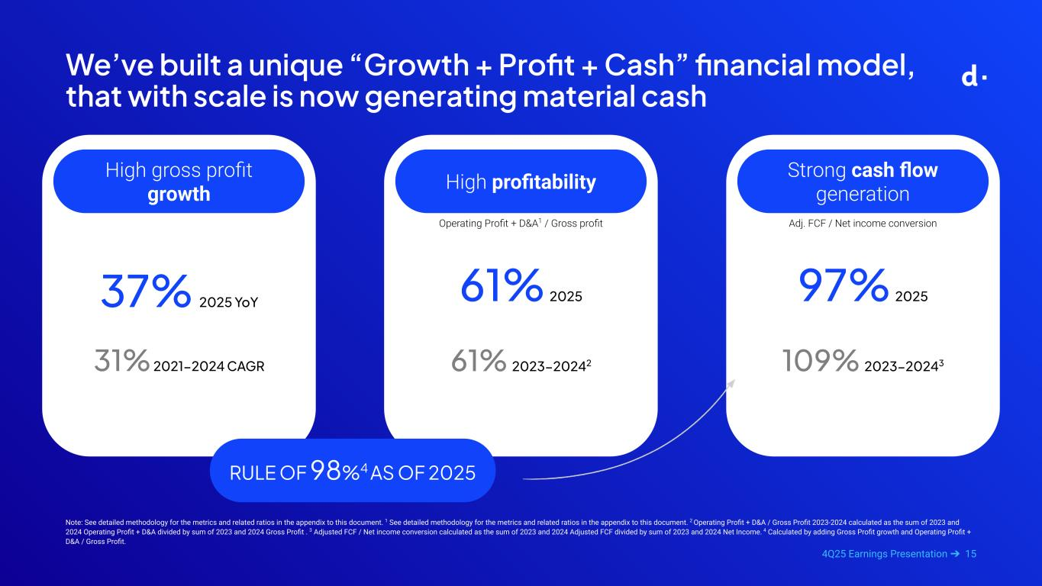
154Q25 Earnings Presentation ➔ Operating Profit + D&A1 / Gross profit High profitability We’ve built a unique “Growth + Profit + Cash” financial model, that with scale is now generating material cash 37% 2025 YoY 31% 2021−2024 CAGR High gross profit growth Strong cash flow generation 61% 2025 61% 2023−20242 Adj. FCF / Net income conversion 97% 2025 109% 2023−20243 Note: See detailed methodology for the metrics and related ratios in the appendix to this document. 1 See detailed methodology for the metrics and related ratios in the appendix to this document. 2 Operating Profit + D&A / Gross Profit 2023-2024 calculated as the sum of 2023 and 2024 Operating Profit + D&A divided by sum of 2023 and 2024 Gross Profit . 3 Adjusted FCF / Net income conversion calculated as the sum of 2023 and 2024 Adjusted FCF divided by sum of 2023 and 2024 Net Income. 4 Calculated by adding Gross Profit growth and Operating Profit + D&A / Gross Profit. In 2025: RULE OF 98%4 AS OF 2025


164Q25 Earnings Presentation ➔ Financial Highlights

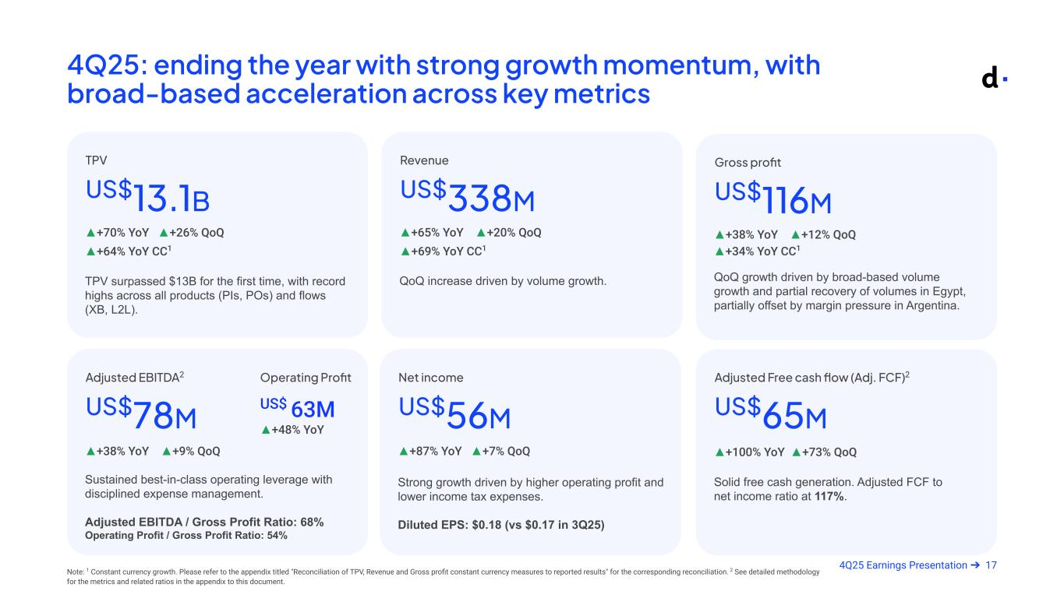
174Q25 Earnings Presentation ➔ 4Q25: ending the year with strong growth momentum, with broad-based acceleration across key metrics TPV surpassed $13B for the first time, with record highs across all products (PIs, POs) and flows (XB, L2L). US$13.1B ▲+70% YoY ▲+26% QoQ TPV Solid free cash generation. Adjusted FCF to net income ratio at 117%. US$65M ▲+100% YoY ▲+73% QoQ Adjusted Free cash flow (Adj. FCF)2 Sustained best-in-class operating leverage with disciplined expense management. Adjusted EBITDA / Gross Profit Ratio: 68% Operating Profit / Gross Profit Ratio: 54% US$78M ▲+38% YoY ▲+9% QoQ Adjusted EBITDA2 QoQ growth driven by broad-based volume growth and partial recovery of volumes in Egypt, partially offset by margin pressure in Argentina. US$116M ▲+38% YoY ▲+12% QoQ Gross profit Strong growth driven by higher operating profit and lower income tax expenses. Diluted EPS: $0.18 (vs $0.17 in 3Q25) US$56M ▲+87% YoY ▲+7% QoQ Net income QoQ increase driven by volume growth. US$338M ▲+65% YoY ▲+20% QoQ Revenue ▲+64% YoY CC1 ▲+69% YoY CC1 ▲+34% YoY CC1 Note: 1 Constant currency growth. Please refer to the appendix titled "Reconciliation of TPV, Revenue and Gross profit constant currency measures to reported results" for the corresponding reconciliation. 2 See detailed methodology for the metrics and related ratios in the appendix to this document. Armado Mar 11 @ 9pm Operating Profit US$ 63M ▲+48% YoY

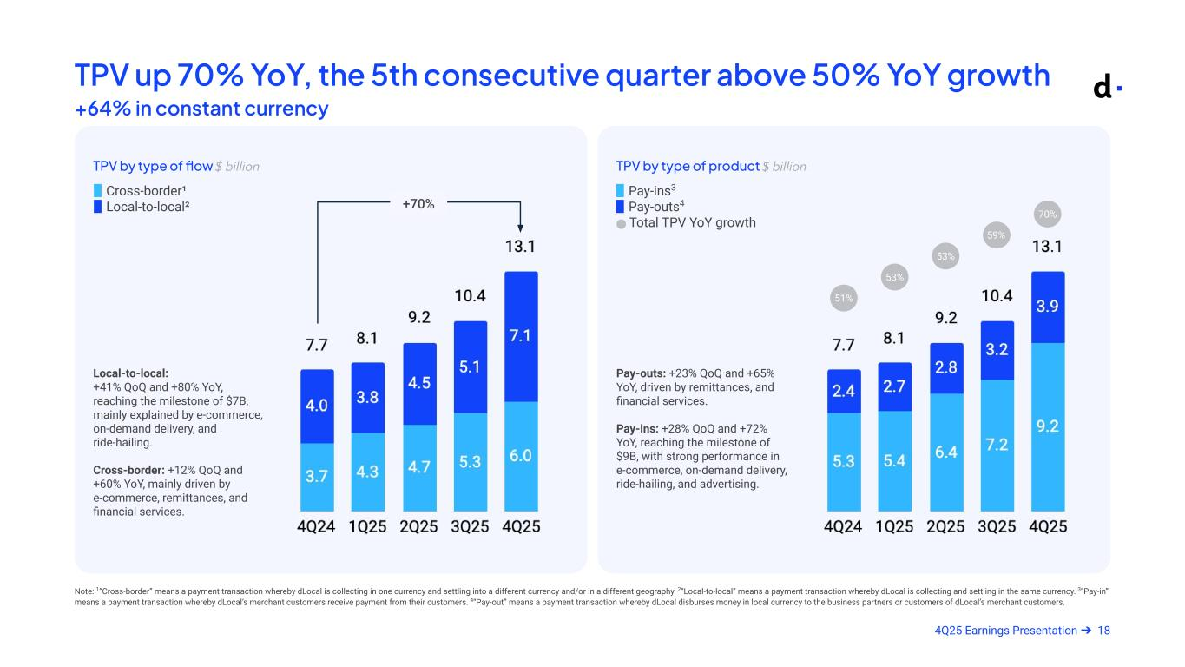
184Q25 Earnings Presentation ➔ TPV up 70% YoY, the 5th consecutive quarter above 50% YoY growth +64% in constant currency TPV by type of flow $ billion Local-to-local: +41% QoQ and +80% YoY, reaching the milestone of $7B, mainly explained by e-commerce, on-demand delivery, and ride-hailing. Cross-border: +12% QoQ and +60% YoY, mainly driven by e-commerce, remittances, and financial services. TPV by type of product $ billion Pay-outs: +23% QoQ and +65% YoY, driven by remittances, and financial services. Pay-ins: +28% QoQ and +72% YoY, reaching the milestone of $9B, with strong performance in e-commerce, on-demand delivery, ride-hailing, and advertising. ▉ Pay-ins3 ▉ Pay-outs4 ⬤ Total TPV YoY growth ▉ Cross-border¹ ▉ Local-to-local² Note: 1“Cross-border” means a payment transaction whereby dLocal is collecting in one currency and settling into a different currency and/or in a different geography. 2“Local-to-local” means a payment transaction whereby dLocal is collecting and settling in the same currency. 3”Pay-in” means a payment transaction whereby dLocal’s merchant customers receive payment from their customers. 4“Pay-out” means a payment transaction whereby dLocal disburses money in local currency to the business partners or customers of dLocal’s merchant customers. 70% 59% 51% 53% 53% +70%

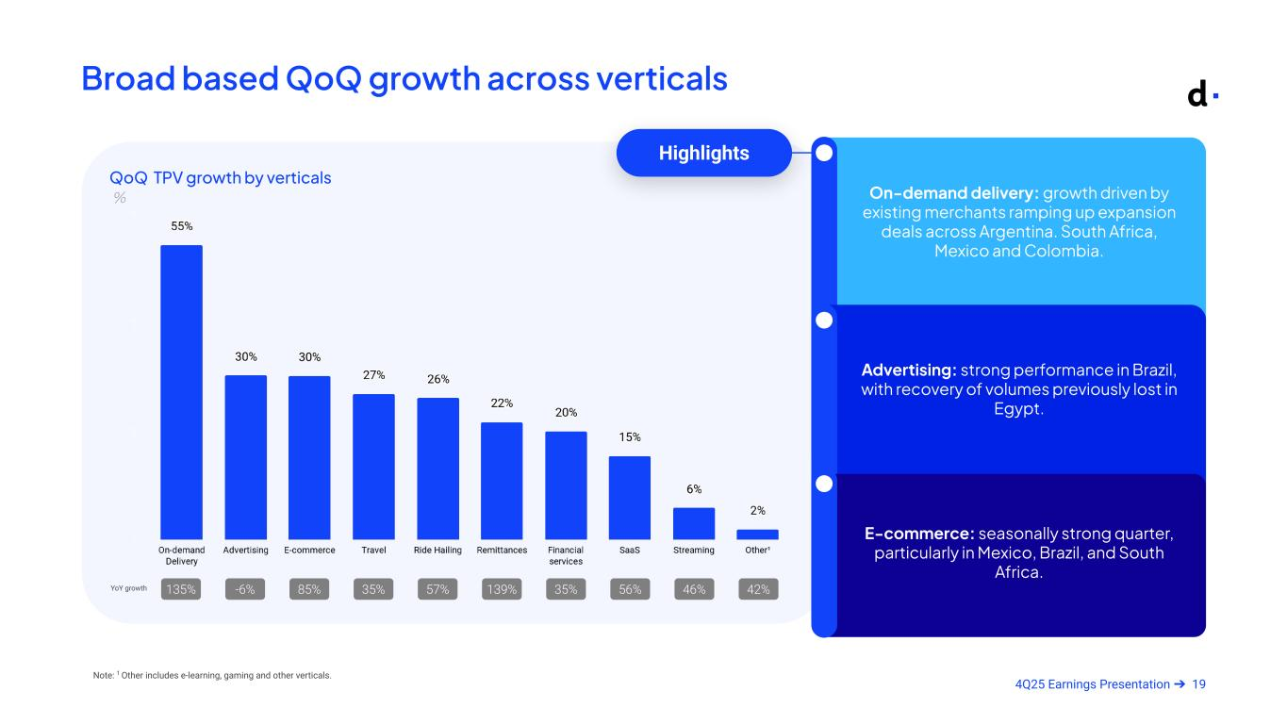
194Q25 Earnings Presentation ➔ Broad based QoQ growth across verticals Note: 1 Other includes e-learning, gaming and other verticals. QoQ TPV growth by verticals % On-demand delivery: growth driven by existing merchants ramping up expansion deals across Argentina. South Africa, Mexico and Colombia. Advertising: strong performance in Brazil, with recovery of volumes previously lost in Egypt. E-commerce: seasonally strong quarter, particularly in Mexico, Brazil, and South Africa. Highlights 135% -6% 85% 35% 57% 139% 35% 56% 46% 42%YoY growth

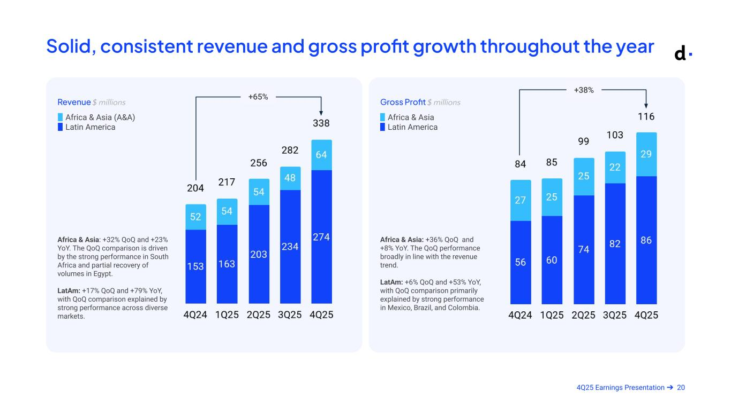
204Q25 Earnings Presentation ➔ Solid, consistent revenue and gross profit growth throughout the year Revenue $ millions Gross Profit $ millions ▉ Africa & Asia ▉ Latin America ▉ Africa & Asia (A&A) ▉ Latin America Africa & Asia: +32% QoQ and +23% YoY. The QoQ comparison is driven by the strong performance in South Africa and partial recovery of volumes in Egypt. LatAm: +17% QoQ and +79% YoY, with QoQ comparison explained by strong performance across diverse markets. Africa & Asia: +36% QoQ and +8% YoY. The QoQ performance broadly in line with the revenue trend. LatAm: +6% QoQ and +53% YoY, with QoQ comparison primarily explained by strong performance in Mexico, Brazil, and Colombia. +65% +38% Armado Mar 11 @ 9pm

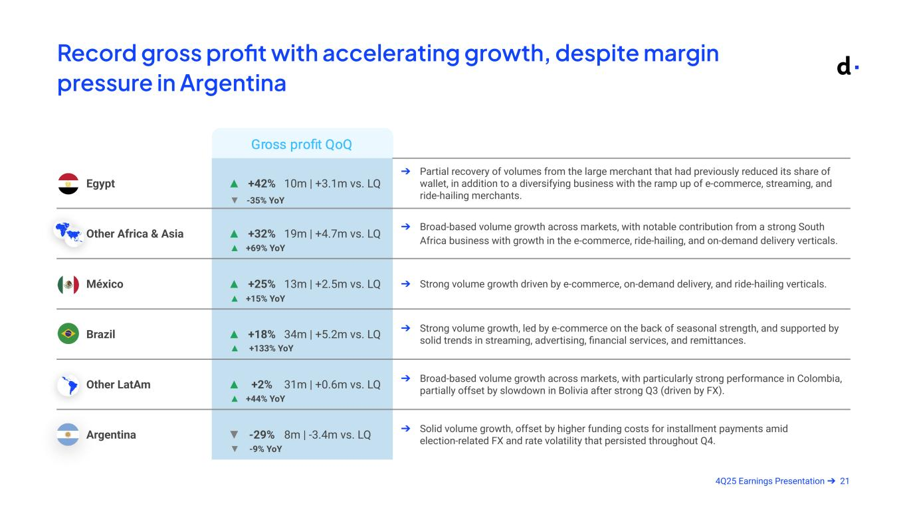
214Q25 Earnings Presentation ➔ Record gross profit with accelerating growth, despite margin pressure in Argentina Egypt ▲ +42% 10m | +3.1m vs. LQ ➔ Partial recovery of volumes from the large merchant that had previously reduced its share of wallet, in addition to a diversifying business with the ramp up of e-commerce, streaming, and ride-hailing merchants. Other Africa & Asia ▲ +32% 19m | +4.7m vs. LQ ➔ Broad-based volume growth across markets, with notable contribution from a strong South Africa business with growth in the e-commerce, ride-hailing, and on-demand delivery verticals. México ▲ +25% 13m | +2.5m vs. LQ ➔ Strong volume growth driven by e-commerce, on-demand delivery, and ride-hailing verticals. Brazil ▲ +18% 34m | +5.2m vs. LQ ➔ Strong volume growth, led by e-commerce on the back of seasonal strength, and supported by solid trends in streaming, advertising, financial services, and remittances. Other LatAm ▲ +2% 31m | +0.6m vs. LQ ➔ Broad-based volume growth across markets, with particularly strong performance in Colombia, partially offset by slowdown in Bolivia after strong Q3 (driven by FX). Argentina ▼ -29% 8m | -3.4m vs. LQ ➔ Solid volume growth, offset by higher funding costs for installment payments amid election-related FX and rate volatility that persisted throughout Q4. ▲ +133% YoY ▼ -9% YoY ▲ +44% YoY ▲ +15% YoY ▲ +69% YoY ▼ -35% YoY

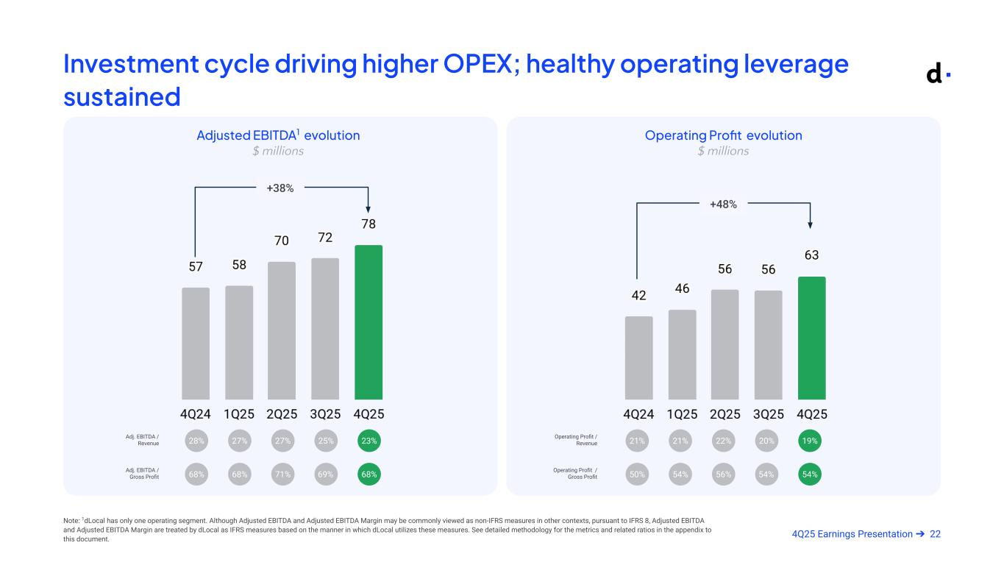
224Q25 Earnings Presentation ➔ Investment cycle driving higher OPEX; healthy operating leverage sustained Note: 1dLocal has only one operating segment. Although Adjusted EBITDA and Adjusted EBITDA Margin may be commonly viewed as non-IFRS measures in other contexts, pursuant to IFRS 8, Adjusted EBITDA and Adjusted EBITDA Margin are treated by dLocal as IFRS measures based on the manner in which dLocal utilizes these measures. See detailed methodology for the metrics and related ratios in the appendix to this document. Adjusted EBITDA1 evolution $ millions Adj. EBITDA / Revenue 23%25%28% 27% 27% 68%69%68% 68% 71%Adj. EBITDA / Gross Profit +38% Operating Profit evolution $ millions +48% Operating Profit / Revenue Operating Profit / Gross Profit 54%54%50% 54% 56% Armado Mar 11 @ 9pm 19%20%21% 21% 22%

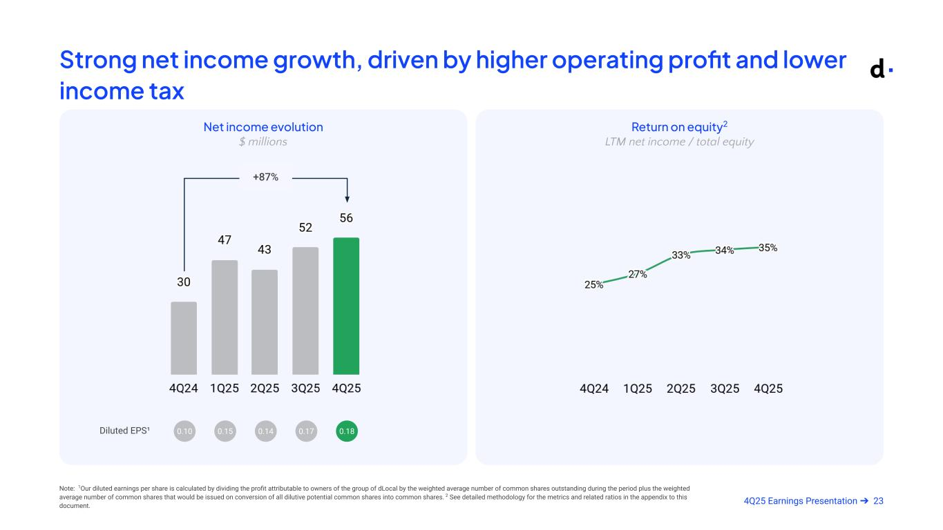
234Q25 Earnings Presentation ➔ Net income evolution $ millions Return on equity2 LTM net income / total equity Strong net income growth, driven by higher operating profit and lower income tax Diluted EPS¹ 0.180.170.10 0.15 0.14 Note: 1Our diluted earnings per share is calculated by dividing the profit attributable to owners of the group of dLocal by the weighted average number of common shares outstanding during the period plus the weighted average number of common shares that would be issued on conversion of all dilutive potential common shares into common shares. 2 See detailed methodology for the metrics and related ratios in the appendix to this document. +87% Armado Mar 11 @ 9pm

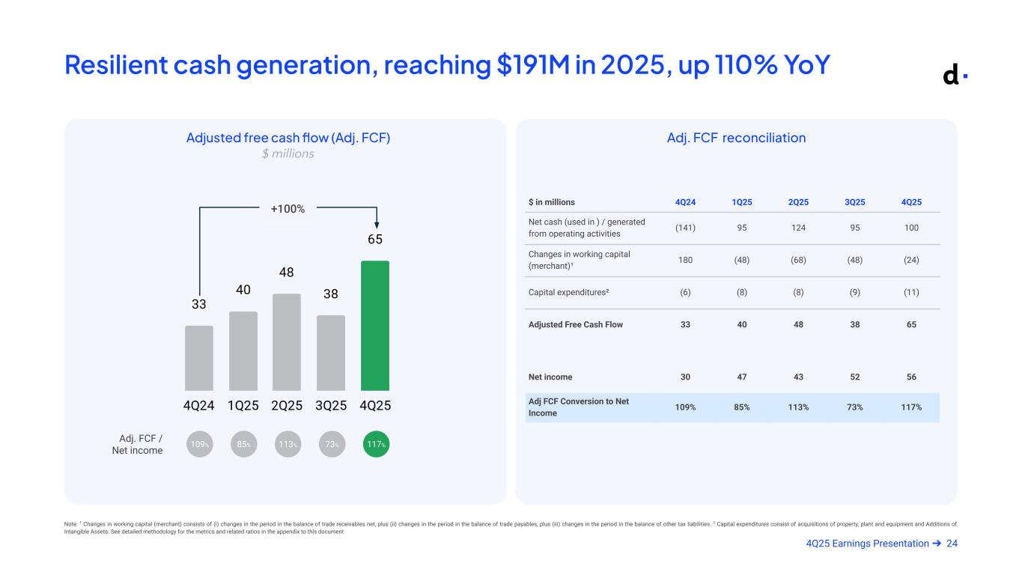
244Q25 Earnings Presentation ➔ Resilient cash generation, reaching $191M in 2025, up 110% YoY Adj. FCF / Net income +100% 117%73%109% 85% 113% Adj. FCF reconciliation $ in millions 4Q24 1Q25 2Q25 3Q25 4Q25 Net cash (used in ) / generated from operating activities (141) 95 124 95 100 Changes in working capital (merchant)¹ 180 (48) (68) (48) (24) Capital expenditures² (6) (8) (8) (9) (11) Adjusted Free Cash Flow 33 40 48 38 65 Net income 30 47 43 52 56 Adj FCF Conversion to Net Income 109% 85% 113% 73% 117% Note: 1 Changes in working capital (merchant) consists of (i) changes in the period in the balance of trade receivables net, plus (ii) changes in the period in the balance of trade payables, plus (iii) changes in the period in the balance of other tax liabilities. 2 Capital expenditures consist of acquisitions of property, plant and equipment and Additions of Intangible Assets. See detailed methodology for the metrics and related ratios in the appendix to this document Armado Mar 11 @ 9pm Adjusted free cash flow (Adj. FCF) $ millions


254Q25 Earnings Presentation ➔ Final Remarks

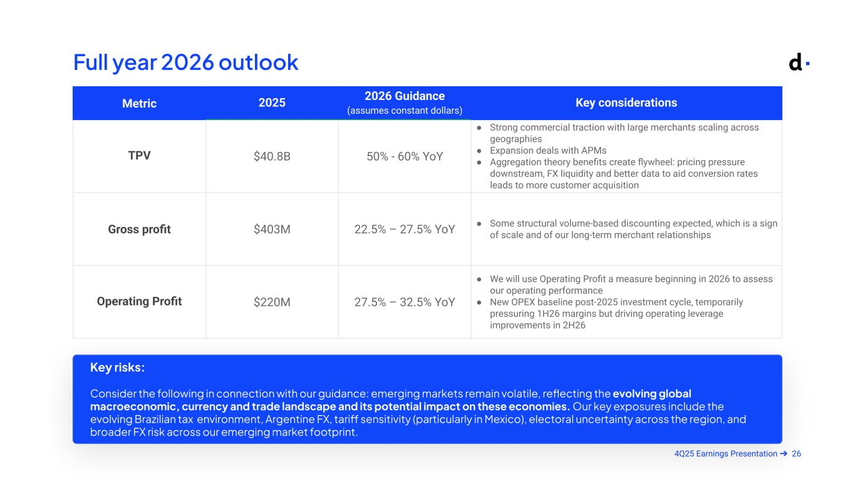
264Q25 Earnings Presentation ➔ Metric 2025 2026 Guidance (assumes constant dollars) Key considerations TPV $40.8B 50% - 60% YoY ● Strong commercial traction with large merchants scaling across geographies ● Expansion deals with APMs ● Aggregation theory benefits create flywheel: pricing pressure downstream, FX liquidity and better data to aid conversion rates leads to more customer acquisition Gross profit $403M 22.5% – 27.5% YoY ● Some structural volume-based discounting expected, which is a sign of scale and of our long-term merchant relationships Operating Profit $220M 27.5% – 32.5% YoY ● We will use Operating Profit a measure beginning in 2026 to assess our operating performance ● New OPEX baseline post-2025 investment cycle, temporarily pressuring 1H26 margins but driving operating leverage improvements in 2H26 Full year 2026 outlook Key risks: Consider the following in connection with our guidance: emerging markets remain volatile, reflecting the evolving global macroeconomic, currency and trade landscape and its potential impact on these economies. Our key exposures include the evolving Brazilian tax environment, Argentine FX, tariff sensitivity (particularly in Mexico), electoral uncertainty across the region, and broader FX risk across our emerging market footprint. Armado Mar 11 @ 9pm

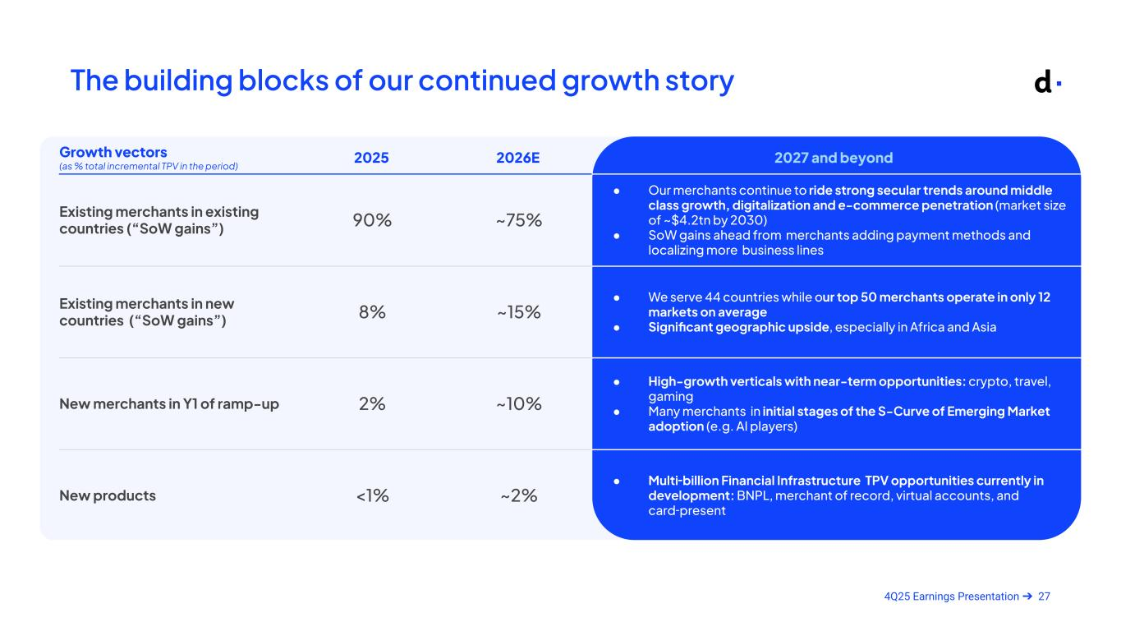
274Q25 Earnings Presentation ➔ The building blocks of our continued growth story Growth vectors (as % total incremental TPV in the period) 2025 2026E 2027 and beyond Existing merchants in existing countries (“SoW gains”) 90% ~75% ● Our merchants continue to ride strong secular trends around middle class growth, digitalization and e-commerce penetration (market size of ~$4.2tn by 2030) ● SoW gains ahead from merchants adding payment methods and localizing more business lines Existing merchants in new countries (“SoW gains”) 8% ~15% ● We serve 44 countries while our top 50 merchants operate in only 12 markets on average ● Significant geographic upside, especially in Africa and Asia New merchants in Y1 of ramp-up 2% ~10% ● High-growth verticals with near-term opportunities: crypto, travel, gaming ● Many merchants in initial stages of the S-Curve of Emerging Market adoption (e.g. AI players) New products <1% ~2% ● Multi-billion Financial Infrastructure TPV opportunities currently in development: BNPL, merchant of record, virtual accounts, and card-present

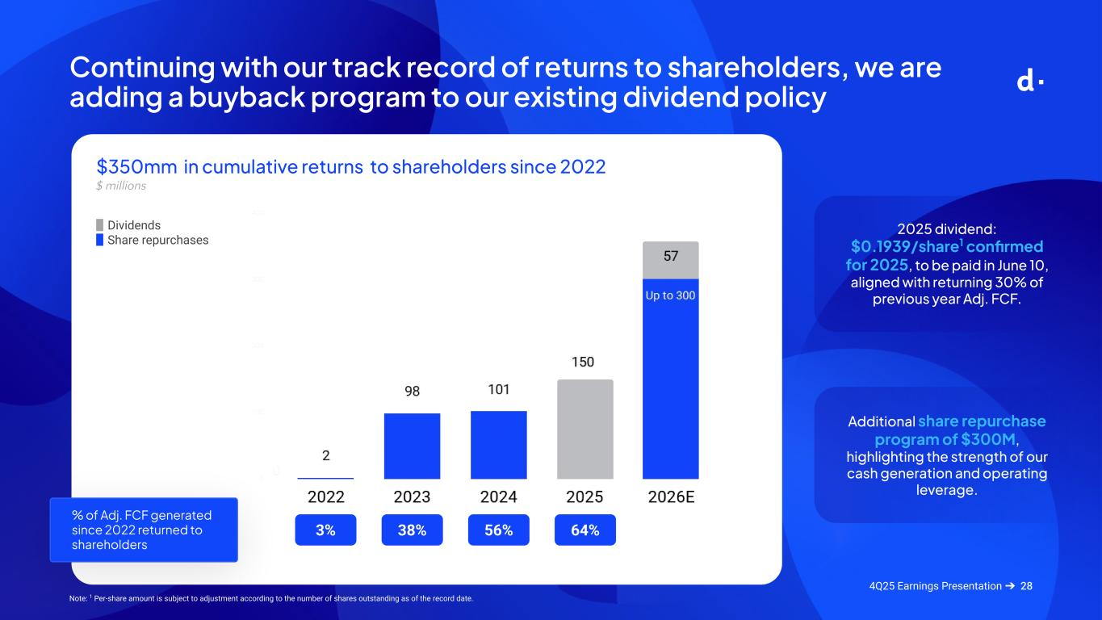
28 $350mm in cumulative returns to shareholders since 2022 $ millions 4Q25 Earnings Presentation ➔ ▉ Dividends ▉ Share repurchases % of Adj. FCF generated since 2022 returned to shareholders 3% 38% 56% 64% Continuing with our track record of returns to shareholders, we are adding a buyback program to our existing dividend policy 2025 dividend: $0.1939/share1 confirmed for 2025, to be paid in June 10, aligned with returning 30% of previous year Adj. FCF. Additional share repurchase program of $300M, highlighting the strength of our cash generation and operating leverage. Note: 1 Per-share amount is subject to adjustment according to the number of shares outstanding as of the record date.

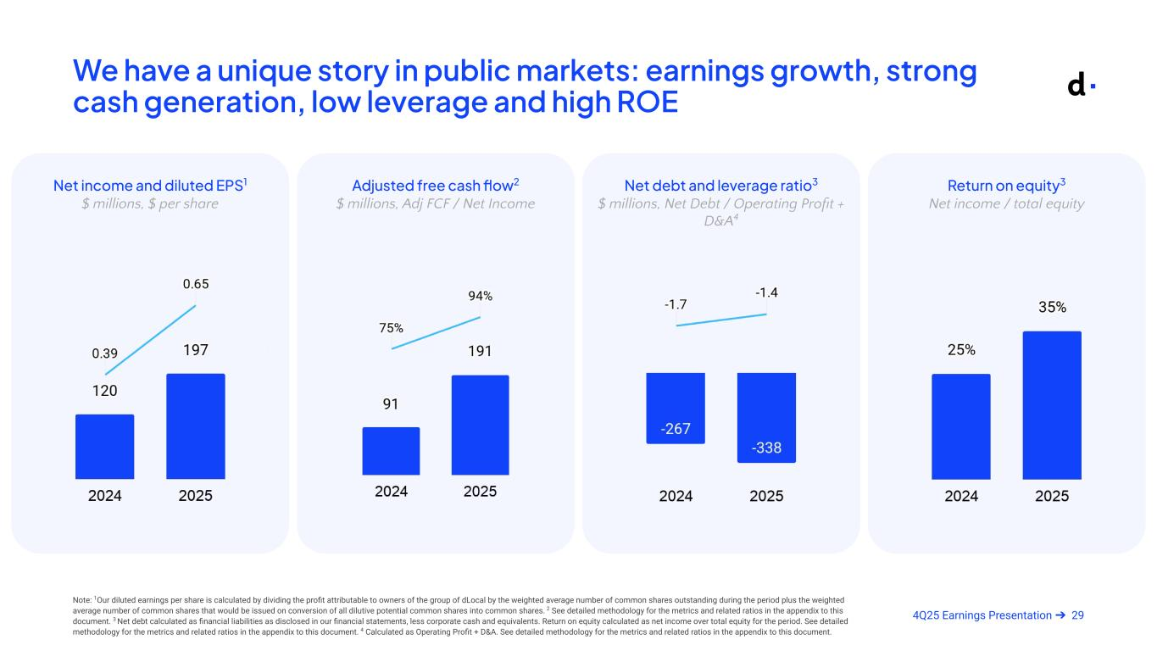
294Q25 Earnings Presentation ➔ We have a unique story in public markets: earnings growth, strong cash generation, low leverage and high ROE Return on equity3 Net income / total equity Net income and diluted EPS1 $ millions, $ per share Net debt and leverage ratio3 $ millions, Net Debt / Operating Profit + D&A4 Adjusted free cash flow2 $ millions, Adj FCF / Net Income Note: 1Our diluted earnings per share is calculated by dividing the profit attributable to owners of the group of dLocal by the weighted average number of common shares outstanding during the period plus the weighted average number of common shares that would be issued on conversion of all dilutive potential common shares into common shares. 2 See detailed methodology for the metrics and related ratios in the appendix to this document. 3 Net debt calculated as financial liabilities as disclosed in our financial statements, less corporate cash and equivalents. Return on equity calculated as net income over total equity for the period. See detailed methodology for the metrics and related ratios in the appendix to this document. 4 Calculated as Operating Profit + D&A. See detailed methodology for the metrics and related ratios in the appendix to this document. Armado Mar 11 @ 9pm


304Q25 Earnings Presentation ➔ Q&A


314Q25 Earnings Presentation ➔ Appendix


324Q25 Earnings Presentation ➔ Non-IFRS Financial Measures

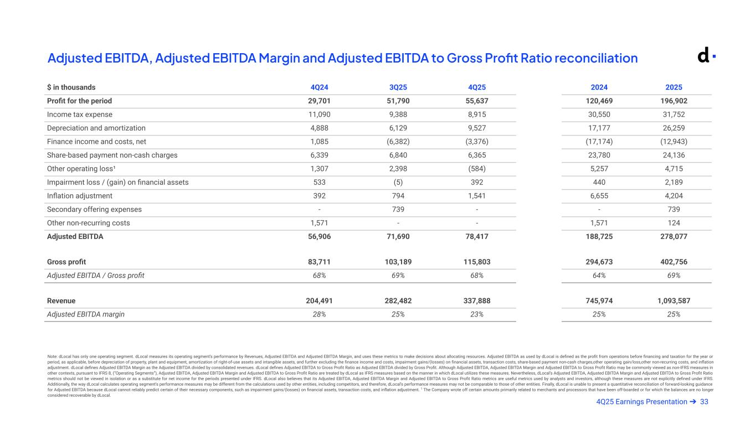
334Q25 Earnings Presentation ➔ Adjusted EBITDA, Adjusted EBITDA Margin and Adjusted EBITDA to Gross Profit Ratio reconciliation Note: dLocal has only one operating segment. dLocal measures its operating segment’s performance by Revenues, Adjusted EBITDA and Adjusted EBITDA Margin, and uses these metrics to make decisions about allocating resources. Adjusted EBITDA as used by dLocal is defined as the profit from operations before financing and taxation for the year or period, as applicable, before depreciation of property, plant and equipment, amortization of right-of-use assets and intangible assets, and further excluding the finance income and costs, impairment gains/(losses) on financial assets, transaction costs, share-based payment non-cash charges,other operating gain/loss,other non-recurring costs, and inflation adjustment. dLocal defines Adjusted EBITDA Margin as the Adjusted EBITDA divided by consolidated revenues. dLocal defines Adjusted EBITDA to Gross Profit Ratio as Adjusted EBITDA divided by Gross Profit. Although Adjusted EBITDA, Adjusted EBITDA Margin and Adjusted EBITDA to Gross Profit Ratio may be commonly viewed as non-IFRS measures in other contexts, pursuant to IFRS 8, (“Operating Segments”), Adjusted EBITDA, Adjusted EBITDA Margin and Adjusted EBITDA to Gross Profit Ratio are treated by dLocal as IFRS measures based on the manner in which dLocal utilizes these measures. Nevertheless, dLocal’s Adjusted EBITDA, Adjusted EBITDA Margin and Adjusted EBITDA to Gross Profit Ratio metrics should not be viewed in isolation or as a substitute for net income for the periods presented under IFRS. dLocal also believes that its Adjusted EBITDA, Adjusted EBITDA Margin and Adjusted EBITDA to Gross Profit Ratio metrics are useful metrics used by analysts and investors, although these measures are not explicitly defined under IFRS. Additionally, the way dLocal calculates operating segment’s performance measures may be different from the calculations used by other entities, including competitors, and therefore, dLocal’s performance measures may not be comparable to those of other entities. Finally, dLocal is unable to present a quantitative reconciliation of forward-looking guidance for Adjusted EBITDA because dLocal cannot reliably predict certain of their necessary components, such as impairment gains/(losses) on financial assets, transaction costs, and inflation adjustment. 1 The Company wrote off certain amounts primarily related to merchants and processors that have been off-boarded or for which the balances are no longer considered recoverable by dLocal. Armado Mar 11 @ 9pm $ in thousands 4Q24 3Q25 4Q25 2024 2025 Profit for the period 29,701 51,790 55,637 120,469 196,902 Income tax expense 11,090 9,388 8,915 30,550 31,752 Depreciation and amortization 4,888 6,129 9,527 17,177 26,259 Finance income and costs, net 1,085 (6,382) (3,376) (17,174) (12,943) Share-based payment non-cash charges 6,339 6,840 6,365 23,780 24,136 Other operating loss¹ 1,307 2,398 (584) 5,257 4,715 Impairment loss / (gain) on financial assets 533 (5) 392 440 2,189 Inflation adjustment 392 794 1,541 6,655 4,204 Secondary offering expenses - 739 - - 739 Other non-recurring costs 1,571 - - 1,571 124 Adjusted EBITDA 56,906 71,690 78,417 188,725 278,077 Gross profit 83,711 103,189 115,803 294,673 402,756 Adjusted EBITDA / Gross profit 68% 69% 68% 64% 69% Revenue 204,491 282,482 337,888 745,974 1,093,587 Adjusted EBITDA margin 28% 25% 23% 25% 25%

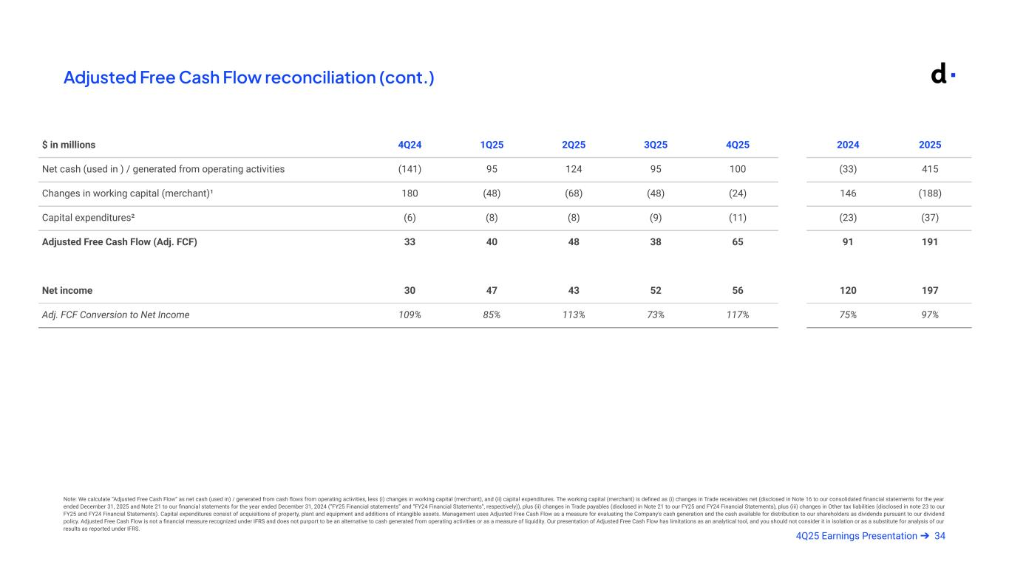
344Q25 Earnings Presentation ➔ Adjusted Free Cash Flow reconciliation (cont.) Note: We calculate “Adjusted Free Cash Flow” as net cash (used in) / generated from cash flows from operating activities, less (i) changes in working capital (merchant), and (ii) capital expenditures. The working capital (merchant) is defined as (i) changes in Trade receivables net (disclosed in Note 16 to our consolidated financial statements for the year ended December 31, 2025 and Note 21 to our financial statements for the year ended December 31, 2024 (“FY25 Financial statements” and “FY24 Financial Statements”, respectively)), plus (ii) changes in Trade payables (disclosed in Note 21 to our FY25 and FY24 Financial Statements), plus (iii) changes in Other tax liabilities (disclosed in note 23 to our FY25 and FY24 Financial Statements). Capital expenditures consist of acquisitions of property, plant and equipment and additions of intangible assets. Management uses Adjusted Free Cash Flow as a measure for evaluating the Company's cash generation and the cash available for distribution to our shareholders as dividends pursuant to our dividend policy. Adjusted Free Cash Flow is not a financial measure recognized under IFRS and does not purport to be an alternative to cash generated from operating activities or as a measure of liquidity. Our presentation of Adjusted Free Cash Flow has limitations as an analytical tool, and you should not consider it in isolation or as a substitute for analysis of our results as reported under IFRS. Armado Mar 11 @ 9pm $ in millions 4Q24 1Q25 2Q25 3Q25 4Q25 2024 2025 Net cash (used in ) / generated from operating activities (141) 95 124 95 100 (33) 415 Changes in working capital (merchant)¹ 180 (48) (68) (48) (24) 146 (188) Capital expenditures² (6) (8) (8) (9) (11) (23) (37) Adjusted Free Cash Flow (Adj. FCF) 33 40 48 38 65 91 191 Net income 30 47 43 52 56 120 197 Adj. FCF Conversion to Net Income 109% 85% 113% 73% 117% 75% 97%

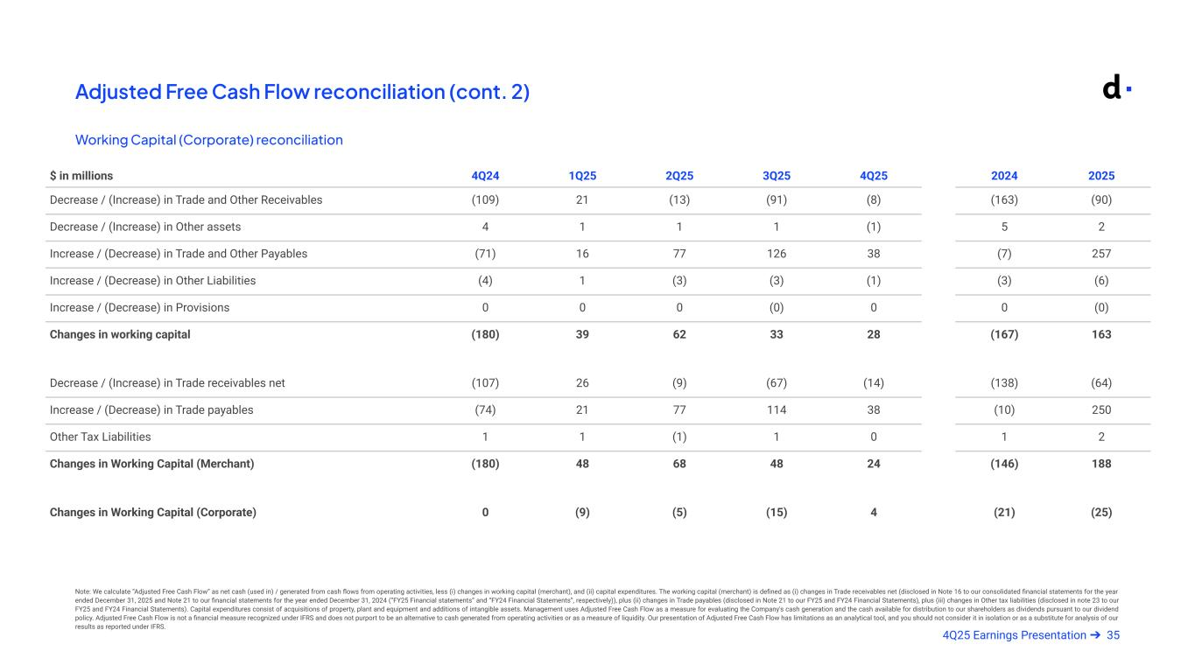
354Q25 Earnings Presentation ➔ Adjusted Free Cash Flow reconciliation (cont. 2) Armado Mar 11 @ 9pm $ in millions 4Q24 1Q25 2Q25 3Q25 4Q25 2024 2025 Decrease / (Increase) in Trade and Other Receivables (109) 21 (13) (91) (8) (163) (90) Decrease / (Increase) in Other assets 4 1 1 1 (1) 5 2 Increase / (Decrease) in Trade and Other Payables (71) 16 77 126 38 (7) 257 Increase / (Decrease) in Other Liabilities (4) 1 (3) (3) (1) (3) (6) Increase / (Decrease) in Provisions 0 0 0 (0) 0 0 (0) Changes in working capital (180) 39 62 33 28 (167) 163 Decrease / (Increase) in Trade receivables net (107) 26 (9) (67) (14) (138) (64) Increase / (Decrease) in Trade payables (74) 21 77 114 38 (10) 250 Other Tax Liabilities 1 1 (1) 1 0 1 2 Changes in Working Capital (Merchant) (180) 48 68 48 24 (146) 188 Changes in Working Capital (Corporate) 0 (9) (5) (15) 4 (21) (25) Working Capital (Corporate) reconciliation Note: We calculate “Adjusted Free Cash Flow” as net cash (used in) / generated from cash flows from operating activities, less (i) changes in working capital (merchant), and (ii) capital expenditures. The working capital (merchant) is defined as (i) changes in Trade receivables net (disclosed in Note 16 to our consolidated financial statements for the year ended December 31, 2025 and Note 21 to our financial statements for the year ended December 31, 2024 (“FY25 Financial statements” and “FY24 Financial Statements”, respectively)), plus (ii) changes in Trade payables (disclosed in Note 21 to our FY25 and FY24 Financial Statements), plus (iii) changes in Other tax liabilities (disclosed in note 23 to our FY25 and FY24 Financial Statements). Capital expenditures consist of acquisitions of property, plant and equipment and additions of intangible assets. Management uses Adjusted Free Cash Flow as a measure for evaluating the Company's cash generation and the cash available for distribution to our shareholders as dividends pursuant to our dividend policy. Adjusted Free Cash Flow is not a financial measure recognized under IFRS and does not purport to be an alternative to cash generated from operating activities or as a measure of liquidity. Our presentation of Adjusted Free Cash Flow has limitations as an analytical tool, and you should not consider it in isolation or as a substitute for analysis of our results as reported under IFRS.


364Q25 Earnings Presentation ➔ Additional Information and Non-GAAP Measurements Reconciliations

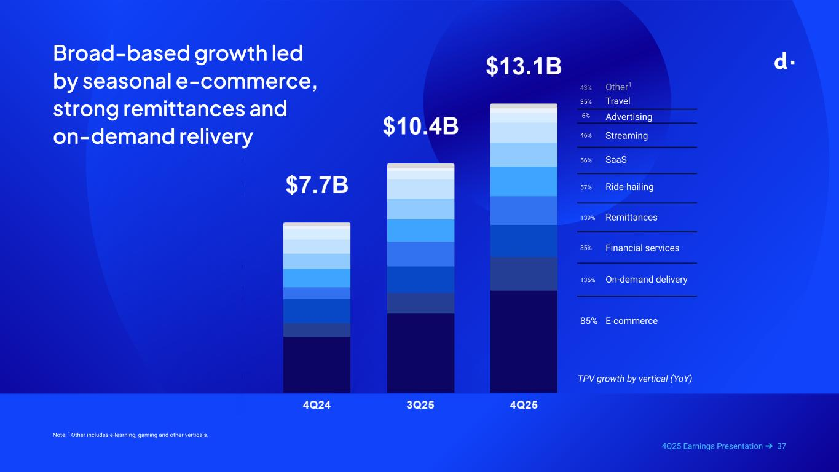
374Q25 Earnings Presentation ➔ Broad-based growth led by seasonal e-commerce, strong remittances and on-demand relivery TPV growth by vertical (YoY) 85% E-commerce 135% On-demand delivery 35% Financial services 139% Remittances 57% Ride-hailing 56% SaaS 46% Streaming -6% Advertising 35% Travel Note: 1 Other includes e-learning, gaming and other verticals. 43% Other1

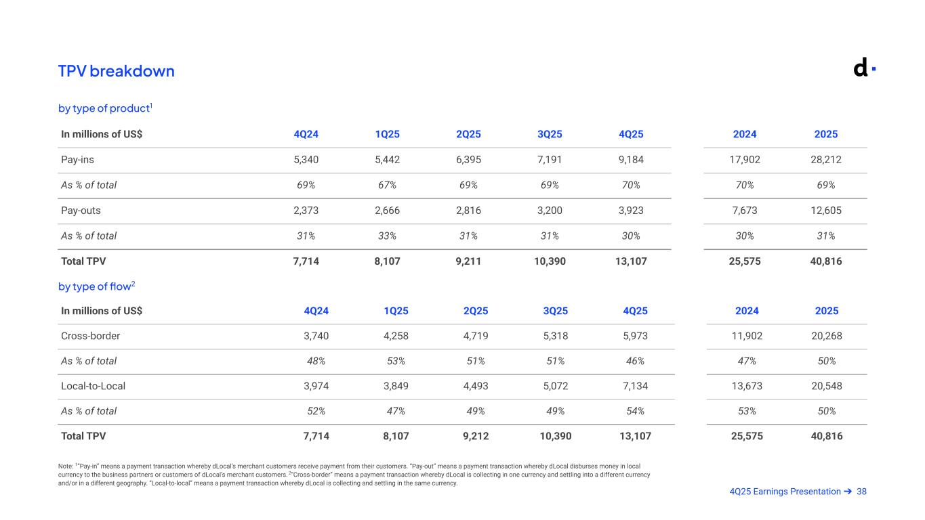
384Q25 Earnings Presentation ➔ TPV breakdown Note: 1”Pay-in” means a payment transaction whereby dLocal’s merchant customers receive payment from their customers. “Pay-out” means a payment transaction whereby dLocal disburses money in local currency to the business partners or customers of dLocal’s merchant customers. 2“Cross-border” means a payment transaction whereby dLocal is collecting in one currency and settling into a different currency and/or in a different geography. “Local-to-local” means a payment transaction whereby dLocal is collecting and settling in the same currency. by type of product1 by type of flow2 In millions of US$ 4Q24 1Q25 2Q25 3Q25 4Q25 2024 2025 Pay-ins 5,340 5,442 6,395 7,191 9,184 17,902 28,212 As % of total 69% 67% 69% 69% 70% 70% 69% Pay-outs 2,373 2,666 2,816 3,200 3,923 7,673 12,605 As % of total 31% 33% 31% 31% 30% 30% 31% Total TPV 7,714 8,107 9,211 10,390 13,107 25,575 40,816 In millions of US$ 4Q24 1Q25 2Q25 3Q25 4Q25 2024 2025 Cross-border 3,740 4,258 4,719 5,318 5,973 11,902 20,268 As % of total 48% 53% 51% 51% 46% 47% 50% Local-to-Local 3,974 3,849 4,493 5,072 7,134 13,673 20,548 As % of total 52% 47% 49% 49% 54% 53% 50% Total TPV 7,714 8,107 9,212 10,390 13,107 25,575 40,816

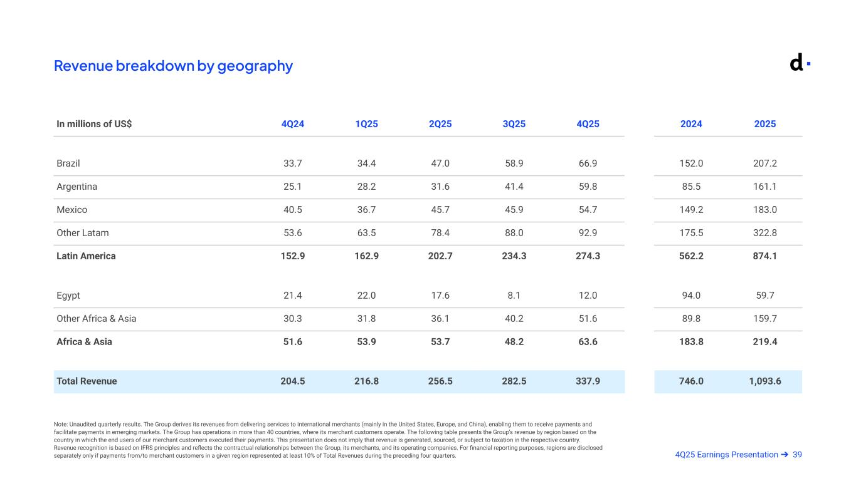
394Q25 Earnings Presentation ➔ Revenue breakdown by geography Note: Unaudited quarterly results. The Group derives its revenues from delivering services to international merchants (mainly in the United States, Europe, and China), enabling them to receive payments and facilitate payments in emerging markets. The Group has operations in more than 40 countries, where its merchant customers operate. The following table presents the Group’s revenue by region based on the country in which the end users of our merchant customers executed their payments. This presentation does not imply that revenue is generated, sourced, or subject to taxation in the respective country. Revenue recognition is based on IFRS principles and reflects the contractual relationships between the Group, its merchants, and its operating companies. For financial reporting purposes, regions are disclosed separately only if payments from/to merchant customers in a given region represented at least 10% of Total Revenues during the preceding four quarters. In millions of US$ 4Q24 1Q25 2Q25 3Q25 4Q25 2024 2025 Brazil 33.7 34.4 47.0 58.9 66.9 152.0 207.2 Argentina 25.1 28.2 31.6 41.4 59.8 85.5 161.1 Mexico 40.5 36.7 45.7 45.9 54.7 149.2 183.0 Other Latam 53.6 63.5 78.4 88.0 92.9 175.5 322.8 Latin America 152.9 162.9 202.7 234.3 274.3 562.2 874.1 Egypt 21.4 22.0 17.6 8.1 12.0 94.0 59.7 Other Africa & Asia 30.3 31.8 36.1 40.2 51.6 89.8 159.7 Africa & Asia 51.6 53.9 53.7 48.2 63.6 183.8 219.4 Total Revenue 204.5 216.8 256.5 282.5 337.9 746.0 1,093.6 Armado Mar 11 @ 9pm

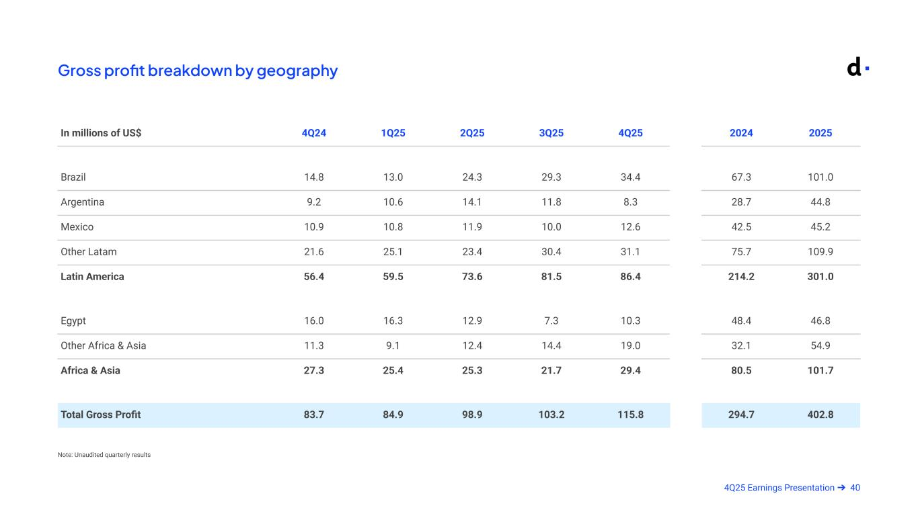
404Q25 Earnings Presentation ➔ Gross profit breakdown by geography Note: Unaudited quarterly results In millions of US$ 4Q24 1Q25 2Q25 3Q25 4Q25 2024 2025 Brazil 14.8 13.0 24.3 29.3 34.4 67.3 101.0 Argentina 9.2 10.6 14.1 11.8 8.3 28.7 44.8 Mexico 10.9 10.8 11.9 10.0 12.6 42.5 45.2 Other Latam 21.6 25.1 23.4 30.4 31.1 75.7 109.9 Latin America 56.4 59.5 73.6 81.5 86.4 214.2 301.0 Egypt 16.0 16.3 12.9 7.3 10.3 48.4 46.8 Other Africa & Asia 11.3 9.1 12.4 14.4 19.0 32.1 54.9 Africa & Asia 27.3 25.4 25.3 21.7 29.4 80.5 101.7 Total Gross Profit 83.7 84.9 98.9 103.2 115.8 294.7 402.8

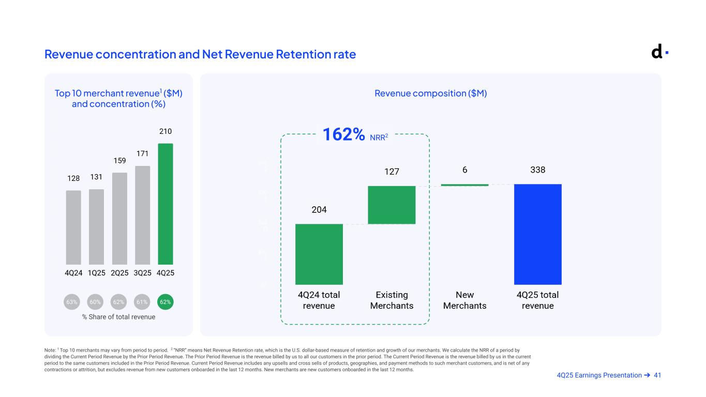
414Q25 Earnings Presentation ➔ Revenue concentration and Net Revenue Retention rate Note: 1 Top 10 merchants may vary from period to period. 2 “NRR” means Net Revenue Retention rate, which is the U.S. dollar-based measure of retention and growth of our merchants. We calculate the NRR of a period by dividing the Current Period Revenue by the Prior Period Revenue. The Prior Period Revenue is the revenue billed by us to all our customers in the prior period. The Current Period Revenue is the revenue billed by us in the current period to the same customers included in the Prior Period Revenue. Current Period Revenue includes any upsells and cross sells of products, geographies, and payment methods to such merchant customers, and is net of any contractions or attrition, but excludes revenue from new customers onboarded in the last 12 months. New merchants are new customers onboarded in the last 12 months. Top 10 merchant revenue1 ($M) and concentration (%) Revenue composition ($M) % Share of total revenue 62%61%63% 60% 62% 162% NRR2

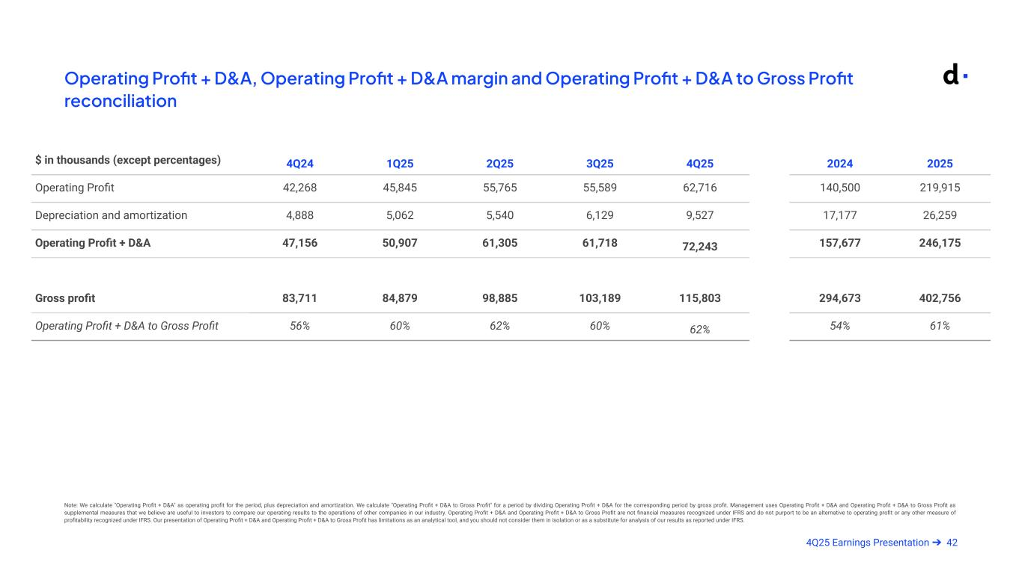
424Q25 Earnings Presentation ➔ Operating Profit + D&A, Operating Profit + D&A margin and Operating Profit + D&A to Gross Profit reconciliation Armado Mar 11 @ 9pm Note: We calculate "Operating Profit + D&A" as operating profit for the period, plus depreciation and amortization. We calculate "Operating Profit + D&A to Gross Profit" for a period by dividing Operating Profit + D&A for the corresponding period by gross profit. Management uses Operating Profit + D&A and Operating Profit + D&A to Gross Profit as supplemental measures that we believe are useful to investors to compare our operating results to the operations of other companies in our industry. Operating Profit + D&A and Operating Profit + D&A to Gross Profit are not financial measures recognized under IFRS and do not purport to be an alternative to operating profit or any other measure of profitability recognized under IFRS. Our presentation of Operating Profit + D&A and Operating Profit + D&A to Gross Profit has limitations as an analytical tool, and you should not consider them in isolation or as a substitute for analysis of our results as reported under IFRS. $ in thousands (except percentages) 4Q24 1Q25 2Q25 3Q25 4Q25 2024 2025 Operating Profit 42,268 45,845 55,765 55,589 62,716 140,500 219,915 Depreciation and amortization 4,888 5,062 5,540 6,129 9,527 17,177 26,259 Operating Profit + D&A 47,156 50,907 61,305 61,718 72,243 157,677 246,175 Gross profit 83,711 84,879 98,885 103,189 115,803 294,673 402,756 Operating Profit + D&A to Gross Profit 56% 60% 62% 60% 62% 54% 61%

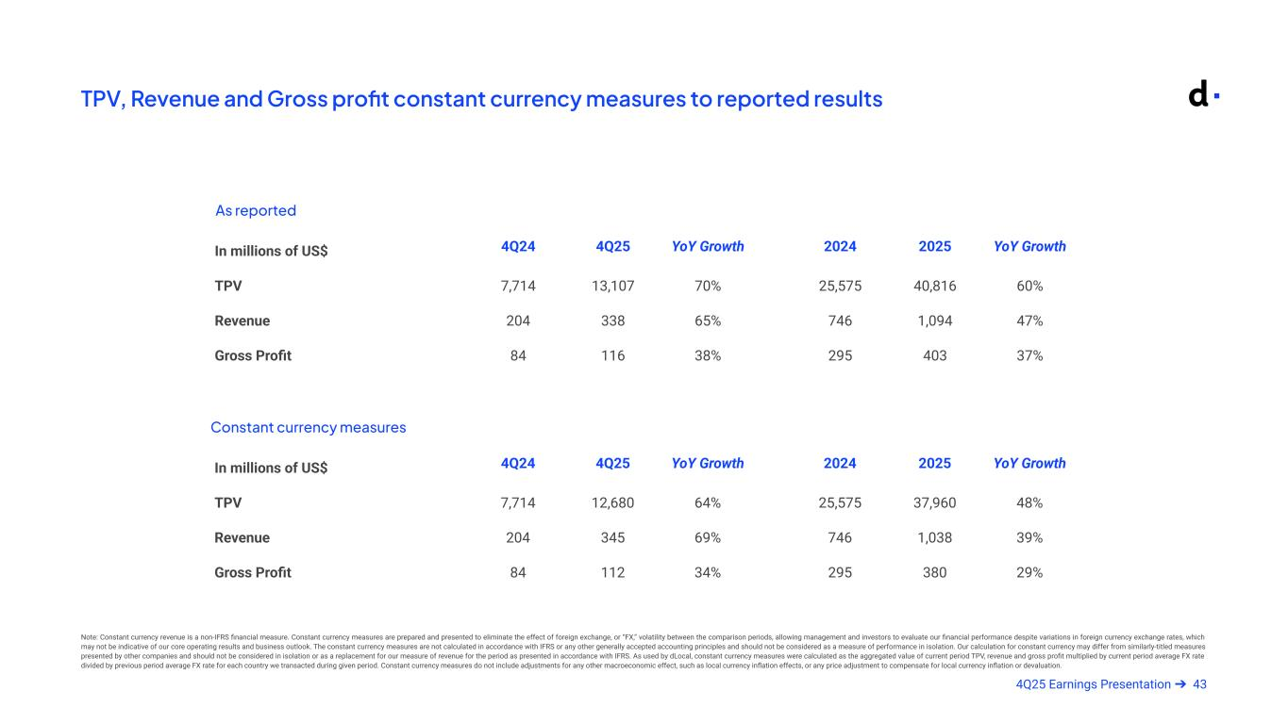
434Q25 Earnings Presentation ➔ TPV, Revenue and Gross profit constant currency measures to reported results As reported Constant currency measures Note: Constant currency revenue is a non-IFRS financial measure. Constant currency measures are prepared and presented to eliminate the effect of foreign exchange, or “FX,” volatility between the comparison periods, allowing management and investors to evaluate our financial performance despite variations in foreign currency exchange rates, which may not be indicative of our core operating results and business outlook. The constant currency measures are not calculated in accordance with IFRS or any other generally accepted accounting principles and should not be considered as a measure of performance in isolation. Our calculation for constant currency may differ from similarly-titled measures presented by other companies and should not be considered in isolation or as a replacement for our measure of revenue for the period as presented in accordance with IFRS. As used by dLocal, constant currency measures were calculated as the aggregated value of current period TPV, revenue and gross profit multiplied by current period average FX rate divided by previous period average FX rate for each country we transacted during given period. Constant currency measures do not include adjustments for any other macroeconomic effect, such as local currency inflation effects, or any price adjustment to compensate for local currency inflation or devaluation. In millions of US$ 4Q24 4Q25 YoY Growth 2024 2025 YoY Growth TPV 7,714 13,107 70% 25,575 40,816 60% Revenue 204 338 65% 746 1,094 47% Gross Profit 84 116 38% 295 403 37% In millions of US$ 4Q24 4Q25 YoY Growth 2024 2025 YoY Growth TPV 7,714 12,680 64% 25,575 37,960 48% Revenue 204 345 69% 746 1,038 39% Gross Profit 84 112 34% 295 380 29%

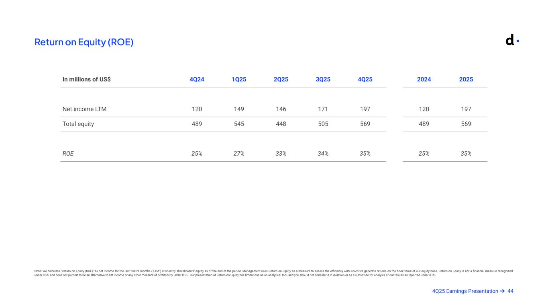
444Q25 Earnings Presentation ➔ Return on Equity (ROE) Note: We calculate "Return on Equity (ROE)" as net income for the last twelve months ("LTM") divided by shareholders' equity as of the end of the period. Management uses Return on Equity as a measure to assess the efficiency with which we generate returns on the book value of our equity base. Return on Equity is not a financial measure recognized under IFRS and does not purport to be an alternative to net income or any other measure of profitability under IFRS. Our presentation of Return on Equity has limitations as an analytical tool, and you should not consider it in isolation or as a substitute for analysis of our results as reported under IFRS. Armado Mar 11 @ 9pm In millions of US$ 4Q24 1Q25 2Q25 3Q25 4Q25 2024 2025 Net income LTM 120 149 146 171 197 120 197 Total equity 489 545 448 505 569 489 569 ROE 25% 27% 33% 34% 35% 25% 35%

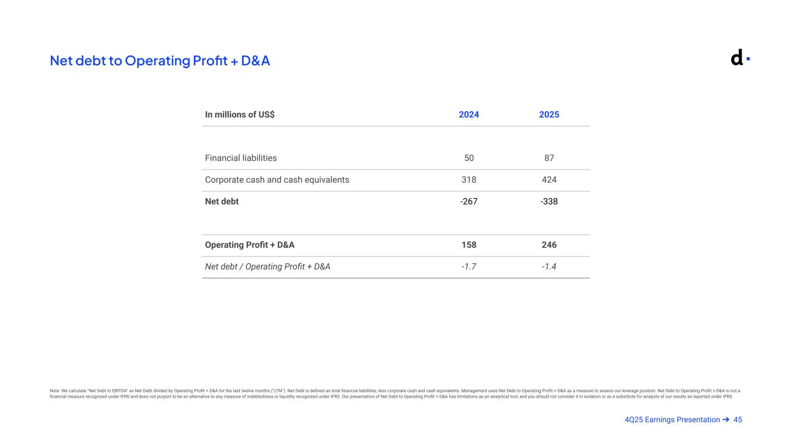
454Q25 Earnings Presentation ➔ Net debt to Operating Profit + D&A Note: We calculate "Net Debt to EBITDA" as Net Debt divided by Operating Profit + D&A for the last twelve months ("LTM"). Net Debt is defined as total financial liabilities, less corporate cash and cash equivalents. Management uses Net Debt to Operating Profit + D&A as a measure to assess our leverage position. Net Debt to Operating Profit + D&A is not a financial measure recognized under IFRS and does not purport to be an alternative to any measure of indebtedness or liquidity recognized under IFRS. Our presentation of Net Debt to Operating Profit + D&A has limitations as an analytical tool, and you should not consider it in isolation or as a substitute for analysis of our results as reported under IFRS. Armado Mar 11 @ 9pm In millions of US$ 2024 2025 Financial liabilities 50 87 Corporate cash and cash equivalents 318 424 Net debt -267 -338 Operating Profit + D&A 158 246 Net debt / Operating Profit + D&A -1.7 -1.4

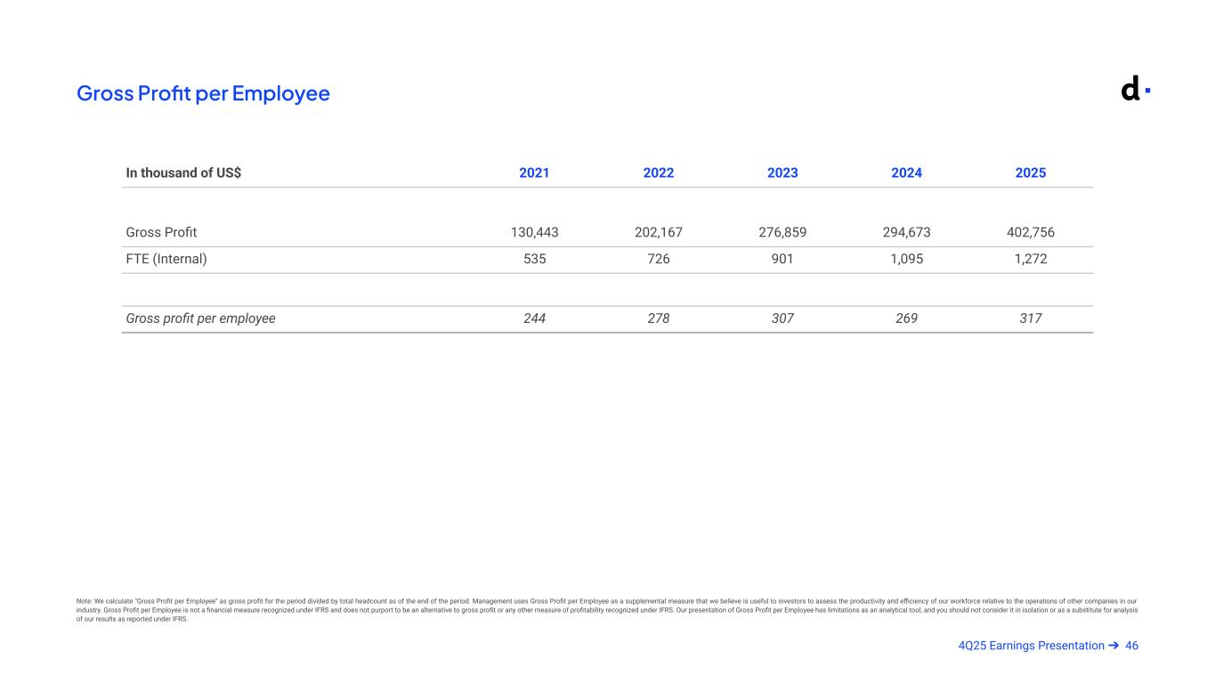
464Q25 Earnings Presentation ➔ Gross Profit per Employee Note: We calculate "Gross Profit per Employee" as gross profit for the period divided by total headcount as of the end of the period. Management uses Gross Profit per Employee as a supplemental measure that we believe is useful to investors to assess the productivity and efficiency of our workforce relative to the operations of other companies in our industry. Gross Profit per Employee is not a financial measure recognized under IFRS and does not purport to be an alternative to gross profit or any other measure of profitability recognized under IFRS. Our presentation of Gross Profit per Employee has limitations as an analytical tool, and you should not consider it in isolation or as a substitute for analysis of our results as reported under IFRS. Armado Mar 11 @ 9pm In thousand of US$ 2021 2022 2023 2024 2025 Gross Profit 130,443 202,167 276,859 294,673 402,756 FTE (Internal) 535 726 901 1,095 1,272 Gross profit per employee 244 278 307 269 317

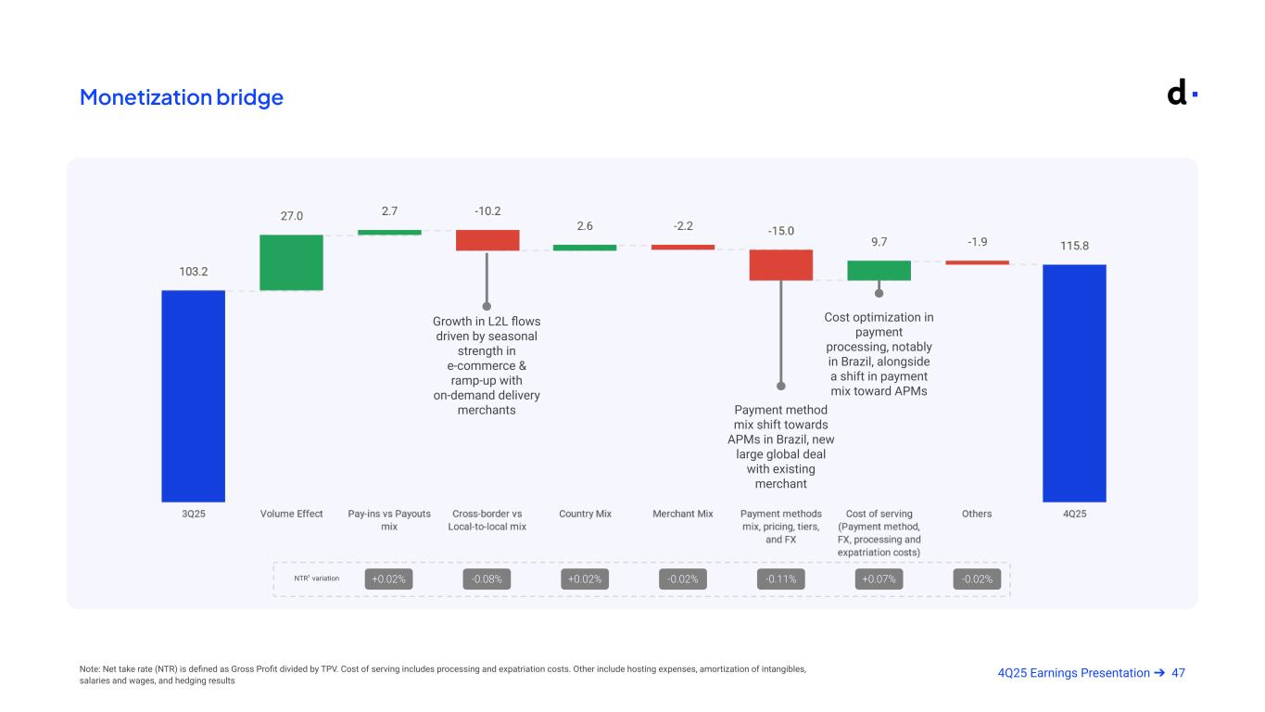
474Q25 Earnings Presentation ➔Note: Net take rate (NTR) is defined as Gross Profit divided by TPV. Cost of serving includes processing and expatriation costs. Other include hosting expenses, amortization of intangibles, salaries and wages, and hedging results +0.02% -0.08% +0.02% -0.02% -0.11% +0.07% -0.02% Monetization bridge NTR1 variation Payment method mix shift towards APMs in Brazil, new large global deal with existing merchant Growth in L2L flows driven by seasonal strength in e-commerce & ramp-up with on-demand delivery merchants Cost optimization in payment processing, notably in Brazil, alongside a shift in payment mix toward APMs


Investor Relations Contact investor@dlocal.com Media Contact media@dlocal.com This presentation does not contain sufficient information to constitute an interim financial report as defined in International Accounting Standards 34, “Interim Financial Reporting” nor a financial statement as defined by International Accounting Standards 1 “Presentation of Financial Statements”. The fourth quarter financial information in this press release has not been audited nor has it been subject to any limited review procedures, whereas the annual results for the year ended December 31, 2025 are audited.

Exhibit 99.4

DLocal Limited Declares Dividend Distribution

MONTEVIDEO, Uruguay, March 18, 2026 – DLocal Limited (NASDAQ: DLO, “DLocal” or the “Company”), a technology-first payments platform enabling global enterprise merchants to connect with billions of consumers in emerging markets, today announced that it has declared a cash dividend of an aggregate of US$57,211,274, equivalent to approximately US$0.1939 (subject to adjustment according to the number of shares outstanding as of the record date), to shareholders of record as of the close of the business day on May 27, 2026, to be paid on or about June 10, 2026.

About DLocal

DLocal powers local payments in emerging markets connecting global enterprise merchants with billions of emerging market consumers across APAC, the Middle East, Latin America, and Africa. Through the “One DLocal” concept (one direct API, one platform, and one contract), global companies can accept payments, send pay-outs and settle funds globally without the need to manage separate pay-in and payout processors, set up numerous local entities, and integrate multiple acquirers and payment methods in each market.

Forward Looking Statements

This announcement contains certain forward-looking statements. These forward-looking statements convey our current expectations or forecasts of future events. Forward-looking statements regarding DLocal involve known and unknown risks, uncertainties and other factors that may cause our actual results, performance or achievements to be materially different from any future results, performances or achievements expressed or implied by the forward-looking statements. Certain of these risks and uncertainties are described in our filings with the U.S. Securities and Exchange Commission. Unless required by law, we undertake no obligation to publicly update or revise any forward-looking statements to reflect circumstances or events after the date hereof.

Investor Relations Contact:
investor@dlocal.com

Media Contact:
marketing@dlocal.com

